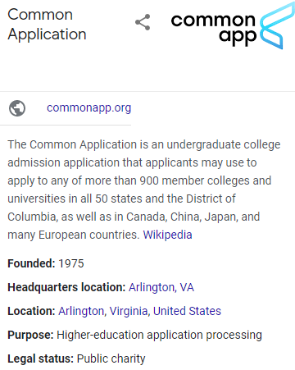

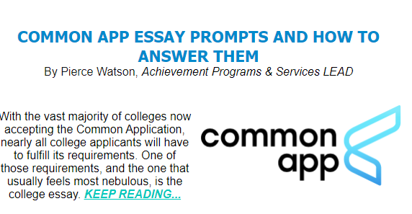

Common App Essay Prompts and How to Answer Them
by Pierce Watson, Achievement Programs & Services LEAD
With the vast majority of colleges now accepting the Common Application, nearly all college applicants will have to fulfill its requirements. One of those requirements, and the one that usually feels most nebulous, is the college essay. These days, the Common App provides students with seven different prompts to choose from, which makes the task a little more focused than it was in my day, but does put the onus on the student to pick the one that fits them best. So, how do you choose?
Admissions offices are mainly attempting to understand who you are from this prompt, so picking one depends on which prompt conjures experiences that exemplify you as a person. In pulling back the veil on each of these, I hope to make choosing a prompt a more clear task.
1. Some students have a background, identity, interest, or talent that is so meaningful they believe their application would be incomplete without it. If this sounds like you, then please share your story.
The operative clause here is: “would be incomplete without it.” This prompt is for those folks who feel so strongly tied to a hobby, concept, event, or interest, that failing to mention it would not sufficiently describe them. Though I have a whole slew of hobbies and things I care about deeply, for me, none of them necessarily define me, so this wouldn’t be a great choice. Additionally, this is not an explanation about this event or hobby is so great—it is an explanation of how and why it came to be a piece of you.
2. The lessons we take from obstacles we encounter can be fundamental to later success. Recount a time when you faced a challenge, setback, or failure. How did it affect you, and what did you learn from the experience?
This is one of the easier, more straightforward prompts, as almost all people have faced challenges and setbacks in their lives. The key to answering this prompt is to ensure you’ve connected the challenge to a “later success.” If you’ve done that and kept the response focused on yourself, your essay will be in a good spot.
3. Reflect on a time when you questioned or challenged a belief or idea. What prompted your thinking? What was the outcome?
It can be useful to hold a magnifying glass up to these prompts and ask yourself, what personality trait or value are they looking for here? In this case, we can surmise that admissions officers are attempting to find students who are independent thinkers—those who challenge the status quo and imagine alternatives. Understanding what personal quality the admissions folks are looking for within each prompt can give direction and focus to your writing. This is important to keep in mind with this one.
4. Describe a problem you've solved or a problem you'd like to solve. It can be an intellectual challenge, a research query, an ethical dilemma—anything that is of personal importance, no matter the scale. Explain its significance to you and what steps you took or could be taken to identify a solution.
This is one of the tougher prompts, only because it can be very easy to get lost in the “problem” you encountered, and fail to tie that problem back to yourself in a meaningful way. The other pitfall occurs when a student tries to force significance and meaning when it isn’t there. If you do choose this prompt, remember that responses need to reflect your character. That is the one and only goal—not convincing admissions officers that you’ve figured out how to rid the ocean of plastics (please do figure that out, though)!
5. Discuss an accomplishment, event, or realization that sparked a period of personal growth and a new understanding of yourself or others
The required detective work for each of these prompts is understanding what aspects are most important. Hopefully, you’ve noticed a pattern in that all of these prompts are in service of understanding you. Relaying an accomplishment is great, but the crux here is how that proceeded to influence your personal growth while demonstrating introspection. It is not just explaining how the event helped you grow, but also what growth means to you and how you measure it in yourself.
6. Describe a topic, idea, or concept you find so engaging that it makes you lose all track of time. Why does it captivate you? What or who do you turn to when you want to learn more?
This is a seemingly innocuous choice among the various prompts, but it is actually the prompt I most often see answered poorly. In part, the prompt is subject to the same pitfall as several others, which is failing to tie the prompt back to yourself. The danger is in the prompt—it is asking you to speak to a topic that makes you lose track of time. It also may cause you to lose focus when writing, leading to rambling thoughts and poor fluidity. Additionally, students tend to ignore the last question, despite it being core to the prompt. Speaking to who or what you turn to for more information is an opportunity to demonstrate resourcefulness and curiosity. Overall, unless you feel very strongly about this one, skip it.
7. Share an essay on any topic of your choice. It can be one you've already written, one that responds to a different prompt, or one of your own design.
Unless it’s a perfect fit, it’s not a great idea to use an essay you’ve already written. College essays should be directly pointed to and focused on the prompt at hand, which is quite difficult if you’re using a prewritten essay. There are no real brownie points for coming up with your own prompt, so there isn’t a lot of incentive to go this route. I would say that if you do pursue your own prompt, make sure that it allows for an answer that shows who you are. Admissions officers can see your grades, extracurriculars, and test scores, but they won’t know you unless you write a great essay.
Good luck to all college applicants!

4 Tips For High School Students to Stay Active Over The Summer
by Amelia Allen, Student Outreach Assistant
With the summer rapidly approaching, many students are wondering what they can do during these months of downtime to help pad out their resumes and college applications. If this is something you’ve been worried about, here are four things you can do to make your college applications look even better.
1. Volunteer. Volunteer experience is a great addition to any college application, especially if your volunteer experience ties into the academic program you’re applying for. For example, if you’re planning to pursue a medical education, try volunteering at WakeMed, Rex Hospital, or Duke Hospital. If you plan to join an environmental studies program, try volunteering with a local clean-up group. If you’d like to find more opportunities, go to ActivateGood.com to find volunteer opportunities that fit your interests.
2. Find Leadership Experiences.Having leadership experience on an application can really set you apart in the application process. There are plenty of youth leadership opportunities that you can try to pursue in Wake County. You can join the Raleigh Youth Council, the Wake Forest Youth Advisory Board, or the Lightner Y Achievers at the YMCA. Having leadership experience while in high school also helps when pursuing potential leadership opportunities in college.
3. Find More Educational opportunities. The summer is a great time to explore more educational opportunities that aren’t available during the school year. In Wake County, the one of the best places to get extra educational opportunities is at NC State, which has a variety of summer camps for high schoolers that cover a wide variety of topics, from agricultural sciences, to design, to engineering. If you want to pursue an education in topics that you probably aren’t learning in high school, look into these summer camps.
4. Try to get a Summer Job. Having work experience on your application can distinguish you from other applicants, especially if you maintain this job throughout the school year while still maintaining a good GPA. If possible, try to get a job relevant to the field you plan to pursue, but if no opportunity is available, getting any job available to you still works and shows to applicant reviewers that you’re a hard worker.
While it’s important to use the summer as a time to destress from the school year, especially with the added stress of the pandemic in the past school year, keeping active and working to pursue extracurricular activities can help you in the long run.

