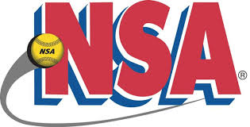 NSA Valentines Day Bash
Plex South-Ft Wayne, IN
February 2-3, 2019

18u Pool

- Ind. Shockwaves 4) Krash 18u Green
- Hoosier Force 5) Ft Wayne Force
- Downers Grove Outlaws

Saturday 12:40 PM Field #1 Shockwaves vs Hoosier Force 2-0
Saturday 12:40 PM Field #2 Downers Grove vs Krash 2-1
Staurday 1:50 PM Field #1 Shockwaves vs FW Force 12-0
Saturday 1:50 PM Field #2 Hoosier Force vs Downers Grove 1-0
Saturday 3:00 PM Field #1 Krash vs FW Force 2-0
Saturday 3:00 PM Field #2 Shockwaves vs Downers Grove 3-0
Saturday 4:10 PM Field #1 Shockwaves vs Krash 5-0
Saturday 4:10 PM Field #2 Hoosier Force vs FW Force 4-2

All pool games are 60 minutes, drop dead, revert back if not a complete inning,
Games may end in a tie.

