Eco Orca Class MARCH 2026 Food and Water Sources
SUNDAY |  |  | MONDAY | TUESDAY | WEDNESDAY | THURSDAY | FRIDAY | SATURDAY
 |  | 1 | 2 | 3 | 4 | 5 | 6 | 7
  This Photo by Unknown Author is licensed under CC BY-SA-NC |  |  | Ruby Ridge Trails | Honey Crisp Park | Humpback Dam/Pipeline | Thrifty Foods Tour $5 | Island View Beach
 | 8 |  | 9 | 10 | 11 | 12 | 13 | 14
 |  |  | Beaver  Lake | Lower Sooke River Trails | Central Saanich Park | Witty’s Lagoon | Swan Lake Nature House $5 | 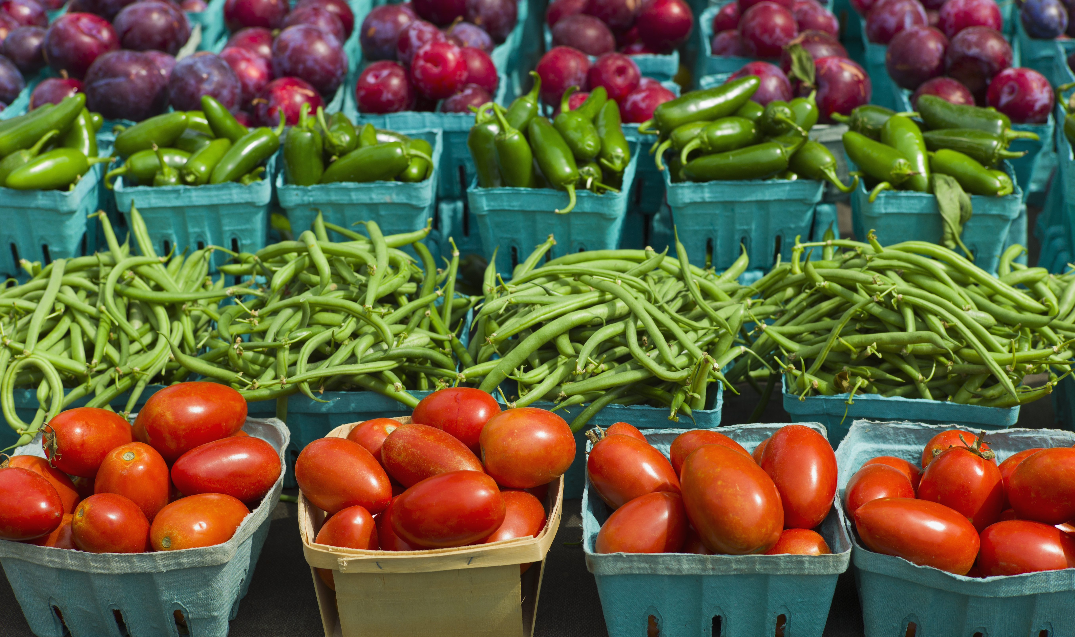
 | 15 |  | 16 | 17 | 18 | 19 | 20 | 21
  This Photo by Unknown Author is licensed under CC BY-NC-ND |  |  | Spring | Break | -------- | -------- | --------
 | 22 |  | 23 | 24 | 25 | 26 | 27 | 28
 |  |  | Spring | Break | -------- | -------- | --------
 | 29 |  | 30 | 31 | 1 | 2 | 3 | 4
 |  |  | Gyro  Park | Charlies  Trail |  |  | 