l 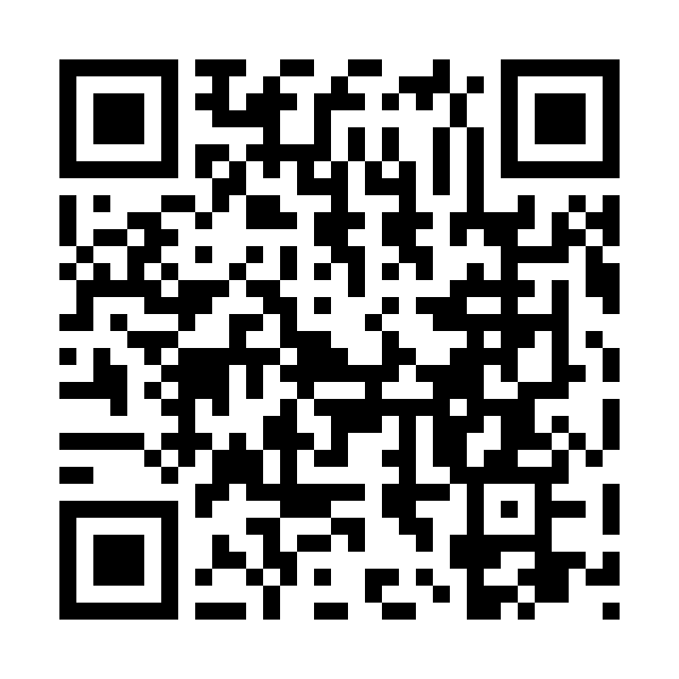
Catholic Church cluster of Davenport
St. Francis of Assisi – Harrington
Immaculate Conception Catholic Church – Davenport
St. Michael Catholic Church – Reardan
St. Kateri Tekawitha Catholic Church – Ford
Sacred Heart Catholic Church – Wellpinit
Mailing Address: Immaculate Conception Catholic Church - Davenport
1310 Adams St., Davenport, WA 99122-9454
(509)725-1761
Office manager: Jackie – icdavenport@dioceseofspokane.org
Immaculateconceptiondavenport.org
Any information for the bulletin needs to be to Jackie
Pastor – Fr. Brian Sattler – bsattler@dioceseofspokane.org
Sacramental requests: Call Fr. Brian 503-989-7585

The Holy Sacrifice of the Mass
Daily Tues. Davenport at 9am and 5:30pm, adoration, Wed. & Fri. Davenport 9am, Reardan Thurs. 9am.
Saturday Harrington mass at 5:30pm Sunday Rosary at 8am in Davenport
Davenport at 8:30am, Reardan at 10:30am, Ford 12:30pm (1st-2nd-3rd Sunday in Ford) (4th Sunday in Wellpinit)
Confessions – half hour before Sunday mass.

ACA Goals ICC $12,582 St.Francis $2,440 St.Michael $8,844
Collected $12,400 $3,900 $8,150 $__________________________________________________________
$ 182 + $ 1,460 $ 694

Thanks to all those who have contributed to the ACA!

There will be a tub for collecting socks and toiletries for Charity Christmas collection in the entrance of the church in Davenport. We will be collecting through December 10. Any questions contact Patty Pebbles 509-721-0326.

Anyone interested in 2 in-ground inurnment plots at Holy Cross Cemetery on Spokane for $6,300. See Fr Brian or Jackie for more details.

Fr. Brian will be on vacation from Dec. 8-22. Fr Kruse will cover masses the weekends of Dec 14th and 20th.

Mass Intentions: Nov. 15 Sat. 5:30pm in Harrington Nov. 16 Sun. 8:30am, 10:30 am, 12:30 pm
Nov. 18 Tues. 9am and 5:30pm Nov. 19 Wed. 9am Nov. 20 Thurs. Reardan 9am Nov. 21 Fri. 9am

