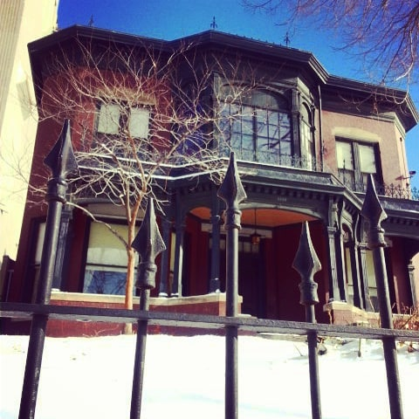

WHAT: RMGA MEMBERSHIP MEETING –
WHEN: September 12, 2022
6:00 pm – House Tour & Center for Colorado Women’s History (Program and Meeting will not be Zoomed)
7:30 pm – Short Meeting
GUESTS: Members are encouraged to invite potential members as a guest to the meeting.
MEETING NIGHT CONTACT: J. Mark Blaising, Program Chair 303-830-8440 (voice) 303-263-8647 (text)
PROGRAM: Situated in the heart of today’s thriving museum and cultural district is a unique historic gem that connects Denver’s past and present. The Byers-Evans House is now the Center for Colorado’s Women’s History. Built in 1883 for Denver Pioneer and founder of the Rocky Mountain news William Newton Byers and his wife Elizabeth, this Italianate style Mansion has been home to two of early Denver’s most prominent families. In 1888, the son of the former Territorial Governor and future head of the Denver Tramway Monopoly, William Evans and his wife Cornelia along with their two young children John and Josephine purchased and took residence in the house. Two additional children Margaret and Katherine were born in the home and a member of the family resided in the home for 90 years before being deeded to the state for use as a museum.
It has gone through multiple renovations and a major expansion in 1897 to accommodate William’s mother Margaret and sister Anne after the death of the former Governor. Anne Evans was a pioneer in her own right as she championed the arts and cultural institutions of the fledgling metropolis. She was a founding member of the Denver Arts Society precursor to the Denver Art Museum as well as the library and a guiding force in the renovation and restoration of the Central City Opera House.
The museum is based on an interpretive period between 1912-1924. The beginning year is that of the last major renovation and the end year marks the death of William Evans. Unique to house museums is the overwhelming percentage of original family furnishings and pieces from that period. Ninety percent of the objects on display are from the family. Other objects include a Tiffany Lamp contributed by the family of Mamie Doud Eisenhower.
More recently the House and the Carriage House Gallery have become the home of the Center for Colorado’s Women’s History. The Center for Colorado Women’s History focuses on scholarship, research, lectures, tours and exhibits that expand the understanding and collective memory of the history of women in Colorado. Most importantly, the Center is connecting local stories to the broader stories of women’s history worldwide.
The Rocky Mountain Guides Association is pleased to announce that its members are welcome to attend an evening at the Center for Colorado Women’s History on Monday September 12th from 6-8pm. The event will be hosted by Cat Jensen, the Guest Services Coordinator and Educator at the Center for Colorado Women's History. A Folklorist and performer who has worked in museums across the country for ten years, Cat loves giving tours, creating educational materials and telling the stories of the inspiring women of the museum's beautiful historic home. Cat's presentation will provide information on the museum, the families who lived there and the legacy of Anne Evans, an inductee of the Colorado Women's Hall of Fame.
The cost is $5.00 per person. Please RSVP to Blaising303@gmail.com

