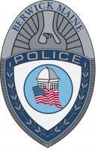
HONOR-
good name or public esteem

INTEGRITY-
Firm ADHERENCE to a code of especially moral or artistic values

VALOR-
strength of mind or spirit that enables a person to encounter danger with firmness: personal bravery

