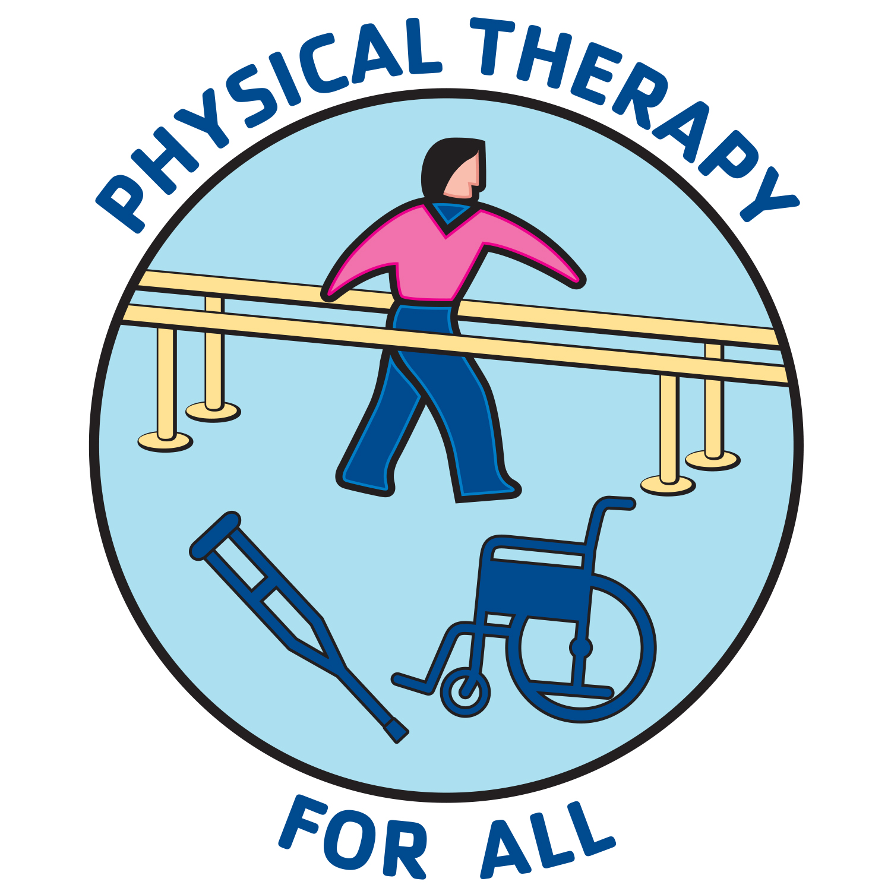 Pro Bono Physical Therapy
Rehabilitation services for those in need
The Process:
A licensed PT/PTA contacts PTFORALL looking for PT clinics willing to host them as they provide pro bono physical therapy. PTFORALL provides the PT/PTA with a list of PT clinics who are willing to host them. The PT/PTA contacts the private practice owner (PPO) of a nearby clinic via email and the two parties arrange for an interview and then determine the best days for scheduling pro bono work (once-a-month or more frequently if reasonable to do so by both parties). In the once-a-month scenario the patient would receive a comprehensive evaluation and a detailed home management program. At the discretion of both parties, follow-up visits may be arranged.

For the licensed PT/PTA:
The licensed PT/PTA is expected, and strongly encouraged, to have their own professional liability insurance ($160-$185/annually). PTFORALL offers a limited number of grants (up to $200) for licensed PTs/PTAs providing pro bono physical therapy care. The PT/PTA is responsible for documenting and maintaining a record of each treatment for each patient they provide care and should not assume that they will be added to the PT clinics EMR system.

For the private practice owner (FAQ):
Please note that your information (name, website and email) will be on a private database and only released to licensed PTs/PTAs interested in providing pro bono PT services.
1. Would I be covered under my clinic’s liability insurance (professional and general) if a patient sued and named the volunteer PT/PTA as responsible for the incident/injury?
Yes. Dave Powers, CPTA Board member (Finance Officer) and PPO, was gracious enough to check with CNA, the largest provider of PT professional liability insurance, and they confirmed that the PPO would be covered.

2. Who should I allow to receive pro bono physical therapy services at my clinic and how do I find them?
You decide who you want to provide services for inside your clinic. If requested, PTFORALL can assist in referrals of potential pro bono patients to your clinic – usually form a nearby Community Healthcare Clinic. Below are a couple of strategies to consider.

Community healthcare clinics: 95% of the patients that receive physical therapy care through Physical Therapy For All are referred by Community Healthcare Clinics. This has been great for us as the clinic does two things for us – they vet the financial need/low-income status of the patient including verification that they have no insurance, and they provide us with a physical examination report from the patient’s medical visit that clearly demonstrates that there is a need for PT services.

Another benchmark people use is the Federal Poverty Level (FPL). The FPL (https://www.healthcare.gov/glossary/federal-poverty-level-FPL/) as of 2020 is $12,760 annual income for an individual and $26,200 for a family of four. Many people feel the FPL is incredibly low and so it is common to see a line drawn anywhere from 100% to 400% of the FPL.

