Healing Hoof Steps
LIABILITY RELEASE FORM
In consideration of the services of HEALING HOOF STEPS CORP, its managing partners, board members, employees, representatives, agents and associates (hereinafter referred to as “HHS”), I hereby agree to release, indemnify, and discharge HHS, on behalf of myself, my children, my parents, my heirs, assigns, personal representative and estate as follows:
1. I acknowledge that horseback riding, caring for horses, and all therapeutic and learning/ self-discovery and/or psychotherapeutic activities involving horses entail known and unanticipated risks which could result in physical or emotional injury, paralysis, death, or damage to me, to property or to third parties. I understand that such risks simply cannot be eliminated without jeopardizing the essential qualities of the activity.
The risks include, among other things: loss of control, collisions; horses, irrespective of their previous behavior and characteristics, may act or react unpredictably based upon instinct, fright, or lack of proper control by rider or handler, latent or apparent defects or conditions in equipment, animals or property, acts of other students in this activity, adverse weather conditions; contact with plants, insects, or animals; my own physical conditions or my own acts or omissions; the conditions of remote roads, trails, waterways, or terrain, and accidents connected with their use; first-aid, emergency treatment or other services rendered; consumption of food and drink. Furthermore, HHS seeks safety, but they are not infallible. They might be unaware of a student’s fitness or abilities. They might misjudge weather, the elements or the terrain. They may give adequate warnings or instructions and the equipment being used might malfunction.
2. I expressly agree and promise to accept and assume all of the risks existing in this activity. My or my child participation in this activity is purely voluntary, and elects to participation in spite of the risks.
3. I hereby voluntarily release, forever discharge, and agree to indemnify and hold harmless HHS from any and all claims, demands, or causes of action, which are in any way connected with my or my child’s participation in this activity or my or my child’s use of HHS equipment or facilities, including any such claims which allege negligent acts or omissions of HHS.
4. Should HHS or anyone acting on their behalf be required to incur attorney’s fees and costs to enforce this agreement, I agree to indemnify and hold them harmless for all such fees and costs.
5. I certify that I have adequate insurance to cover any injury or damage I or my child may cause or suffer while participating or else I agree to bear the costs of such injury or damage myself. I further certify that I nor my child have no medical or physical conditions, which could interfere with my safety in this activity, or else I am willing to assume-and bear the cost of-all risks that may be created, directly or indirectly, by any such condition.
6. In the event that I file a lawsuit against HHS, I agree to do so solely in the state of Florida, and I further agree that the substantive law of that state shall apply in that action without regard to the “conflict of laws” rules of that state. I agree that if any portion of this agreement is found to be void or unenforceable, the remaining portion shall remain in full force and effect.
By signing this document, I acknowledge that if anyone is hurt or property is damaged during my or my child’s participation in this activity, I may be found by a court of law to have waived my or my child’s right to maintain a lawsuit against HHS on the basis of any claim from any claim from which I have released them herein. EQUINE WARNING: Under Florida Law, an equine activity sponsor or equine professional is not liable for an injury to, or the death of, a participant in equine activities resulting from the inherent risks of equine activities. I have had sufficient opportunity to read this entire document. I have read and understood it, and I agree to be bound by its terms.
Student/ Participant Name:_____________________________________________________________
_________________________________________ __________________________________
Teacher participant or parent/Guardian signature Date Print Name of Guardian or Teacher Participant___________________________________________ Address:___________________________________________________________________________ Phone:____________________________________ Email:___________________________________
Emergency Contact:__________________________________________________________________
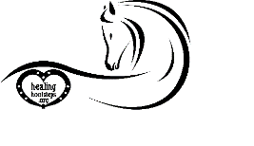
Name/Phone
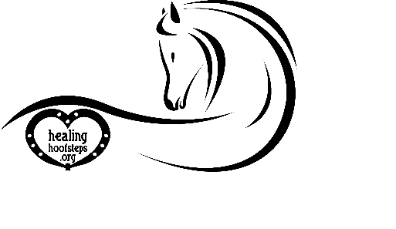

HEALING HOOF STEPS SAFETY GUIDELINES

Welcome to Healing Hoof Steps! We are glad you are here. After reading the material, please sign where indicated showing that you understand and are in agreement with the policies and procedures of our organization.

• Anyone riding or handling a horse on Healing Hoof Steps property must have a signed waiver on file. Waivers are available online or from your instructor.
• Designated Healing Hoof Steps parking is located at the front of the property inside the security gate.
• If you wish to observe the session, please sit at the tables and chairs located under the wonderful shade tree. Please keep the conversation levels down so there will be no distractions for the student.
• The home located on the property is a private residence – no trespassing please.
• All riders must wear an ASTM approved helmet at all times while riding on the property.
• Under no circumstance is a child allowed to retrieve a horse in a turnout without adult supervision.
• Children under the age of 16 must be under the direct supervision of a parent or adult designated by a parent at all times while on Healing Hoof Steps property.
• For safety reasons, no one is allowed on the horse trail without permission from a staff member. Students and boarders use this trail to relax after their lessons. Unfamiliar noises in the woods could cause a horse to spook.
• Do not hand feed treats to horses without permission from the owner. Some horses, have allergies, such as
corn.

I have read the preceding information and will agree to adhere to the safety practices and facility guidelines while on property with my family and/or clients.

_____________________________________________
Student Name/Signature

_____________________________________________
Parent Name/Signature

_____________________________________________
Date

THANK YOU FOR YOUR COOPERATION IN MAKING HEALING HOOF STEPS A SAFE AND HAPPY FARM!

