

QUEENSLAND CHAMPIONSHIPS

EVENT: QUEENSLAND CHAMPIONSHIPS

VENUE: MT GRAVATT SHOWGROUNDS

DATE: 2 AND 3 MAY 2026

FORMAT: SWISS ROUNDS

ROUNDS: 4

MISSIONS: CONFRONTATION, FORWARD PUSH, SEIZE AND HOLD, HOLD GROUND (DOUBLE POINTS)

RESTRICTIONS: 2000 POINTS

ENTRY FEE: $60

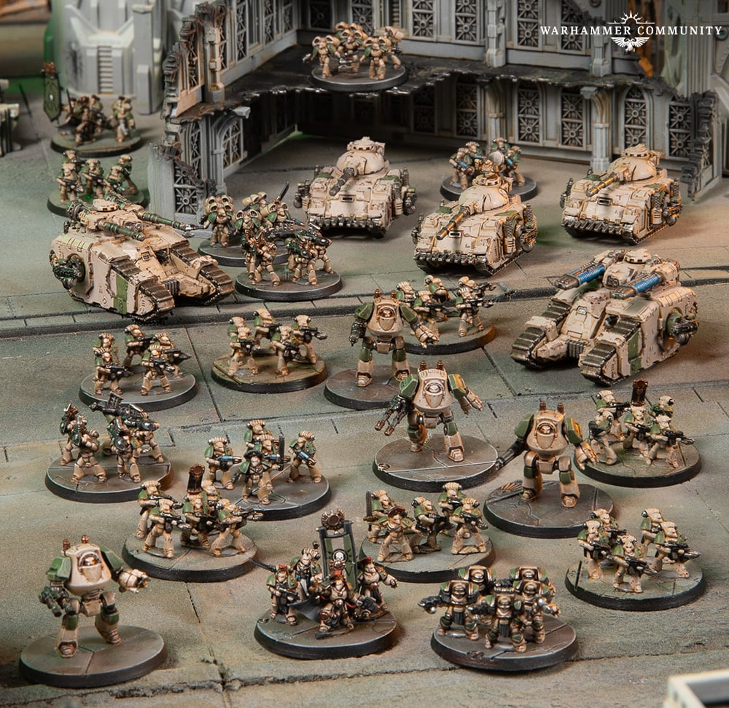

SATURDAY SCHEDULE
8:15AM - TABLE SET UP
8:45AM - BRIEFING

9:00AM - ROUND1

12:00PM - END ROUND 1

1:00PM - ROUND2

4:00PM – END ROUND 2

SUNDAY SCHEDULE
8:30AM – ROUND 3
11:30 AM – END ROUND 3

12:00PM – ROUND 4

3:00PM – END ROUND 4

PACK UP AND PRESENTATION

QUEENSLAND CHAMPIONSHIPS
WHAT TO BRING
- YOUR MODELS
- MEASURING TAPE
- DICE
- 6 X OBJECTIVE MARKERS
- A COPY OF YOUR LIST FOR YOUR OPPONENT
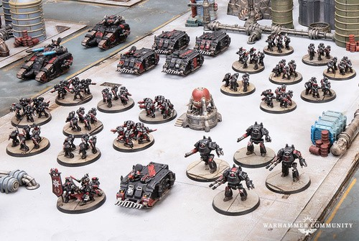

PRIZE CATEGORIES
- BEST GENERAL
- BEST PAINTED
- BEST TABLE

SCORING
2 MATCH POINTS – AWARDED FOR A WIN/BYE
1 MATCH POINT – AWARDED FOR A DRAW
0 MATCH POINTS – AWARDED FOR A LOSS
A BYE WILL BE AWARDED TO A RANDOM PLAYER AT THE BEGINNING OF THE EVENT, IF THERE ARE ODD NUMBERS. A BYE WILL THEN BE GIVEN TOTHE LOWEST SCORING(LOWEST MP AND VP) PLAYER OF EACH ROUND, AND CAN ONLY BE GIVEN TO A PLAYER ONCE DURING THE EVENT.
A BYE WILL BE WORTH A MATCH WIN AND THE VICTORY POINTS AWARDED WILL BE CALCULATED BY AVERAGING THE HIGHEST VICTORY POINT WIN FOR THE ROUND, AND THE LOWEST SCORING WIN FOR THE ROUND.
EXAMPLE, PLAYER A WON THEIR GAME IN ROUND TWO AND SCORED 85 VICTORY POINTS – THE HIGHEST FOR ROUND TWO.
THREE OTHER PLAYERS ALSO WON THEIRGAMES DURING ROUND 2 AND THE LOWEST SCORING WINNER MANAGED TO ACCRUE 25 VICTORY POINTS.
SO THE PLAYER WHO RECEIVED THE BYE THAT ROUND IS AWARDED THEWIN (2 MATCHPOINTS), AND (85+25)/2=55 VICTORY POINTS.
THE WINNER OF THE EVENT (BEST GENERAL), WILL HAVE THE HIGHEST AMOUNT OF MATCH POINTS. IF THIS IS TIED, THEN VICTORY POINTS WILL BE USED AS THE TIEBREAKER TO DETERMINE THE WINNER.
QUEENSLAND CHAMPIONSHIPS

IF A GAME HAS NOT COMPLETED PLAYERS WILL NEED TO WORK BETWEEN THEMSLVES TO DECIDE WHO WOULD LIKELY HAVE SCORED THE POINTS IF THE GAME WENT TO CONCLUSION. IF THIS IS UNCLEAR THEN POINTS ARE AWARDED TO THE PLAYER THAT CURRENTLY HOLDS THEM.
IF A PLAYER FORFEITS AFTER A CERTAIN TURN THEN ALL REMAINING POINTS ARE AWARED TO THEIR APPONENT.

MODEL REPRESENTATION
QUEENSLAND CHAMPIONSHIPS

MODELS ARE TO REPRESENT THE DETACHMENT THAT THEY’RE PART OF. WYSIWYG IS EXPECTED FOR MAIN WEAPONS. HULL AND SPONSON MOUNTED WEAPONS ARE NOT REQUIRED TO BE ACCURATE ON THE MODEL, BUT HIGHLY ENCOURAGED. IF THEY’RE NOT, THEY MUST BE
CLEARLY OUTLINED TO YOUR OPPONENT BEFORE THE GAME BEGINS.
ANY MODELS ON BASES SHOULD BE
REPRESENTED AS FOLLOWS (COMPARED TO GW ILLUSTRATIONS):
5 ON A BASE: MINIMUM 3 ON A BASE
3 ON A BASE: MINIMUM 2 ON A BASE
2 ON A BASE: 1 IS ACCEPTABLE (2PREFERRED) ALL MODELS SHOULD BE FULLY PAINTED.

LIST SUBMISSION:
PLEASE SEND YOUR LIST TO
HASTLEON@OUTLOOK.COM NO LATER THAN 24 APRIL, 2026. ANY RELEASED MODEL OR FORMATION BY GW WILL BE ACCEPTED UP UNTIL THIS DATE.



