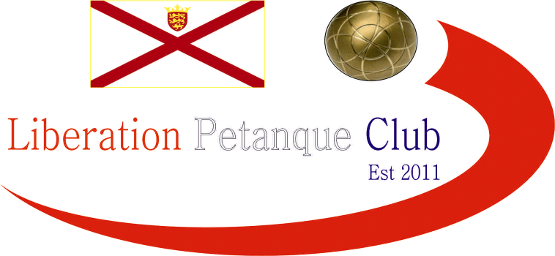

**2024**

**International Singles Open**

# A sell out 44 players took part in day 1 of our International Open weekend. Players from 7 Countries / Islands.

# Round one saw six double digit scores as Harry Brodie from Scotland won 13 – 11 against Vikki Le Poidevin from Guernsey as did Bruce Rowland from England against Eli Gjenstoe from Norway.

# Geoffroy Buffetrille won 13 – 0 against Englishman John Innocent. Reigning champion Benny Bel-Lafkih won 13 – 6 over Chris Bigmore, this was also the score for 2022 winner Laurent Pellaton against Scotsman Godfrey Schmidt.

# Round two, Liberation Chairman Toby Northern faced Damien Hureau and gave a good account losing 13 – 7. A very low scoring match saw Murray beat Steve 7 – 6!

# Mark Gay also not making 13 but won 12 – 9 against Christine as did Daniel over Nancy whilst Janice won 11 – 5 over Godfrey.

# Round three, saw 2022 winner play 2023 winner in Laurent and Benny with Benny coming out on top 13 – 6. Mark just beat Eric 11 – 10 the same score as Steve Smith over Nancy.

# Malcolm Cheyne beat Dian Cheyne 13 - 12 the same score as Vikki over John Whitworth. Big wins for James Villalard 13 – 1 over Janice and Godfrey over Carolyn.

# Round four, saw a big win for Keith White over Geoffroy 13 – 11 and close wins for Laurent over Neil and John Whitworth over Toby, both 13 – 12.

# Eli beat Andy Fisher 11 – 10 whilst Jude and Margaret both won 13 – 11. Some big wins for Janice over John 13 – 3 and Seb over James also 13 – 3.

# In the final Round to determine the top sixteen for the Main and the next eight players for the plate with the bottom four players missing out. Damien Hureau topped the rankings with a win over Seb Renaud 13 - 2 who finished nineth in the rankings. Mark Gay also ended with 5 wins from 5 with a big 13 – 2 over Keith White who finished sixth. Four wins also for Benny, Eli, Laurent, Vikki and Julian to easy into the main competition.

# John Whitworth 13 – 7 win over Janice Robertson to make the cut. Six players with three wins missed the cut and went into the Plate.

# Final Swiss Rankings

# The Plate Competition

# Last 16

# A number of really close matches in the last 16 of the Plate competition. Jude just overcame Margaret in an all Stirling Petanque Club match. Paul beat Aileen 12 – 11 as England beat Scotland. Whilst Mari from Scotland beat Patrick from Belgium.

# Ranked 17th Margaret 12 v 13 Jude Ranked 32nd

# Ranked 18th Patrick 09 v 11 Mari Ranked 31st

# Ranked 19th Graham 13 v 06 Delphine Ranked 30th

# Ranked 20th James 05 v 13 Bruce Ranked 29th

# Ranked 21st Aileen 11 v 12 Paul Ranked 28th

# Ranked 22nd Malcolm 06 v 13 Toby Ranked 27th

# Ranked 23rd Brian 13 v 03 Mo Ranked 26th

# Ranked 24th Andy 13 v 09 Harry Ranked 25th

# The Plate Competition

# Quarter Finals

# In the Quarter Finals Mari again failed to reach 13 but beat Liberation player Brian 9 – 8 to make the Semi Finals with Liberation chairman Toby also bowing out 13 – 11 to Graham from England.

# Ranked 24th Andy 05 v 13 Jude Ranked 32nd

# Ranked 28th Paul 07 v 13 Bruce Ranked 29th

# Ranked 19th Graham 13 v 11 Toby Ranked 27th

# Ranked 23rd Brian 08 v 09 Mari Ranked 31st

# The Plate Competition

# Semi Finals

# Jude Thomson was making a habit of 13 – 12 wins, this time over Bruce Rowland and Mari snel beat Graham Lewis to make it an all Scottish Plate Final.

# Ranked 32nd Jude Thomson 13 v 12 Bruce Rowland Ranked 29th

# Ranked 19th Graham Lewis 09 v 13 Mari Snell Ranked 31st

# Graham Lewis took third place with 13-12 win over Bruce Rowland as both matches went to the wire with the Plate title going to Jude Thomson with another 13 – 12 over Mari Snell an all Scottish Final.

# 2024 – Plate Winner – Jude Thomson

# The Main Competition

# Last 16

# A step too far for Murray who just qualified in 16th meaning he face Damien. Neil Selby would have been rueing a missed opportunity just losing 13 – 11 to the champion Benny.

# Two Jersey legends and friends Laurent & Geoffroy played each other, with Geoffroy just taking a close match 13 – 10. A big win for Andrew 13 – 0 over Vikki.

# Ranked 1st Damien Huereau 13 v 1 Murray Buchanan Ranked 16th

# Ranked 2nd Mark Gay 13 v 5 Ross Churchill Ranked 15th

# Ranked 3rd Julian Rouhaud 13 v 5 John Whitworth Ranked 14th

# Ranked 4th Laurent Pellaton 10 v 13 Geoffroy Buffetrille Ranked 13th

# Ranked 5th Benny Bel Lafkih 13 v 11 Neil Selby Ranked 12th

# Ranked 6th Keith White 08 v 13 Eric Bouef Ranked 11th

# Ranked 7th Vikki Le Poidevin 0 v 13 Andrew Bellamy-B Ranked 10th

# Ranked 8th Eli Gjenstoe 13 v 08 Seb Renaud Ranked 9th

# The Main Competition

# Quarter Finals

# Damien again only conceded one point against Eli to go through to the Semi Finals. An all Roulliac Petanque club match saw Julian just beat Eric 11 – 09, whilst Andrew will be rueing his shot choice which saw Mark Gay win 11 – 10, whilst Geoffroy knockout the champion Benny 13 – 5.

# Ranked 1st Damien Huereau 13 v 1 Eli Gjenstoe Ranked 8th

# Ranked 2nd Mark Gay 11 v 10 Andrew Bellamy-B Ranked 10th

# Ranked 3rd Julian Rouhaud 11 v 09 Eric Bouef Ranked 11th

# Ranked 5th Benny Bel Lafkih 05 v 13 Geoffroy Buffetrille Ranked 13th

# The Main Competition

# Semi Finals

# Geoffroy was neck and neck at 6 – 6 against Damien before a drop off pace saw Damien seeming cruise to a 13 – 6 win, whilst Julian Rouhaud made it successive finals beating Mark Gay 13 – 10.

# Ranked 1st Damien Huereau 13 v 6 Geoffroy Buffetrille Ranked 13th Ranked 3rd Julian Rouhaud 13 v 10 Mark Gay Ranked 2nd

# In the Third Place Play-Off it was Jersey – Geoffroy Buffetrille v England – Mark Gay. Another really close match that just went Mark way 13 – 10.

# In an all French final it was the star player and French legend Damien Hureau who won the day beating Julian Rouhaud 13 – 3, meaning Julian finished Runners Up for the second year running.

# 2024 – Winner – Damien Hureau

# There were twelve 13-12 results and two 13 – 0.

# Thanks to all those who helped, especially Dawn Buckley and Elaine Paisnel for umpiring on the day to make it another great competition.

# Club email address - [liberationpc@gmail.com](mailto:liberationpc@gmail.com)

# Club Website - [www.liberationpetanque.co.uk](http://www.liberationpetanque.co.uk)

# Kind Regards

# Toby Northern

# Chairman

# Liberation Petanque Club