# DIRT DAWG SPORTS

AAU Program

What sets us Apart from the others…

We believe that top notch instruction is an integral component for player development. We have a [**dedicated staff of instructors and coaches**](http://www.dirtdawgsports.com/instructors.html) that are able to draw upon past experiences of playing and coaching at a high level to accelerate the development of all [**Dirt Dawg Sports**](http://www.dirtdawgsports.com/index.html) AAU players. Our goal is to provide the tools, knowledge and know how. These along with player commitment will put your child in a position to succeed and learn detail down to every pitch during a game. We as a facility are focused on the details and we work with every team and player to ensure these details of baseball are passed on to each AAU individual. It's the ability to gain the edge that will set our program apart.

**Practice**



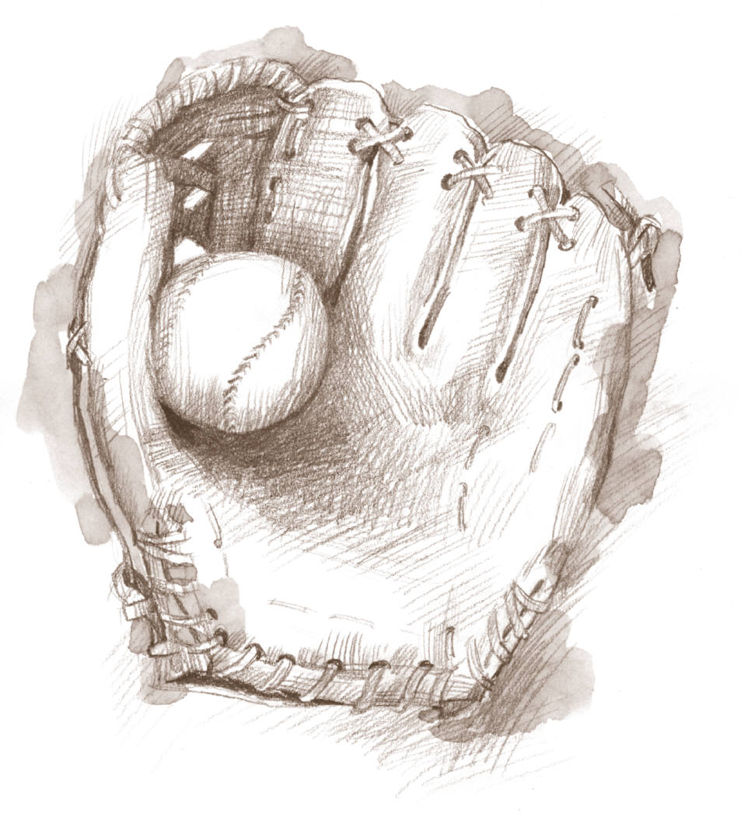

*IF YOU WANT TO TAKE YOUR GAME TO THE HIGHEST LEVEL…BECOME A DIRT DAWG!*

40 Industrial Drive Unit 3A

Canton, MA 02120

781-562-0758

[www.dirtdawgsports.com](http://www.dirtdawgsports.com)

Email: info@dirtdawgsports.com

**Hard**

**Win**

**Easy**

# PRACTICE HARD – WIN EASY

________________________________

What we offer…

Opportunity to play at the highest level of baseball

Playing the best teams in New England

Prep and Skill Honing for High School and College aspirations

Local schedule – travel limited

Weekend games – 2-4 games per weekend (weather dependent)

*TEAM*

*Skills Analysis of AAU Players by Hitting and Pitching staff to kick off first practice*

*Top Notch Coaching at all levels*

*Commitment of Facility and Coaching Staff to all Players to make them better players on and off the field.*

Cost: 2015 rates

* $1700.00 per Player
* Includes Full Year Membership $300 (Originally $480 + $100 Admin Fee=$580)
* Payment Plan for parents ($900 up front, $200 per month until paid in full. Jan-Feb-March-April
* Fundraising Opportunities to defray the cost
* TOP NOTCH Coaching- Best in New England by far

**AAU Tryout Details & Registration**

Tryout Dates :

August 15th and 22nd at Dirt Dawgs Facility

9-10’s 9:00-10:30

11-12’s 10:30 – 12:00

13-14’s 1:00 – 2:30

15 Plus 2:30 – 4:00

Outdoor 29th time and place TBD

**Player Details**

Date of Birth____________

First Name:__________________________

Last Name:__________________________

Address:____________________________

Town:_____________State:_____Zip:_____

Parent Name:_________________________

Home Phone:_________________________

Cell Phone:__________________________

Email Address:________________________

**Tryout Dates:**

Call to set up private workout

Cost $50.00

Players must attend 1 tryout to be considered to be a DAWG. Great deal 3 solid workouts for $50.00

*Programs:*

*10U – 11U – 12U – 13U – 14U -15U – and 16/18*

Included in Cost:

* 20-25 Game Schedule
* Full Uniforms
* Practice Uniform-Warmup
* Player Helmets
* Bat Bag
* 2 Team Practices per Week in our state of the art facility
* Travel Tournament