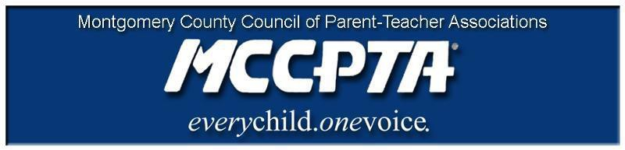

DELEGATES’ ASSEMBLY MEETING AGENDA
Tuesday, January 28, 2020

Richard Montgomery HS Cafeteria

7:00 pm Call to Order

- Welcome; Approval of Agenda & December 2019 Minutes

7:05 pm Chris Rutledge, Nominating Committee Chair

7:15 pm Ed Clarke, Director of School Safety and Security for MCPS

7:45 pm New Business

- PTAs and protocol during the upcoming election cycle
- Course Selection
- Board of Education Structure and Committees

8:10 pm Old Business

- Update on Major Initiatives – CIP, Boundary Analysis, Operating Budget, Kirwan, OLO Report

8:35 pm Officer Reports

- All reports in the January 2020 Folder

8:50 pm Committee Updates & Announcements

- Nominating Committee
- Membership Report & Awards

9:00 pm Adjourn

Dates:

1/29/20 Special Education Workshop (7 pm, Weller Rd ES)
2/8/20 Subdivision Staging Policy Workshop (9 am – noon, Richard Montgomery HS)
2/13/20 MCCPTA Board of Directors Meeting (7 pm, Carver Auditorium)
3/30/20 MCCPTA/LWV Candidate Forum (CESC)

