5/5/2017 The Beasts of Heaven say “Come and See”

I need to clarify the previous article just a little.

The previous article of 5/4/2017 revealed the Jerusalem solar eclipse of 993 AD. Another solar eclipse crossed Riyadh, Saudi Arabia, 2422 days later on 4/7/1000 AD forming a Tav "X" on the earth.

When the Jerusalem - Riyadh Tav of 993-1000 AD was revealed to me on 5/3/2017, I was initially disappointed because it didn't cross Mecca, the home of Islam. But the next day I heard that President Trump was going to Riyadh and then to Jerusalem on his 1st international tour. I then realized there might be some special importance to the newly revealed Tav after all.

That "Tav" over Jerusalem and Riyadh more than 1,000 years ago is related to President Donald Trump's scheduled upcoming diplomatic visits to Riyadh, Jerusalem, Rome, and beyond. It's very possible that we're about to see some historic and prophetic events take place that signal the coming of Israel's King. We need to be watching closely at what transpires in the coming month.

Below is a map that shows the exact path of the 4/7/1000 AD total solar eclipse showing how it missed Mecca altogether, but passed over Riyadh.

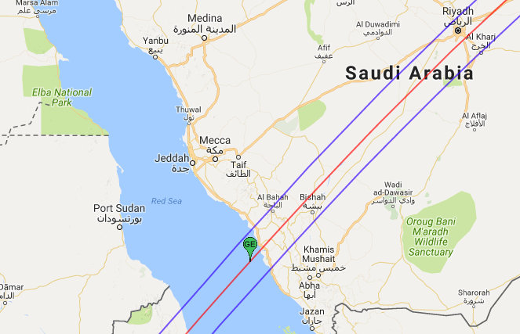
Image courtesy NASA and Google Maps
Our Special Visitor

The evening and night of 5/4/2017 we had a special visitor. After sunset we heard something walking on our roof. I thought it might be some kind of a wild cat, because we had been hearing a loud, low pitched, meowing sound in the neighborhood for the past month.

I looked on the roof and there was George, a neighbor's pet Peacock, walking around. It's the first time I've seen him on our roof. George's only other visit with us was on 9/4/2016, exactly 8 months to the day earlier from 5/4/2017.

While on the roof he made the strange loud meowing sound. Then we knew that it was George who had been making the strange sound in the neighborhood that we had been hearing for about a month. I looked out a while later and saw him roosting on our porch swing.

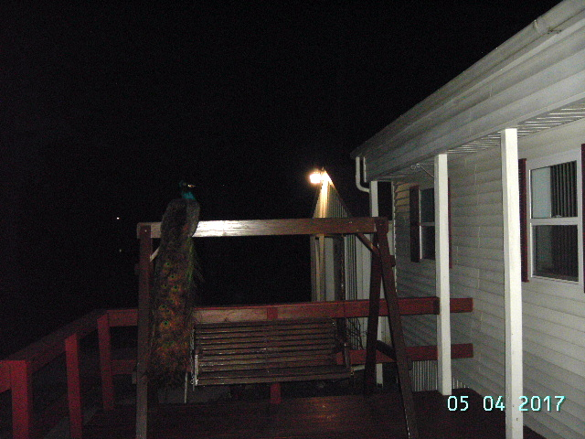

Above: George the peacock spent the entire night quietly roosting on our porch swing the evening of 5/4/2017. His tail feathers are now about 3 1/2' long, reaching down to the level of the swing.

The last time George was here 8 months ago, I was encouraged to write some information that I had been "sitting on" for a while. It was information about the 5th Tav that occurs between 2045 and 2052 and places another "X" on the United States at that time.

The Jerusalem and Riyadh Tav of 993 - 1000 AD is now the 6th Paleo Hebrew Tav "X" revealed by YaHuWaH Elohim. Each one has the special quality of marking the beginning of Aviv 1, Nisan 1, the first day of the first biblical month.

The "Beasts" of Heaven Invite Us to "Come and See"

I'm sitting on information again, like I was the last time when George the Peacock came to visit the first time 242 days earlier. The new information concerns the four beasts in heaven in Revelation chapter 6 who say to John "come and see".

Understand that there are symbolic "beasts in heaven" known as constellations, groups of stars, that are revealed in the daytime during total solar eclipses when the sky goes black. These "heavenly beasts", the constellations, are saying to us "come and see". They speak to us silently without uttering a sound.

Psalms 19:1 The heavens declare (Strong's 05608 - count exactly) the honor of Elohim; and the firmament sheweth His handywork.
2 Day unto day uttereth speech, and night unto night sheweth knowledge.
3 There is no speech nor language, where their voice is not heard.
4 Their line (Strong's 06957 - measuring line) is gone out through all the earth, and their words to the end of the world.

In Psalm 19:4 above, the "heavens", the constellations of stars, provide us with "measuring lines", exactly counted timelines, that can be used to show us a relationship between certain events.

Our Creator Elohim inscribe measuring lines on the earth using the moon's shadow during a total solar eclipse.

Zechariah 2:1 I lifted up mine eyes again, and looked, and behold a man with a measuring line in his hand.
2 Then said I, Whither goest thou? And he said unto me, To measure Jerusalem, to see what is the breadth thereof, and what is the length thereof.

The Lion of the Tribe of Judah Hath Prevailed

Revelation 5:1 And I saw in the right hand of him that sat on the throne a book written within and on the backside, sealed with seven seals.
2 And I saw a strong angel proclaiming with a loud voice, Who is worthy to open the book, and to loose the seals thereof?
3 And no man in heaven, nor in earth, neither under the earth, was able to open the book, neither to look thereon.
4 And I wept much, because no man was found worthy to open and to read the book, neither to look thereon.
5 And one of the elders saith unto me, Weep not: behold, the Lion of the tribe of Judah, the Root of David, hath prevailed to open the book, and to loose the seven seals thereof.
6 And I beheld, and, lo, in the midst of the throne and of the four beasts, and in the midst of the elders, stood a Lamb as it had been slain, having seven horns and seven eyes, which are the seven Spirits of Elohim sent forth into all the earth.

The symbolic Lion of Judah in heaven who prevails to open the seven seals:

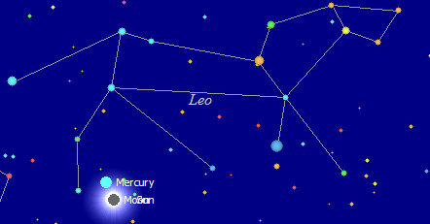
Above: The symbolic Lion of Judah speaking to the people of Jerusalem from the heavens on 8/20/993 AD, and again to us today.

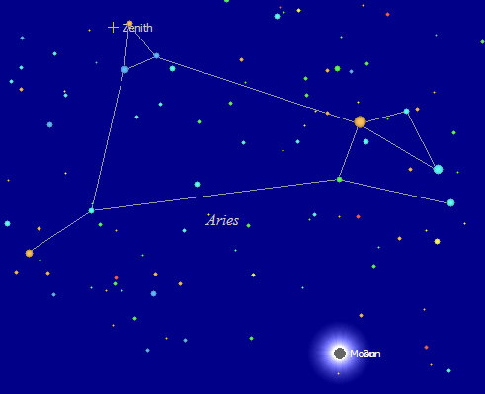
Above: Aries, symbolic of The Lamb of YaHuWaH , speaking to the people of Riyadh on 4/7/1000 AD, and also silently speaking to us today.

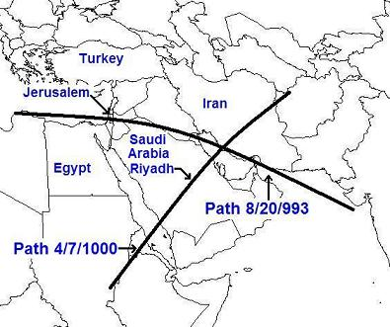
Above: The exact measuring lines (Psalms 19:1-4 further above) stretched across Jerusalem and Riyadh by YaHuWaH Elohim. The Tav was precisely placed on Iran by YaHuWaH Elohim on 4/7/1000 AD.

Below: The midpoint of the Jerusalem-Riyadh Tav 993 -1000 AD:
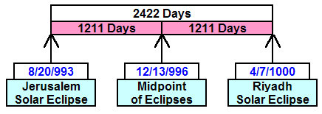

Below: Measuring 1,000 years in each direction from the midpoint of the Jerusalem-Riyadh Tav. A day count is used to arrive at the dates in the graphic. The end dates, 12/21 and 12/18, are different from the midpoint date, 12/13, because of leap years and calendar modifications through the centuries, but the day count is accurate.

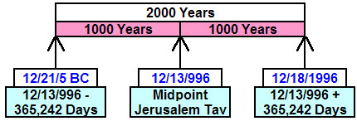
Above: Note that the date 12/21/5 BC is around the date for the incarnation of YAHUSHUA Messiah or the conception of John the Baptist.

Below: A Tav began to be placed on the head of Satan by our Creator Elohim on 4/11/1996, during the 1,000th year from 12/13/996 AD. The 1000th inclusive year from 12/13/996 AD began on 12/18/1995 and ended on 12/17/1996.

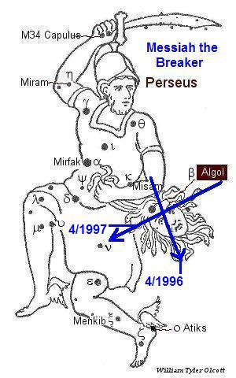
The above exact measuring lines were placed in the heavens by our Creator Elohim using comets in 1996-1997 at the culmination of 1,000 years from the midpoint (996 AD) of the Jerusalem - Riyadh Tav of 993 - 1000 AD.

The Messages in Heaven are going to be Removed

At the time of the end, the heavens will be rolled up like a scroll, and the stars will depart.

Isaiah 34:4 And all the host of heaven shall be dissolved, and the heavens shall be rolled together as a scroll: and all their host shall fall down, as the leaf falleth off from the vine, and as a falling fig from the fig tree.

Revelation 6:14 And the heaven departed as a scroll when it is rolled together; and every mountain and island were moved out of their places.
15 And the kings of the earth, and the great men, and the rich men, and the chief captains, and the mighty men, and every bondman, and every free man, hid themselves in the dens and in the rocks of the mountains;
16 And said to the mountains and rocks, Fall on us, and hide us from the face of Him that sitteth on the throne, and from the wrath of the Lamb:
17 For the great day of His wrath is come; and who shall be able to stand?

The scroll of the heavens will be rolled up. There will be nothing more to see. Our Creator will be done speaking to us at that point. Something will be happening to space-time that is beyond human comprehension.

May YaHuWaH Elohim have mercy on us all.

