

Winter 2016-2017 Season

Week 19

11th March 2017

Firing Competition

The clubs first ever firing competition with Trophy kindly donated by Keith Pinel was held this weekend on the new Weighbridge terrains.

With each of the 14 players who took part in Liberations first ever club Firing Competition, a great turn out. Playing two rounds of the at all the main disciplines of the firing format from European competitions.

Round 1 saw some really good scores with Keith Pinel leading the way on 25, five more points than second placed Geoffroy Buffetrille on 20. In 3rd was Richard Nevitt on 17, but unfortunately he couldn’t continue but would have had a great chance of going through to the knockout stages.

Matt Pinel only scoring 14 points in round 1 scored the highest points of the day with a second round of 31 to finish first place in the knockout stages.

Andrew Bellamy-Burt had the second highest score of round 2 with 22 points to finish 4th and was 15 points above 5th placed Brian Harris.

Matt Pinel played 4th placed Andrew Bellamy-Burt who had the potential to get a shock victory but it wasn’t to be as Matt made the first Firing final.

He may have been expecting to meet dad Keith who finished 2nd after the first two rounds. But Keith lost to Geoffroy Buffetrille.

The final was a close affair although with Geoffroy taking an early advantage with a 9 point gap after the first 4 shots. Going into the last attempt though Matt had narrowed the scores to 27 for Geoffroy and 25 for Matt. Unfortunately both players didn’t score as a result Geoffroy became the first Liberation Firing Champion.

Congratulations Geoffroy.

Complete Scores

RD1 RD2

1st Matt Pinel 14 & 31 = 45

2nd Keith Pinel 25 & 15 = 40

3rd Geoffroy Buffetrille 20 & 19 = 39

4th Andrew Bellamy-Burt 16 & 22 = 38

5th Brian Harris 7 & 16 = 23

6th Ian Foster 8 & 11 = 19

7th Matt Buesnel 14 & 3 = 17

7th James Rondel 14 & 3 = 17

9th Ross Payne 7 & 7 = 14

10th James Gennoe 4 & 9 = 13

11th Alice Ibitson 5 & 3 = 8

11th David Ibitson 0 & 8 = 8

13th Alan Oliveira 0 & 3 = 3

14th Richard Nevitt 17 (Did not finish)
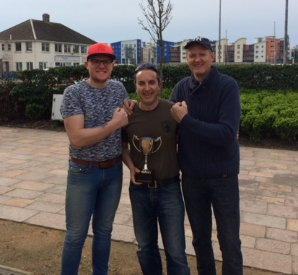

SEASON ENDED: 12TH MARCH 2017

END OF SEASON MEAL
DATE: 25TH MARCH 2017
VENUE: Moulen De Lecq
PRICE: £20
CONTACT: James Gennoe to book your place
EMAIL: jgennoe@live.com

WEBSITE www.liberationpetanque.co.uk
EMAIL liberationpc@gmail.com

Kind Regards
Report Editor
Liberation Petanque Club

SPONSORED BY



