RSAI Legislative Update
May 20, 2022
Week Nineteen of the 2022 Session: The Legislative Logjam breaks free on the Budget. Still no word on School Choice or other education policies pending. This RSAI Weekly Report from the 2022 Legislative Session covers the following:
- Appropriations Bill Status
- Budget Bills Move in Senate Appropriations Committee
- SF 2369 Governor’s School Choice/Voucher Omnibus
- Other Education Policies on a Calendar
- Politics of School Choice in the Primary Election on June 7
- Advocacy Actions and Links to Advocacy Resources
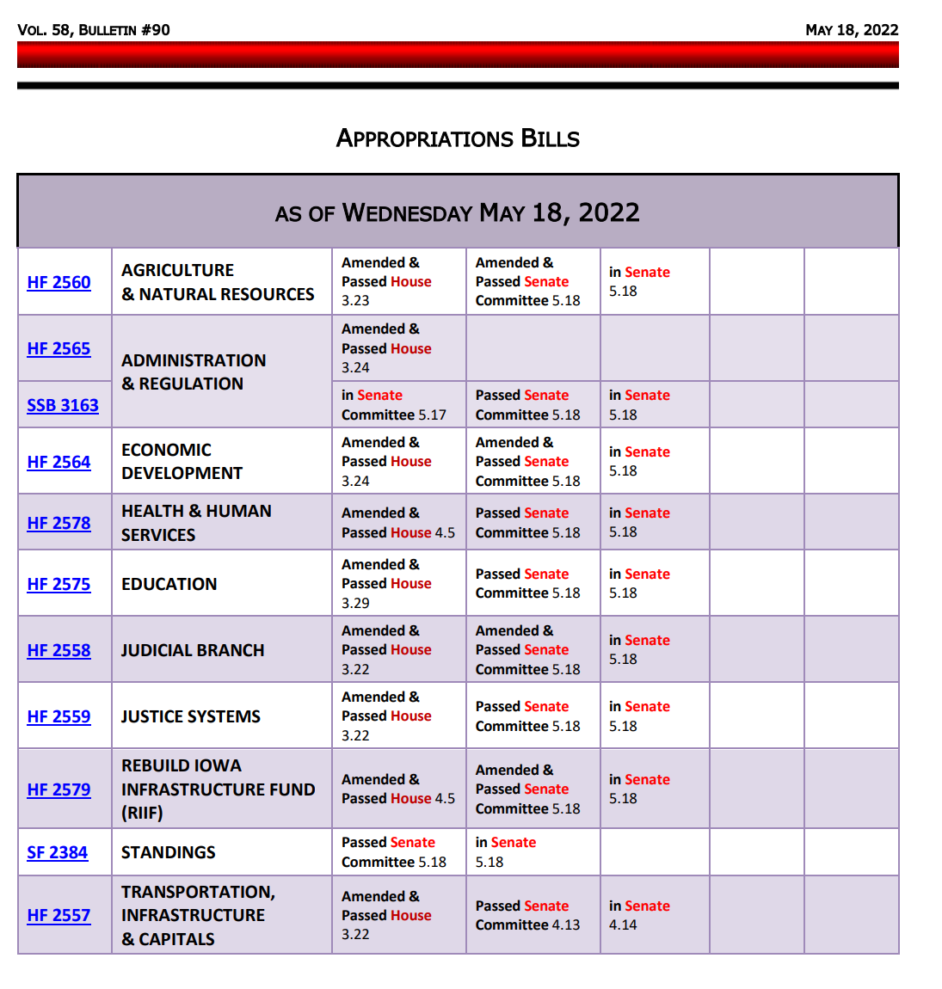
Status of Appropriations: This table, from the IALNS Bulletin, May 18, 2022, shows the progress of appropriations bills, all of which have been approved by the full House and the Senate Appropriations Committee, but for the Standings Appropriations bill, which includes state foundation aid, that originated in the Senate Appropriations Committee and must pass the Senate before heading to the House.
Two of these budget bills approved in the Senate Appropriations Committee on Wednesday directly impact PK-12 education: HF 2575 Education Appropriations, which was not amended during committee but is expected to be amended during the debate on the Senate floor, and SF 2384 Standings Appropriations, which was initiated in the Senate. RSAI is registered as undecided on both bills.

HF 2575 Education Appropriations:
- General Fund FY 2023: Appropriates a total of $1,004.1 million from the GF and 11,769.3 FTE positions to the Department for the Blind, the College Student Aid Commission, the DE, and the Board of Regents. This is an increase of $31.8 million and an increase of 2.0 FTE positions compared to estimated FY22.

- The bill includes the following new policy language:
  - Provides a new appropriation to the College Student Aid Commission to support the new Mental Health Practitioner Loan Repayment Program (includes a $1.5 million appropriation). The funding is contingent on the enactment of HF 2549 (Mental Health Provider Loan Forgiveness Bill) or SF 2195 (Mental Health Loan Repayment Bill).
  - Provides a new appropriation to Iowa State University to support the new cybersecurity simulator on the campus of ISU (includes a $905,000 appropriation).
  - Provides a new appropriation to the College Student Aid Commission to coordinate with the Iowa College Access Network (ICAN) to support students in the completion of the Free Application of Federal Student Aid (FAFSA) (includes a $150,000 appropriation).
  - Provisions regarding Teacher Bonuses:
    - Allows districts to pay a bonus to teachers not receiving the Governor’s ESSER bonus, not to exceed $1,000, from the school’s general fund in the 2022 calendar year.
    - Sets a State Individual Income Tax Exemption for Specified Recruitment or Retention Bonuses: Division XII of the Bill provides for State individual income tax exemptions for bonuses paid with federal funds or local funds. The State Individual Income Tax exemption applies retroactively to tax years beginning on or after Jan. 1, 2022, but before Jan. 1, 2023. The fiscal impact is estimated to be a General Fund reduction of $2.83 million in FY 2023 compared to what would have been collected if the identified bonuses would have been subject to State individual income tax (bonuses for teachers and others including emergency workers in law enforcement and corrections). Specifies that the provision allowing school districts to pay a bonus not to exceed $1,000 to each individual employed by the school district who did not receive a $1,000 retention bonus payment in calendar 2022 through the DE is effective upon enactment.
  - Prohibits a school district from paying a superintendent a severance payment that exceeds an amount equal to three times the superintendent's monthly compensation, retroactive to Jan. 1, 2022. (Sen. Cournoyer stated she has negotiated this provision out of the bill and that action will happen during the floor debate in the Senate.)
- Appropriations Increases compared to FY 2022
  - College Student Aid Commission: An increase of $250,000 for the Teach Iowa Scholar Program
  - DE: An increase of $10.6 million from the GF compared to estimated FY 2022. The increases to DE include:
    - $200,000 for Early Childhood Iowa (ECI) General Aid (School Ready Grant)
    - $3.5 million for the Iowa Jobs for America's Graduates (iJAG) Program
    - $200,000 for Children's Mental Health Training
    - $10,000 for Best Buddies Iowa
    - $6.5 million for General Aid for Community Colleges
    - $41,850 for the Therapeutic Classroom Incentive Fund (applies SSA per pupil increase to serve 150 students)
    - $120,000 for Iowa Vocational Rehabilitation Services

- Line Item Appropriations Detail (SQ = Status Quo, or same level of funding as FY 2022)
  - $598,197 (SQ funding and FTE positions) for part of the overall MOE requirement to receive federal Perkins funding.
  - $2,952,459 (SQ funding) for part of the overall Maintenance of Effort (MOE) requirement to receive federal Perkins funding.
  - $2,176,797 (SQ funding) for part of the overall MOE requirement to receive federal school lunch funding.
  - $23,406,799 (increase of $200,000) for Early Childhood Iowa General Aid. The increase is for a new data system to inform and improve results.
  - $852,000 (SQ funding) for nonpublic school textbook reimbursement (still limited to $30 per private school student and prohibited from exceeding comparable services for public school students).
  - $2,965,467 (SQ funding) for SATQ for support of six programs (National Board Certification, Teacher of the Year, Career Development and Evaluator Training, Teacher Development Academies, TLC technical assistance, Fine Arts mentoring).
  - $3,000,000 (SQ funding) to Iowa Testing Programs to offset the costs of administering Iowa Tests at private schools.
  - $300,000 (SQ funding) for the statewide clearinghouse of work-based learning opportunities.
  - $600,000 (SQ funding) for the Summer Joint Enrollment Program to provide concurrent enrollment in the Summer, which isn’t funded by school aid weighting.
  - $8,146,450 to iJAG (Iowa Jobs for American’s Graduates), an increase of $3,480,262, estimated to start 151 additional iJAG programs across Iowa.
  - $250,000 (SQ funding) for attendance center performance/general Internet site and data system support (provides for the Iowa Report Card by district and attendance center).
  - $230,000 (SQ funding) for online state job posting system.
  - $7,824,782 (SQ funding) Successful Progression for Early Readers Program.
  - $1,915,000 (SQ funding) for the Early Warning System for Literacy (FAST assessment) for PK-6th grade. Allows DE to charge districts and allows districts to pay out of Early Intervention funds. Currently, DE provides the assessments at no cost to schools. Local school districts use universal screening and progress monitoring assessments and store student performance data on a statewide database.
  - $1,550,176 (SQ funding) for the Iowa Reading Research Center.
  - $500,000 (SQ funding) for the Computer Science PD Incentive Fund.
  - $3,383,936, an increase of $200,000, for Children’s Mental Health school-based training, support and services provided by AEAs. Requires $200,000 to implement a children’s grief and loss rural pilot program to serve students in rural districts or private schools.
  - $35,000 (an increase of $10,000) for Best Buddies Iowa.
  - $1,000,000 (SQ funding) for nonpublic school concurrent enrollment payments to community colleges. Allows unused funds to carry forward.
  - Limits the Standing Appropriation for At-Risk Children to $10,524,389 (SQ funding).
  - $1,667,925 (increase of $41,850) for therapeutic classroom incentive fund and $500,000 (SQ funding) to reimburse districts for transportation associated with Therapeutic Classrooms. Allow for carry forward of any unexpended funds.
  - Postpones the allocation of $10,000,000 for high-needs schools until the year beginning July 1, 2023. (This appropriation was originally set for FY 2015 during the 2013 Legislative Session as part of Gov. Branstad’s Education Reform plan, but has been postponed.)
  - Requires DE to submit a written report by Jan. 15, 2023, to the General Assembly describing their antibullying programming and current and projected expenditures for antibullying programming for FY 2023.
SF 2384 Standing Appropriations: de-appropriates a total of $33.7 million compared to what would be otherwise appropriated, which leaves a total of $4.183 billion after the reductions. Of this amount, an estimated $3,654.6 million is state foundation aid for schools. Actions impacting education include:
- Reduces the nonpublic school transportation reimbursement to $8,997,091 (SQ funding).
- Sets the Instructional Support Levy state share at zero (SQ funding. Legislatures have been de-appropriating this mandated state share since 2011).
- Cuts the AEAs by $17 million, which is a reduction of an additional $2 million, and specifies that $2 million must come out of professional development.
- Includes other corrective provisions and changes to bills passed this year with errors or inconsistencies unrelated to education.
Governor’s School Choice/Voucher Omnibus Bill: SF 2369 Governor’s School Choice/Voucher Omnibus is still in the House Appropriations Committee. The March 31 weekly report provided all of the details, including the Parents’ Rights Provisions and Policies to Address Teacher Shortages amended onto the bill. We are still hearing that there are insufficient votes in the House to pass the voucher provisions. Several other policies may receive consideration in the closing weeks of the Session. RSAI is opposed to this bill, although we support several of the other policies amended onto the bill in the Senate.
Other Education Policies Pending: In addition to education savings accounts (ESAs) or vouchers , SF 2369 was amended in the Senate to include policies related many of the House priorities regarding teacher recruitment, retention, licensure, mandatory reporter/teacher misconduct and parent rights/transparency. As a result, those bills sent to the Senate from the House are still on the Senate Calendar in the Senate Education Committee. The following bills are priorities of either chamber and could still see some action:
Bills Pending in the Senate | Bills Pending in the House
HF 2080 Operational Sharing (increase superintendent weighting from 8-9 and allow one person to fulfill multiple sharing roles) on Senate Calendar | HF 2498 Gov.’s Ed Omnibus I (open enrollment, teacher librarians, special ed for home school students) on House Calendar and in SF 2369 (except for the teacher librarian provisions)
HF 2081 Praxis and Field Experience for teacher degree on Senate Calendar (in SF 2369) | HF 2553 CSAC Help with FAFSA on House Calendar (this language is also contained in the Education Appropriations bill HF 2575)
HF 2083 Teach Iowa Scholar Program eligibility on Senate Calendar (in SF 2369) | SF 2081 Disbursement from Computer Science Fund House Calendar
HF 2398 Permanent Licensure for higher-degreed teachers without CEU’s on Senate Calendar (in SF 2369) | SF 2356 Volunteer Substitute Teachers on House Calendar
HF 2567 Mandatory Reporters/Teacher Misconduct in Senate Education Committee (in SF 2369) | SF 2362 Electronic Posting, E-Signatures, and other provisions on House Calendar
SF 2129 Last Dollar Scholars Eligibility (attached to HF 2165) on Senate Calendar | SF 2377 Teach Iowa Scholar Grant Eligibility, Intern Teaching License and use of Management Fund for Teacher Recruitment Incentives on House Calendar
 | SF 2380 George Washington Carver Day (Feb. 1 annually) on House Calendar

Politics of School Choice in the Primary on June 7: Media reported that Gov. Reynolds has endorsed Barb Kniff McCulla, a pro-voucher conservative challenger to an incumbent Republican House member, Rep. Thorup, who has been a critic of the voucher proposal. The Des Moines Register reported on the endorsement on May 18 in the article, “In unusual move, Gov. Kim Reynolds endorses an Iowa Republican lawmaker’s primary opponent”, found here.
There are several House Districts with Republican Primary contests, including districts 3, 37, 43, 53, 60, 66, 87, and 88. Due to redistricting following the Census, you may have a different district number and/or Representative and Senator for the November 2022 election than you have this year. Check for your new legislative district number by entering your address in the search bar on the redistricting page: https://iowa- legis.maps.arcgis.com/apps/instant/lookup/index.html?appid=d32118cf09ed47beacd12742c1cf3fb3
Then check out the Iowa Secretary of State list of Primary Candidates to confirm if there is a primary in your district. See the spreadsheet of primary candidates here: https://sos.iowa.gov/elections/pdf/Candidates/primarycandidatelist.pdf
Advocacy Actions This Week: Pay Attention
As the legislature works through the remaining education policies and the budget, stay tuned to your email address in case last-minute Calls to Action arise. If any action on vouchers surfaces, the talking points in the March 31 RSAI School Choice Call to Action will likely still be relevant.
- Primary battles: See if there is a primary and confirm if your legislator who has expressed opposition to vouchers has a primary fight. Contact us for ideas on how you can advocate for public schools during the remaining three weeks before the primary.
- Send a note to your legislators: As most are home awaiting the announcement of leadership compromises, this is a good time to circle back and reinforce your local connections. Thank them for working on teacher shortage policies, improving the transparency requirements to what’s workable, and for being there to represent you and your district. If they had committed to you their opposition to vouchers, you could thank them for that as well.
Find Representatives here: https://www.legis.iowa.gov/legislators/house
Find Senators here: https://www.legis.iowa.gov/legislators/senate
Connecting with Legislators at the Statehouse: To call and leave a message for a Senator, call the Senate switchboard operator number is 515.281.3371. To call and leave a message for a representative, the House switchboard operator number is 515.281-3221. You can ask if they are available or leave a message for them to call you back. You can also ask them what’s the best way to contact them during Session. They may tell you email, text message or phone call is the best way to connect with them during the Session, based on their personal preferences.
RSAI Advocacy Resources: To find Advocacy Resources such as Position Papers, RSAI Weekly Legislative Reports and video updates, RSAI Calls to Action when immediate advocacy action is required, testimony presented to the State Board of Education, the DE or any legislative committee or public hearing, and links to fiscal information that may inform your work, visit the RSAI legislative web page here: http://www.rsaia.org/legislative.html. Also, check out the newly released 2022 RSAI Advocacy Handbook, and also available on the legislative page of the RSAI website
Contact us with any questions, feedback or suggestions to better prepare your advocacy work:
*Margaret Buckton, RSAI Professional Advocate, margaret@iowaschoolfinance.com , 515.201.3755 Cell
*Dave Daughton, RSAI Grassroots Advocate, dave.daughton@rsaia.org, 641-344-5205 Cell

Thanks to our RSAI Corporate Sponsors:
Special thank you to your RSAI Corporate Sponsors for their support of RSAI programs and services. Find information about how these organizations may help your district on the Corporate Sponsor page of the RSAI website at www.rsaia.org/corporate-sponsors.html.
 | www.apptegy.com
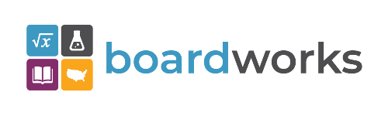 | www.boardworkseducation.com
 | www.carlanelsonco.com
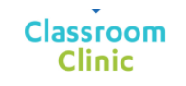 | www.classroomclinic.com
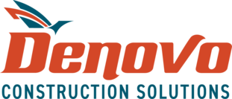 | www.teamdenovo.com
 | www.friedman-group.com
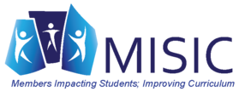 | www.misiciowa.org
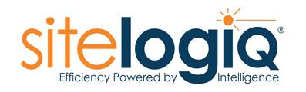 | www.sitelogiq.com
 | www.wgu.edu

