WELCOME TO
HOLY SPIRIT LUTHERAN CHURCH
A Member of the Evangelical Lutheran Church in America, New Jersey Synod
1220 Bayshore Rd., Villas, NJ 08251, 609-886-2414,
holyspiritlutheran@comcast.net, holyspiritvillas.com, facebook.com/holyspiritvillas
Vicar Vince Piekarski can be contacted at any time for conversation or prayer through call or text at 412-225-0287, or through email at vpie8282@gmail.com.
THURSDAY, APRIL 2ND, 2026
MAUNDY THURSDAY
5PM WORSHIP SERVICE WITH HOLY COMMUNION 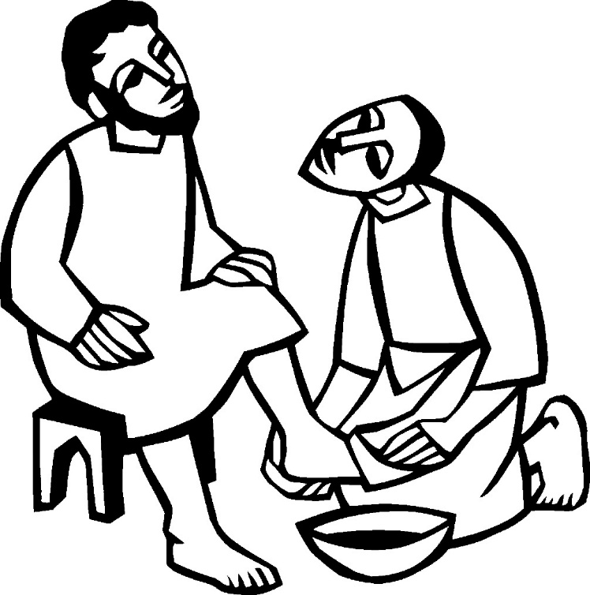

We, the Evangelical Lutheran Church of the Holy Spirit, are People of God, who
are called by the Holy Spirit to pray, worship, joyfully proclaim Jesus Christ,
and compassionately witness and serve others in Christian Love.


We are glad that you joined us for Worship today! Thank you for enriching our time together! We would like to get to know you better, and for you to get to know us better too. Brochures, welcome gifts, prayer shawls, Bibles, and other items are available throughout the church. We would be happy to show you around and share about our ministries. Please do not hesitate to speak up and ask questions.
Also, please make sure you sign-in on our clipboard on the podium in the lobby.


Our Worship Services are conducted in coordination with our Conference Call.
Join us at 657-390-7423 or 701-802-5170, with access code 8221190#.
You may need to dial 1 first depending on your phone plan. After logging in please announce your name and feel free to talk with others until we get started.

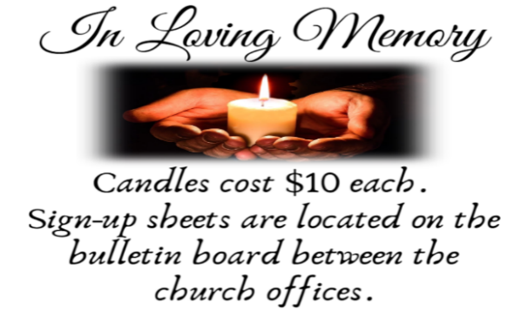
SANCTUARY CANDLE FOR APRIL
Given to the Glory of God & In Memory of
EDWARD & LINDA SCHUBERT by Vicki, Bob, Evan Rinier.
ALTAR CANDLES FOR APRIL
Given to the Glory of God & In Memory of
JOSEPH “MAC” MCKENNA & JAMES P ROONEY by Del McKenna & Children.
CONFERENCE CALL CHECK-IN, WELCOME, & ANNOUNCEMENTS
(Vicar (V), Assistant (A), Reader (R), and Congregation (C).)

INTRODUCTION
A. The word "Maundy" comes from the Latin word, "Mandatum," which means
"Commandment." This evening our Lenten observance comes to an end, and we
gather with Christians around the world to celebrate the Three Days of Jesus’
death and resurrection. Tonight we remember Christ’s last meal with his
disciples, but the central focus is his commandment that we live out the promise
embodied in this meal. As Jesus washed his disciples’ feet, so we are called to
give and receive love in humble service to one another. Formed into a new body
in Christ through this holy meal, we are transformed by the mercy we have
received and carry it into the world. Departing worship in solemn silence, we
anticipate the coming days.

PRELUDE
(Music offered by our Organist before the start of our Worship Service.)
Alas and Did My Savior Bleed

(We invite you to stand as you are able.)

CONFESSION & FORGIVENESS
(All may make the sign of the cross, the sign that is marked at baptism.)
V. Friends in Christ, in this Lenten season we have heard our Lord’s call to struggle
against sin, death, and the devil—all that keeps us from loving God and each
other. This is the struggle to which we were called at baptism.

Within the community of the church, God never wearies of forgiving sin and
giving the peace of reconciliation. On this night let us confess our sin against God
and our neighbor, and enter the celebration of the great Three Days reconciled
with God and with one another.

(Silence is kept for reflection.)

V. Most merciful God,
C. we confess that we are captive to sin
and cannot free ourselves.
We have sinned against you in thought, word, and deed,
by what we have done and by what we have left undone.
We have not loved you with our whole heart;
we have not loved our neighbors as ourselves.
For the sake of your Son, Jesus Christ,
have mercy on us.
Forgive us, renew us, and lead us,
so that we may delight in your will
and walk in your ways,
to the glory of your holy name.
Amen.

V. God, who is rich in mercy, loved us
even when we were dead in sin,
and made us alive together with Christ.
By grace you have been saved.
In the name of ☩ Jesus Christ, your sins are forgiven.
Almighty God strengthen you with power
through the Holy Spirit,
that Christ may live in your hearts through faith.
C. Amen.

(We invite you to remain standing as you are able.)

GATHERING HYMN
(We invite you to sing along with the music offered by our Organist.)
Lutheran Book of Worship—Green Book
102—On My Heart Imprint Your Image

APOSTOLIC GREETING
V. May the grace of our Lord Jesus Christ, the love of God,
and the communion of the Holy Spirit be with you all.
C. And also with you.

KYRIE
V. In peace, let us pray to the Lord.
C. Lord, have mercy.

V. For the peace from above, and for our salvation, let us pray to the Lord.
C. Lord, have mercy.

V. For the peace of the whole world, for the well-being of the church of God,
and for the unity of all, let us pray to the Lord.
C. Lord, have mercy.

V. For this holy house, and for all who offer here their worship and praise,
let us pray to the Lord.
C. Lord, have mercy.

V. Help, save, comfort, and defend us, gracious Lord.
C. Amen.

PRAYER OF THE DAY
V. The Lord be with you.
C. And also with you.

V. Let us pray,
Holy God, source of all love, on the night of his betrayal, Jesus gave us a new
commandment, to love one another as he loves us. Write this commandment in
our hearts, and give us the will to serve others as he was the servant of all, your
Son, Jesus Christ, our Savior and Lord, who lives and reigns with you and the
Holy Spirit, one God, now and forever.
C. Amen.

(We invite you to be seated for our Readings and Psalm.)

FIRST READING
Israel remembered its deliverance from slavery in Egypt by celebrating the
festival of Passover. This festival featured the Passover lamb, whose blood was
used as a sign to protect God’s people from the threat of death. The early church
described the Lord’s supper using imagery from the Passover, especially in
portraying Jesus as the lamb who delivers God’s people from sin and death.

R. Our First Reading is from Exodus (Chapter 12, Verses 1-4 [5-10] 11-14).

R. 1 The Lord said to Moses and Aaron in the land of Egypt, 2 “This month shall
mark for you the beginning of months; it shall be the first month of the year for
you. 3 Tell the whole congregation of Israel that on the tenth of this month they
are to take a lamb for each family, a lamb for each household. 4 If a household is
too small for a whole lamb, it shall join its closest neighbor in obtaining one; the
lamb shall be divided in proportion to the number of people who eat of it. [5 Your
lamb shall be without blemish, a year-old male; you may take it from the sheep or
from the goats. 6 You shall keep it until the fourteenth day of this month; then the
whole assembled congregation of Israel shall slaughter it at twilight. 7 They shall
take some of the blood and put it on the two doorposts and the lintel of the
houses in which they eat it. 8 They shall eat the lamb that same night; they shall
eat it roasted over the fire with unleavened bread and bitter herbs. 9 Do not eat
any of it raw or boiled in water but roasted over the fire, with its head, legs, and
inner organs. 10 You shall let none of it remain until the morning; anything that
remains until the morning you shall burn with fire.] 11 This is how you shall eat it:
your loins girded, your sandals on your feet, and your staff in your hand, and you
shall eat it hurriedly. It is the Passover of the Lord. 12 I will pass through the land
of Egypt that night, and I will strike down every firstborn in the land of Egypt, from
human to animal, and on all the gods of Egypt I will execute judgments: I am the
Lord. 13 The blood shall be a sign for you on the houses where you live: when I
see the blood, I will pass over you, and no plague shall destroy you when I strike
the land of Egypt.

14 “This day shall be a day of remembrance for you. You shall celebrate it as a
festival to the Lord; throughout your generations you shall observe it as a
perpetual ordinance.”

R. This is the Word of the Lord.
C. Thanks be to God.

PSALM
R. Our Responsorial Psalm is from the 116th Psalm (Verses 1-2, 12-19).
C. I will lift the cup of salvation and call on the name of the Lord. (Ps. 116:13)

R. 1 I love the Lord, who has heard my voice,
and listened to my supplication,
2 for the Lord has given ear to me
whenever I called.
12 How shall I repay the Lord
for all the good things God has done for me?
13 I will lift the cup of salvation
and call on the name of the Lord.
C. I will lift the cup of salvation and call on the name of the Lord. (Ps. 116:13)

R. 14 I will fulfill my vows to the Lord
in the presence of all God’s people.
15 Precious in your sight, O Lord,
is the death of your servants.
16 O Lord, truly I am your servant;
I am your servant, the child of your handmaid;
you have freed me from my bonds.
17 I will offer you the sacrifice of thanksgiving
and call upon the name of the Lord.
18 I will fulfill my vows to the Lord
in the presence of all God’s people,
19 in the courts of the Lord’s house,
in the midst of you, O Jerusalem.
C. I will lift the cup of salvation and call on the name of the Lord. (Ps. 116:13)

SECOND READING
In the bread and cup of the Lord’s supper, we experience intimate fellowship with
Christ and with one another because it involves his body given for us and the
new covenant in his blood. Faithful participation in this meal is a living
proclamation of Christ’s death until he comes in the future.

R. Our Second Reading is from the 1st Corinthians (Chapter 11, Verses 23-26).

R. 23 For I received from the Lord what I also handed on to you, that the Lord Jesus
on the night when he was betrayed took a loaf of bread, 24 and when he had
given thanks, he broke it and said, “This is my body that is for you. Do this in
remembrance of me.” 25 In the same way he took the cup also, after supper,
saying, “This cup is the new covenant in my blood. Do this, as often as you drink
it, in remembrance of me.” 26 For as often as you eat this bread and drink the
cup, you proclaim the Lord’s death until he comes.

R. This is the Word of the Lord.
C. Thanks be to God.

V. I invite you to stand as you are able, and I invite you to announce the Gospel
Acclamation with me.

GOSPEL ACCLAMATION
C. I give you a new commandment, that you love one another just as I have
loved you. (John 13:34)

GOSPEL READING
The story of the last supper in John’s gospel recalls a remarkable event not
mentioned elsewhere: Jesus performs the duty of a slave, washing the feet of his
disciples and urging them to do the same for one other.

V. The Holy Gospel According to John (Chapter 13, Verses 1-17, 31b-35).
C. Glory to you, O Lord.

V. 1 Now before the festival of the Passover, Jesus knew that his hour had come to
depart from this world and go to the Father. Having loved his own who were in
the world, he loved them to the end. 2 The devil had already decided that Judas
son of Simon Iscariot would betray Jesus. And during supper 3 Jesus, knowing
that the Father had given all things into his hands and that he had come from
God and was going to God, 4 got up from supper, took off his outer robe, and tied
a towel around himself. 5 Then he poured water into a basin and began to wash
the disciples’ feet and to wipe them with the towel that was tied around him. 6 He
came to Simon Peter, who said to him, “Lord, are you going to wash my feet?”
7 Jesus answered, “You do not know now what I am doing, but later you will
understand.” 8 Peter said to him, “You will never wash my feet.” Jesus answered,
“Unless I wash you, you have no share with me.” 9 Simon Peter said to him,
“Lord, not my feet only but also my hands and my head!” 10 Jesus said to him,
“One who has bathed does not need to wash, except for the feet, but is entirely
clean. And you are clean, though not all of you.” 11 For he knew who was to
betray him; for this reason he said, “Not all of you are clean.”

12 After he had washed their feet, had put on his robe, and had reclined again, he
said to them, “Do you know what I have done to you? 13 You call me Teacher
and Lord, and you are right, for that is what I am. 14 So if I, your Lord and
Teacher, have washed your feet, you also ought to wash one another’s feet.
15 For I have set you an example, that you also should do as I have done to you.
16 Very truly, I tell you, slaves are not greater than their master, nor are
messengers greater than the one who sent them. 17 If you know these things,
you are blessed if you do them.”

31b “Now the Son of Man has been glorified, and God has been glorified in him.
32 If God has been glorified in him, God will also glorify him in himself and will
glorify him at once. 33 Little children, I am with you only a little longer. You will
look for me, and as I said to the Jews so now I say to you, ‘Where I am going,
you cannot come.’ 34 I give you a new commandment, that you love one another.
Just as I have loved you, you also should love one another. 35 By this everyone
will know that you are my disciples, if you have love for one another.”
V. This is the Gospel of the Lord,
C. Praise to you, O Christ.

(We invite you to be seated.)

SERMON
(Delivered by Vicar Vince Piekarski.)

(Following the Sermon, we invite you to stand as you are able.)

HYMN OF THE DAY
(We invite you to sing along with the music offered by our Organist.)
Lutheran Book of Worship—Green Book
482—When I Survey the Wondrous Cross

APOSTLES’ CREED
V. God has made us his people through our Baptism into Christ. Living together in
trust and hope let us confess our faith together using the Apostles’ Creed.
C. I believe in God, the Father almighty,
creator of heaven and earth.

I believe in Jesus Christ, God’s only Son, our Lord,
who was conceived by the Holy Spirit,
born of the Virgin Mary,
suffered under Pontius Pilate,
was crucified, died, and was buried;
he descended to the dead.
On the third day he rose again;
he ascended into heaven,
he is seated at the right hand of the Father,
and he will come to judge the living and the dead.

I believe in the Holy Spirit,
the holy catholic church,
the communion of saints,
the forgiveness of sins,
the resurrection of the body,
and the life everlasting. Amen.

PRAYERS OF INTERCESSION
(The prayers are prepared locally for each occasion.)
V. On this night when Jesus gave us a new commandment to love one another, let
us bring our prayers before the One whose love knows no bounds.

(A brief silence.)

A. Gracious host, you knelt to wash your disciples’ feet. Cleanse us from pride and
self-centeredness, and teach us to love one another as you have loved us. Hear
us, O God.
C. Your mercy is great.

A. Creator God, the earth is yours and everything in it. Awaken us to care for all you
have made and conserve the rich diversity of your good creation. Hear us, O
God.
C. Your mercy is great.

A. God of the nations, guide the world’s leaders in the ways of justice and peace.
Where they wield power unjustly, confront them. Where they are indifferent to
suffering, awaken their conscience. Hear us, O God.
C. Your mercy is great.

A. Compassionate One, embrace all who are lonely or in captivity, comfort the
grieving, and relieve those in pain. Draw near to all who suffer. Hear us, O God.
C. Your mercy is great.

A. Blessed redeemer, we give you thanks for this community of faith, and for all who
gather around your table of grace. Unite us in love for you and for one another.
Hear us, O God.
C. Your mercy is great.

A. Eternal God, we praise you for the great cloud of witnesses who now rest from
their labors. At the last, gather us with them at your heavenly banquet. Hear us,
O God.
C. Your mercy is great.

(Here other intercessions may be offered.)

V. Watch over all of us who are worried and suffering, and especially those whose
names we now say aloud or hold within our hearts (extended pause). Hear us,
O God.
C. Your mercy is great.

V. We entrust these prayers to you, O God, confident that you will strengthen us by
your Spirit to love one another as Christ has loved us. We ask this in Jesus’
name.
C. Amen.

SHARING OF THE PEACE
V. May the peace of the Lord be with you always.
C. And also with you.
V. Now, let us share God’s Peace with one another.



(Please respect your neighbor if they desire to still only offer a peace sign or wave.)

(Following the Sharing of the Peace, we invite you to be seated.)

OFFERING
V. We now worship God with our tithes and offerings, wine and bread for use in holy
communion, and monetary gifts to support our ministry for service in God’s name.
Our Ushers will be around to your pews to pass the Offering Plates.

(Ushers come forward to get the Offering Plates from the Assistant.)

(Vicar and Assistant prepare the Altar for Communion.)

OFFERING SONG
(We invite you to sing along.)
Worship & Praise
156—What Have We to Offer?
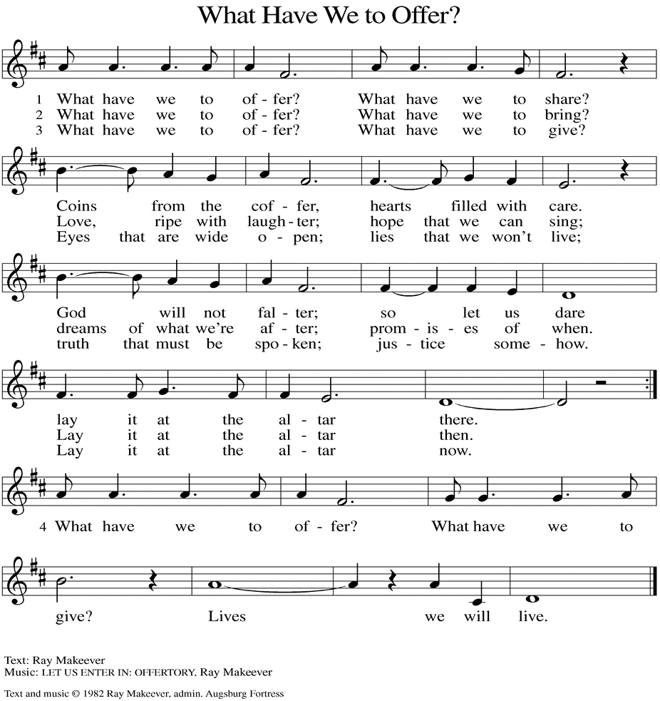
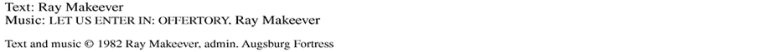

(Usher(s) brings the Tithes and Offerings up front to the Assistant.)
V. We invite you to stand as you are able.

OFFERING PRAYER
V. Let us pray,
O God, maker of heaven and earth,
your steadfast love embraces all creation.
You send rain and sunshine to nourish the earth
and bring forth its bounty.
Through these gifts of bread and wine,
draw us into the death and life of your Son,
who calls us to bear witness to his saving work.
We ask this in Jesus’ name.
C. Amen.

GREAT THANKSGIVING
V. The Lord be with you.
C. And also with you.

V. Lift up your hearts.
C. We lift them to the Lord.

V. Let us give thanks to the Lord our God.
C. It is right to give him thanks and praise.

V. It is indeed right and salutary that we should at all times and in all places offer
thanks and praise to you, O Lord, holy Father, through Christ our Lord; who rose
beyond the bounds of death and, as he promised, poured out your Spirit of life
and power upon the chosen disciples. At this the whole earth exults in boundless
joy. And so, with the Church on earth and the hosts of heaven, we praise your
name and join their unending hymn:

SANCTUS
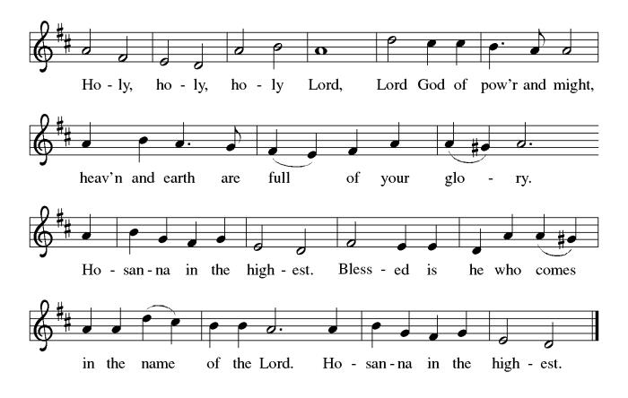

THE EUCHARISTIC PRAYER
V. Blessed are you, Lord of heaven and earth, in mercy for our fallen world you gave
your only Son, that all those who believe in Him should not perish, but have
eternal life. We give thanks to you for the salvation you have prepared for us
through Jesus Christ. Send now your Holy Spirit into our hearts that we may
receive our Lord with a living faith as He comes to us in His holy supper.
C. Amen. Come, Lord Jesus.

V. In the night in which he was betrayed our Lord Jesus took bread,
he gave thanks; broke it, and gave it to his disciples, saying:
Take and eat; this is my body, given for you.
Do this for the remembrance of me.

V. Again, after supper, He took the cup, he gave thanks,
and gave it for all to drink, saying:
This cup is the new covenant in my blood,
shed for you and for all people for the forgiveness of sin.
Do this for the remembrance of me.

THE LORD’S PRAYER
(We ring the bell throughout the Lord’s Prayer at all services to
invite those in the community to join in praying the Lord’s Prayer.)
V. May we now join with one another and pray together as Jesus has taught us.
C. Our Father, who art in heaven, hallowed be thy name, thy kingdom come,
thy will be done, on earth as it is in heaven. Give us this day our daily
bread; and forgive us our trespasses, as we forgive those who trespass
against us; and lead us not into temptation, but deliver us from evil. For
thine is the kingdom, and the power, and the glory, forever and ever.
Amen.

LAMB OF GOD

(We invite you to be seated.)

HOLY COMMUNION
V. We extend the invitation to Communion to all who are baptized and believe in
Jesus Christ.

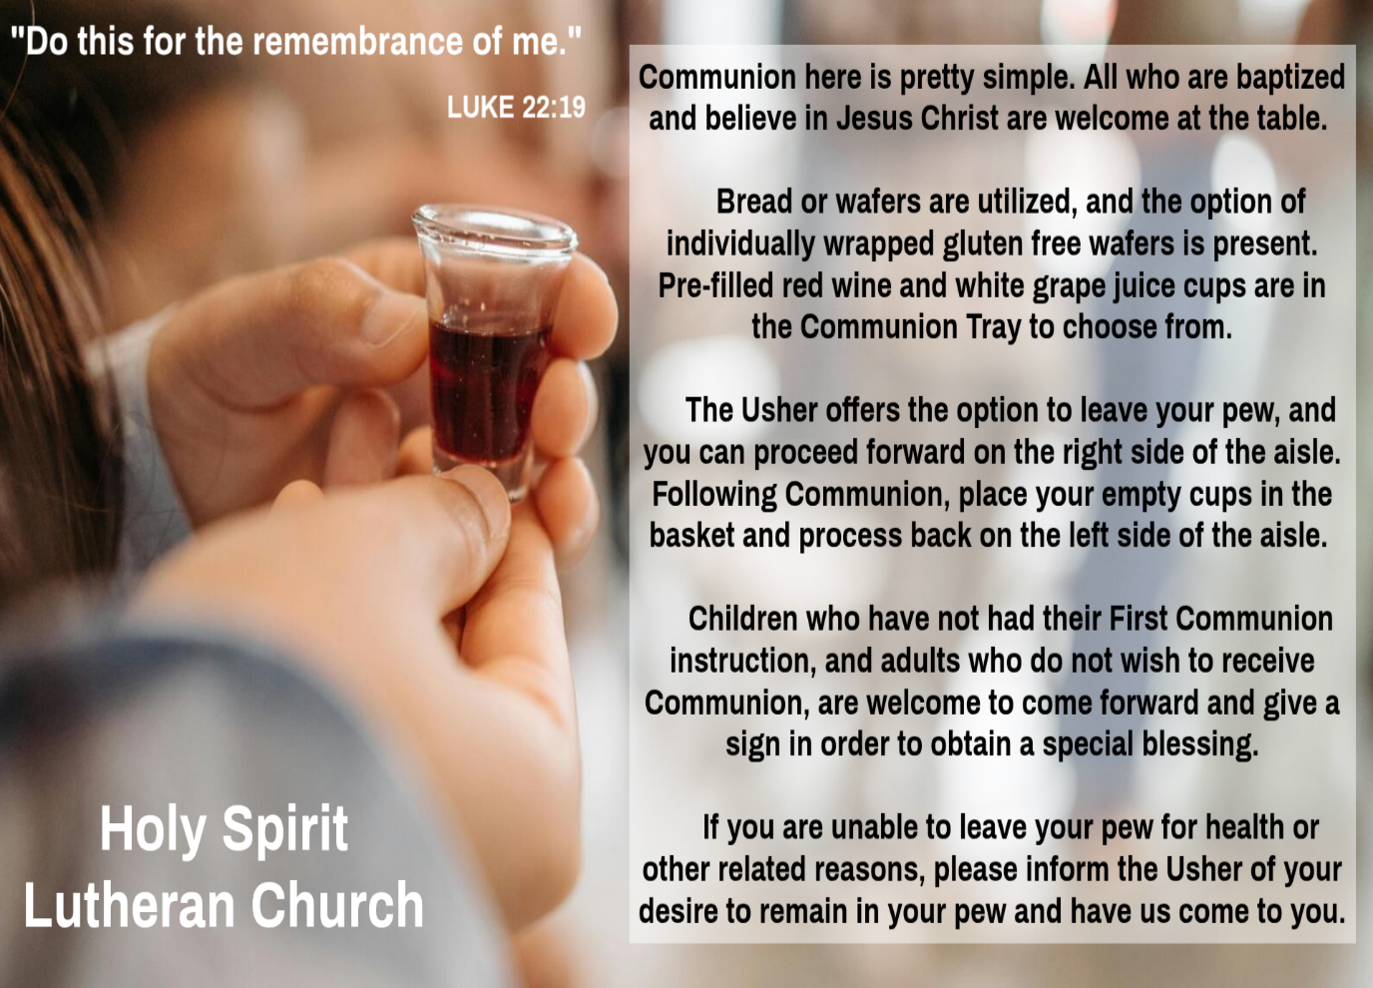

INVITATION TO COMMUNION
V. Come to the table.
Feast on God’s goodness and mercy.
C. Amen.

(Distribution of Holy Communion)

COMMUNION HYMN
(Please enjoy various music offered by our Organist during your
quiet time, prayer, and reflection following Holy Communion.)

(Vicar and Assistant remove Communion Vessels from the Altar.)

V. We invite you to stand as you are able.

POST COMMUNION BLESSING
V. May the body and blood of our Lord Jesus Christ strengthen us and keep us
always in His grace.
C. Amen.

POST COMMUNION CANTICLE

PRAYER AFTER COMMUNION
A. Let us pray,
Lord Jesus, in a wonderful sacrament
you strengthen us with the saving power
of your suffering, death, and resurrection.
May this sacrament of your body and blood
so work in us that the fruits of your redemption
will show forth in the way we live,
for you live and reign with the Father and the Holy Spirit,
one God, now and forever.
C. Amen.

BLESSING
V. God, the giver of love,
☩ Christ, the resurrection and the life,
and the Holy Spirit of rebirth bless you.
C. Amen.

THE STRIPPING OF THE ALTAR
(The Sacramental Vessels are removed to the Fellowship Hall, and the Candles
are Extinguished. The Altar Book, Missal Stand, Bible, Bible Stand, Candles,
Fair Linen, and Paraments are removed. Psalm 22 is read in unison by the Congregation as this represents the humiliation of Christ during His Passion.)

PSALM 22
C. 1 My God, my God, why have you forsaken me?
Why are you so far from helping me, from the words of my groaning?
2 O my God, I cry by day, but you do not answer;
and by night but find no rest.

3 Yet you are holy,
enthroned on the praises of Israel.
4 In you our ancestors trusted;
they trusted, and you delivered them.
5 To you they cried and were saved;
in you they trusted and were not put to shame.

6 But I am a worm and not human,
scorned by others and despised by the people.
7 All who see me mock me;
they sneer at me; they shake their heads;
8 “Commit your cause to the Lord; let him deliver—
let him rescue the one in whom he delights!”

9 Yet it was you who took me from the womb;
you kept me safe on my mother’s breast.
10 On you I was cast from my birth,
and since my mother bore me you have been my God.
11 Do not be far from me,
for trouble is near,
and there is no one to help.

12 Many bulls encircle me;
strong bulls of Bashan surround me;
13 they open wide their mouths at me,
like a ravening and roaring lion.

14 I am poured out like water,
and all my bones are out of joint;
my heart is like wax;
it is melted within my breast;
15 my mouth is dried up like a potsherd,
and my tongue sticks to my jaws;
you lay me in the dust of death.

16 For dogs are all around me;
a company of evildoers encircles me;
they bound my hands and feet.
17 I can count all my bones.
They stare and gloat over me;
18 they divide my clothes among themselves,
and for my clothing they cast lots.

19 But you, O Lord, do not be far away!
O my help, come quickly to my aid!
20 Deliver my soul from the sword,
my life from the power of the dog!
21 Save me from the mouth of the lion!
From the horns of the wild oxen you have rescued me.
22 I will tell of your name to my brothers and sisters;
in the midst of the congregation I will praise you:
23 You who fear the Lord, praise him!
All you offspring of Jacob, glorify him;
stand in awe of him, all you offspring of Israel!
24 For he did not despise or abhor
the affliction of the afflicted;
he did not hide his face from me
but heard when I cried to him.

25 From you comes my praise in the great congregation;
my vows I will pay before those who fear him.
26 The poor shall eat and be satisfied;
those who seek him shall praise the Lord.
May your hearts live forever!

27 All the ends of the earth shall remember
and turn to the Lord,
and all the families of the nations
shall worship before him.
28 For dominion belongs to the Lord,
and he rules over the nations.

29 To him, indeed, shall all who sleep in the earth bow down;
before him shall bow all who go down to the dust,
and I shall live for him.
30 Posterity will serve him;
future generations will be told about the Lord
31 and proclaim his deliverance to a people yet unborn,
saying that he has done it.

(After the Psalm, no further words are said.
There is no Benediction and no Postlude.)

THE CONGREGATION LEAVES IN SILENCE
(The transition is made from the Eucharistic Celebration to Jesus' Crucifixion
and death. Symbolically, Christ is stripped of His power and glory,
and he is now in the hands of his captors.)



EASTER VIGIL INVITATION
Father Marcel has extended an invitation again this year to celebrate the Easter Vigil together. Please consider joining us at St. Simeon’s By The Sea in North Wildwood, on Saturday, April 4th, at 5PM. Vicar Vince will assist with various points of the service. Vicar Ken from Holy Trinity in Wildwood will be delivering the Sermon. Please see Vicar Vince with any questions, or to confirm your interest in attending.


WHAT IS THE EVANGELICAL LUTHERAN CHURCH IN AMERICA?
The ELCA was formed in 1987 by the merger of three Lutheran Church bodies –
the ALC (American Lutheran Church), the LCA (Lutheran Church in America), and the AELC (Association of Evangelical Lutheran Churches). Learn more at elca.org.


The New Jersey Synod is a geographical grouping of Evangelical Lutheran Church in America (ELCA) congregations that share the mission and ministry of the Church on the New Jersey territory. It is one of 65 synods in the ELCA. The NJ Synod is comprised of 143 congregations, which include over 45,000 baptized members.

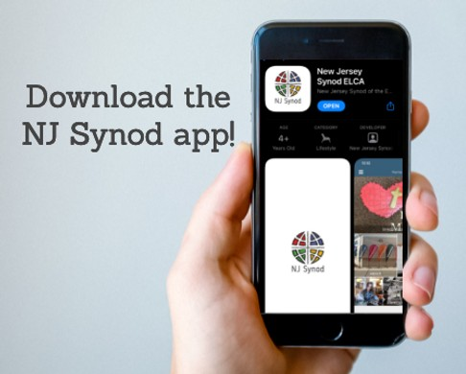
There is a weekly e-newsletter connecting our synod together with weekly prayer, upcoming events, synod and churchwide activities, mission stories, congregational activities, & more. Download the app or sign up at www.njsynod.org/stay-connected.


CHURCH STAFF & VOLUNTEERS
VICAR
Vicar Vince Piekarski
VICE PASTOR
Pastor William Hodgetts
ORGANIST & PIANIST
Carol Amundsen
CHURCH OFFICE, SUNDAY SCHOOL, & FOOD PANTRY
Heather Piekarski
CHURCH COUNCIL PRESIDENT & CHURCH PROPERTY
Wayne Rand
CHURCH COUNCIL VICE PRESIDENT & WOMEN OF THE CHURCH
Judy Brannan
CHURCH COUNCIL TREASURER
Bonnie Millard
CHURCH COUNCIL SECRETARY
Vicki Rinier

LICENSES & EXPIRATION DATES
Worship Service Content is used via permission through Augsburg Fortress Liturgies Annual License #SB144368. The next Subscription Renewal Date is 2/28/2027.
Our Hymns and Worship Music are used via permission through CCLI One
License #11327166. The next Subscription Renewal Date is 1/31/2027.

