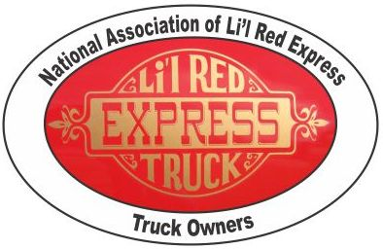

First Annual Li’l Red Express Truck Meet
2019
Hampton Inn Pigeon Forge
2497 Teaster Lane, Pigeon Forge, TN 37863
866-238-4218
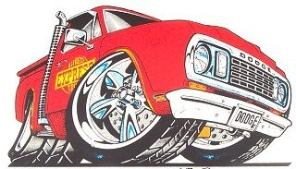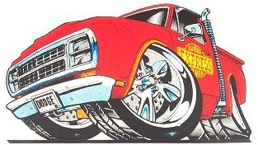
 7 & 8 June, 2019 

For meet information, contact:
Bob Aucoin 850-866-9447, John Roberts 941-380-9977
Jeff Brown 845-978-9065

