New Fundraising Ideas  FundraisingWithCandleFundraisers.com  Deb Murray  National Fundraising Distributor | 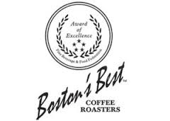 | Phone: (860) 384-3691  Email: CHFundraiser@gmail.com  Fax: (410) 630-7080

Boston’s Best Coffee Roasters Fundraising

Coffee fundraising that is uncomplicated, fun, and easy, with high quality, affordably priced products! There are no upfront costs, low minimums, no case requirements with our brochure fundraisers, and fast UPS shipping!

We are proud to offer your organization an exceptional fundraising program and we look forward to helping you achieve a very success coffee fundraiser this season! Coffee products are very easy to sell, are purchased routinely, are great for personal enjoyment and gift-giving, and will be loved by your customers. Coffee fundraisers are very successful when repeated often!

Profit: You’ll earn a generous profit up to 45% with no hidden fees. Earn 45% profit with 500 items sold, 40% if less than 500 items.
Price Range: All our coffee items are priced at just $15 each.
Brochure Includes: The Ultimate Coffee Collection Brochure, 4 pages, offers a selection of delicious 11 oz. bags of ready-to-brew gourmet coffee selections as well as Single Serve Coffee Selections, 12 single serve cups per box, for use in all single-serve brewers, including the Keurig K-Cup Brewing System.
Number of Items: 15. We offer 8 of our award winning 11 oz. bags of ready to brew coffee, a coffee sampler with 7 flavors, and 6 boxes of single Serve Cups.
Recommended for: Groups of 10 or more
Minimum Order: 30 items
Case Requirements: None. Order only what you sell.
Upfront Costs: None
Prize Program: None
Pack-by-Seller: FREE with 500 or more items sold. Pack-by-seller is optional for orders with less than 500 items and if selected, adds a 6% fee on retail sales.
Shipping: Shipping charges are free with 30 or more items. Products ship in just a few days upon receipt of payment.
Payment: Organization, Business, or Cashier’s Check, Money Order

How does the program work?

Submit your Sales Agreement by fax or scan/email today (or electronically through our website) and Brochures will be shipped FREE!
You'll receive your brochures within a few days. You can send your sales agreement by postal mail as well but please allow a few
additional days to receive your brochures.
Use our Chairman’s Toolbox on our website for all the documents you’ll need, including a sample cover letter you can modify.
You’ll also find in the Toolbox fundraising instructions, helpful tips, steps for submitting your order, etc.
Distribute brochures to your sellers and determine how long you will continue your sales. (We recommend 2-3 weeks) Customer
checks, if taken, are made payable to your organization.
Collect all brochures and payments at the end of your selling period. There is just a 30 item minimum for submitting an order.
Standard Bulk Orders For bulk orders you can complete a Master Order Form, fax or email it to us and we’ll email your invoice
with the total amount due.
Pack-by-Seller If selected, we will email a spreadsheet for you to complete. Once completed, we will email an invoice to you.
Pay for your purchase. We accept business check, school check, cashier's check, or a money order. A W-9 or vendor application is
provided if required. You'll keep your brochures and your profit upfront.
A confirmation will be emailed to you once we receive payment. Once received, your order will be processed and shipped by UPS.
You can expect to receive your shipment generally well within 2-3 weeks. Late orders are accepted with no minimum order required. A $15 shipping fee will be added to an order with less than 30 items.
Report any missing or broken items. Seldom are there any missing or damaged items with our shipments. However, should any
corrections be required, we will process a new order for you.

We’ll provide coaching to help your campaign succeed, extended office hours Mon-Sun 9am-9pm EST, and a solid commitment to
process your order and needed replacements with no delay. When you require help we'll be available to help you!

In-Hand Seller Backpack Gourmet Coffee Fundraiser

Simple and easy fundraising! Order backpacks of coffee for your participants to sell. Each backpack contains 52 assorted coffee packets which sell for $1 each, each packet makes up to 12 cups of gourmet coffee. 7 flavors are available in each backpack. Backpacks are ordered by the case and each case includes 9 backpacks. With our Backpack Coffee program, you’ll earn 30% when ordering 1 case, 35% when ordering 2-4 cases, and with 5 or more cases you’ll profit 40%. Your participants will keep their coffee backpack as a reward for their participation. Simply call us to place an order and we’ll email an invoice to you. Your order will be processed upon receipt of payment.
.

 | Boston’s Coffee Roasters Brochure Fundraiser  Sales Agreement 2017  New Fundraising Ideas  FundraisingWithCandleFundraisers.com  Phone: 860-384-3691  Submit Sales Agreement by - Fax: 1-410-630-7080  Email: CHFundraiser@gmail.com  Postal Mail: 97 Overshot Drive, South Glastonbury CT 06073 | 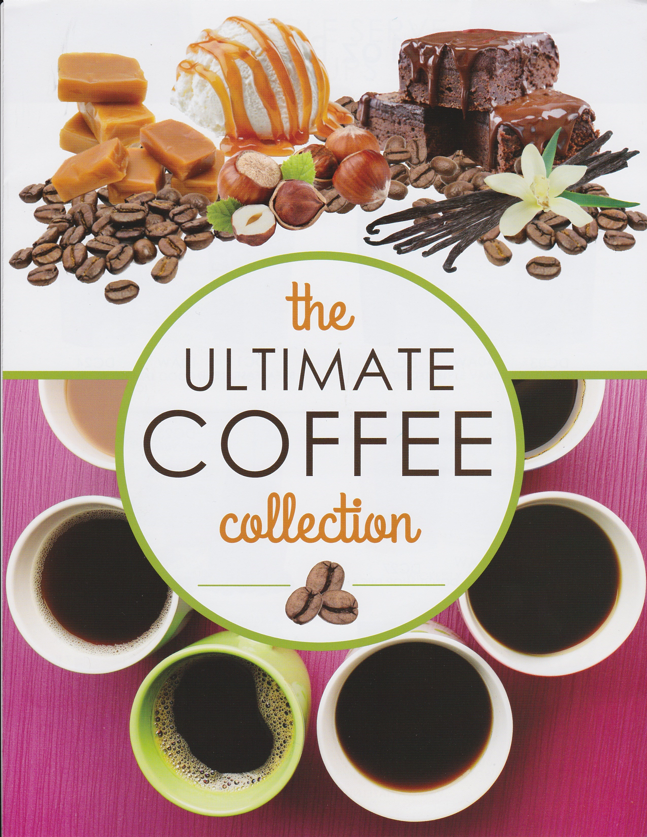

Organization Name: _______________________________________________________________________________________________________
Shipping Address for BROCHURES: ____________ Shipped to Business/School ____________ Shipped to Home Address
Business Name or School if applicable: _______________________________________________________________________________________
Street Address (No PO Box): ________________________________________________________________________________________________ City: ____________________________________________State:______________________________Zip:__________________________________
Shipping Address for PRODUCTS: _____ Shipped to Business/School (signature is required)
Business Name or School: __________________________________________________________________________________________________
Street Address (No PO Boxes):_______________________________________________________________________________________________
City: ____________________________________________State:______________________________Zip:__________________________________
Chairperson: _________________________________ Email (Print Clearly):__________________________________________________________
Phone-Day: (_______) __________________________ Evening: (________) __________________________ Cell: (_______) __________________
Number of Participants: ____________________Approximate Date of Fundraiser: _______/________/_________ to _______/________/________
Select Brochure(s): ______ The Ultimate Coffee Collection

Brochures: Brochures are FREE! There are NO upfront costs to ship our Brochures to your organization. Please do not cancel.

Profit: Organizations will earn 40% profit. Organization will pay 60% of the retail selling price. Organizations will earn 45% when selling 500 or more items. Profit is retained by the organization.

Product Availability/Pricing Guarantee: Our 2016 Brochures will retire 12/31/17 and require payment by 12/30/17.

Standard/Bulk Shipping and Late Orders: Free on orders with 30 or more items. Orders less than 30 items will add a $15 shipping fee. All orders are shipped UPS.

Pack-by-Seller: If selected, pack-by-seller is free when selling 500 or more items. Fee is 6% of sales if less than 500 items is sold.

Payments: Customer checks are made payable to your organization. A single payment by Money Order, Business, or School Check will be accepted for your purchase. Personal checks, temporary checks, checks with hand-written group/business names can’t be accepted. Credit cards and purchase orders are not accepted.

Delivery: Orders will be processed upon receipt of payment and are generally delivered within 2 weeks. Pack-by-seller orders may requires a few additional days to process

Check-In Forms: Replacements for missing or damaged items will be shipped only when a fully completed Check-In Form has been submitted within 72 hours. Phone calls or emails alone WILL NOT be accepted. Organization will be responsible for the accuracy of the total number of items sold and ordered.

Sales Agreement: MUST be returned to Deb Murray prior to distributing your brochures. I have read, understand and agree with the terms and conditions listed above and have received approval from my organization (school principal, board members etc.) to sign on behalf of my organization.

_____________________________ _________________ Deb Murray __________________
Chairperson Title Fundraising Representative Date

Frequently Asked Questions

Do I need a local representative?
No. Our fundraising program is not structured with local representatives. Brochures are shipped to you promptly and will be delivered to you within 3-4 days. All product orders are processed through our shipping department and are shipped by UPS from our distribution center. We offer extended office hours Mon-Sat and coaching from start to finish. You keep your brochures and remit payment only for the purchase due. Shipping updates are provided and any missing/broken items, although very infrequent, are shipped to you directly from our distribution center.

How much profit can our organization earn?
Organizations can earn up to 45% profit with our fundraising brochures. Potential profit is based upon organizations volume of sales. Profit is 40% on your order and is increased to 45% when selling 500 or more items.

Does the group pay for the fundraiser brochures?
No. An organization has no upfront cost for the brochures. Brochures are provided complimentary, but we request that once you’ve submitted your sales agreement you do not cancel your fundraiser. If the number of items sold is less than the number of brochures shipped we will add .50 per brochure for the shortage. For example, if you request 150 brochures, sell just 100 items we will charge a .50 fee for 50 brochures.

How should we collect the money?
We suggest you collect all payments when you take your orders. All checks or money orders are made payable to your organization. At the conclusion of your fundraiser, your organization will keep your profits upfront and send one payment to our office for the cost of the products.

How do we submit the order once we have collected them?
If you opt to order a bulk order, print a Master Order Form from the website ToolBox and fax/email the order to us. If you are eligible for packed-by-seller or if you have opted for the youth prize program we will require you to send us our copy of the participant’s order form. A vendor application or W-9 will be provided to your organization upon request. Once payment has been received your order will be placed and you’ll receive your shipment by UPS generally well within two weeks. A few additional days may be required for packed-by-seller order. Your organization will keep your fundraising brochures, copy of your order forms, and profit.

How do we pay for the order?
When you submit your master order form, we will email an invoice to you. Once payment has been received by business or school check, cashier's check, or money order payable to New Fundraising Ideas Deb Murray, the order will be processed. Personal checks, credit cards, and purchase orders are not accepted.

How do I handle any late or add-on orders?
We will be happy to process any late or add-on orders. Additional orders submitted after the original order has been entered will be a new and separate order and will include a $15 Shipping Fee if ordering less than 30 items. No minimums are required for late orders.

Do I have any sorting options?
Yes, an organization is eligible for packed-by-seller service with an order of 500 or more items. There is no fee. If preferred, we can ship the products as one bulk order in which your organization will sort by seller. You choose at the conclusion of your sales how you want your order to be shipped. If you have sold less than 500 items and opt to have your order packed-by-seller a 6% fee will be added.

How do I handle any broken or missing products?
We do our best to ensure that you receive all products you have ordered in full and with no quality problems. If you encounter a problem with any missing or damaged product, a Check-In-Form can be printed from our website ToolBox for you to submit any needed replacements. Rarely are there ANY discrepancies with our shipments. However, should items be missing or damaged we will do our best to resolve any issues in a quick and timely manner, processing your replacements upon the date your Check-In-Form is received. Check-In Forms MUST be received within 72 hours.

If you're looking for an experienced and proven fundraising representative look no further! Since 2002 I have worked as a full-time national fundraising representative and I take pride in having worked with thousands of organizations across the US. I began working with Celebrating Home/La-Tee-Da! Fundraising, held the record for highest fundraising sales in company history, and was consistently the top seller each year from 2003-2015. Over the years our office expanded by offering additional programs to better service our fundraising organizations. My commitment is to provide you with the best experience possible in anticipation of working together for years to come. I worked with our corporate office in product and brochure development, expanded our product line, initiated and helped develop online fundraising, packed by seller shipping, training programs, and much more. I’m confident you’ll be pleased with our program and your supporters will be too! Complete the Sales Agreement and return it by fax, scanned email attachment, or postal mail. You can also submit your Sales Agreement electronically from our website. Your brochures will be sent immediately and you can begin your fundraiser in just 3-4 days. You can depend on receiving excellent customer service and I look forward to working with you!

