RSAI Legislative Update
March 10, 2022
Week Nine of the 2022 Session: REC sets a new revenue estimate, Governor’s School Choice policy gets a hearing in the House Appropriations Subcommittee, and several other policy bills receive some action. This RSAI Weekly Report from the 2022 Legislative Session includes:
- Status of Governor’s School Choice Omnibus in House Appropriations Committee
- The Cost of Transparency: Fiscal Note HF 2499
- Revenue Estimating Conference, March 10, estimates revenue growth for FY22, FY23, and FY24
- School Complaint Procedures (Teacher Misconduct) in House Ways and Means
- Floor, Committee and Subcommittee Action
- Advocacy Action Steps for This Week
- Links to Advocacy Resources
Status of Governor’s School Choice Omnibus in House Appropriations Committee: A subcommittee of the House Appropriations Committee met to hear testimony on HSB 672, which includes all of the proposals in the Governor’s School Choice Omnibus bill. The Chair alternated those there to speak, pro and then con, for over an hour. The subcommittee voted to recommend the bill move to the full Appropriations Committee 2:0. See the list of Appropriations Committee members below. If you are represented by one of those Committee members, continue to connect, provide additional rationale and keep the discussion going. No activity occurred this week in the Senate on HF 2369, which is an identical bill in the Senate, on the Senate’s Debate Calendar.
HSB 672 and SF 2369 contain the following:
- Establishes a student first scholarship program (vouchers) and a student first enrollment supplement fund (expected to be amended to instead increase operational sharing incentives typically used by smaller districts). Includes a standing unlimited appropriation for up to 10,000 vouchers.
- Requires school boards to publish instructional materials, standards and whether standards are met and exceeded by grade, course and teacher, and library books, and sets up a process/policy for parents to request removal of library books.
- Changes required social studies instruction including a high-stakes test for graduation.
- Changes some open enrollment provisions, teacher librarian endorsements, competent private instruction/special education process. (Formerly SSB 3080 and SF 2349.)
SF 2369 is on the Senate Calendar. HSB 672 is in the House Ways and Means Committee. RSAI is registered in opposition. See the updated March 10 Call to Action Vouchers.
HF 2498 includes the provisions on open enrollment of siblings for good cause, teacher librarian endorsements, and the placement of children identified as requiring special education in competent private instruction (formerly HSB 705). This bill is on the House Calendar and RSAI is registered as undecided.
HF 2499 includes the provisions requiring school districts to publish certain specified information (transparency provisions) and processes for parents to request removal of library books, changes social studies content and requires 70% correct on the citizenship test in order to graduate from high school (formerly HSB 706). This bill is on the House Calendar and RSAI is registered opposed.
Cost of Transparency: Fiscal Note to HF 2499 was published and included some estimates of the cost to local school districts to implement the transparency provisions of the Governor’s proposal. They estimate 5 days of teacher time to identify and upload instructional materials and estimate the cost for substitutes to cover that time. The statewide estimate is $27.4 million. As there is a shortage of substitutes and the deadline to complete the posting, should the bill be enacted, is Aug. 23, we estimate that districts will be required to add a week of contract time for teachers to complete this work at a statewide cost of over $50 million. The software programs to allow sorting of materials, training time for new employees and ongoing oversight and management of the website would cost more. The penalty for noncompliance is withholding state foundation aid for each day of noncompliance. This process would also stifle innovation and instructional response to student assessment in classrooms, all of which is why RSAI is registered opposed.

Revenue Estimating Committee: the 3-member panel meets quarterly (or more often as needed) to consider state revenue growth and set a consensus estimate that binds the legislature’s budgeting process. Kraig Paulsen, Director of Iowa Department of Revenue and Iowa Department of Management, is the Governor’s Appointee. Holly Lyons, Fiscal Services Division Director at Iowa Legislative Services Agency is the Legislature’s Appointee. David Underwood, Clear Lake businessman, is jointly appointed. The panel discussed optimism as Iowa grows and the Omicron variant of COVID-19 recedes, but uncertainty due to Russia’s war on Ukraine.

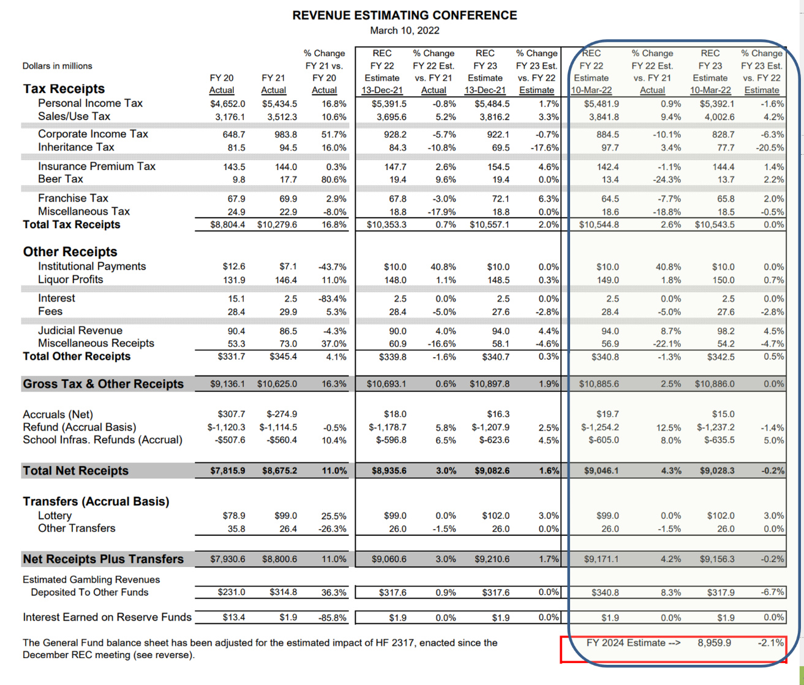
The panel raised the estimate for FY 2022 by another $110 million, which results in predicted growth of $370.9 million, or 4.2%. They lowered the estimate for FY 2023, expecting a loss of $17.8 million, which is a growth rate of (-0.2%), primarily due to the implementation of HF 2417 Personal and Corporate Income Tax Cuts. They set the revenue estimate for FY 2024 at (-2.1%) for FY 2024 due to additional phasing-in of the HF 2417 tax cuts.

This chart from the Legislative Services Agency shows the total impact by general fund revenue source:

School Complaint Procedures (Teacher Misconduct) in House Ways and Means

HF 2505 School Complaint Procedures: this bill, previously approved by the House Education Committee on party lines, requires school districts to form a local committee to investigate teacher misconduct, creates civil penalties for administrators who do not report teacher misconduct, changes the BOEE make-up to include more public members and only four licensed members of whom only 1 can be an administrator, and sets some investigation expectations. The bill also requires school districts to check with BOEE if there are any complaints filed, including unfounded complaints, before hiring a teacher. The subcommittee approved 2:0 to move forward to the full House Ways and Means Committee. Rep. Hite, the Chair of the subcommittee and floor manager of the bill, stated his intention to remove the local committee and make other amendments, inviting stakeholders to reach out to him with suggestions. RSAI is registered opposed to this bill.

Floor Debate and Committee Action this Week
HF 2495 Para-Educator Substitutes: this bill allows schools to use para-educators as substitutes, except for driver’s education, if the school makes a good-faith effort to find a qualified sub. Requires the district to seek a BOEE waiver. Requires the para-educator to be paid at the higher of the regular sub or para-educator rate. The bill is effective on enactment. Authorizes the BOEE to adopt rules. The House approved the bill 99-0 (3/2), the Senate approved it 47-0; sending it to the Governor. RSAI is registered in support.
HF 2412 Radon Testing and Mitigation: this bill Requires school boards to conduct a short-term test (2 to 7-day test) for radon in school buildings at least once by July 2027 and at least once every five years afterwards, by certified testers or district employees trained by an approved course. Requires the results to be published. Requires a second test if the results are above 4 picocuries per liter and requires mitigation efforts by certified mitigation person if the results are still high with two years of testing. Does not require mitigation if the district intends to remodel or stop using the building. Requires new buildings to be built with radon-resistant construction. Requires DE and DPH to adopt rules. Allows use of SAVE for the costs of testing and mitigation. The House passed it 93-2, sending it to the Senate. A subcommittee on the Senate side met and recommended the bill move forward to the full Senate Education Committee. Subcommittee members expressed concern about the cost to school districts and are looking for some relief for high-cost mitigations. RSAI is registered as undecided.
SF 2357 School Board Meetings: this bill requires school board members to cast a vote during meetings, either yea or nay on issues, except in cases of a personal conflict of interest. The Senate approved the bill, 48-0, sending it to the House. RSAI is registered in support.
SF 2080 Student Health Screenings: this bill prohibits school districts from administering or conducting invasive physical health screenings not required by state or federal law without written parent permissions. The bill does not prohibit a health screening in an emergent care situation or from cooperating in a child abuse assessment. The Senate passed it 47:0, sending it to the House Education Committee. RSAI is registered as undecided.
SF 2359 Cognitive Impact of Technology Work Group: this bill requires DE and DPH to convene a workgroup to study the impact of technology on cognitive function of students. The workgroup is required to submit findings by Dec. 31, 2022, and the report is required to include recommendations on best practices related to the use of technology in educational settings with a focus on ways to mitigate tech’s negative impact on social and behavioral development, attention span, and other cognitive functions. The Senate passed it 46:0, sending it to the House Education Committee. RSAI is registered as undecided.
Subcommittee Action this Week
- HF 2505 School Complaint Procedures: local committee to investigate teacher misconduct (that will come out), civil penalties for administrators who do not report, change in BOEE make-up and some investigation expectations, etc. Subcommittee approved 2:0 to move forward to the full House Ways and Means Committee. RSAI is registered opposed.
- SF 2322 Copying Records Costs: limits costs to copying costs if it takes less than 30 minutes to copy the records, requires fees to be reasonable, and limits legal fees for redacting information be limited to the redacting of confidential information. Subcommittee approved 2:0 to move forward to the full House Ways and Means Committee. RSAI is registered as undecided.
- HF 2081 Teacher Assessment (Praxis): eliminates the praxis test requirement for either entry to a teacher prep program or to get a teaching license. Subcommittee approved 3:0 to move forward to the full Senate Education Committee. RSAI is registered in support.
- SF 2356 Volunteer Substitute Teachers: Subcommittee approved 2:0 to move forward to the full House Education Committee. RSAI is registered as undecided.
- SF 2362 Electronic Notice, E-Signatures and Health Trainings Work Group: Subcommittee approved 2:0 to move forward to the full House Education Committee. (Used to include a seizure disorder training mandate, but those provisions were removed.) RSAI is now registered in support with the removal of the seizure disorder training mandate.
- HF 2412 Radon Testing and Mitigation: Requires testing and mitigation, allows SAVE to pay for both, exempts buildings if construction/renovation/building closer will happen in the next 5 years. Subcommittee approved 2:0 to move forward to the full House Education Committee. RSAI is registered as undecided.
- HF 771 Bronchodilators: Allows students to self-administer with parent permission, allows (does not mandate) districts to stock and administer for an asthma or other breathing emergency and protects district employees who administer the bronchodilators from liability. Subcommittee approved to move forward to the full House Education Committee. RSAI is registered as undecided since this is permissive language, however, we have concerns about potential litigation if a district does not provide for the storage and administration of bronchodilators.

Advocacy Actions This Week:
- Always start with a thank you! See the 2021 Legislative Session Successes on the RSAI website and find one you are grateful for them accomplishing. Weigh in your support on the bills above that are moving that might benefit your districts. Tell your legislators and the Governor thank you for getting SSA decided at the beginning of Session so you can work on your budgets within the mandated timelines.
- Funding: now that SSA is done, advocate with the Senate to approve HF 2315, which provides $19.2 million in supplemental funding to help schools with inflationary costs. Explain that federal pandemic funds are (pick the one or two that apply to your district): 1) already exhausted, 2) obligated but waiting for labor/materials/other supply chain issues that have slowed HVAC construction or simply no applicants for instructional positions, 3) local district must have the funds to expend first, and then seek reimbursement, which can take time to properly document and obtain approval and for all districts, the federal pandemic funds are to be used through Sept. 2024, but then are gone. Adequate state funding would provide sustainability for many of the programs districts have been able to fund with the pandemic funds, but only for a limited time.
- Shore up Voucher Opposition: Circle back with all House legislators, but especially those on the House Appropriations Committee and reiterate key messages:
  - Taxpayer dollars should not support private, religious schools.
  - Public funds require public accountability and transparency.
  - Private and public schools do not have a level playing field. If privates are to receive public money, they must have the same regulations and requirements.
  - This is a slippery slope toward a costly an expansive voucher program.
  - Iowa already has many parent choice options and financial support for private schools, scholarships and tax credits to help parents making that choice.
  - The state has not been able to adequately fund one education system and should not commit to the hefty price tag of funding another.
House Appropriations Committee Members: Next stop for HSB 672 Voucher bill after the subcommittee meeting
The following links will take you to each committee member’s legislative page, with email address and often home or cell phone number so you can easily connect with them. Remember to be respectful and explain the impact these bills would have on your school and education for your students. Please be sensitive to using school email when contacting legislators who may prefer you use your personal email rather than school property for advocacy purposes.

- Gary M. Mohr (R, District 94), Chair
- Shannon Latham (R, District 54), Vice Chair
- Jo Oldson (D, District 41), Ranking Member
- Michael R. Bergan (R, District 55)
- Jacob Bossman (R, District 6)
- Holly Brink (R, District 80)
- Timi Brown-Powers (D, District 61)
- Dave Deyoe (R, District 49)
- Tracy Ehlert (D, District 70)
- John Forbes (D, District 40)
- Joel Fry (R, District 27)
- Chris Hall (D, District 13)
- Steven Holt (R, District 18)
- David Kerr (R, District 88)
- Ann Meyer (R, District 9)
- Brian Meyer (D, District 33)
- Norlin Mommsen (R, District 97)
- Todd Prichard (D, District 52)
- Kirsten Running-Marquardt (D, District 69)
- Ray Sorensen (R, District 20)
- Phyllis Thede (D, District 93)
- Phil Thompson (R, District 47)
- Dave Williams (D, District 60)
- John H. Wills (R, District 1)
- Gary Worthan (R, District 11)

Find other Representatives here: https://www.legis.iowa.gov/legislators/house
To call and leave a message at the Statehouse, the House switchboard operator number is 515.281-3221. You can ask if they are available, leave a message for them to call you back, or just leave a short message such as “Oppose HSB 672 Governor’s School Choice Vouchers and Unfunded Mandate on Transparency.” (Legislators typically return to the Capitol by noon on Monday).

Connecting with Legislators: To call and leave a message at the Statehouse during the legislative session, the House switchboard operator number is 515.281.3221 and the Senate switchboard operator number is 515.281.3371. You can ask if they are available or leave a message for them to call you back. You can also ask them what’s the best way to contact them during session. They may prefer email or text message or phone call based on their personal preferences.
RSAI Advocacy Resources: To find Advocacy Resources such as Position Papers, RSAI Weekly Legislative Reports and video updates, RSAI Calls to Action when immediate advocacy action is required, testimony presented to the State Board of Education, the DE or any legislative committee or public hearing, and links to fiscal information that may inform your work, visit the RSAI legislative web page here: http://www.rsaia.org/legislative.html. Also, check out the newly released 2022 RSAI Advocacy Handbook, and also available on the legislative page of the RSAI website
Contact us with any questions, feedback or suggestions to better prepare your advocacy work:
*Margaret Buckton, RSAI Professional Advocate, margaret@iowaschoolfinance.com , 515.201.3755 Cell
*Dave Daughton, RSAI Grassroots Advocate, dave.daughton@rsaia.org, 641-344-5205 Cell

Thanks to our RSAI Corporate Sponsors:
Special thank you to your RSAI Corporate Sponsors for their support of RSAI programs and services. Find information about how these organizations may help your district on the Corporate Sponsor page of the RSAI website at www.rsaia.org/corporate-sponsors.html.
 | www.apptegy.com
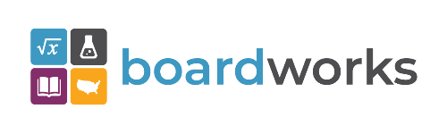 | www.boardworkseducation.com
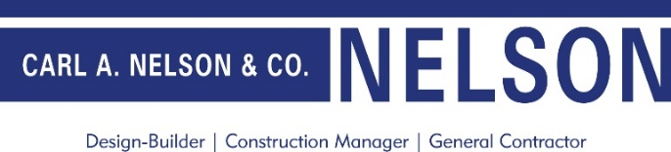 | www.carlanelsonco.com
 | www.classroomclinic.com
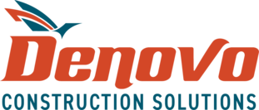 | www.teamdenovo.com
 | www.friedman-group.com
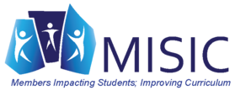 | www.misiciowa.org
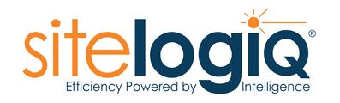 | www.sitelogiq.com
 | www.wgu.edu

