
PATREON CHANNEL: The following catalogue will guide you through the videos I have posted on Patreon.
They are divided into levels:
Card Party/ $5/month - Full of watercolor lessons but shorter videos, and sometimes smaller formats
Classical Lessons: $7/month - A little more in depth information, a little more technical
Both Card Party & Classical lessons: $10/month

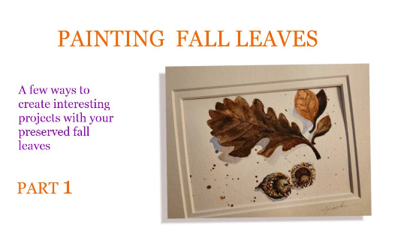 | PAINTING FALL LEAVES - 1  This two-part video will give you some ideas for project to do with Fall leaves which have been preserved. It's great to be able to celebrate these beautiful art objects that fall out of trees every year for us to enjoy.  Card Party  Link to Painting Fall Leaves
PAINTING FALL LEAVES - 2  Five ideas for using Preserved Fall Leaves on cards or small paintings.  Card Party  Link to Painting Fall Leaves - 2 | 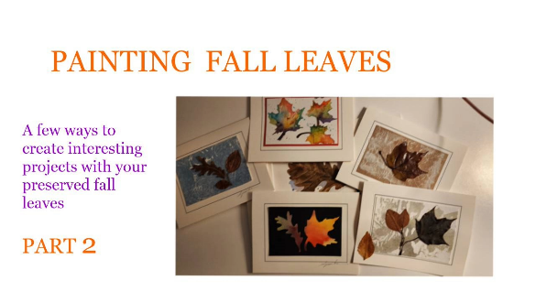
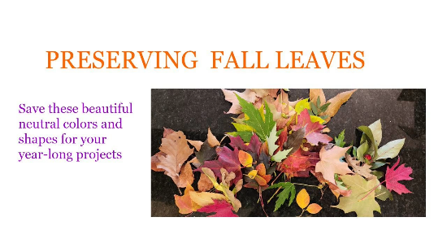 | PRESERVING FALL LEAVES  A great way to save the beauty of Fall leaves...for projects you can do all year long.  Card Party  Link to Preserving Leaves
PUMPKINS  This lesson teaches how values create a three-dimensional look on a two-dimensional piece of paper. Although it makes for great holiday cards, you will be able to translate your skills to classical watercolors.  Card Party  Link to Pumpkins | 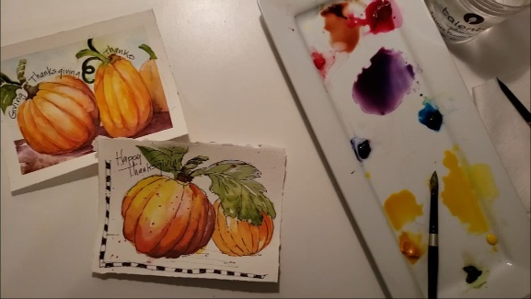
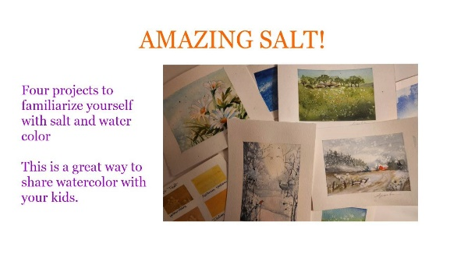 | SALT Here are four projects for you to choose from...or do all four! Just fast forward to the one you like, after you have seen the intro. I have attached source outlines, which are card-size, but you can enlarge them at any print shop and most copiers.  Card Party  Link to Amazing Salt
FIVE-MINUTE HOLIDAY CARD  This card is quick, but will give you an amazing amount of skills when thinking about watercolor: timing, mix of water per paint, negative painting, salt techniques. You may have to try it more than once, so get yourself the back of a few paintings to practice.  FREE  Link for 5-Minute Christmas Card | 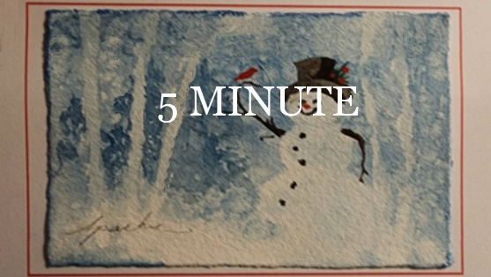
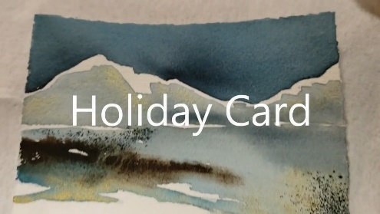 | HOLIDAY CARD  Brilliante Daniel Smith Iridescent Gold watercolors bring this little card to life. So fun to infuse the gentle sparkling into a simple statement.  Classical Lessons  Link to 5 min Christmas Card
LUMINESCENT PAINTS There are so many choices for luminescent paints that this might make your choices easier. Plus, we will do three different projects that give you some ideas as to how to mix them with regular watercolor and colorless medium.  Card Party  Link to Luminescent Paints | 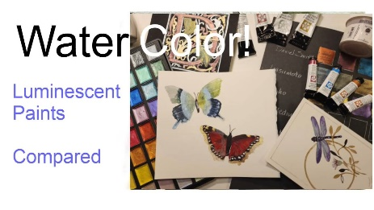
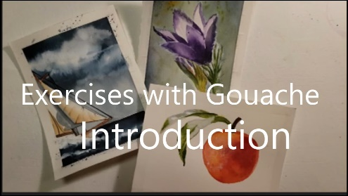 | Introduction to a series on GOUACHE  Adding Gouache to watercolors is a game changer  Classical Lessons  Link to Intro to Gouache
GOUAGHE 1 - Use Gouache techniques to fuzz out anything...but lets work on a peach this time  Classical Lessons  Link to Peach Fuzz with Gouache | 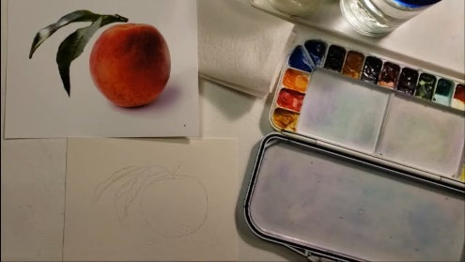
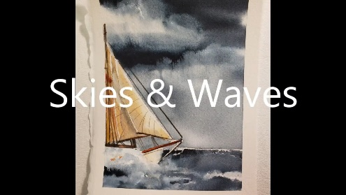 | GOUACHE 2 -Gouache actually works great when creating waves, sea foam etc. It's awesome  Classical Lessons  Link to Gouache - 2
GOUACHE – 3 Letting the gouache flow into wetter areas give a very nice fuzzy look to stems and flowers  Classical Lessons  Link to Gouache - 3 | 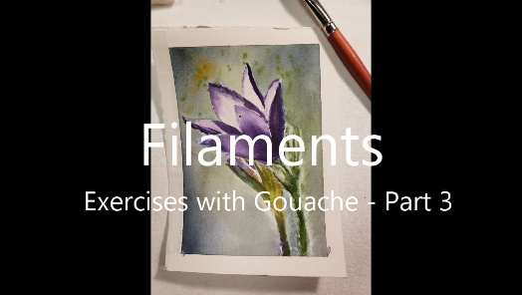
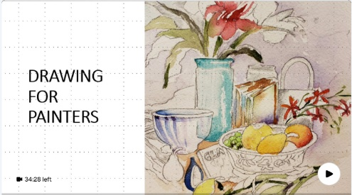 | DRAWING FOR PAINTERS  You will be introduced to supplies and geometric shapes. This is a great way to put together great compositions.  Classical Lessons  Link to Drawing for Painters 1
DRAWING FOR PAINTERS  This video covers contour drawing, blind contour drawing & gesture drawing  Classical Lessons  Drawing for Painters - 2 Link | 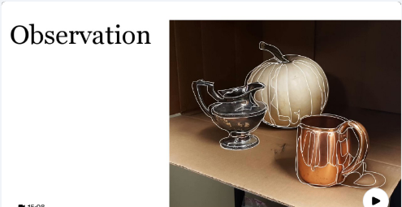
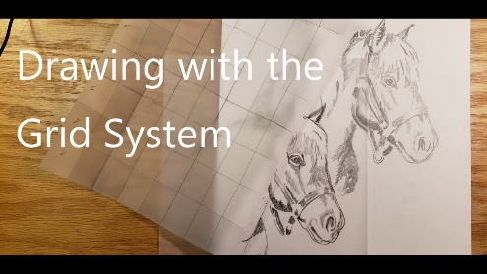 | DRAWING FOR PAINTERS - 3  Drawing for Painters - 3 The grid system  Classical Lessons
DRAWING FOR PAINTERS – 4  Learn value before you learn color. It is the heart of your composition, defines perspective and creates dimension in your objects.  Classical Lessons  Link to Drawing for Painters - 4 | 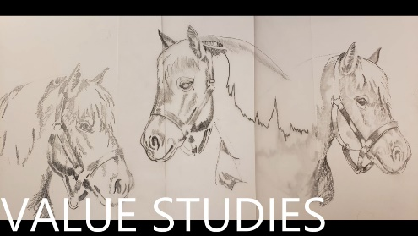
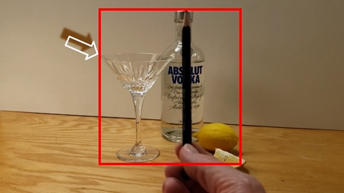 | DRAWING FOR PAINTERS – 5  Learn how to draw by sight - comparative sizes  Classical Lessons  Link to Drawing for Painters - 5
DRAWING FOR PAINTERS – 6  You have all the drawing skills needed to pull together a very successful painting. This video will walk you through it.  Classical Lessons  Link to Drawing for Painters - 6 | 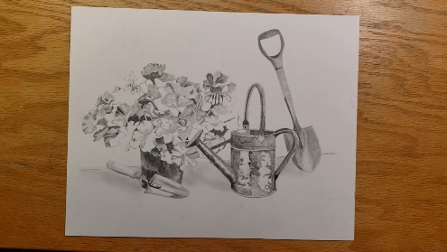
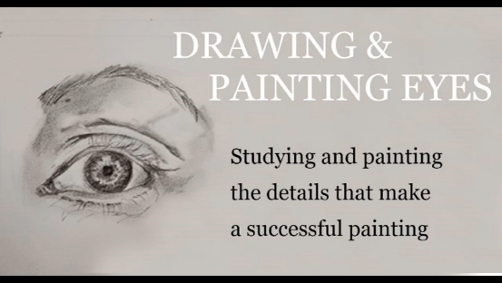 | DRAWING AND PAINTING EYES  Classical Lessons  Link to Drawing & Painting Eyes
DAFFODILS!  Daffodils! Part of a series of Spring Flowers - if you can paint flowers, you can paint anything!  Card Party  Link to Daffodils | 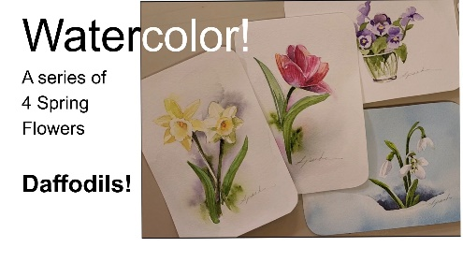
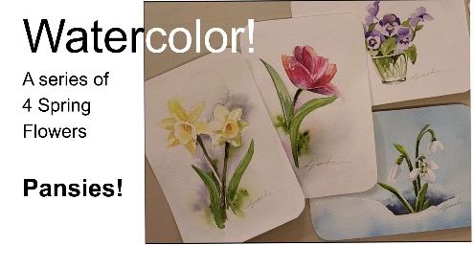 | PANSIES!  Part of a series of Spring Flowers - if you can paint flowers, you can paint anything!  Card Party  Link to Pansies
TULIPS  Part of a series of Spring Flowers - if you can paint flowers, you can paint anything!  Card Party  Link to Tulips | 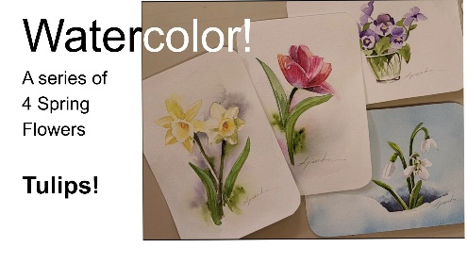
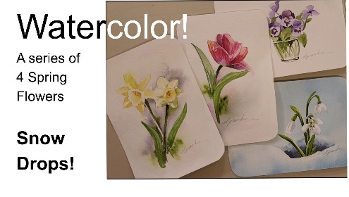 | SNOWDROPS  Part of a series of Spring Flowers - if you can paint flowers, you can paint anything!  Card Party  Link to Snow Drops
STAMP GERANIUM LEAVES  This technique works also on ferns and other leaves with pronounced veins  Card Party  Link to Geraniums | 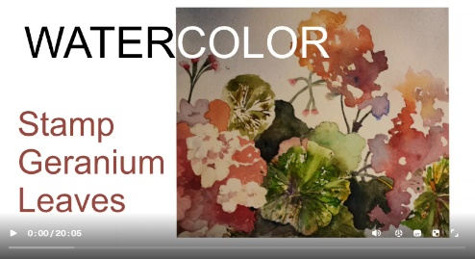
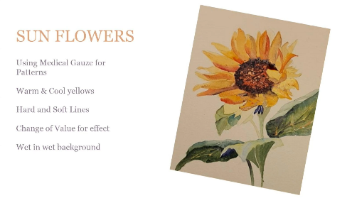 | SUNFLOWERS  No, not just sun flowers but classical watercolor techniques along the way  Card Party  Link to Sunflowers
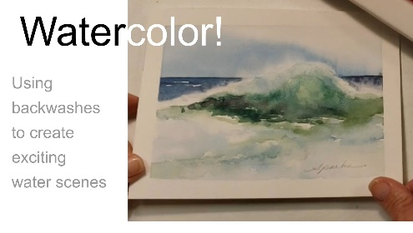 | BACKWASHES – Ocean Mist  Use backwashes to create exciting water scenes  Classical Lessons  Link to backwashes and water
BACKWASHES – Fog and Mist the Easy Way  Use backwashes to create exciting water scenes  Classical Lessons  Link to Painting Mist | 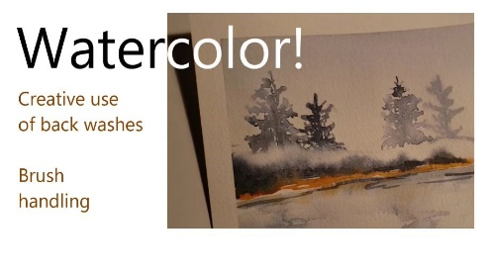
SUNSETS  This beginner lesson focuses on mixing vibrant and muted colors, graduated washes, using kleenex and cue tips to lift paint and primary triads for mixing. A lot to be learned here!  Classical Lessons  Link to Sunset | 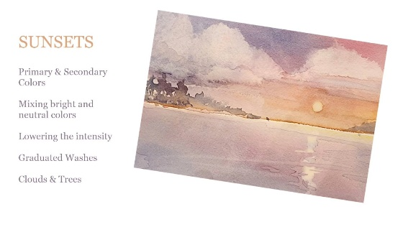
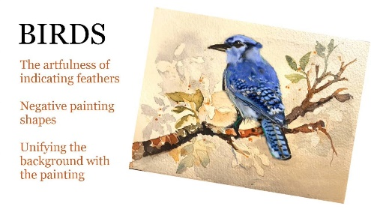 | BIRDS – Blue Jay  This video teaches how to soften the look of a bird and yet hint at the definition of feathers. We concentrate on values and how to lighten the shade of a color.  Classical Lessons  Link to Birds
BIRDS – Chickadee  Layered Backgrounds, loose and tight techniques to emphasize focus, dominance of color  Classical Lessons  Link to Chickadee | 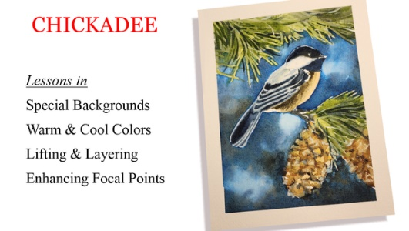
BUTTERFLIES  A lesson in jewel tones, and muted colors, value changes and mixing from a primary-cool-color triad. A magic marker sets it all off with permanent black ink  Classical Lessons  Link to Butterflies | 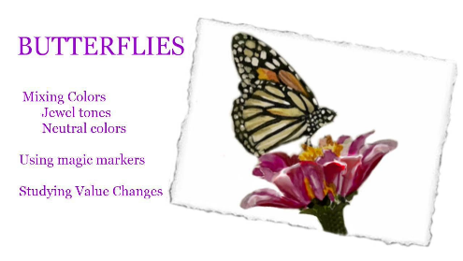
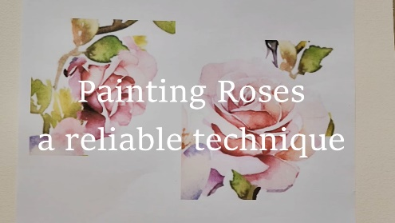 | PAINTING ROSES  This video prepares us with techniques that make painting the roses in the Valentine Wreath much easier  Card Party  Link to Painting Roses
VALENTINE WREATH  I created this valentine by drawing a big heart, and then placing hearts and flowers in strategic places. Then, connecting them with vines and leaves. As you are painting this valentine (go for an 8 x 10 size - its easier) think of how you would do your own  Card Party  Link to Valentine Wreath | 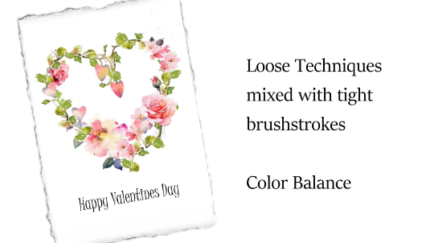
 | TOILET PAPER ROLL STAMP!  There is a fun little trick in this 3-minute video. Later on this month I will be providing two step-by-steps lessons on some pretty cute valentines. These are shown at the end.  FREE  Link to Toilet Paper Roll Stamp
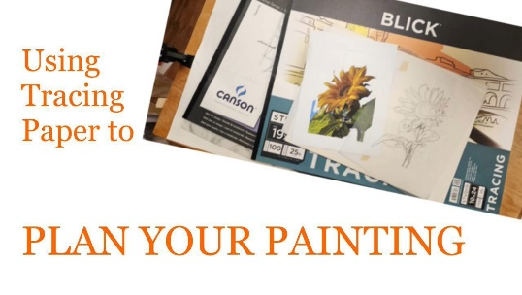 | TRACING PAPER – a great planning tool  Some of the benefits of starting with tracing paper, and papers that are better than others  Classical lessons  Link to Tracing Paper
MIXING COLORS  Paint with me on the tedious exercise and you will be able to control colors on anything you paint. It's an hour. But, paint along with the video. There are a lot of tips in there that will serve you well.  Classical lessons  Link to Mixing Colors | 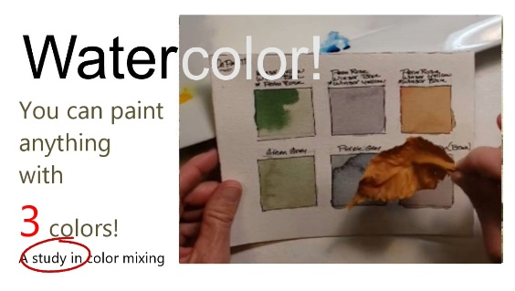
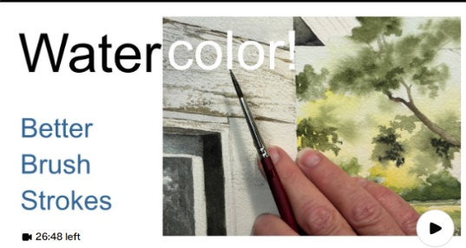 | BETTER BRUSH STROKES  How to hold the brush in such a way that you get the look you want  FREE  Link to Better Brush Strokes
TWO APPS- GREAT TOOLS  These two apps, (one on phones and IPads, the other on the web) make studying values and composing value-shapes a lot easier.  FREE  Link to Posterizing and Notan | 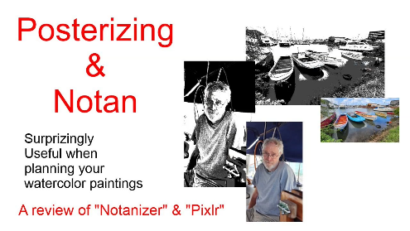
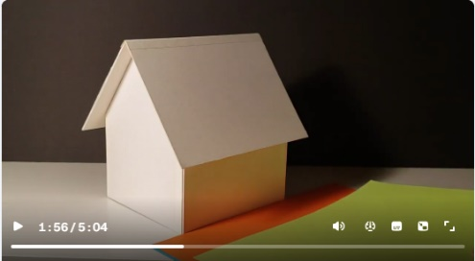 | REFLECTED LIGHT  You will be amazed at the opportunity to add color to your painting.  FREE  Link to Reflected Light

