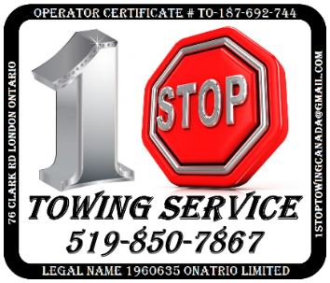***MAXIMUM RATEs***

|  |  |
| --- | --- |
| **Towing rates** | **Recovery rates** |
| Towing: Basic tow, towed vehicle  up to 4,536 kg GVWR  $1500 Base rate | Recovery – Tow Trucks:  less than 10 tons, or flat bed  $325 per hour |
| Towing: Basic tow, towed vehicle  from 4,536.1 - 11,793 kg GVWR  $2500 Base rate | Recovery – Specialized vehicles:  Underground extraction vehicle  $200 per hour |
| Towing: Basic Tow, towed vehicle  more than 11,793 kg GVWR  $5000 Base rate | recovery – Support vehicles:  Response vehicle with 360 degree lighting  $200 0per hour |
| Towing: Extended Tow, towed vehicle  up to 4,536 kg GVWR  $7.50 per kilometre | Recovery – Support vehicles:  response vehicle with tools and materials  $300 per hour |
| Towing: Extended Tow, towed vehicle  between 4,536.1 - 11,793 kg GVWR  $10.00 per kilometre | Recovery – Tow Trucks: Fixed boom, 10 tons  $350 per hour |
| Towing: Extended Tow, towed vehicle  more than 11,793 kg GVWR  $15.00 per kilometre | Recovery – Tow Trucks: Fixed boom, 15 tons  $375 per hour |
| Towing: En route travel  $7.50 per kilometre | Recovery – Tow Trucks: Fixed boom, 20 tons  $400 per hour |
| Towing: Standing-by, tow driver    $200 per hour | Recovery – Tow Trucks: Fixed boom, 25 tons  $425 per hour |
| **Labour rates** | **Storage rates** |
| Recovery – Labour:  Casual  $150 per hour | Outdoor storage,  vehicle length up to 6.5m  $85 per day |
| Recovery – Labour:  Mechanic  $200 per hour | Outdoor storage,  vehicle length from 6.51m to 12.5m  $100 per day |
| Recovery – Labour:  Rigger  $175 per hour | Outdoor storage,  vehicle length more than 12.5m  $120 per day |
| Recovery – Labour:  scene supervisor  $175per hour | Indoor storage, vehicle length up to 6.5m    $100 per day |
| Recovery – Labour:  recovery coordinator  $175 per hour | After-hours access    $100 Pre occurrence |

**These are the maximum rates that can be charged**

**the actual costs may vary**