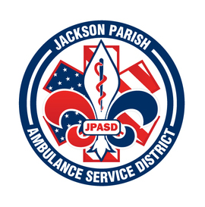

**JACKSON PARISH AMBULANCE SERVICE DISTRICT**

**115 Watts Street**

**Jonesboro, LA 71251**

**Office: (318)-259-2877 Fax: (318)-259-2099**

**jacksonparishambulance@jpasd.com**

**Aaron Johnson BOARD MEMBERS**

**EMS Director [ ] Newspaper** Allen Lindsay, Chairman

**Paula Parkerson , MD** [ ] **Minutes** Conchita Doyle, Vice-Chairman

Medical Director Joe Vail

Alma Williams

Deidre Hollis

**NOTICE OF PUBLIC MEETING**

**A public meeting will be held as follows:**

**DATE:** March 13, 2025

**TIME:**  12:00 PM

**PLACE OF MEETING:** Jackson Parish Ambulance Service District

115 Watts Street, Jonesboro, LA 71251

CANCELLED

***Reminder: Next Meeting: April 10, 2025 @ 12 Noon***

In accordance with the Americans with Disabilities Act, if you need special assistance, please contact Aaron Johnson, EMS Director at 318-259-2891 describing the assistance that is necessary. Due to the Covid-19 virus visitors are asked to not present to the meeting with fever, cough, diarrhea, or general weakness. Masks will be provided for visitors.