CENSUS. . .CENSUS. . .CENSUS

Fellow Residents,

Once again, we are all called upon by the US Census Bureau to provide them with the ten (10) year update of household residents. The survey is as of April 1, 2020.

The Census is an official count of population, typically recording various details of individuals such as name, sex, age, etc. We are mandated by the US Constitution to assist with this survey.
The census provides critical data to the Federal Government to assist in the disposition of billions of dollars to all states for funding of hospitals, fire department, schools, roads and other resources based on the data that is collected. It also determines the number of Representatives that voters in NH send to Washington. (Currently we have two Representatives in Washington.)
In mid-March, homes will be receiving an invitation to complete the 2020 census. You may do so either online, phone or paper. (Please complete within two weeks)

What you receive will be addressed to RESIDENT. Please do not toss as junk mail.

If you do not respond in two weeks a reminder will be sent with a paper survey to complete. If still no response, you will receive a personal visit from a census taker. Be sure to check their badge for proper identification and please do not turn them away if the credentials are valid.

A valid ID badge will have their photograph, a US Department of Commerce watermark and an expiration date.

If you still have questions about their identity, you may call the Regional Census Center at 212-882-7100.

FEDERAL CENSUS TAKERS ARE NOT SOLICITORS

As you know, solicitation here in our community is on everyone’s mind. We want to point out that since the census is federally mandated it would be against the law for Medvil to ban the census takers from our community. Having said that, we are all aware of the political minions who are going door to door seeking votes for their candidates, particularly on the weekends (see the article addressing this issue, below.) We cannot stress enough how important it is for you to check identification of anyone coming to your door who say there are representing the census. If after checking their ID you still feel unsafe, then it is your right not to allow them into your home. However, you can avoid all of this by completing the census before a home visit happens. Thank you.

HAS IT HAPPENED TO YOU YET?

It’s Saturday afternoon and there’s a knock on your door. Or it’s Sunday morning and your doorbell rings. It’s not the pizza delivery you were expecting or your family coming for Sunday dinner…it’s the (in most cases) dreaded political volunteer who wants to tell you all about their chosen candidate.

Please do not let that person into your home. There are too many instances of bad things happening to people who do that; that’s why we have signs posted at both entrances to our community specifically stating, "No Solicitation is Allowed."

Here’s what we recommend you do:

- Remind that person or persons that we are a private community, and we do not allow solicitation of any kind. And YES, that applies to them even though they may tell you that it doesn’t.
- Tell them to leave the community immediately or you will call the Goffstown Police Department.
- If they give you a hard time, or if you see them continue on to your neighbor’s home, then call the police. That phone number is 497-4858.

Thanks for your help in keeping our community safe.

Please consider keeping this information handy in the event someone comes to your door.
OTHER NOTICES

LAST CALL (REALLY!)

The Hannaford’s pharmacist is offering to set up another date to have various vaccines: Shingles, Pneumonia, Tetanus, Diphtheria & Pertussis (TDaP), Hepatitis A or B, and Hepatitis A & B combination.

Please contact Irene Gagne at 622-1869 if you have any interest in any of these vaccines. Once we see if there is enough interest, we will schedule a date & time and get the necessary forms to those who are interested. IG
MONDAY NIGHT CRIBBAGE CLUB

A reminder that the Monday night cribbage league starts on 4/6 for 20 weeks at PLC with an awards banquet on 8/31. We are not playing 5/25. Cost is $2/week. Anyone interested in joining the group should contact Irene Gagne at 622-1869 by 3/15. If you played last year or have already signed up, please confirm you will continue playing. If you decide not to play, please call. We are currently playing for fun & learning until the end of March.
IG

MEDVIL COOPERATIVE
INDOOR YARD SALE. . .

Will take place downstairs at the Partridge Lane Clubhouse
APRIL 4 from 9 AM TO 2 PM.

- A multi-family assortment of donated items
- luncheon
- bake sale
- 50/50 raffle

Bring family & friends!

Call Irene Gagne at 622-1869 to donate items or to volunteer.
IG

HELP WANTED!

RECEPTION OFFICE—The Reception Office at the Donald Drive Clubhouse is looking for people interested in coming in one day a week, either morning from 9 AM to 12:30 PM or afternoon from 12:30 to 4 PM. This is a total of 3 ½ hours for one day a week. You would do basic, easy office work, for example: answer phones, answer or help out people who come into the office looking for information, collect money and register people for the various events that happen at Medvil, or do some easy jobs asked of you by workers in other offices. If interested call Kathy Parry at 603-867-4871 or email William.parry1@comcast.net.

PLEASE, MEDVIL RESIDENTS

If you get together for a private social event with some friends and have food or drinks in one of the clubhouses, please make sure the hall is clean and left the same way you found it. Also please empty the trash barrel and dispose of the trash in the trash buckets outside. Replace with a clean liner.

Thank you for your time and attention.
KP
BOARD AND COMMITTEE REPORTS

BOARD OF DIRECTORS
The second board meeting of the year began with the Pledge of Allegiance at 6:00 PM on 18 February 2020.
During the Member comments period a resident owner expressed concern that December 2019 corrections to the Capital Reserve had not been made. He did not want our auditor to have the wrong data. The Board explained that the corrections are underway and usually take a month or two; Medvil is working with the auditor to have a final version which will include all the corrections.
The Treasurer’s Report showed January income higher than budgeted, with expenses lower than budgeted. Because this was the first meeting this year where 2020 results were discussed, President Capen took the opportunity to review a few variances from the planned expenses. All were in keeping with recent unplanned needs and events. The report was approved by the board with no one opposed and no abstentions.
The Secretary’s report was also approved with no one opposed and with no abstentions.
During the Operations Report, the board approved a wheelchair ramp, then discussed this year’s pedestal replacements. The board is working to get more bids. New application of siding to the maintenance garage began the day of the meeting, and no issues have turned up with our new security monitors. Drainage issues on Brandon Lane were discussed, and the board expects an additional quote to add to what they have already garnered. Access panels were discussed briefly as were new signs that are expected soon. Tree cutting has been completed, and stump grinding costs were discussed by the board. Replacement trees were discussed, and 5’ to 8’ arbor vitaes are favored by the president.
The Membership Committee offered three sets of new members for ratification of email votes. Vote for ratification passed 8-0.
The Fundraising Committee has received a wealth of donations from a member who is moving. The Social Committee mentioned a Meat Bingo on February 22nd, an upcoming scrambled egg breakfast, and on March 18th Sheryl Fay will return to Medvil to portray Ann Frank. This will be free to Medvil residents only, and is expected to be well attended. Sign up early.
No old business was discussed. New business, however, included a long discussion on records retention and destruction of those records no longer required. Kim will lead a group of board members who will identify what records are no longer needed, and a shredding truck will be hired.
It was announced that Jeff Foy from Foy Insurance will be at the next coffee house. Another reason to show up for coffee and baked goods and news from the board next month.
Volunteer Recognition day will be 18 April (subject to change) and will be a catered lunch.
A long discussion was held over communication to residents in emergencies. Email blasts work for some, but not all members.
Two items not on the agenda were then discussed. The elevator in Donald Drive Clubhouse will require inspection in April. State representatives have told the board that they charge more than most contractors, so the board will be pricing contractors to do the inspection. The board has also been asked to weigh in on an abutter across the river who is putting in a dock. No immediate objections were raised by any board members.
Kim also mentioned an article in the Financial Times on manufactured homes.
No members had anything to bring up during the final member comments session.
Motion to close the session was seconded and passed unanimously at 7:09 PM.
Alyn Miller reporting

EVENTS COMMITTEE

The Events Committee has been busy on behalf of the Medvil community for the past couple of months, planning lots of exciting activities for the year ahead. Check below for a peek at some of the coming attractions.

Last month, as you all know, we experienced the side effects of a water main break near the Police Station and needed to postpone our Soup & Chowder evening. However, it was very successful on January 29, as you can see from these snaps.
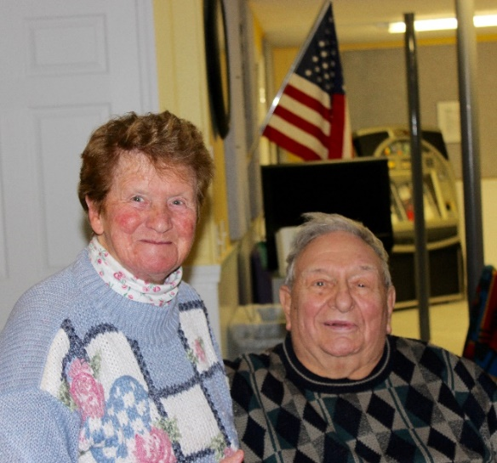

Sister Regina and Pietro Photo by CP
At the bar Photo by Cat Pragoff

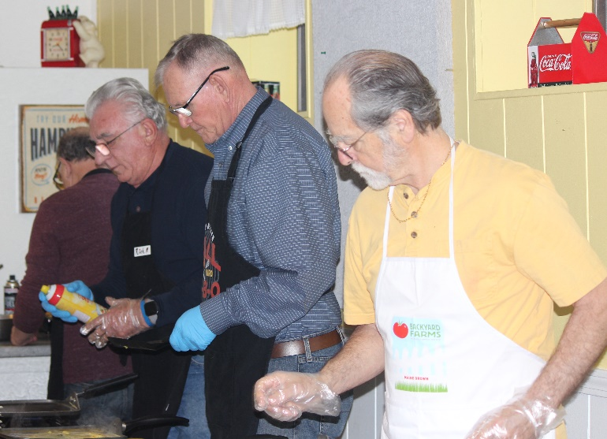
Patiently in line Photo by Cat Pragoff

Despite the postponement, we had 42 attendees. Deb Lodge won the 50/50 and JoAnne Kelley won the raffle for a free breakfast.

On February 8 we had another wonderful Omelet Breakfast, with more scheduled for later in the year. The choose-your-fillings omelet bar as always was a big hit, with choices that include diced ham, onions, tomato, peppers, mushrooms, spinach, and cheese, along with baked beans, hash browns, sausages, bacon, and our ever-present coffee and decaf.

Bartender Jim served Mimosas and Bloody Marys (with shrimp!!!). Fred Plett won the 50/50 raffle and Pauline Bouchard won the free breakfast drawing. Congratulations to all our winners!

On March 7, please join us for the Eggs Etc. Breakfast from 8:30 to 10 at DDC. This is your chance to have eggs your way: scrambled, sunny-side-up, or over easy, along with tasty sides like hash browns, fruit salad, sausages, bacon and beans. Only $7 for adults and $3.50 for kids. On Wednesday, March 18 at PLC, Sheryl Faye will once again share her talents with us, this time bringing Anne Frank to Medvil; and on Saturday, March 28, we'll be holding another Meat Bingo afternoon. Please check the mail houses for more information on these upcoming events, and make sure to sign up in the Volunteer Office for both the breakfast and Sheryl Faye's performance, so that we have a correct head count.

That's it for now. Don't be a stranger! CP
Chef Kim and his crew Photo by Cat Pragoff
Helping hands Pauline and Rita Photo by CP
The busy omelet bar Photo by Cat Pragoff

FUNDRAISING COMMITTEE
Contact Irene Gagne at 622-1869.

Fundraising Pool

The 2/1 winner was Dale Rheaume for $250. All numbers are being played with a guaranteed winner. There are currently no residents on the wait list. Please call the office at 497-4440, Option “0” to place your name on the list. It’s only $5/month and you can play more than one number.

Consignment Store/Yard Sale

If you have items to donate please contact Irene. What doesn’t get accepted by the consignment stores or sold on Ebay will be placed in the 4/4/20 yard sale. However, we do not take electronics, TV’s, large appliances, furniture, or exercise equipment. Please do not place any items in the mail houses.

Yard Sale

Our yard sale on 4/4 is fast approaching. Please call Irene if you have items to donate or if you wish to volunteer to set up, sell, or pack and/or clean up.

Committee Members

We are a committee of 9. We are looking for more members with fresh ideas and help with yard sales.

Ideas Needed

However, you don’t have to be a committee member to give us suggestions for projects to use our funds for the benefit of the Medvil community – call Irene with suggestions, including cost. IG

REAL ESTATE COMMITTEE

During the month of February 2020, the Real Estate Committee had 7 showings, 2 listings, 0 under contract, and 0 closings.

There are people driving through our community and stopping into the office asking to see our homes for sale. We are always available to show them our listings. We also get website and phone inquiries requesting information about Medvil Cooperative living. Medvil is a sought-after community.

If you are thinking of selling your home, the first
step is to fill out the Intent to Sell form and return it to the office. The second step is to locate a realtor. Please consider Medvil Real Estate to help you sell your home. Sales benefit Medvil community.

Medvil RE Committee - 497-4440 Prompt 2
Website: www.medvilcooperative.com Homes for Sale

Dorrie Kossuth, Chairperson

SINCERE CONDOLENCES

Heartfelt condolences to those who have recently lost a loved one:
- Anita and Michael O’Brien in the loss of Anita’s Mother
- Beverly Perry in the loss of her father
- Bill Bigg in the loss of his mother
- Rachael Hogan in the loss of her mother

We meet them in the lives they’ve shaped. We enjoy them in the jokes and wisdom they’ve passed down. Be active in the community they’ve built. It is a way of walking with them into the future. It is a way of never losing them.

Linda Robinson, Sunshine Lady
(603)851-5209
GOOD STUFF WE FIND
SKY WATCH – March 2020
What is happening in the night sky this month? Set your sights on the eastern sky just before dawn. Superior planets Mars, Jupiter, and Saturn bunch together in a line starting on the 17th. The waning crescent Moon joins this group on the 18th, just below the planets, with dim orange Mars on the right, brilliant Jupiter in the middle, and medium-bright Saturn farther left. This is a don’t-miss conjunction, with the four celestial bodies standing 17 degrees high 40 minutes before local sunrise, easily seen with the naked eye. The three planets, minus the Moon, again form a nice grouping from the 28th to the 31st, with Jupiter on the right and Saturn on the left. The vernal equinox – the earliest in 124 years – falls on the 19th at 11:50 pm EDT.

In March, the full Moon was traditionally called the Full Worm Moon by Native Americans who used lunar phases to track the seasons. Colonial Americans also used these names, especially those of the local Algonquin tribes who lived between New England and Lake Superior.

There are many alternative names for the March Moon, depending on the Native American tribe and region. One alternative name is the Full Sap Moon, as this is the time of year when the sap of sugar maples starts to flow.

At the time of this Moon, the ground begins to soften enough for earthworm casts to reappear, inviting the return of robins and migrating birds, a true sign of spring. Roots begin to push their way up through the soil, and the Earth experiences a rebirth as it awakens from its winter slumber.

With thanks to The Old Farmer’s Almanac Astronomy and Astrology Almanac
The Medvil Messenger encourages members to submit articles for consideration. Recipes, helpful hints, reminiscences, jokes, poems--please keep it upbeat and positive. Due to space considerations, original material will take precedence over reprints from other sources, including printouts of email pass-arounds. If you submit previously published material, please try to cite a source. We reserve the right to reject material that may offend, divide our community or cause political arguments. Please submit your items to our email: medvilnewsletter@comcast.net Or place a copy in the Messenger mailbox in the Reception Office in the DDC.

Deadline for submissions not from the Board is noon the day of the Board Meeting (3rd Tuesdays.) Board submissions deadline is noon of the Wednesday.

Medvil Messenger Staff: Debbie Cyr, and MB. Wulf

Medvil Messenger Writers this issue: Debbie Cyr, Irene Gagne, Alyn Miller, Cat Pragoff, Linda Robinson

Special thanks to Irene Gagne for additional proofreading.

