NOTICES

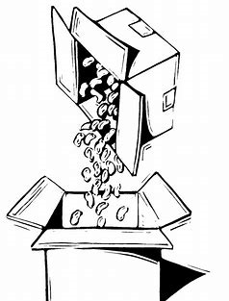
NO PACKING “PEANUTS” NEEDED

The Fundraising Committee has received enough packing peanuts. We will request more when needed.

Thank you.
IG

THE HANNAFORD’S PHARMACIST. . .

. . . is offering to set up another date to have various vaccines: Shingles, Pneumonia, Tetanus, Diphtheria & Pertussis (TDaP), Hepatitis A or B, and Hepatitis A & B combination.

Please contact Irene Gagne at 622-1869 if you have any interest in any of these vaccines. Once we see if there is enough interest, we will schedule a date and time, and get the necessary forms to those who are interested.
IG
NEWSFLASH!!! CHRISTMAS COMES EARLY TO ONE MEDVIL RESIDENT

I have been showered with gifts throughout November – even before Thanksgiving!

I received a cancer diagnosis in late October and many Medvil friends & neighbors have come to my rescue! Here’s a list of some of the great gifts I have received over the past month:
- Providing rides to doctors’ appointments and the grocery store.
- Bringing over a few Medvil Omelet Breakfasts, cooking homemade soups and stews, baking banana bread and cookies and even sneaking in my favorites, Three Musketeers candy bars and Tate’s chocolate chip cookies! (Boy, have I been spoiled!)
- Taking my barrels out for Wednesday morning trash and recycling; and then having the ‘barrel elf’ put them back under my carport!
- Coming over for periodic visits, making me feel ‘connected’ when I didn’t have wheels to go places.
- Giving me a challenge playing one of my favorite games, Scrabble!
- Putting my driveway markers out across my yard.
- Snow blowing and/or shoveling my driveway and ramp.
- Picking me up for my Medvil Ukes practices.
- Bringing my Christmas tree and totes into the house from my shed.
- Saying many prayers for me (that’s why I’m doing so well!)
- Sending get well cards my way. . .
. . . and I may have even forgotten a thing or two, but isn’t this a wonderful list of the efforts of Marge and Richard Ball, Sisi Johanssen, Cat Pragoff, Tony Roy and Susan Smith? (in alphabetical order, sans favoritism). These folks make me glad I’m part of such a wonderful and caring community! Hats off to them (and anyone I may have forgotten too.)

THANKS TO ALL OF YOU!

Humbly blessed and doing quite well,
Eveleen Barcomb
BOARD & COMMITTEE REPORTS

BOARD OF DIRECTORS
The last board meeting of the year was held on 17 December 2019 and started at 6:01 with the Pledge of Allegiance.
Members Comments consisted of the suggestion that the new Rachael Circle street sign be spelled correctly. The board promised to take that into consideration. As an aside, the board revealed that the street is named after Medford Farm's developer's granddaughter.
The Treasurer's Report for November gave our Debt Ration at 1.30, with income higher than budgeted and expenses lower than budgeted. 2019 expenses were reviewed for accuracy in classification, and some were corrected. Large expenses were all properly coded. A motion was made to move Fundraising's surplus to an account that would allow them to retain their surplus into 2020. The motion passed.
The new administrative assistant did not work out and Medvil is again seeking a new one.
The Secretary's report had November's board meeting minutes accepted without changes by the board.
The Operations report started with the board's ratification of their email vote to allow a shed improvement.
Rather than a general email blast, people affected by the next round of tree cutting will be individually notified. Pedestal quotes have been solicited from Brian Williams. Also, the security cameras are up and running and no wrongdoing has been discovered.
It has been determined that our head of maintenance is not required to take a water certification course. He will be taking a shorter course on maintaining our water hydrants.
We plan to use Eversource to install a pole and light on Constitution Way for safety. A quote will be obtained.
The town will be approached for required specs on new salt sheds, and the board will look into new paving in the area to support delivery trucks.
Eversource will be consulted about accessing underground energy issues as a result of a recent event on Donald Drive which took longer to repair than necessary.
A motion was made to order individual signs for for Rachael Circle and Roger Road, motion carried.
There was a recent flooding event on Brandon Road. The Operations Director thinks we may be able to run the water to the river. The various required government approvals will be investigated.
New heat tape installation is under consideration for Donald Drive Clubhouse.
Operations requested guidance on requests to plow the ends of individual driveway. The board agrees that "No" is the proper answer. It is the responsibility of the homeowner to clear their driveways and walkways.
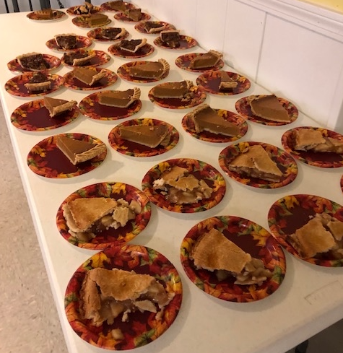
The Membership committee asked for and received ratification votes for new members.
The Events Committee reminds us that there is a Christmas Luncheon on Dec. 22, though the registration period may be closed. Also, an a cappella music event was being held on the evening of the 18th at the PLC.
Membership has only one more Real Estate closing for 2019.
In Old Business the board discussed quotes for bathroom cleaning in the two clubhouses, and voted to hire one of them.
In New Business, the new member approval process was described in some detail to bring the new board members up to speed.
Reception Office volunteers asked for two and a half days off for the winter holidays, and the board granted their request.
Recycle bins in the club houses will be retrofitted as trash containers.
The Comfort Center closet contents were discussed as was administration of the closet's key.
A short discussion was had on the problem of black bears and bird feeders. Recommendations on bird feeding will be posted at the mail houses.
Motion to adjourn the meeting for Executive Session passed unanimously at 7:20 PM.
Alyn Miller reporting
EVENTS COMMITTEE

There was a nice turn-out for Thanksgiving, with about 40 folks attending. We also made five home deliveries, and had lots of leftovers for take-away, so everyone went home happy. Thanks to all who donated (there were many, many pies!) and volunteered. The spirit of Medvil was very much in evidence and we all had much for which to be thankful, especially our neighbors.
Diane Lamarre photo

Diane Lamarre photo

The Christmas Party on December 7 at the Derryfield Country Club was a big success! Over 100 people attended on a clear, sunny, but definitely very cold, day. The room was beautifully decorated. Summer the DJ was again on hand to play a wide variety of tunes that got many toes tapping, including a few you wouldn't usually expect.

Since we had such nice feedback on the party, we reserved the room and asked Summer back for next year's Medvil Christmas Party. Watch this space for all the particulars as we get closer to the date.

The Northern Voices a Cappella Concert on December 18th was a delight! This Manchester-based chapter of the nationally known Sweet Adelines presented an evening of three- and four-part harmony for both humorous and serious
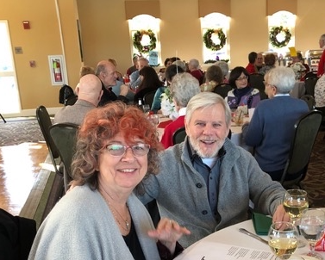
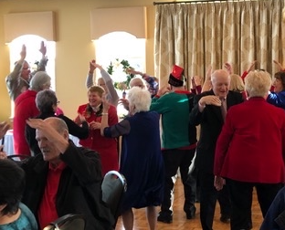
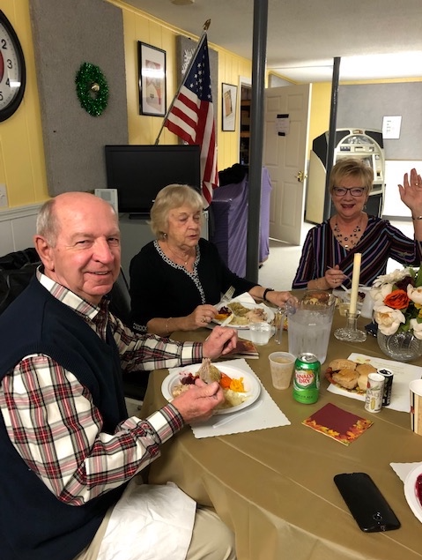
Diane Lamarre photo

Diane Lamarre photo

Christmas music with a twist, and included the audience in a sing-along as well!

Our next event will be courtesy of Allen Brown of Brown Excavating—the Holiday Luncheon on the Sunday before Christmas.

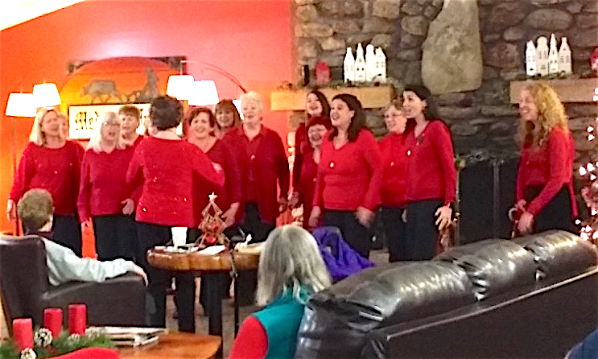

Cat Pragoff photo

On Friday, January 10, we'll have another of Kim's wonderful Baked Stuffed Haddock dinners. There will be two seatings (4:30 and 6 pm) so be sure to sign up at the office for your preferred time. Later that month, on Wednesday, January 22, it will be time for our Soup & Chowder evening, so check the mailhouses for more information coming soon. Until next time, Happy Hanukkah, Merry Christmas, and Happy New Year to you and yours!
CP

FUNDRAISING COMMITTEE

Contact Irene Gagne at 622-1869

Fundraising Pool

The 12/1 winner was Denise Menczywor for $250. All numbers are being played with a guaranteed winner. There are currently 5 residents on the wait list but more are needed.

Please call the office at 497-4440, Option “0” to place your name on the list. It’s only $5/month and you can play more than one number.

Consignment Store/Yard Sale
If you have items to donate please contact Irene. What doesn’t get accepted by the consignment stores or sold on Ebay will be placed in the 4/4/20 yard sale. However, we do not take electronics, TV’s, large appliances, furniture, or exercise equipment. Please do not place any items in the mail houses.

Committee Members

We are a committee of 9. We are looking for more members with fresh ideas and help with yard sales.

Ideas Needed

You don’t have to be a committee member to give us suggestions for projects to use our funds for the benefit of the Medvil community – call Irene with suggestions, including cost. IG
Partial List of Items Purchased by the Fundraising Committee over the Years, to Date:

PLC Downstairs:
- automated external defibrillator (AED)
- stove
- 72 chairs with rack
- 12 - 8’ & 8 - 6’ tables with dolly trucks
- 6 bar stools
- television
- 2 pool table repairs
- 2 large trash cans
- hot dog steamer

PLC Upstairs:

- automated external defibrillator (AED)
- 6 swivel chairs
- portion of lighting
- 2 medium trash cans
- card tables & chairs
- 10’ Christmas tree

DDC Outside:
- canopy & sign

DDC Downstairs:
- automated external defibrillator (AED)
- stove
- flooring
- counter top & double sink

DDC Upstairs:
- automated external defibrillator (AED)
- television
- 2 medium trash cans
- 6 vertical blinds for conference & supply rooms
- storage cabinets for supply room
- conference room sound system
- 10’ Christmas tree

Pavillion:

- water fountain & accessories
- kegerator
- 3 fryers & 4 tanks
- DDC shed roof
- 8-burner grill with 2 large gas tanks
- 2 sets of grilling utensils
- 6 picnic tables

Other:

- 3 entrance signs & est. 2006 add-on
- 10 Years of Community Living Medvil brochures (250 x 3)
- Medvil key chains (500 x 3)
- Medvil pens (500)
- newsletter colored printing – 100th issue
- park bench & walk – common area

REAL ESTATE COMMITTEE

During the month of December, we had 1 closing.

Medvil Real Estate had a successful 2019 with a total of 41 listings and 39 closings.

We wish everyone a Happy and Healthy New Year!! DK

There are people driving through our community and stopping into the office asking to see our homes for sale. We are always available to show them our listings. We also get website and phone inquiries requesting information about Medvil Cooperative living. Medvil is a sought-after community.

If you are thinking of selling your home, the first
step is to fill out the Intent to Sell form and return it to the office. The second step is to locate a realtor. Please consider Medvil Real Estate to help you sell your home. Sales benefit Medvil community.

Medvil RE Committee - 497-4440 Prompt 2
Website: www.medvilcooperative.com Homes for Sale

Dorrie Kossuth, Chairperson

SINCERE CONDOLENCES

Heartfelt condolences to those who have recently lost a loved one:

- the family of Viola Meighan.
- Mary Wojdylak in the loss of her husband James.
We meet them in the lives they’ve shaped. We enjoy them in the jokes and wisdom they’ve passed down. Be active in the community they’ve built. It is a way of walking with them into the future. It is a way of never losing them.

Linda Robinson, Sunshine Lady
(603)851-5209
An occasional, recurring feature reprinted from from the October 2019 issue of HGTV Magazine.
WHY DOES MY PET DO THAT?
WHY DOES MY DOG BARK AT THE VACUUM?

They probably see it as a threat and are barking to scare it off. Help your pup get more comfortable through counterconditioning – as in, give them a treat whenever they see the machine, so they learn to associate it with something good. Gradually get your dog closer to the vacuum by rewarding them with goodies when they approach, working in short sessions and paying attention to their response. If you’re right near the vacuum and your dog’s too scared to take the treat, go back to the distance they were able to handle so you can end on a positive note, then try again another time.
MEMBERS’ MISCELLANY

HOLIDAYS WITH TEACHER

By Karolina Nolan

Merry Christmas and Happy Hanukkah!

I taught in a large central school system nestled among the Adirondack Mountains. I taught third, fourth, and fifth grades for 33 years. The most memorable times were usually during the Christmas season. I designed an entire unit called Christmas Around the World. There was a holiday shop for teachers, which sold workbooks which could be copied, so I purchased three of them. They all featured a story of Christmas and Hanukkah around the world and also had an art activity following the story. They were all geared for third through fifth grade, and so interesting and fun. I also purchased white sweatshirts for all the kids, visited the hardware store for 3-inch and 1-inch dowels, green and red paint and glitter tube paint. The students painted green circles in the shape of a Christmas tree, with 1-inch red balls, and a glitter star. They were going to be worn for our senior housing carol singing.

Every afternoon, starting after Thanksgiving, we devoted at least an hour or more for our "social studies" Christmas unit. We read our stories, did our art, practiced carols, had parents bring their Christmas or Hanukkah sweet treats, made mobiles, watched Prancer and Polar Express, all of us with happy smiles on our faces. . .and at times, a few tears. Granted, they were mostly mine.

One afternoon we did not have time to make the paper menorah after we read about Hanukkah. The next morning, one of my students raised his hand and asked if we were making the "manure" that day. A good start to the day, so I wrote the word ‘menorah’ on the board and explained the difference. That afternoon we quickly practiced our carols because the principal told me we could go caroling through our halls as a practice session for our little trip, and to give the children in classrooms a chance to get a little Christmas spirit. That afternoon we put on our sweatshirts and slowly meandered down the kindergarten through third grade hallway. With gusto, we sang, “We wish you a Merry Christmas, we wish you. . .” and all of a sudden, I heard a very loud voice singing, "and bring us some freaking pudding, and bring us some freaking pudding. . .” Now, one must realize that this was not the first time we had sung this song--practiced it for weeks! I had explained what figgy pudding was. I think my pronunciation of words may have needed a little clarification! Menorah and Figgy. The two boys who misinterpreted the words are now in their late thirties. I wonder if they smile when they think of it, or if they even remember such cute mistakes. I remember, and I remember crying all through Prancer and at the end of The Polar Express. I showed Prancer to my college student teachers when I taught at the college, and to my inmates when I taught at the Correction Facility. There was rarely a dry eye.

I hope everyone experiences or has experienced wonderful memories during the holiday season. May everyone's New Year be healthy and bright!

The Medvil Messenger encourages members to submit articles for consideration. Recipes, helpful hints, reminiscences, jokes, poems--please keep it upbeat and positive. Due to space considerations, original material will take precedence over reprints from other sources, including printouts of email pass-arounds. If you submit previously published material, please try to cite a source. We reserve the right to reject material that may offend, divide our community or cause political arguments. Please submit your items to our email: medvilnewsletter@comcast.net Or place a copy in the Messenger mailbox in the Reception Office in the DDC.

Deadline for submissions not from the Board is noon the day of the Board Meeting (3rd Tuesdays.) Board submissions deadline is noon of the Wednesday.

Medvil Messenger Staff: Debbie Cyr, and MB. Wulf

Medvil Messenger Writers this issue: Debbie Cyr, Eveleen Barcomb, Irene Gagne, Alyn Miller, Karolina Nolan, Cat Pragoff, Linda Robinson

Special thanks to Irene Gagne for additional proofreading.

