Good News

We praise YaHuWaH Elohim that Pastor Kent Hovind has been released from prison. He was imprisoned for over 8 1/2 years for withdrawing his own money from his own bank account. Be aware that in the United States your bank is required by the government to report to the government any activity which the bank feels is not normal, such as regular withdrawals of thousands of dollars in cash month after month. Pastor Hovind was placed in 24/7 solitary confinement for the last 30 days of his incarceration.
Info here: http://www.newswithviews.com/Daubenmire/dave427.htm

Pastor Hovind might have been prison for the rest of his life except for a juror who was aware of this information concerning Jury Nullification that the judge wouldn't allow to be mentioned in court proceedings: http://www.truth-out.org/opinion/item/23929-jury-nullification-why-every-american-needs-to-learn-this-taboo-verdict If you're on a jury and you feel that a law is being used as a weapon against an innocent person, you can deliver the innocent one from the hands of the wicked. Please pass this info along. It might be useful to you in the future, considering the state of this current "on its' way to completely insane" society.

Death, Woe, and Destruction

Here's a graphic similar to one I sent previously that illustrates some similarities between the Hebrew calendars in the 1st and 7th months and this current Roman calendar 7th month of July.

As indicated in the graphic below, in a few days we arrive at the culmination of events involving Pluto, the Moon, Jupiter, Eclipse Sequences, Atomic Energy, Islam,and end times Babylon the Great. Add to this the current nuclear negotiations between the US and Iran.

Also at this present time, the eyes of the world are on the US-Iran nuclear negotiation talks in Vienna.

Remember that ancient Babylon was conquered in one night by King Cyrus the Persian. The name "Cyrus" means "like the sun", the description of an exploding nuclear device. The ancient Persia of King Cyrus is now modern day Iran, and modern Babylon the Great is currently being set up for destruction by the descendants of ancient Persia using a weapon that is "like the sun". Bible prophecy tells us that modern Babylon the Great will be destroyed by fire in one hour.

If an agreement is reached between the United States and Iran next week, we can add that information to the timeline below. It would be fitting and ominous if that agreement were reached in the next week or so.

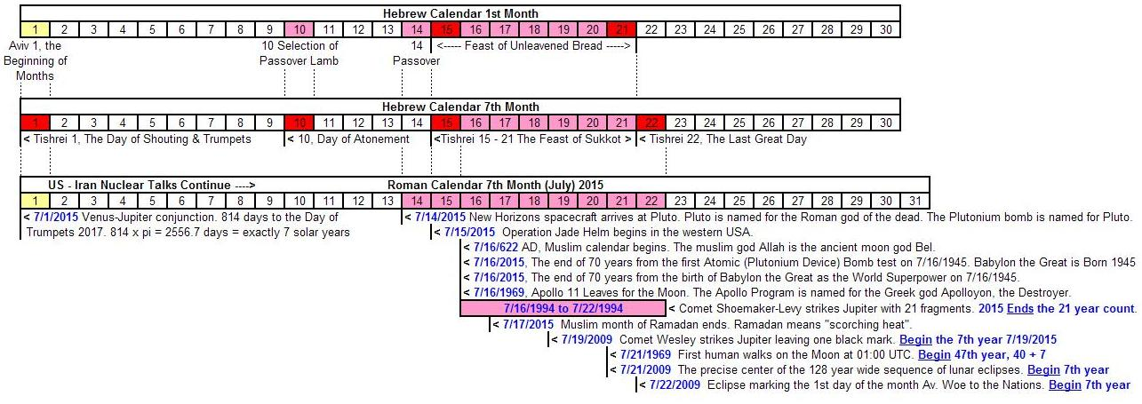

In a few days NASA will have its' closest look at the planet Pluto as the New Horizons spacecraft approaches on July 14 . The planet Pluto is named after the Roman god of the dead. Pluto's largest moon Charon is named after the Greek demon that ferried people to the underworld. This sets the mood for what's coming.

Two days later July 16 marks the 70th anniversary of the successful test of the first atomic device, which was a plutonium device. Of the two devices dropped on Japan, one was a uranium device, the other was plutonium. The Trinity Test in Nevada marked the birth of Babylon the Great as the World Superpower. Babylon the Great is also reaching maturity at 70 years of age on July 16.

The 70 year age of modern Babylon the Great protecting (or forcing it's will upon) modern Israel (1948 - 2018?) may somehow correspond to the 70 years that ancient Babylon nurtured and oppressed ancient Israel, etc., until the Handwriting on the Wall (Wall Street?) in 539 BC and the return to Jerusalem around 536 BC.

Back in 2009 I examined all the lunar eclipse tetrads and triads from about 300 years in the past to about 300 years in the future. The tetrads and triads were random until the year 1910 when coherence appears and the lunar eclipse sequences became symmetrical and regular, just like the clockwork of Morse code (I'm a ham radio operator). Coherence does not arise out of chaos without the intervention of an intelligent Being! That's the whole premise of the SETI search for extraterrestrial intelligence. They watch for coherent radio signals, and have found none yet. But there is a coherence that has been placed into the orbital parameters of the earth-moon system at this particular time in history.

Here's a link to an Xcel file of the 128 year wide eclipse sequence mentioned at 7/21/2009 above: http://www.joybysurprise.com/uploads/Chiastic_Structure.xls

Here's a link that reveals the menorah structure of that 128 year wide eclipse sequence: http://www.joybysurprise.com/uploads/Menorah_Structure.xls
Messiah's Name

Again, calling upon YAHUSHUA Messiah for salvation and repentance from sin will result in our salvation from the coming destruction. There's a reason that the name of Moses' helper Joshua (pronounced Yehoshua in Hebrew) was changed from Oshea to Yehoshua (Joshua).

Numbers 13:16 These are the names of the men which Moses sent to spy out the land. And Moses called Oshea the son of Nun Jehoshua. (KJV)

Because modern translators use the Greek non-name Jesus in the New Testament, the link to Yehoshua, the one coming after Moses to lead YaHuWaH 's people into the promised land has been cut. Of course the translators use scholarly rules from Greek manuscripts, but they know the true spiritual typography that they have destroyed in their human authority. Moses was not allowed to enter the promised land on account of his own self-will concerning the botching of a spiritual type ordered by YaHuWaH .

Numbers 20:7 And YaHuWaH spake unto Moses, saying,
8 Take the rod, and gather thou the assembly together, thou, and Aaron thy brother, and speak ye unto the rock before their eyes; and it shall give forth his water, and thou shalt bring forth to them water out of the rock: so thou shalt give the congregation and their beasts drink.
9 And Moses took the rod from before YaHuWaH , as he commanded him.
10 And Moses and Aaron gathered the congregation together before the rock, and he said unto them, Hear now, ye rebels; must we fetch you water out of this rock?
11 And Moses lifted up his hand, and with his rod he smote the rock twice: and the water came out abundantly, and the congregation drank, and their beasts also.
The spiritual type that YaHuWaH wanted to convey to His people in Numbers 20 above is that we can speak to the Rock (YAHUSHUA the Messiah) and He will give us living (alive, flowing, spiritual) water. Messiah was struck once for our salvation, at His crucifixion. Now we're to speak to Him for our salvation. Call upon His Name and be saved. I was saved by calling upon the name of Jesus. But now I'll call Him by the Name the Angel, His parents, and His friends called Him.

If the name Yehoshua had been faithfully rendered from the Hebrew culture of 2000 years ago by the bible translators, many Jews would see the name as a sign, and perhaps be saved as a result. The name "Jesus" separates the Messiah from His real Name and hinders His recognition by His own people, Israel, as the Promised One like unto Moses who will lead them into the true promised land.

