Ogilby Rd is way out east off Hwy 8 almost to the Arizona border. Our club went out there on 2/4/17 to hunt for dumortierite, fossilized palm bog and jasper. We also found kyanite, dacite and epidote out there. Richard Mueller and Dave Rosendahl again took us right to where the cool rocks were hiding we everyone went home with happy buckets.
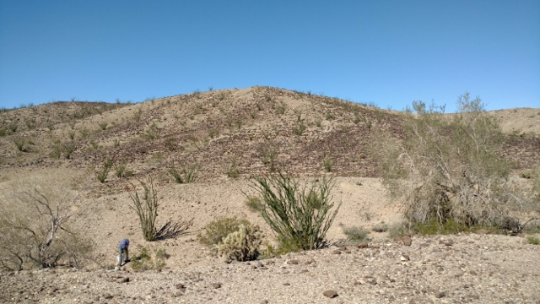Desert and rocks
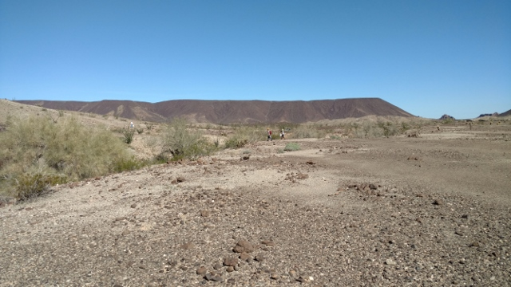More desert and rocks
It took us a little while to be able to distinguish between the regular volcanic rock in the area and the palm bog and dumortierite we were looking for, but it did not take long.
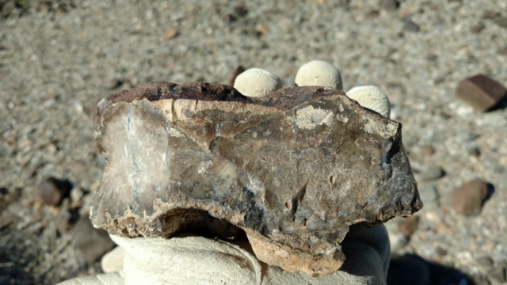Palm Bog
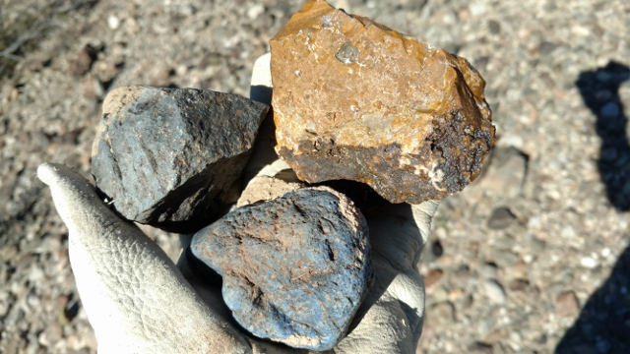Dumortierite and yellow jasper

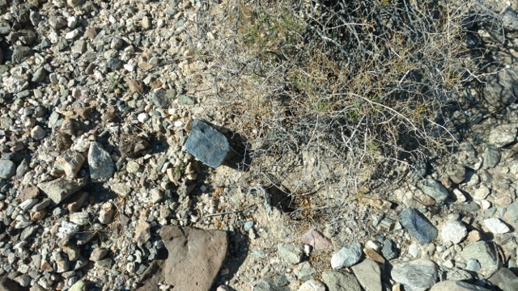Dumortierite and other rocks
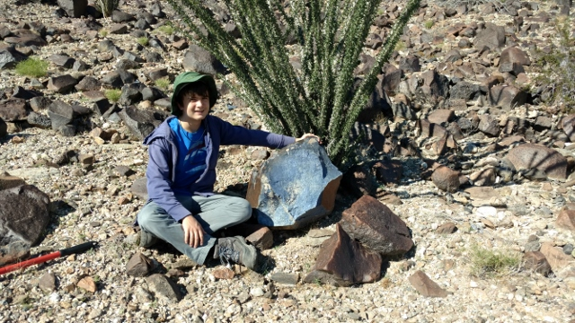The one that got away with Victor Norton
Victor Norton and I found a boulder of dumortierite 2/3 of the way up a rocky hill. I estimate it was about 350 lbs. People had been knocking chunks off of it exposing the nice denim blue color. Putting my back into it I could not make it move in the slightest. If only it was closer to where we could bring a vehicle and haul that puppy away. Another one of the “prizes” to find in this area is pieces of palm bog with snail shells in them. They can be in the surface or inside. At least three of us found them. Here are the best two.
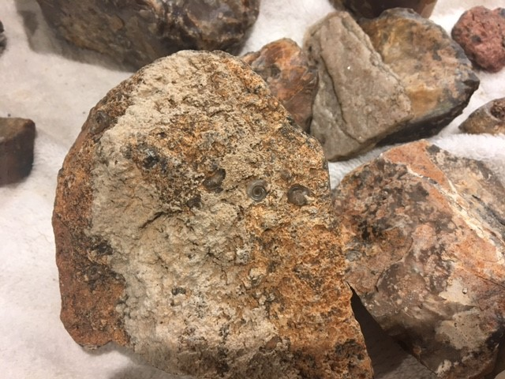Palm bog with snail shell (Nita Sani)
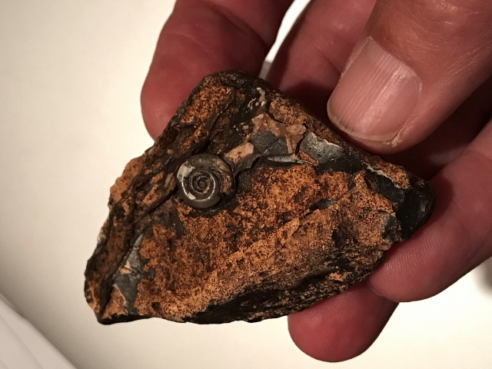Palm bog with snail shell (Brian Lorenz)
After we got home it is time to wash our treasures and see if the rock which looked so good in the field lives up to its promise. The yellow jasper has a nice yellow-gold color and the quartz areas remind me of stone canyon jasper, but not quite as brecciated.
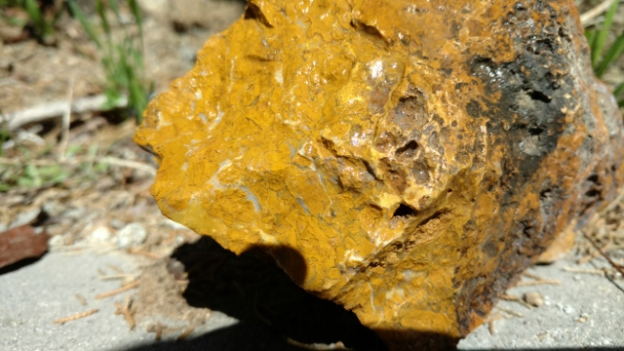Yellow jasper
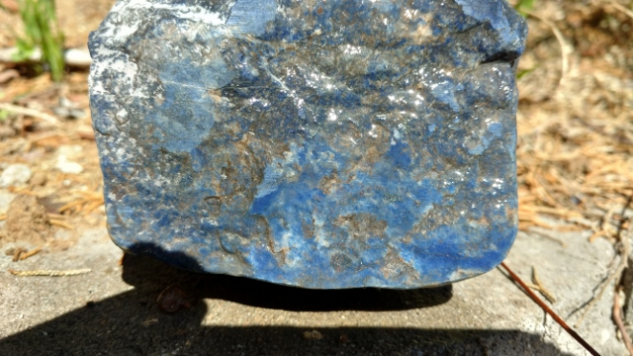Dumortierite (yummy denim blue)
The epidote is probably too soft to work, but if stabilized maybe I could make it work
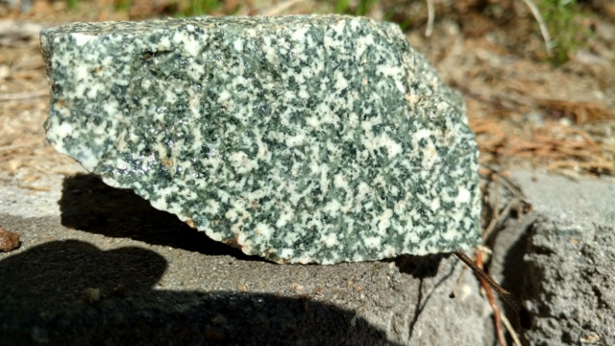Epidote in feldspar
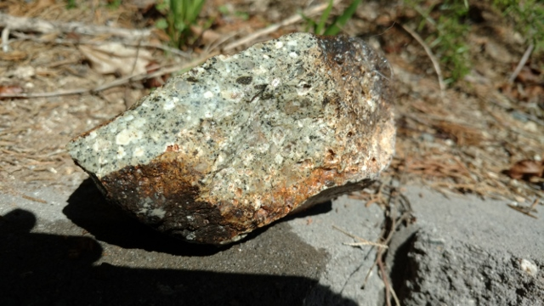Dacite
Dacite is a kind of lava that is a jumble of quartz, feldspar and other minerals. It reminds me of the Army’s digital camouflage. I used it for handles for a pocket knife and it sold fast.
Sometimes the dumortierite came with other minerals which made for neat contrasts and designs.
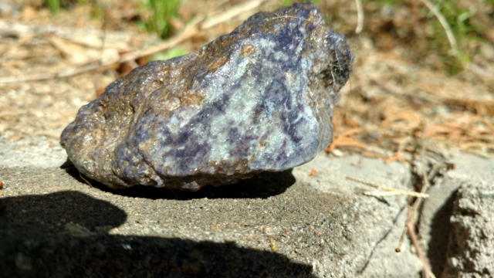Dumortierite with kyanite
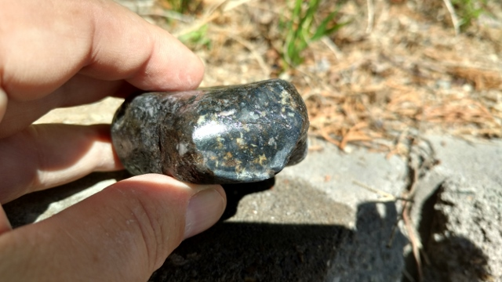Dumortierite with feldspar?
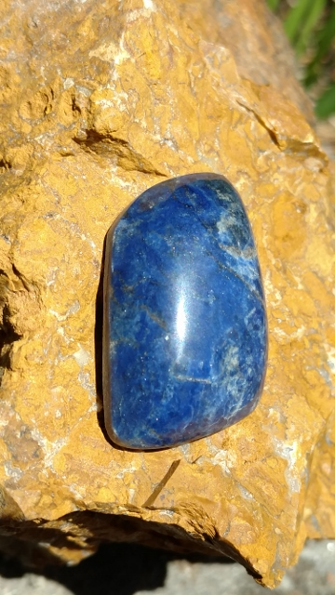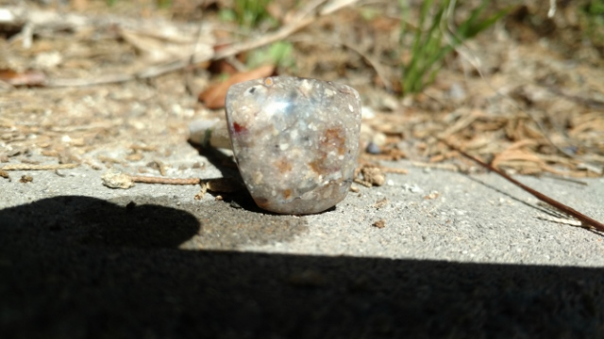Cabs of dumortierite and palm bog
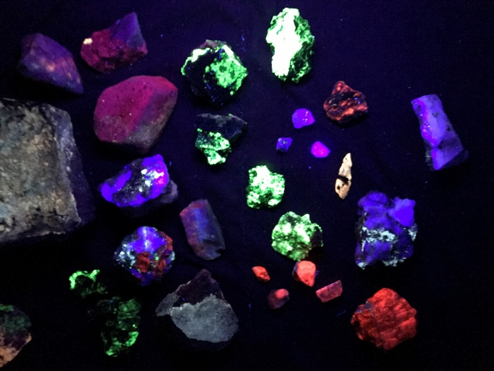Fluorescent specimens (Brian Lorenz)
After the official trip Brian Lorenz and his boys went to the Castle Dome Mine area and found fluorite, calcite, caliche and other minerals fluoresce under ultraviolet light. Gotta love the glow in the dark stuff. These minerals would make a cool display for the club to take around to the schools when we talk about rocks and geology.
I was able to round up most of the group for a photo. We even had a couple visitors from the Sierra Peloma rock club who invited us to come up to their travertine claim sometime. They are up by the towns of North Edwards and Kramer Junction, both of which have a number of good rock hounding areas. Thanks to everyone who sent me pictures to include in this trip report and made this trip a success.
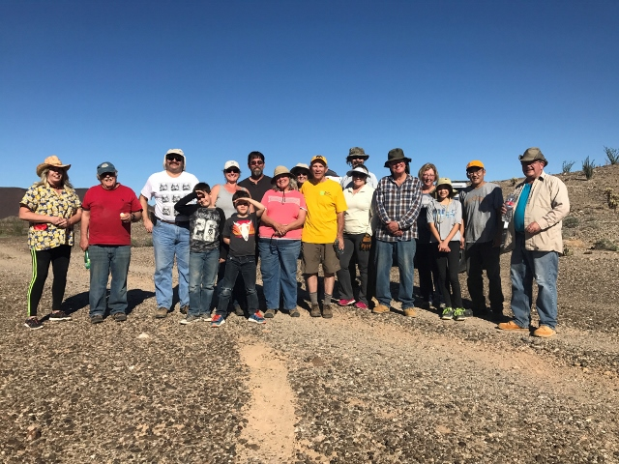Happy Rock Hounds with full buckets (Brian Lorenz)
The End

