INSSWA Spring Seminar
Supporting Cross-Cultural Kids (CCKs) in Our Schools
April 16, 2021
Facilitated by Ruth E. Van Reken
RDvanreken@aol.com
Panelists: Elizabeth Dunbar, Zikra Mostafa, Aiko Minematsu, Saeko Mizuta

In our changing world, issues common to educators and administrative staff working in ‘international schools’ have come to Indiana. Schools whose students generally used to share a common cultural background are now filled with those from many places and cultures. This growing reality brings new opportunities as well as new challenges—for local administration, support staff, educators, and students. With the help of our four panelists who are from different places and experiences, we explore what the story was like for them as they entered schools in the USA. In the end, we will consider how social workers might be best involved in helping students in similar circumstances find ways to maximize the gifts of their story and deal well with the challenges.

Introduction—How this topic of Cross-Cultural Kids (CCKs) began

Who are Third Culture Kids (TCKs)?

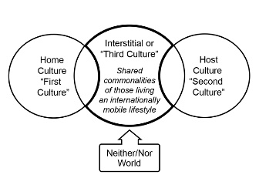
In the 1950’s a sociologist from Michigan State University, Ruth Useem, first noticed something ‘different’ about children of expatriates in India whose parents were there for international careers. They had come from a home or ‘first culture’ and were living in a host of ‘second culture’ but their way of life lived together with others in similar circumstances wasn’t exactly like where they had come from or how locals were living. But it was a subculture shared in this interstitial space.

Dr. Useem called those who grew up in this environment third culture kids. She defined them simply as
“Children who accompany their parents into another culture.” Likely in her day, it was assumed they moved due to a parent’s career but she did not state that.

As times have changed and more people have identified with the common characteristics of TCKs, it is helpful to more specifically define the cohort originally studied as:

“A traditional third culture kid (TCK) is a person who has spent a significant
part of his or her first eighteen years of life accompanying parents into a country
outside either/both parents' passport country(ies) due to the parent’s choice
of work or advanced training.” (Ruth E Van Reken, Michael V. Pollock, 2017)
This group would include military, foreign service, missionary, international business, and educators.

After hearing many ask me if they were TCKs because they related to the TCK characteristics, such as not being able to easily answer where they were from, or feeling they belonged everywhere and nowhere, but didn’t fit the exact definition, I became curious. Why did they relate? Could we find a way to compare and contrast the responses of children who grew up interacting with different cultural worlds from many different backgrounds?

In 2001 I tried a new model to see if we could make that happen. I wanted to make a larger model for all who grow up in some cross-cultural experience, not necessarily dependent on geography. I called them cross-cultural kids (CCKs) and included the traditional TCK experience as one way children can grow up cross-culturally, but not the only way.

The model below demonstrates some of the other ways children may grow up cross-culturally. There are countless other options we can add in the ‘other’ category, including foster children who change family cultures with each new placement. I defined a CCK as:

A cross-cultural kid (CCK) is a person who is living/has lived in—or meaningfully
interacted with—two or more cultural environments for a significant period of
time during the first eighteen years of life.
    - An Adult Cross-Cultural Kid (ACCK) is someone who grew up as a CCK.
      - Ruth E. Van Reken, co-author, Third Culture Kids: Growing Up Among Worlds, 2002
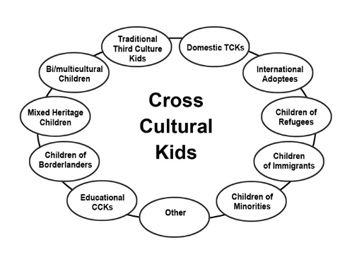
    - CCKs represent any and all nationalities/ ethnicities/economic groups

This group includes (but not exclusively):
- Traditional TCK—Children who move into another culture with parents due to a parent’s career choice
- Children of Bi/multi-cultural home—Children born to parents from at least two cultures. May or may not be bi-racial
- Children of Bi/multi-racial home—Children born to parents from at least two races. May or may not be bi-cultural
- Children of immigrants—Children whose parents have made a permanent move to a new country where they were not originally citizens
- Educational CCKs—Children who may remain in their home or passport country but are sent to a school (e.g. an international school, or local public school) with a different cultural base then the culture they return home to each night.
- Children of refugees—Children whose parents are living outside their original country or place due to unchosen circumstances such as war, violence, famine, other natural disasters
- Children of borderlanders—Children who cross national borders on regular basis
- International adoptees—Children adopted by parents from another country other than the one of that child’s birth
- Children of minorities—Children whose parents are from a racial or ethnic group which is not part of the majority race or ethnicity of the country in which they live.
- Domestic TCKs—Children whose parents have moved in or among various subcultures within that child’s home country.
  - Note: Children can be in more than one circle at a time

The fascinating thing was after initially making this model, it became apparent that many in today’s world are living very culturally complicated stories. They are not in just one circle. Some tell me they are in six or seven of these basic circles! What does that do to identity?!! And what does that do to social workers working with these children and trying to understand them?!

Why these global changes matter to you as school social workers
- These are the kids in your schools
- You are part of a discovery process:
  - How does growing up among many cultural worlds impact the developmental/educational/counseling process for a child?

Where we are
- How have global changes affected demographics in our schools?
  - As we said, How things used to be in local USA schools
    - Initially, most communities were ‘mono-cultural’
    - In the 1970’s school busing began to integrate schools and seeking to bring more equity to educational system
    - Most students, however, spoke same language and had same citizenship
      - Racial mixing mandated
      - Cultural mixing overlooked
  - How they are now
    - Multiple nationalities
    - Multiple 'mother tongues'
    - Diverse cultural and religious views and values

The cultural components of our schools populations can no longer be ignored.

Potential opportunities of a culturally complex school environment
- Chance to learn about the world first hand from people who have been there/done that
- Opportunity to understand our likeness as humans
  - 'emotions are the universal language'
- Preparing to live and work in a global environment
  - Learning about the differences as well

Challenges of unrecognized cultural complexities
- Difficulties with language
  - For those from English speaking countries
  - For those from non-English speaking countries
- Lack of availability for help with homework
  - Parents may not share assumed knowledge
- Parental interactions or support may be misunderstood
  - Difference in expectations of how teachers and parents relate
- Academic learning may suffer if student or parents don’t understand expectations of new school
- Gaps in knowledge due to differences between curriculum in different school systems
- The wealth of what they know through life itself is lost to the class
- Child can be placed in wrong grade
- May be misdiagnosed with learning disabilities
- Learning disabilities may be overlooked

The results if cultural complexities are recognized
- Students are affirmed
  - Don’t need to hide their core story
  - Don’t need to hide their core identity
  - They move on to value and use their experiences well throughout life
- Teachers can tap previously unrecognized resources of knowledge and experience among their students

How can school social workers help?

Help enlarge the concept of diversity
Traditionally, our diversity programs have not focused as much in the deeper levels of culture as surface. Dr. Gary Weaver, founder of Intercultural Management Institute of American University, Washington, DC, developed the iceberg model of culture several decades ago

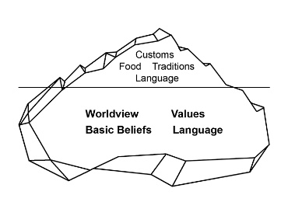
The basic thesis behind this model is that the elements on the surface, or visible, layer of culture traditionally have been used to identify what is in the deeper, or invisible, layer. Conversely, the visible is where the invisible is expressed. Thus, what we see becomes our shorthand method to make early assessments and expectations of others. Is this person an ‘us’ or a ‘them’? Will we relate from ‘likeness’ or ‘’difference’? When what we see externally is not who the person is within, we will have more confusion rather than less. Dr. Weaver’s point was that the Titanic didn’t sink because it hit the visible layer of the iceberg, but it was the unseen part that cause the disaster.

The challenge is that traditional D&I programs often focus more on the external or visible layer of culture then the hidden layer. While LGBTQ issues may be more in the deeper layer, race and gender are generally seen. While this is an important focus since racism often begins with how people look or don’t look, in our changing world it is not enough. Because cross-cultural kids grow up among many cultural rules, they can easily develop a ‘hidden cultural diversity’, a diversity of experience that shapes a person’s life and world view but is not readily apparent on the outside, unlike the usual diversity markers such as race, ethnicity, nationality, etc (Ruth E.Van Reken and Paulette Bethel, CIES, 2003) Take a look and see what I mean.

Diversity for Indiana Schools as defined by DOE
When we look at this chart, what do we see? Diversity is essentially defined by race alone. Presumably, it is the part we see of that person and often draw conclusions based on that reality.

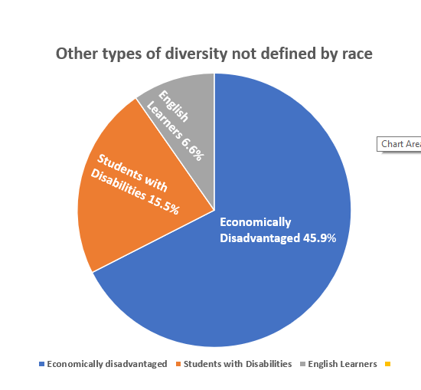
But think about it: How many ethnicities or cultural subgroups are embedded in each category? Could children in the White group be newly arrived from Europe and speak only Czech? Are those in the Black group first generation immigrant children from Liberia or have they grown up in Carmel, IN? Perhaps some in the Hispanic group are recent immigrants from Mexico who go home to a Spanish only environment while others have parents who are executives for one of the large international corporations in our state. Certainly among the Asian category, there are countless sub-groups. Some may have families who have lived in the USA for several generations while others have come via refugee camps in Thailand. And so it goes for the other communities listed here as well. We cannot make assumptions about each child based on these facts alone.

To the credit of Indiana DOE, they do list statistics on other types of diversity that are not race based: economic, disability, and language barriers are also types of diversities and can be present in any and all the groups listed in the first diagram. This is a good beginning in expanding our view of diversity.

The basic point is in today’s world we can never assume we know a person’s story by appearances alone. And that is also the exciting part! In order to work effectively with every student, or to help other educators and administrators do their job for the fullest benefit of each student, we must find ways to discover the student’s and the cultural nuances within them that we may not expect or previously know.
But how can that happen when everyone is already too busy and too stretched?

Where we need to go from here –
- Remember….Get started!!!
  - 'When you don’t know how to do everything, do the one thing that you can do. In the end you will be surprised with what has happened. Too many people never do anything because they don’t know how to do everything. '
    - Jill Briscoe to Ruth Van Reken, private conversation, 1980

So what are things we can do?
- We can begin by remembering that no matter which race or ethnicity they are, the K in CCK stands for 'Kid' – a human being who is…

  - Relational
  - Emotional
  - Intellectual
  - Creative
  - Volitional
  - Unified
  - Valuable
  - Spiritual
  - Physical

- What are the needs each human being has because of being made in these ways?
  - Meaningful relationships
    - A place to be understood
    - A place to belong
  - A place to express full range of emotions
  - A place to explore new ideas and thinking without shame
  - A way to create something new—physically, intellectually, or both
  - A place to make choices
  - A sense of significance
  - A way to develop strengths—to be successful
  - A safe, nurturing physical environment
  - Some understanding/explanation of the mysteries of life that are beyond our physical realm

Given these human needs, why is it that a cross-cultural move is hard for anyone of any culture?
- Cultural practices and responses are often a ‘short-hand’ method for meeting these needs!
- If you can see the child first as a person and begin to meet some of these needs and help others working with them to understand how to also help, you will allow them to have space for the learning process as well in a powerful way.

We must get to know their stories
- How are we going to hear the stories?
- How are we going to understand the stories?

How are we going to hear their stories?
- Admission form
- Writing assignments
- Art
- Drama
- Show and tell
- School fairs – any country/culture to which you feel connected
- Interviews with parents

How will we understand their stories…
- Listen for where they’ve been and gone to school, family patterns, etc
  - What kind of help do they have at home?
  - What other cultures are they adjusting to each night?

- Understand difference between educational systems or cultural expectations in areas e.g.
  - Overall educational model in different countries
  - Grading system
  - Methods of teaching
  - Homework expectations
  - Writing style/spelling
  - Emphasis on 'whole person' vs. primarily academics
  - Cultural role of the school
We can help them build on and with the gifts of their stories
- How do we help students (and parents and staff) ‘normalize’ and build with their story?

Help students discover and ‘normalize’ their story!
- Help them understand why questions of identity may be difficult
- Help them understand the process of transition and how it has perhaps impacted their lives and where they are now in that story.

Suggestions for how educators can use classroom assignments to ‘normalize’ the experience – for all!
- Show and tell
  - Draw a shield and a picture in each quarter that represents something about a place you have lived.
    - Have them explain their story to the class using their drawings
- Social studies, e.g.
  - Choose a place where you have lived and give a 5 minute report on the history, geography, and current events of that land
    - If you are no longer living there, how did it feel when you left? Was there anything you particularly missed or were, in fact, glad to be done with? (the both/and of moving!)
- Art
- Are there other ways to use curriculum to help students from all cultures affirm their background and story?

What are some of the gifts they have received and can build on with their story?
- Practical skills often acquired
    - Can be effective cultural bridge
    - Language skills
    - Observational skills
    - Thinking “outside the box”
    - Adaptability
    - Confidence
    - To start something new
    - To move and start again

- Practical/marketable values of the gifts
    - Broad world view/ 3-D view of the world
      - Political commentators
      - Writers
      - Foreign service
    - Understanding transition experience
      - Effective counselors in today’s globalizing world
    - Going into social sciences to help develop “new normals” for this time in history

Understand some possible differences between cultures
- ‘The myth of moral neutrality’ John Patrick, MD, bioethicist (we all have our bias and think we are ‘right’)
  - Time vs. relationship
  - What is “bullying” vs. “honor”?
  - Importance and style of greeting
  - To accuse or shame worse than the crime
  - How emotions are expressed
  - Protocol highly important
  - Queuing!
  - What is lying vs. being polite?
  - Academic expectations/teaching/learning styles
  - Causation for events
  - Left hand/right hand use

What you can do for educators/staff…
- Develop programs to make sure orientation for new teachers is strong in this topic
    - Original and on-going awareness of culture and CCK matters
    - How cross-cultural matters relate directly to educational process
      - Canadian teacher’s story – she couldn’t get her Japanese students to exchange their papers for writing critiques in the class as no one wanted to shame the other with ‘criticism’
      - When questioning the teacher is not allowed in one culture, how does that impact view of “silent” student in the next one?
- Planned mentoring with veteran teachers?

Helping parents…
- Parent orientation – group and individuals
  - Making sure they understand overall educational structure
  - Making sure they understand grading system

- Use translators for group meetings or school announcements when possible or needed
- Make sure parents of different cultural backgrounds are included in committees looking at various policies
- Use PTO to find mentors for new families
- Work with parent’s organization to develop regular session on transition/CCK matters for new parents
- Help new parents understand dynamics of this school compared to where they are from
  - Homework expectations – (student vs. parent driven!)
  - Grading system
  - Teaching styles/methods of teaching
  - Interactions between educators and parents
  - Cultural role of the school
Can you think of at least one personal “action plan” you might do that will start the ball rolling in any of these directions?

In general, learn about the push for transition programs in schools and see how that might be helpful to your schools. See Safe Passage by Doug Ota for a clear school wide transition program.

Wisdom from Isaac Njuguna, D. Min, Kenyan educator, ACCK

- Basic to education is the respect of each child as a human person. We cannot teach those whose humanity we denigrate.
- Second, we live in a multicultural/global village of nomads. Nurturing a sense of belonging and of a hospitable environment for children is an imperative for effective and meaningful education.
- Third, is the cultivation of a cultural humility and teachability and thus engendering a willingness to be taught by the children that we are teaching.
- Fourth, the development of a sense of belonging where each child's name feels safe in the teacher's mouth is crucial to all children and, particularly, to non-western children. That sense of safety in being named empowers the child to become a namer of his/her experiences, which is what education is all about, I think.

May you be leaders in the field of developing effective models for maximizing the gifts of a cross-cultural childhood and helping kids...and our world…deal well with the challenges

Enjoy the journey!
Contact information: Ruth E. Van Reken, www.crossculturalkid.org or RDvanreken@aol.com

Resource page
All available on Amazon or SummertimePublishing.com

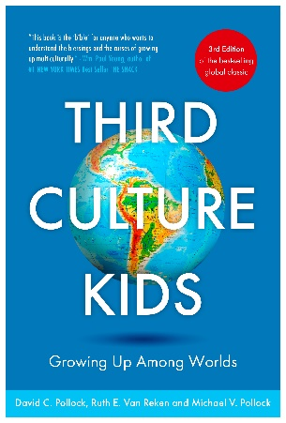
In this 3rd edition of the ground-breaking, global classic, Ruth E. Van Reken and Michael V. Pollock, son of the late original co-author, David C. Pollock have significantly updated what is widely recognized as The TCK Bible. Emphasis is on the modern TCK and addressing the impact of technology, cultural complexity, diversity & inclusion and transitions. Includes new advice for parents and others for how to support TCKs as they navigate work, relationships, social settings and their own personal development.
- A second PolVan Cultural Identity diagram on cultural identity
- New models for identity formation
- Updated explanation of unresolved grief
- New material on 'highly mobile communities' addressing the needs of people who stay put while a community around them moves rapidly
- Revamped Section III so readers can more easily find what is relevant to them as Adult TCKs, parents, counselors, employers, spouses, administrators, etc.
- New "stages and needs" tool that will help families and organizations identify and meet needs\
- Greater emphasis on tools for educators as they grapple with demographic shifts in the classroom
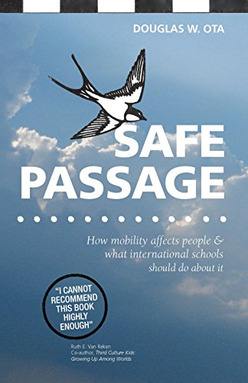

"Moving is one of life's greatest challenges. The largest study in educational research history demonstrates that moving harms learning. But moving not only challenges students. The experience of lost identity extends across the lifespan, also affecting parents and school staff. Firmly grounded in psychological theory and cutting-edge neuroscience, Safe Passage maps the challenges and charts a course for individuals, schools, and accrediting bodies to navigate them. Although primarily focusing on international schools, the hopeful message within this book reaches into any school, university, or organization where human beings come and go

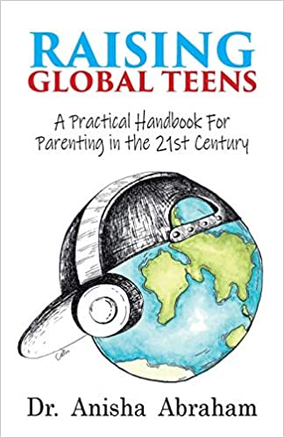
Globalization has given many of us unparalleled opportunities to work, travel, fall in love, and raise kids all over the world. But it has made being a teen more complicated than ever. Imagine having to discover your identity and place in the world when you keep having to move communities, your parents are from different backgrounds, you’re exposed to multiple cultures daily or faced with challenges such as global warming and pandemics. How can we help these teensbe happy, healthy, and resilient?Raising Global Teens explores the hot topics adolescents experience today: identity, social media, body image, traumatic events, puberty, drugs and stress all in the context of our modern, mobile world. In this easy-to-read handbook, Dr. Anisha combines real-world examples with practical solutions, drawing on the latest research, her own experience and that of the many cross-cultural teens she has worked with over the last 25 years. Raising Global Teens enables busy families, health providers, and educators apply powerful tools to help today’s adolescents thrive.

