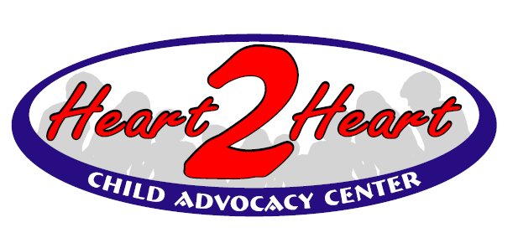

Heart to Heart Child Advocacy Center
Serving child abuse victims and non-offending family members in Harvey, McPherson, and Marion counties

702 N Main 400 E Kansas Ave
Newton KS 67114 McPherson KS 67460
316-804-4603 620-245-0048

Dear Parent/Caregiver:

Your feedback is vitally important to us in order to provide the best support possible to children and families through Heart to Heart Child Advocacy Center.

Please complete the enclosed survey and return it as soon as possible in the envelope provided.

If you prefer, you may also use the following link to complete the survey online:

https://nca.az1.qualtrics.com/jfe/form/SV_07BNXLmvOXCXCfz?RID=MLRP_6hTHTrk7ORrrK2F

No names are used and your answers are completely confidential.

If you have any questions or concerns, please contact Heart to Heart at
316-804-4603 or email h2h.director@gmail.com.

Thank you,

Heart to Heart CAC Staff

Enclosures

