Ferren Family Counseling LLC  895 S. Cooper Street, Suite 3  Memphis, TN 38104  (901) 498-9126 | 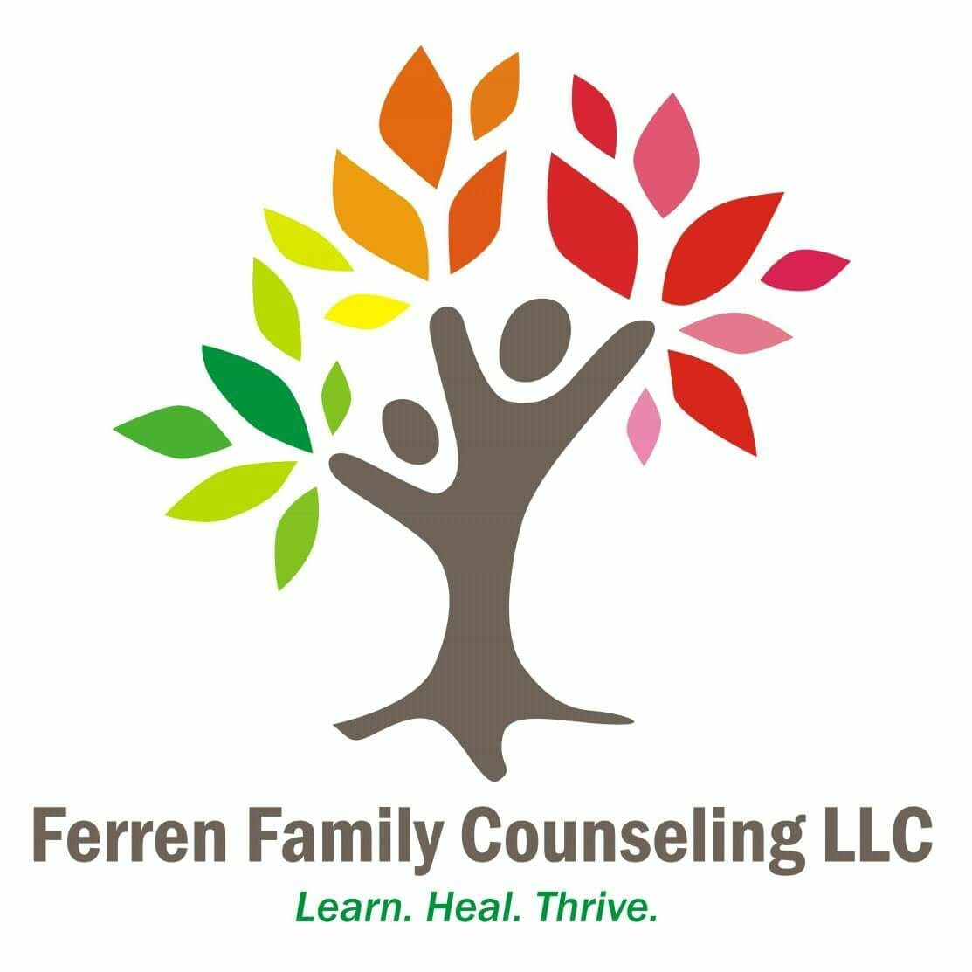
Ferren Family Counseling LLC requests your help. Please complete the following Client Satisfaction Survey, as we would like to continue to provide quality mental health services to our community. Thank you for your time.

Client Satisfaction Survey

I was treated considerately and respectfully by my counselor at Ferren Family Counseling LLC.
 | Not at all true |  | Somewhat true |  | Mostly true |  | True to a great extent

2. My counselor understood my problems and concerns.
 | Not at all true |  | Somewhat true |  | Mostly true |  | True to a great extent

3. My counselor and I worked well together.
 | Not at all true |  | Somewhat true |  | Mostly true |  | True to a great extent

4. I could have done more to make counseling more useful for me.
 | Not at all true |  | Somewhat true |  | Mostly true |  | True to a great extent

5. My counselor could have done more to make counseling more useful for me.
 | Not at all true |  | Somewhat true |  | Mostly true |  | True to a great extent

6. My concerns that brought me to Ferren Family Counseling LLC have improved as a result of the services provided.
 | Not at all true |  | Somewhat true |  | Mostly true |  | True to a great extent

7. What did you find most helpful about counseling?
_________________________________________________________________________________________
_________________________________________________________________________________________

8. What did you find least helpful about counseling?
_________________________________________________________________________________________
_________________________________________________________________________________________

9. If you could change anything about your counseling, what would it be?
_________________________________________________________________________________________
_________________________________________________________________________________________

10. How likely are you to recommend Ferren Family Counseling LLC to a close friend or other?
 | Not at all likely to recommend |  | Somewhat likely to recommend |  | Most likely to recommend |  | Would highly recommend

Any comments or questions:
_________________________________________________________________________________________
_________________________________________________________________________________________
Thank you very much for taking the time to complete this survey.
Your feedback is valued and very much appreciated!

