

SUMMER 2025
CLUB SINGLES CUP

18 Players took part this year on a beautiful evening.

Round 1 saw champion Andrew Bellamy lose to Jim Waddell 13 – 9 for a big shock in round 1.

Jean Stewart beat Brian Harris is another shock as two Premier League players lost but that was it with wins as expected for Geoffroy over Keith, Callum over Lorna, Ross over James Villalard, Toby over Daniel Villalard as well as Neil, Ross Churchill and Alan Oliveira.

Round 2 saw Geoffroy lose 12 – 10 to Brian and Ross Churchill just beat Ross Payne 13 – 12. With Toby beating Alan and Neil beating Jim.

Good wins for Branden, Lorna and Mo.

In round 3 Callum just beat Neil 11 – 10, with Ross Churchill beating Toby 13 – 10. A great come back for ross Payne against Brian, 10-0 down coming back to win 13 – 11.

A huge win for Jim 13 – 0 over Lorna with wins for Daniel and Tommy.

In the final Round of the Swiss qualifiers Callum Stewarts 13 – 12 win over ross Churchill put him in first place with Ross finishing second.

Toby win over Neil gave him third with Neil still qualifying with two wins with the highest BHN of 12!

Geoffroy beat Jean to finish sixth with Jean taking the last spot in eighth. Ross Payne 13 – 8 win over Andrew Bellamy put him fourth and ended Andrew run of finishing in the top 3 and the holder going out.

Despite wins for Brian, Alan and Tommy who all finished on two wins it wasn’t enough and James Villard 13 – 12 win over Keith White meant Keith finished bottom.

Swiss Rankings

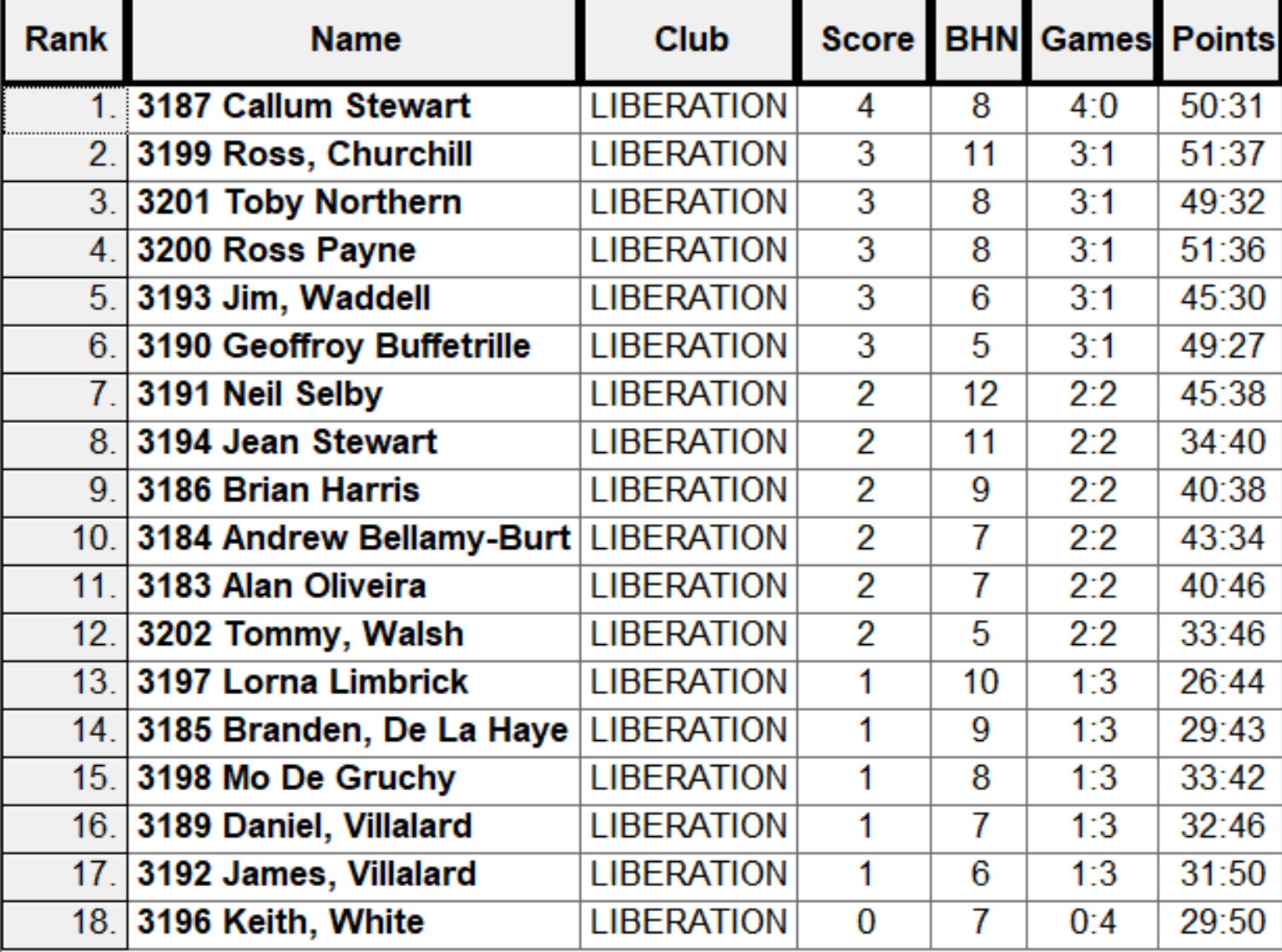

Quarter Finals

Ranked 1st Callum Stewart v Jean Stewart Ranked 8th

Ranked 2nd Ross Churchill v Neil Selby Ranked 7th

Ranked 3rd Toby Northern v Geoffroy Buffetrille Ranked 6th

Ranked 4th Ross Payne v Jim Waddell Ranked 5th

Despite having a big lead early on Callum won eventually 13 – 8 over Jean, the second win over Jean in the tournament.

Ross Churchill was on top form as he beat Neil 13 – 8 to make the semi finals. Whilst Ross Payne was too good for Jim who had a great tournament.

The last quarter final saw Geoffroy pull clear to lead 11 – 7 with two ends to go, but a decision not shoot gave Toby the chance to get three points and make it 11 – 10 and again Geoffroy decision not to shoot cost him the match with Toby pointing superbly to win 12 – 11 with a boule to spare.

Semi Finals

Ranked 1st Callum Stewart v Ross Payne Ranked 4th

Ranked 2nd Ross Churchill v Toby Northern Ranked 3rd

Toby blew a good lead at the start of his semi final against Ross Churchill who then lead 8 – 5 before Toby turned it around to gain revenge for his third round loss to Ross, winning by the same score. Callum continued his winning form to make the final winning 13 – 8 against Ross Payne.

In the Final Callum lead 4 – 1 before Toby made it 4 – 4, it was then alternate leads up to 8 – 8 and a bad end from Callum gave toby the opportunity for three points which he took. Credi though to Callum who placed and shot well to get it back to 11 – 11. A great point on the next end was out done by Toby who sat on the jack with Callum missing his shot placed another good boule. Toby though had two to play for the title but only needed one for an excellent finish to a great final.

Ross Payne took third place over ross Churchill.

2025 Winner

Toby Northern
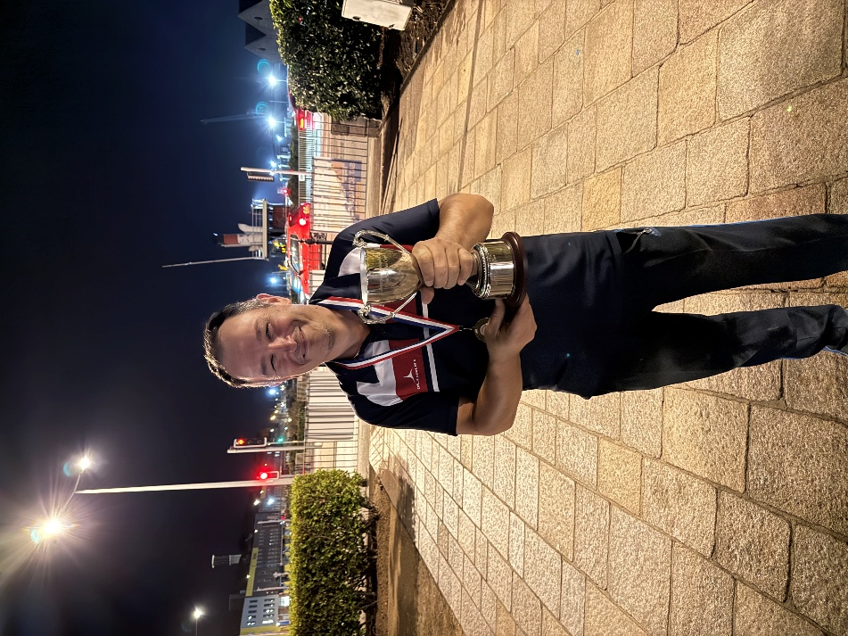

Thanks to Toby again for running the competition anyone who helped Toby tidy at the end.

NEXT WEEK - SINGLES LEAGUE

Club email address - liberationpc@gmail.com

Club Website - www.liberationpetanque.co.uk

Toby Northern

Chairman - Liberation Petanque Club

