4/2/2016 The Jerusalem Jubilee

There are many timelines that are coming to fruition in the months ahead. Here’s a graphic that shows the timing of the Jerusalem Jubilee we’re currently in.

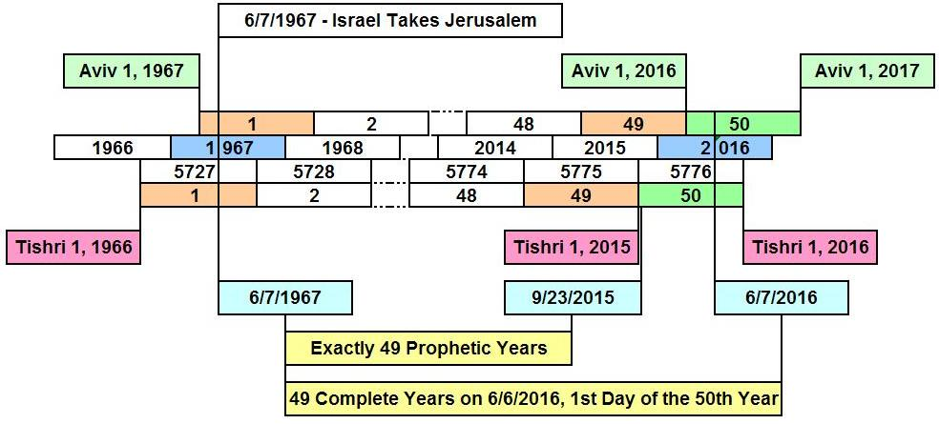

We can see that we’re in the 50th year from when Israel acquired Jerusalem from Jordan in the 1967 Six days War. This is true whether the year is counted as a civil year beginning in the 7th month, or as a biblical year beginning in the 1st month. For those who are observing an Adar Bet this year, the 50th year will begin on the sighting of the next new moon around April 9, 2016.

There is a lot happening this year. The current civil Jerusalem Jubilee year which began on Tishri 1, 2015 and was announced 10 days later on 9/23/2015, the Hebrew Day of Atonement, will end on approximately 9/3/2016 with the sighting of the new moon on the 1st day of the 7th month. If you are observing an Adar Bet this year, the 1st day of the 7th month will probably be around October 2-3.

For those observing Biblical years and the early aviv barley this year, we entered the Jerusalem Jubilee Aviv 1, 3/11/2016, and will exit the Jerusalem Jubilee Aviv 1, 2017.

Research done at the site listed below indicates that the aviv barley for the First Fruits wave offering was cut the day before Passover.
Link: http://www.ahbjewishcenter.org/harvest.htm

Waiting up to the day before Passover to observe the barley and declare the month of Aviv gives the barley about 14 more days to mature to the aviv stage. It takes barley about 10 days to advance from one stage of maturity to another. Current Karaite practice is to stop the barley search in Israel by the sighting of the new moon. If none is found by the time the new moon is sighted, then a 13th month is declared. The Hillel calendar inserts a 13 month automatically from time to time in order to resolve the 10 day per year time lapse between lunar and solar years that would cause the seasons to float through the Hebrew year if left unchecked.

It’s been previously mentioned that because Israel took control of the Temple Mount in Jerusalem for a few days in 1967 and then gave it back into Jordanian hands, that control of the Temple Mount must return to Israel in the Jubilee Year. These are the instructions of YaHuWaH Elohim concerning the year of Jubilee.

If control of the Temple Mount does not return to Israel during the Jubilee year, at least for some short period of time, then there will be an “abomination which maketh desolate sitting where it ought not” when the Jubilee year ends. The abomination sitting where it ought not is the Islamic Dome of the Rock and other Muslim property on the Temple Mount.

Right now a non-Muslim can’t go onto the Temple Mount and pray without being arrested by the police or stoned by Muslims. The Temple Mount is currently desolate and barren of the worshippers of YaHuWaH Elohim. If the Temple Mount remains off limits to the people of YaHuWaH Elohim after the end of the Jerusalem Jubilee Year without control having been yielded back to Israel, spiritual sparks will fly at some point.

If the continuing desolation of the Temple Mount continues past the end of the current Jubilee year, it then becomes an offence against YaHuWaH Elohim Himself, not just a stumbling block for His people.

Here’s a graphic that further illustrates the current Jerusalem Jubilee Year for those who are observing the early month of Aviv this year, and how our Creator Elohim even has solar eclipses pointing to these important dates concerning the nation of Israel to get our attention.

