There's a movie on the National Geographic Channel at 8pm EDT this Sunday 3/29 in case anyone wants to tune in. It's supposed to be historical and without miracles portrayed, so it won't be biblical. The man portraying "Jesus" in the movie is a Muslim. I haven't seen the movie. But what I've come to find over the years is that we can usually learn something of value from those having other views.

About two thousand years ago some Magi startled the religious priesthood and the government officials in Jerusalem. The Magi announced the coming of Israel's Messiah. The Jewish Priesthood and the government officials apparently weren't interested enough in the testimony of the Magi to actually follow them to the Messiah. YaHuWaH only allowed certain people to approach His Son. Very few were invited to the party.

A similar situation existed in Elijah's day. A group known as the sons of the prophets (2 Kings 2:3) knew that Elijah was going to be taken from the earth by YaHuWaH , but only Elisha followed Elijah to see the event. That event, the taking away of Elijah may be related to the taking away of the manchild revealed in Revelation chapter 12. But who would see Elijah go? Who will see the manchild go?

The Odd Comet

Yesterday morning I awakened with comet P/2010 A2 LINEAR on my mind. Our heavenly Father sometimes speaks to me this way. Comet P/2010 A2 LINEAR is one that I had investigated lightly several times in the last couple of years. This isn't an ordinary comet or asteroid. It's odd. Here's a link: http://en.wikipedia.org/wiki/P/2010_A2

The image of the comet taken by the Hubble Space Telescope:
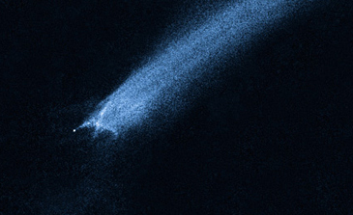
Comet P/2010 A2 (LINEAR)
Photo courtesy NASA, ESA, D. Jewitt (UCLA)

Astronomers had never seen anything like this comet before, and were stymied as to what exactly the thing was and how it formed. It was discovered on 1/6/2010 by Lincoln Near-Earth Asteroid Research (LINEAR) using a 1 meter telescope.

We've been told by Messiah YAHUSHUA in Matthew chapter 24 that there will be signs in the heavens when the time comes for Him to return to the earth. This comet was strange enough to be investigated.

The Messiah instructed His taught ones to "lift up" (Hebrew - "nasa") their heads when they saw signs in the heavens, for their redemption was drawing near. Luke 21:28

The comet's structure resembles an ancient Paleo Hebrew letter, the Tav, which is the last letter in the Hebrew Alphabet. The Tav specifically means a "mark" in ancient Hebrew. The Messiah identified Himself as the Alpha and Omega in Revelation. The Alpha and Omega of the Greek alphabet correspond to the Alef and the Tav of the Hebrew alphabet and the "A" and the "Z" of the English alphabet.

Paleo Hebrew Tav Modern Hebrew Tav

The heavens are the Creator's magnificent timepiece. If this strange comet is a sign from YaHuWaH Elohim, the Creator, then it should exhibit some special qualities that signify or point to certain times or events.

Here's one pointer ordained at creation into the paths of this comet and the earth. The red line is the comet's path with white date stamps attached.
This image is how the sky will appear on 9/23/2017 at the time of the sign of the Woman Clothed with the Sun of Revelation chapter 12.
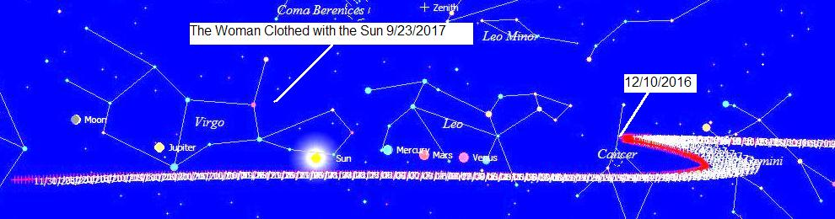
The comet appears to race straight across the sky in 2016 toward the constellation Leo and then abruptly reverse direction on 12/10/2016.

Here's a closer view of the comet's path. We can see how closely defined the point of reversal is.
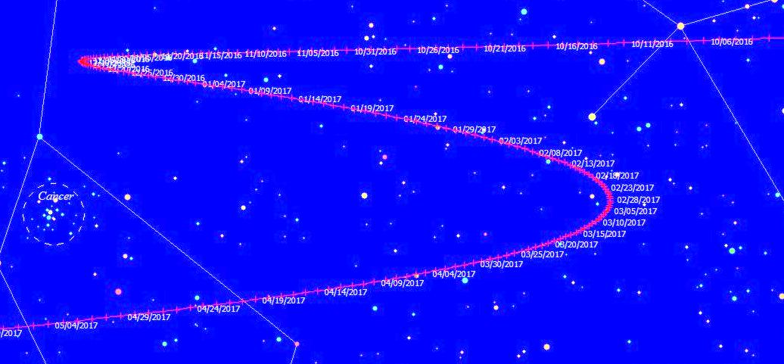

Here's a close up image of the sharp point of reversal:
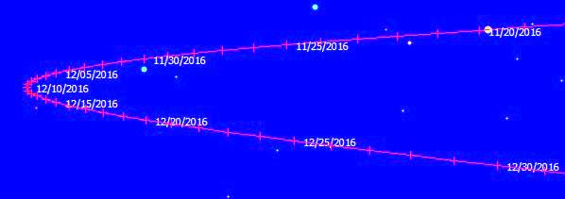

And finally an extreme close up view of the comet's path.
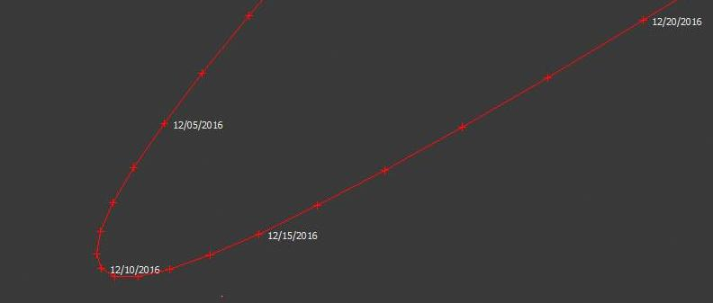

Comet P/2010 A2 LINEAR appears to sharply reverse it's course on 12/10/2016.

7 Year Marker: President Barak Obama accepted his Nobel Peace Prize in Norway exactly 7 years prior to 12/10/2016, on 12/10/2009. Around that time, 12/9 or 12/10/2009, a whirling light appeared in the sky over Norway. This odd occurrence was attributed to Russian missile that had gotten out of control. What the whirling light was is not the main concern, the important thing is that it was there, in the sky, near the time President Obama received the Nobel Peace Prize.

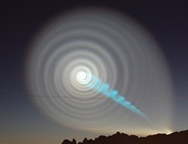
The Whirling Light over Norway, another odd occurrence in the sky.

An odd sign that occurred in the sky on the morning of the day that Obama received the Nobel Prize for Peace 12/10/2009.

The Strange Comet Flies on to Mark another Event

Comet P/2010 A2 (LINEAR) arrives at a Venus-Jupiter conjunction on 11/13/2017, supplying a "Tav" "end marker" to the sign of the Woman Clothed with the Sun which occurs 51 days earlier on 9/23/2017.
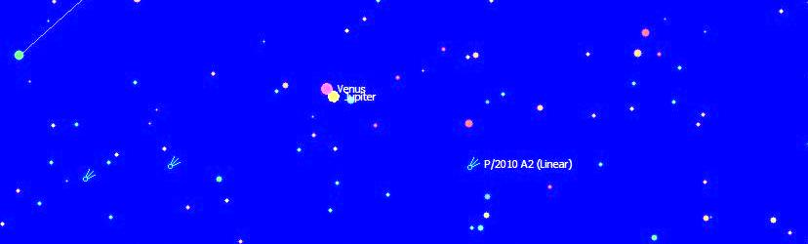
A graphic showing the Venus-Jupiter conjunction of 11/13/2017, with the odd comet P/2010 A2 LINEAR nearby supplying an "end mark".

Other Pointers

There's another marker pointing to 11/13/2017. That pointer is the solar eclipse of 3/20/2015 that ended at the North Pole at 153 degrees in the constellation of Pisces the fish at 10:18:30 UT and then lifted into the sky. See John 21 and the 153 great (Greek - Megas) fish in the net.

The marker is the number of days, 969, from 3/20/2015 to 11/13/2017.

Methuselah, the longest living person in the bible, was 969 years old when he died. He died at the time of Noah's flood. His name, Methuselah, means "when he dies it shall come" (the flood).

Here's a geometric representation of the 969 days.
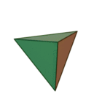

This is a tetrahedron. The number 969 is the 17th tetrahedral number. http://www.virtuescience.com/numbertypes.html#tetrahedralnumbers

The sign of the Woman Clothed with the Sun occurs on 9/23/2017. The Venus-Jupiter conjunction of 11/13/2017 occurs 51 days later.

51 x 19 = 969.

There are 918 days (18 equal lengths of 51 days, also factored as 6 equal lengths of 153 days) from the solar eclipse of 3/20/2015 to sign of the Sun Clothed Woman on 9/23/2017.

There are 969 days (19 equal lengths of 51 days) from the solar eclipse of 3/20/2015 to the Venus-Jupiter conjunction on 11/13/2017 with comet P/2010 A2 LINEAR nearby.

Further information concerning the 3/20/2015 North Pole eclipse can be found here: http://www.joybysurprise.com/The_Warning_SLXR.html

Further information concerning the Sun Clothed Woman can be found here: http://www.joybysurprise.com/The_Sun_Clothed_Woman.html

