December 27/28, 2025
First Sunday of Christmas
Lessons and Carols
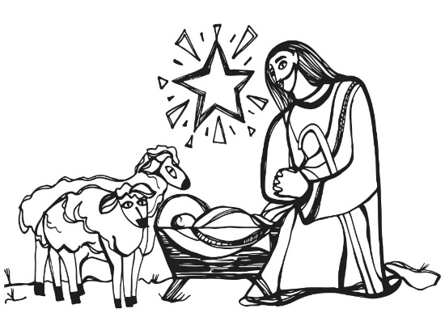
Christ Lutheran Church
“A Place Where You are Always Welcome”
Services: Saturday 5:30 pm and Sunday 10:00 am Sunday School: 9:00 am
600 North Main Street, Stockton, IL 61085 Office: 815-947-2033
Email: christlutheranchurch70@gmail.com http://www.christlutheranstockton.com
Ministers: ALL members of the congregation
Pastor: Rev. Chrissy Salser chrissytherev@att.net 815-988-9450
From Sundays and Seasons.com. Copyright 2017 Augsburg Fortress. All rights reserved. Reprinted by permission under Augsburg Fortress Liturgies Annual License #40643.New Revised Standard Version Bible, copyright 1989, Division of Christian Education of the National Council of the Churches of Christ in the United States of America. Used by permission. All rights reserved.

WELCOME: Thank you for joining us for worship today. We are glad you are with us. Communion will be served in the aisle or in your pew. All are welcome to share this meal. Jesus is our host and invites everyone. Those who would like to come forward, bread and wine will also be available in the front. When directed by the usher, come forward down the center aisle, Pr Chrissy will give you bread (she will be masked and wearing cloves) and then you will take a cup of wine (grape juice) from the tray. After taking communion, you will return to your seat by the side aisle. For those who are unable to come forward, communion elements can be found as you entered worship. At that part of the service, you are invited to take the bread and wine (or grape juice) when Pr. Chrissy leads. On Saturday’s offering is collected as you enter or leave worship. On Sunday we will pass the plate as a response to God’s grace. Online giving is available. Please see QR code on back of bulletin or visit our website.

INTRODUCTION The psalmist calls on the natural world, celestial bodies, fire and earth, creatures, and all humanity, to praise God. The voices of Simeon and 84-year-old Anna join the chorus today, recognizing what God is doing in Jesus. Simeon’s song is often sung after communion, for we have seen God’s salvation in the assembled community and have held Jesus in our hands in the bread. Then, like the prophet Anna, we tell of Jesus to all who look for the healing of the world.
Gathering: The Holy Spirit calls us together as the people of God.
PRELUDE
WELCOME AND ANNOUNCEMENTS
DIALOGUE
P: Jesus, the bright Morning Star, shines light in the world.
C: By day and night he shines for all to see.
P: Jesus was born in the midst of injustice and poverty
C: that the world may see the justice and richness of God.
P: God so loved the world that God sent Jesus,
C: so that all who believe in him may not perish but have eternal life.
P: Jesus is the light of the world.
C: Jesus is the light of our lives.
P: Sing to God a new song!
C: A song of hope, joy, and peace around the world.

GATHERING HYMN: Joy to the World ELW #267
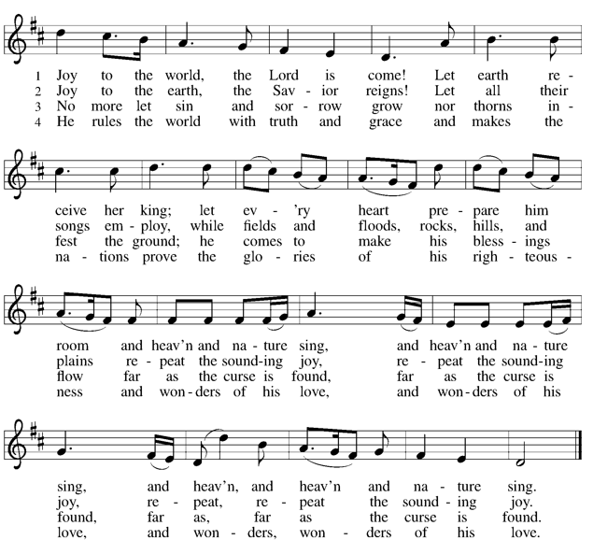
OPENING PRAYER:
P. The Lord be with you.
C. And also with you.
P. Let us pray. Gracious God of heaven and earth, C: you have thrown a lifeline to us in our darkness— a beam of light that shines through Jesus. Though born in a manger, he is the firstborn of all creation. Though crucified on a cross, he is the Lord of life. Fill us with the wonder and joy of his presence in the world and in our hearts. Amen.
WORD: God speaks to us in scripture reading, preaching, and song.

FIRST READING: Genesis 1:1-5, 14-18

A reading from Genesis: ¹In the beginning when God created the heavens and the earth, ²the earth was a formless void and darkness covered the face of the deep, while a wind from God swept over the face of the waters. ³Then God said, "Let there be light"; and there was light. ⁴And God saw that the light was good; and God separated the light from the darkness. ⁵God called the light Day, and the darkness he called Night. And there was evening and there was morning, the first day.
¹⁴And God said, "Let there be lights in the dome of the sky to separate the day from the night; and let them be for signs and for seasons and for days and years, ¹⁵and let them be lights in the dome of the sky to give light upon the earth." And it was so. ¹⁶God made the two great lights — the greater light to rule the day and the lesser light to rule the night — and the stars. ¹⁷God set them in the dome of the sky to give light upon the earth, ¹⁸to rule over the day and over the night, and to separate the light from the darkness. And God saw that it was good.
Word of the Lord. C. Thanks be to God.
I Wonder as I Wander WOV #642 vs 1-3
- I wonder as I wander out under the sky
How Jesus, the savior, had come for to die
For poor on'ry people, like you and like I.
I wonder as I wander out under the sky.
- When Mary birthed Jesus, t'was in a cow's stall
With wisemen and farmers and shepherds and all,
But high in god's heaven a star's light did fall,
And the promise of ages, it then did recall.
- If Jesus had wanted for any wee thing
A star in the sky or a bird on the wing
Or all of god's angels in heaven for to sing
He surely could have it, for he was the king!
SECOND READING: Micah 5:2-5a
A reading from Micah: ² But you, O Bethlehem of Ephrathah, who are one of the little clans of Judah, from you shall come forth for me one who is to rule in Israel, whose origin is from of old, from ancient days. ³Therefore he shall give them up until the time when she who is in labor has brought forth; then the rest of his kindred shall return to the people of Israel.
⁴And he shall stand and feed his flock in the strength of the LLORD, inthe majesty of the name of the LORD his God. And they shall live secure, for now he shall be great to the ends of the earth; ⁵and he shall be the one of peace. If the Assyrians come into our land and tread upon our soil, we
will raise against them seven shepherds and eight installed as rulers.
The word of the Lord C. Thanks be to God.
O Little Town of Bethlehem ELW #279 vs 1 &4

1 O little town of Bethlehem,
how still we see thee lie!
Above thy deep and dreamless sleep the silent stars go by;
yet in thy dark streets shineth
the everlasting light.
The hopes and fears of all the years are met in thee tonight.
4 O holy child of Bethlehem,
descend to us, we pray;
cast out our sin, and enter in,
be born in us today.
We hear the Christmas angels
the great glad tidings tell;
oh, come to us, abide with us,
our Lord Immanuel!

THIRD READING: Luke 1:26-35, 38
A Reading from Luke: ²⁶In the sixth month the angel Gabriel was sent by God to a town in Galilee called Nazareth, ²⁷to a virgin engaged to a man whose name was Joseph, of the house of David. The virgin's name was Mary. ²⁸And he came to her and said, "Greetings, favored one! The Lord is with you." ²⁹But she was much perplexed by his words and pondered what sort of greeting this might be. ³⁰The angel said to her, "Do not be afraid, Mary, for you have found favor with God. ³¹And now, you will conceive in your womb and bear a son, and you will name him Jesus. ³²He will be great, and will be called the Son of the Most High, and the Lord God will give to him the throne of his ancestor David.
³³He will reign over the house of Jacob forever, and of his kingdom there will be no end." ³⁴Mary said to the angel, "How can this be, since I am a virgin?" ³⁵The angel said to her, "The Holy Spirit will come upon you, and the power of the Most High will overshadow you; therefore the child to be born will be holy; he will be called Son of God. ³⁸Then Mary said, "Here am I, the servant of the Lord; let it be with me according to your word." Then the angel departed from her.
Word of the Lord. C. Thanks be to God.
Lo, how a Rose E’er Blooming ELW #272 vs 1 &4

1 Lo, how a rose e'er blooming
from tender stem hath sprung!
Of Jesse's lineage coming
as seers of old have sung,
it came, a flow'r so bright,
amid the cold of winter,
when half-spent was the night.
4 O Savior, child of Mary,
who felt our human woe;
O Savior, king of glory,
who dost our weakness know:
bring us at length, we pray,
to the bright courts of heaven
and into endless day.

FOURTH READING: Matthew 1:18-25
A Reading according to the gospel of Matthew:
¹⁸Now the birth of Jesus the Messiah took place in this way. When his mother Mary had been engaged to Joseph, but before they lived together, she was found to be with child from the Holy Spirit. ¹⁹Her husband Joseph, being a righteous man and unwilling to expose her to public disgrace, planned to dismiss her quietly.
²⁰But just when he had resolved to do this, an angel of the Lord appeared to him in a dream and said, "Joseph, son of David, do not be afraid to take Mary as your wife, for the child conceived in her is from the Holy Spirit. ²¹She will bear a son, and you are to name him Jesus, for he will save his people from their sins." ²²All this took place to fulfill what had been spoken by the Lord through the prophet: ²³"Look, the virgin shall conceive and bear a son, and they shall name him Emmanuel," which means, "God is with us." ²⁴When Joseph awoke from sleep, he did as the angel of the Lord commanded him; he took her as his wife, ²⁵but had no marital relations with her until she had borne a son; and he named him Jesus.
Word of the Lord. C. Thanks be to God.
Go Tell It on The Mountain ELW #290

Refrain
Go tell it on the mountain,
over the hills and ev'rywhere;
go tell it on the mountain
that Jesus Christ is born!

1 While shepherds kept their watching
o'er silent flocks by night,
behold, throughout the heavens
there shone a holy light. Refrain

2 The shepherds feared and trembled
when, lo, above the earth
rang out the angel chorus
that hailed our Savior's birth. Refrain

3 Down in a lonely manger
the humble Christ was born;
and God sent us salvation
that blessed Christmas morn. Refrain

FIFTH READING: Luke 2:8-20
A Reading from the gospel of Luke: ⁸In that region there were shepherds living in the fields, keeping watch over their flock by night. ⁹Then an angel of the Lord stood before them, and the glory of the Lord shone around them, and they were terrified. ¹⁰But the angel said to them, "Do not be afraid; for see — I am bringing you good news of great joy for all the people: ¹¹to you is born this day in the city of David a Savior, who is the Messiah, the Lord. ¹²This will be a sign for you: you will find a child wrapped in bands of cloth and lying in a manger." ¹³And suddenly there was with the angel a multitude of the heavenly host, praising God and saying, ¹⁴"Glory to God in the highest heaven, and on earth peace among those whom he favors!"
¹⁵When the angels had left them and gone into heaven, the shepherds said to one another, "Let us go now to Bethlehem and see this thing that has taken place, which the Lord has made known to us." ¹⁶So they went with haste and found Mary and Joseph, and the child lying in the manger. ¹⁷When they saw this, they made known what had been told them about this child; ¹⁸and all who heard it were amazed at what the shepherds told them. ¹⁹But Mary treasured all these words and pondered them in her heart. ²⁰The shepherds returned, glorifying and praising God for all they had heard and seen, as it had been told them.
Word of the Lord. C. Thanks be to God.
Angels, from the Realms of Glory ELW #275 v 1 & 2

1Angels, from the realms of glory,
wing your flight o'er all the earth;
once you sang creation's story,
now proclaim Messiah's birth:
Come and worship, come and worship, worship Christ, the newborn king.
2 Shepherds, in the fields abiding,
watching o'er your flocks by night, God with us is now residing, yonder shines the infant light. Come and worship, come and worship, worship Christ, the newborn king.

SIXTH READING: John 1:1-14
A reading from the Gospel of John: ¹In the beginning was the Word, and the Word was with God, and the Word was God. ²He was in the beginning with God. ³All things came into being through him, and without him not one thing came into being. What has come into being ⁴in him was life, and the life was the light of all people. ⁵The light shines in the darkness, and the darkness did not overcome it.
⁶There was a man sent from God, whose name was John. ⁷He came as a witness to testify to the light, so that all might believe through him. ⁸He himself was not the light, but he came to testify to the light. ⁹The true light, which enlightens everyone, was coming into the world.
¹⁰He was in the world, and the world came into being through him; yet the world did not know him. ¹¹He came to what was his own, and his own people did not accept him.
¹²But to all who received him, who believed in his name, he gave power to become children of God, ¹³who were born, not of blood or of the will of the flesh or of the will of man, but of God.
¹⁴And the Word became flesh and lived among us, and we have seen his glory, the glory as of a father's only son, full of grace and truth.
Word of the Lord. C. Thanks be to God.
Love Has Come ELW #292
1 Love has come—a light in the darkness!
Love shines forth in the Bethlehem skies.
See, all heaven has come to proclaim it;
hear how their song of joy arises:
Love! Love! Born unto you, a Savior!
Love! Love! Glory to God on high.

2 Love is born! Come, share in the wonder.
Love is God now asleep in the hay.
See the glow in the eyes of his mother;
what is the name her heart is saying?
Love! Love! Love is the name she whispers;
Love! Love! Jesus, Immanuel.

3 Love has come and never will leave us!
Love is life everlasting and free.
Love is Jesus within and among us.
Love is the peace our hearts are seeking.
Love! Love! Love is the gift of Christmas;
Love! Love! Praise to you, God on high!
RESPONSIVE PRAYER:
P. It is you, loving God, who lights our path with truth.
C. Your Word, Jesus, is truth.
P. In his light, draw all to the manger
C. to gather in wonder with the shepherds.
P. In his light, draw all to the manger
C. to kneel in reverence with the wise ones.
P. In his light, draw all to the manger
C. to sing for joy with the angels.
P. In the brightness of his life
C. cast away the darkness of injustice, poverty, and hunger in the world.
P. It is you, loving God, who meets us on our way.
C. In the light of Jesus, show the world the way of life. Amen.
OFFERING: Our offering is a significant act of worship; we worship God through our giving. The ministry of this congregation is completely dependent upon your partnership and generosity. Offering is collected as you enter worship on Saturday. We will pass the offering plate on Sundays. Online giving is available.
Offering SONG Angels We Have Heard On High ELW #289
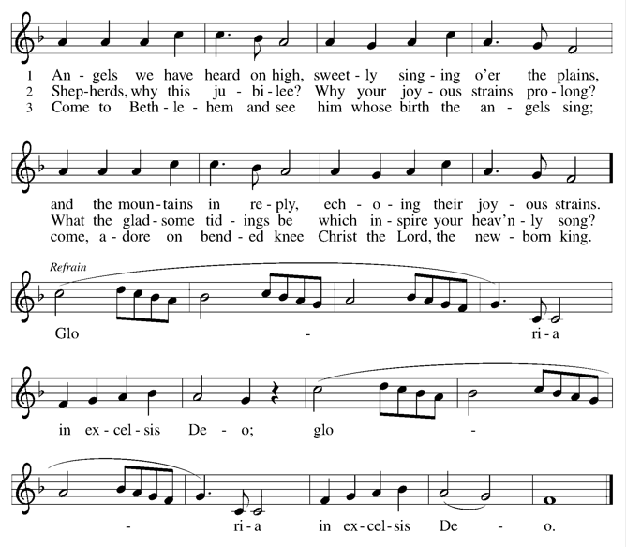
OFFERING PRAYER:
P. Let us pray together: God of abundance,
C. receive and bless these gifts we have offered. Join our hearts with the song of the angels, and gather us at your table of celebration. Strengthen us to share with all the world the abundance of your grace upon grace, poured out in Jesus Christ, the Word made flesh. Amen.

THE LORD’S PRAYER:
Our Father, who art in heaven, hallowed be thy name, thy kingdom come, thy will be done on earth as it is in heaven. Give us this day our daily bread; and forgive us our trespasses, as we forgive those who trespass against us; and lead us not into temptation, but deliver us from evil. For thine is the kingdom, and the power, and the glory, forever and ever. Amen
BLESSING:
P. Praise God, from whom all blessings flow!
C. Praise God, all creatures here below!
P. You are the shepherds telling the story.
C. We tell it in the streets and across the land.
P. You are the wise ones worshiping with thanksgiving.
C. We worship with gifts of song and service, talents and treasures.
P. You are the angels announcing peace.
C. We live with joy and go now in peace.
P. Almighty God, Father, ☩ Son, and Holy Spirit, bless you now and forever.
C. Amen.
SENDING SONG Good Christian Friends Rejoice ELW #288
DISMISSAL
P: Christ the Savior is born! Go in peace. Proclaim this good news.
C: Thanks be to God.

POSTLUDE

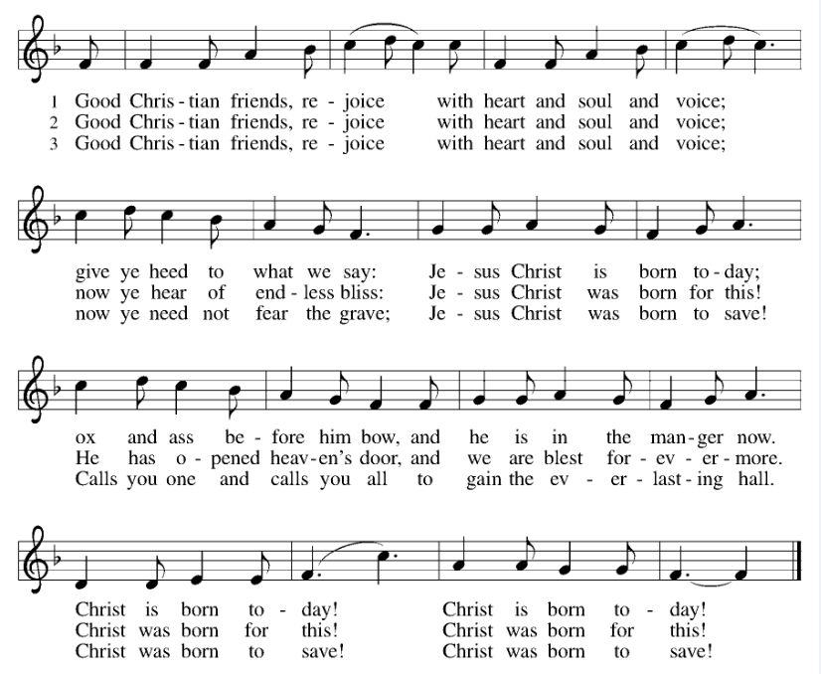

IN OUR PRAYERS TODAY: Teresa Hesselbacher, Elaine Schlicting, Darlene and Walt Steffes, Bob Schreck, Delores Wampfler, Marge and Gerald Arnold, Don & Judy Brudi, June Dittmer, Diego Gonzalez, Grayson Raab, Dan Bonnet, James Dieter, Christine Happ, Kay Hesselbacher, Mary Lou Bunker, Lillian Sefford, Jeff Encheff, Judy Wilson, Russ Synder, Don Kunz, Johnny Blair, Jim Sullivan, Sally Duran Salser, Chris Marek, Joe Karr, John Becker To add someone to the prayer list please contact Pastor Chrissy

Celebrating birthdays/anniversaries this week: Deanna Bonnet, Val Brudi, Jennifer Groezinger, Ty Harmston, Kay Schlichting, Trent Jones, Julia Casper, Darcie Raab, Laura Wilkinson, Don and Judy Brudi

Thanks be to God for your gifts for the ministry of  Christ Lutheran Church *these numbers do not reflect online giving- only offering in worship |  |  |  | Offering/ Attendance  December 20/21
Current Expense | $5,180.00 | Building Fund | $10.00 | Dec 20 | 15
Benevolence | $10.00 | Sunday School | $940.74 | Dec 21 | 110
 |  | Total | $6,140.74 | Sunday School | 30

November Totals: As a way to improve communication around finances, we are sharing the following information: *these numbers reflect online giving contribution
2025
 | November | Year to date
Offerings: | $9,660 | $106,612
Expenses: | $9,286 | $111,730
Overall Gain / Loss | $374 | ($5,118)

ONLINE GIVING: Your gift has a big impact on our ministries and those we serve. Scan this code or visit our website to give online today.

ANNOUNCEMENTS
ANNUAL MEETING REPORTS: Please have your committee reports into the Church Secretary by Sunday, January 4th, 2026. You may email them to christlutheranchurch70@gmail.com or put them in the Secretary door mailbox.
WELCA BIBLE STUDY- This year we will be studying the book “Women of the New Testament” Each month we will encounter and learn about different women of the New Testament. No prep required. Come as you are to explore scripture together. Groups will meet on the second Wednesday at 1 pm, at the church (or Betsy’s house) or the second Thursday at 9 am, at a member’s house or church. All women are welcome to join us for bible study and time of fellowship.
THANK YOU: the Children’s Christmas program went great. Thank you for all who helped. Thank you to the parents for trusting us with your children. Thank you to our children for doing such a great job! It was a fun and great day!
THANK YOU: a special thank you to everyone who made Christmas at LSSI’s Anderson house such an awesome night. We were able to get all the presents for each resident and the items needed for the house as well. Your generosity is greatly appreciated!
THE COMMUNITY TABLE: The Community Table is an opportunity for outreach to the local community. This is a twice a month meal on the first and third Tuesday of the month at 11:30, here at Christ to gather for food, fellowship and fun, if you are interested in volunteering please talk with Janet Haas or Debbie Goebel. Join us Tuesday, December 16th. All are welcome.
BIBLE STUDY: note that bible study will take a break for until January 7, 2026.

AMAZON WISH LIST: did you know that everyday items used at the church are items you could contribute? Find our list here or on our Facebook page.

Upcoming Events
- December 28 - 5:30 pm Worship with no communion
- December 29 - 9:00 am Sunday School
- December 29 – 10am Worship with no communion
- January 3- 5:30 Saturday Lessons and Carols with communion
- January 4 - 9am Sunday School (All ages)
- January 4 - 10 am Worship Lessons and Carols with communion
- January 7- 9 am Bible Study
- January 10- 5:30 pm Lessons and Carols with no communion
- January 11- 8:30 am Confirmation Class
- January 11- 10 am Lessons and Carols with no communion
- January 18 - 11 am Annual Congregational Meeting
