  www.Best-Fundraising-Ideas.com  Deb Murray  National Fundraising Representative  Serving the continental US since 2002 | 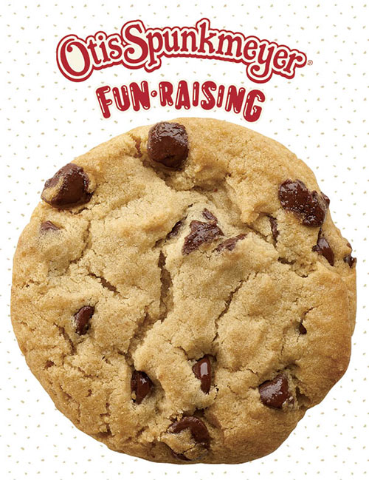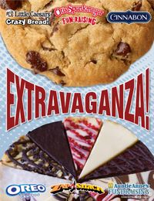 | Contact Us!  Phone: (860) 384-3691  Email: info@best-fundraising-ideas.com  Fax: (410) 630-7080  102 Thompson St,  S. Glastonbury CT 06073

Unipak Frozen Food Fundraisers, Shelf-Stable / Non-Frozen Fundraisers
Fundraising that is uncomplicated, fun, and super easy. Everyone loves our name brands!
For highest sales and participation book early in the season!

Top Reasons for Choosing our Fundraising Brochures for your 2019/2020 Fundraiser

1. Our fundraisers are easy and free to start. Brochures and online sales are provided at no cost. Submit your Project Reservation
Agreement by fax or email today and your brochures will be shipped FREE! You can begin your fundraiser in about one week!
2. Products are shipped packed by seller for FREE! Simply mail your seller’s order forms back with a provided shipping label. We will
enter the orders into our order system and provide you with detailed reports and email an invoice to you.
3. Fundraising with our programs is EASY! There are absolutely no start-up fees, low minimums to place an order, no case
Requirements except for pies and optional bulk orders with our single page brochures. You’ll retain your profit up front, and we
provide extended evening and weekend office hours when you need assistance! Call or email us anytime!
4. We provide exceptional fundraising brochures which offers something for everyone. Our brochures offer a wide selection of
cookie dough, cheesecake, pizza, pretzels, cinnamon rolls, soup, dips, braided bread, snacks, chocolates, cheese & sausage,
pies, kitchen items, and more.
5. Sell delicious items that are affordably priced, very easy to sell, and will be loved by your customers for their own enjoyment or
for gift-giving. It is easy to sell top name brands such as Otis Spunkmeyer, Toll House, Little Caesars, Cinnamon, Auntie Ann’s,
Pine River, and more.
6. Earn a generous profit up to 40% with no additional hidden fees. Online Sales are included to help your organization to raise
more money by selling to out of the area family and friends through sending emails and posting on social media.
7. We offer FREE Pack-By-Seller. Orders can also be grouped by class or team.
8. Payment by Credit Card is accepted in addition to payment by organization/ business check, or money order.
9. Purchase orders are accepted for public schools.
10. Our fundraising brochures are a great choice for increasing your sales with repeat fundraisers. Your supporters will be
anxious to order year after year! With our exceptionally high line of quality products you can offer our brochures with
confidence and you’ll look forward to increased sales each year!

How does the program work?

Complete the enclosed Project Reservation Agreement sheet and fax to 410-630-7080 or scan/email to CHFundraiser.com. A Project Reservation Agreement can also be printed on our website by clicking on “Get Started” from the webpage for the brochure you are selecting. You'll receive your brochures generally within a week, and we’ll include the information for your online sales. Brochures are free but we require you to not cancel once submitting your agreement. Be certain you are approved to hold the fundraiser and that your organization has agreed to fundraise with the brochure you have selected. Some of our brochures include frozen food items. Others, include all shelf-stable items
Distribute brochures to your sellers and determine how long you will continue your sales. (We recommend two weekends for 2-3
weeks) Customer checks, if accepted, are made payable to your organization.
Collect all brochures and payments at the end of your selling period. Your order requires a minimum of just 120 items. There are no case requirements. Order only what you sell. 1-page brochure orders can be submitted as a bulk order when ordered in cases instead of the standard packed-by-seller.
The more you sell the higher percentage of profit you will earn.
400+ items sold = 40% (That’s just 40 participants selling an average of 10 items!)
300-399 items sold = 38%
200-299 items sold = 35%
150-199 items sold = 30%
120-149 items sold = 25%
Mail your order forms back to the company. A shipping label will be provided for returning your order forms. Once your order forms have been received and data entry completed you will receive an invoice for the amount due along with reports for your online sales. You’ll keep your profit upfront.
Pay for your purchase. We accept a school/organization check, cashier's check, or a money order. Credit Cards are accepted and will incur a credit card fee. Purchase orders are accepted for public schools with a 15-day payment agreement.
Shipping is free. Your order will be shipped free with a minimum of 120 items. Orders ship in 2-3 weeks after receiving order forms.
Report any missing or broken items. Seldom are there any missing or damaged items with our shipments. However, should any replacements be required, we will process a new order for you. Please notify us within 72 hours.
We’ll provide coaching to help your campaign succeed, extended office hours Mon-Sun 9am-9pm EST, and a solid commitment to
Process your order and any required replacements. When you require assistance, we'll be available to help you!

Helping organizations successfully raise money since 2002 and we look forward to working with you!
2019/2020 Fundraising Purchase and Reservation Agreement (PRA)
Fax to: 410-630-7080 Scan/Email to: info@best-fundraising ideas.com Questions? Call 860-384-3691

Organization Name: | Sales Rep Name: Deb Murray, Best Fundraising Ideas
Organization Address: | Phone Number(s): 860-384-3691

Contact Name: | Contact Email: info@best-fundraising-ideas.com
Phone Numbers:  Home:_________________ Cell:___________________  Office:_________________ Fax:____________________ | Email Invoice to:  Cc: info@best-fundraising-ideas.com

Frozen Food Brochures – Select 1 Brochure:  [ ] Extravaganza [ ] Simply Delicious [ ] Otis Single-Page  [ ] Otis All Items Same Price $20 [ ] Otis 4-Page  [ ] Indulgence Collection [ ] Reserve Collection  [ ] EPIC Desserts [ ] Zap a Snack 1-Page  [ ] Auntie Anne’s/Cinnabon 1-pg [ ] St Louis Style Pizza  [ ] St Louis Style Pizza & Pretzels |  | Profit Structure:  400+ items sold = 40%  300-399 items sold = 38%  200-299 items sold = 35%  150-199 items sold = 30%  120-149 items sold = 25%  Sales less than 120 items may be canceled at the discretion of UNIPAK Supply
# of Brochures (one/member): | Fundraiser Start & End Date:
Shipping Address for Brochures: |  | Special Instructions / Prize Programs / Incentives:

☐ INVOICE TERMS (Net 15 days) Only available for Public Schools
☐ PREPAY TERMS for all other groups. Orders process upon receipt of payment.

1. The agreement defines the terms and conditions of the fundraising program between the organization listed above & UNIPAK Supply. Frozen Food Brochures are not available in AZ, CA, CO, ID, MN, MT, NE, NM, NV, OR, SD, TX, UT, WA, WY
2. Payments must be made (per selected invoice method) directly to UNIPAK Supply at: 3912 Option Pass, Fort Wayne, IN, 46818. If payment is not made as required, the organization listed above specifically authorizes UNIPAK Supply to take whatever legal action becomes necessary to collect any outstanding debt, and further agrees to be responsible for whatever cost may be associated with collecting debt, including collection fees, reasonable attorney's fee, court costs, and any other expenses related to the collection of this debt. Past due payments will be charged a 1.5% finance charge per month. A $25.00 service charge will be billed for returned checks. Payments made by VISA/MasterCard will incur a 2% upcharge. Payments made by American Express will incur a 4% upcharge.
For invoice terms this agreement must be signed by someone authorized to approve payments.
I hereby certify that the above individual, group, or organization has the authority to conduct business with UNIPAK Supply and shall be responsible for the terms and conditions of this agreement and payment in full.

Signature | Printed Name | Title | Date
* All Information submitted to UNIPAK Supply is confidential.
2019/2020 Fundraising Purchase and Reservation Agreement (PRA)
Fax to: 410-630-7080 Scan/Email to: info@best-fundraising ideas.com Questions? Call 860-384-3691

Organization Name: | Sales Rep Name: Deb Murray, Best Fundraising Ideas
Organization Address: | Phone Number(s): 860-384-3691

Contact Name: | Contact Email: info@best-fundraising-ideas.com
Phone Numbers:  Home:_________________ Cell:___________________  Office:_________________ Fax:____________________ | Email Invoice to:  Cc: info@best-fundraising-ideas.com

Shelf-Stable / Non Frozen Food Brochures – Select 1 Brochure:  [ ] Toll House Cookies 4-Page [ ] Toll House Cookie Dough & Gifts  [ ] Toll House Cookie Dough Enjoy [ ] Minis & More  [ ] Heartland Collection [ ] Preferred Cheese & Sausage  [ ] Amazing Cookie Dough 4-Page [ ] Amazing Cookie Dough 1-pg  [ ] Preferred Sweets [ ] Sweet & Savory [ ] Goodies & Gifts |  | Profit Structure:  400+ items sold = 40%  300-399 items sold = 38%  200-299 items sold = 35%  150-199 items sold = 30%  120-149 items sold = 25%  Sales less than 120 items may be canceled at the discretion of UNIPAK Supply
# of Brochures (one/member): | Fundraiser Start & End Date:
Shipping Address for Brochures: |  | Special Instructions / Prize Programs / Incentives:

☐ INVOICE TERMS (Net 15 days) Only available for Public Schools
☐ PREPAY TERMS for all other groups. Orders process upon receipt of payment.

1. The agreement defines the terms and conditions of the fundraising program between the organization listed above & UNIPAK Supply.
2. Payments must be made (per selected invoice method) directly to UNIPAK Supply at: 3912 Option Pass, Fort Wayne, IN, 46818. If payment is not made as required, the organization listed above specifically authorizes UNIPAK Supply to take whatever legal action becomes necessary to collect any outstanding debt, and further agrees to be responsible for whatever cost may be associated with collecting debt, including collection fees, reasonable attorney's fee, court costs, and any other expenses related to the collection of this debt. Past due payments will be charged a 1.5% finance charge per month. A $25.00 service charge will be billed for returned checks. Payments made by VISA/MasterCard will incur a 2% upcharge. Payments made by American Express will incur a 4% upcharge.
For invoice terms this agreement must be signed by someone authorized to approve payments.
I hereby certify that the above individual, group, or organization has the authority to conduct business with UNIPAK Supply and shall be responsible for the terms and conditions of this agreement and payment in full.

Signature | Printed Name | Title | Date
* All Information submitted to UNIPAK Supply is confidential.

