THE MOST WORSHIPFUL PALMETTO GRAND LODGE
FREE AND ACCEPTED ANCIENT YORK RITE MASONS
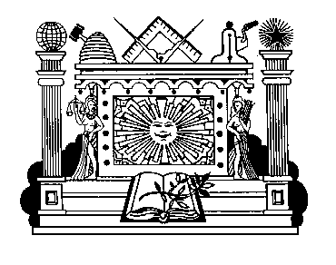
PRINCE HALL ORIGIN – NATIONAL COMPACT, USA

RESOLUTION

WHEREAS: It pleased the great merciful Architect of the Universe, to remove from our midst and break the Chain of Brotherly Love and Friendship of Brother and The Most Worshipful Palmetto Grand Lodge of Free and Accepted Ancient York Rite Masons, Prince Hall Origin, National Compact, USA, and has taken link into the Golden Chain in the Great Beyond, and

WHEREAS: Brother remained faithful and loyal to the teachings of Masonry until his passing on when the kind Father in Heaven laid his alleviating hand upon his weakened and weary body, relieving him of all earthly suffering and pain, so was our Chain of Brotherly Love broken and suffering a great loss, and

WHEREAS: Upon joining our Chain of Brotherhood, this article is but just a fitting recognition of his many virtues as a Brother of this organization and we have enjoyed the fruits of his labors, with sincere Brotherly Love and Friendship, and

THERFORE: Be it Resolved, By on the registry of the Most Worshipful Palmetto Grand Lodge of Free and Accepted Ancient York Rite Masons, Prince Hall Origin, National Compact, USA, that while with humble submission to the will of the Most High, we do not the less mourn for our Brother who has been taken from us.

WHEREAS: That the heartfelt sympathy of this Lodge be extended to his family and their affliction and the ties of friendship among the membership throughout the National Compact and this Palmetto Grand Lodge family are sadly torn, and we realize that this is an early separation, we see the promises of a glorious life to come, where the severed ties shall be mended and the suffering hearts shall be made glad again, and

THEREFORE BE IT RESOLVED, that in the passing of our beloved Brother , his family has suffered a severe loss and our organization has sustained a great sorrow, and

BE IT FURTHER RESOLVED that these resolutions are spread upon the permanent records of The Most Worshipful Palmetto Grand Lodge and a copy thereof be transmitted to the family of our deceased Brother.

In witness whereof, I have set my hand and caused the Seal of the Most Worshipful Palmetto Grand Lodge of Free and Accepted Ancient York Rite Masons, Prince Hall Origin, National Compact, USA to be affixed.

This day of
V.2018.MMACK.2

