GEN-4038H (3800W-48kW-60Hz-16yr) Hybrid 120V-240V | Geneforce Emergency Power System
Product Features
Silent operation. Safe for indoors. No gas or emissions.
No Installation; No Maintenance; No Permits required
Arrives fully charged and ready to work.
Automatic & one-touch start. | 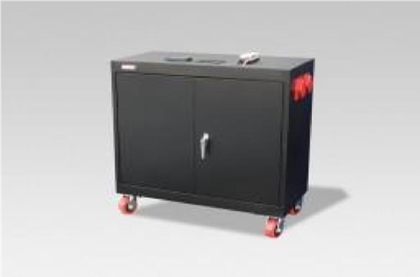
System Control Panel with Graphical 128 x 64-pixel, backlit LCD displays power reserves, amp hours consumed, fault conditions, solar panel output, charging, power consumption.
Overheat Temperature Sensor & Automatic Shutdown feature.
Built-in voltage regulation system for sensitive electronics.
Built-in 30A solar charge controller for solar panel charging.
Electrical Specifications | GEN-4038H (120V-240V)
Output power (continuous) at 25°C | 3,800 W
Output power (30 min) at 25°C | 4,400 W
Output power (5 sec) at 25°C | 7,000 W
Peak current | 41 A
Output frequency | 50 / 60 Hz selectable
Output voltage | 120 / 240 Vac
Output wave form | True sine wave
Input DC voltage range | 40-68 Vdc
AC connections | Single / Split phase
Charger
Output current | 45 A
Output voltage range | 48 Vdc
Charge control | 2 or 3 stages
Charge temperature compensation | Battery temperature sensor included
Input current | 12 A
Input AC voltage | 120 / 240 Vac split phase
Input AC voltage range line to neutral | 95 - 135 Vac single phase; 170 - 270 Vac
AC input voltage requirements | 240V default *phase between L (1) and L (2) must be 180° to qualify AC
AC input 1 | One 30A, 250 Volt, NEMA L14-30P, 3P, 4W, locking plug with 8 ft. cord
AC output 1 | Four (20A/125V) NEMA 5-20R isolated ground receptacles
AC output 2 | One 30A, 125/250 Volt, NEMA L14-30R, 3P, 4W, locking receptacle
Dead battery charge | Yes
Battery bank reserve power | 48 kW (48,000 Watts)
Battery service life | 12-16 years on float
Solar charge controller | 30A/12V (~360 W per hour/sunlight) *(60A/12V-24V) optional
General Specifications
Transfer relay rating | 30A Transfer time (AC to inverter and inverter to AC) <1 cycle (16.7ms)
Optimal operating temperature range | -20°C to 60°C (-4°F to 140°F)
Ingress protection rating | Indoor only, IP20
Regulatory approval
Safety | Components are (CSA) us mark CSA C22.2, No. 107.1-01 UL1741 Ed.2
EMC directive | FCC Part 15 Class B
General Specifications
Product Dimensions (H x D x W) and weight | (51" x 24" x 46”) & (2847 Lbs.) 1295 kg.
Shipping Dimensions (H x W x L) and weight | Custom Pallet 60” x 36” x 60” (2967 lbs.) 1349 kg.
Construction | Strong Steel, Four Casters, Color-Black or Charcoal
Warranty | 5-year warranty on components; up to 4-years on batteries
Part Number | GEN-4038H-120240-3800-16
Price | $21,979
Geneforce Incorporated www.geneforcepower.com Tel: (305) 215-5443 email: sales@geneforcepower.com

