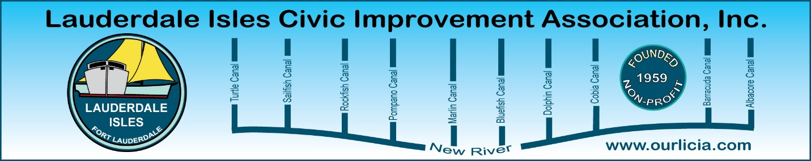
Minutes of the Lauderdale Isles Civic Improvement Association General Meeting August 21, 2025.
The meeting was called to order by Earl Prizlee at 7:05pm. Earl thanked the Pastor for the use of the Church for our General Meetings.
Earl welcomed everyone and gave an overview of the meeting agenda. He presented the Board Members on the screen along with a mention about what we do to help our community. Earl stated the plans are at 60% for the Lauderdale Isles Landing Community Center. He gave an update on the Duck Key Lane sign.
FLPD report: Officer Jackson said there were no Part 1 crimes. She recommends using the FixItFTL app. Now that school is back in session, some of the lanes are experiencing cars blocking the intersections. Officer Jackson said she will talk to the School Resource Officer and to the Police and ask them to address this problem when they see it happening.
Code Compliance report: Matthew Flesher reported there were 35 cases closed, 4 cases complied and 45 cases pending compliance. Cases sited include derelict vehicles, exterior lack of maintenance, overgrowth and trash. Regarding Vacation Rentals, there are 19 registered, 68 complaints and 48 violations issued. There was a complaint about the trees that need to be trimmed on Riverland Road.
Marco Aguilera, Chief Waterway Officer: Marco is working on the following:
- Signage to educate the neighborhood about Charter Vessels
- Pump Out Vessel to be ready September/October
- Oyster ropes in the New River
- Concrete mattress under a New River bridge to prevent scouring under bridge
- David Blvd. bridge repair 2027
- Sept 28 new Waterway Noise Ordinance
- FixItFTL
- Adding signage at 4 public pump out stations
- Anchorage limitations areas – goes to September Commission meeting
- Mangrove Planting Sept 13 at 8 am at Coontie Hatchee Park
- New River Middle School Mangrove planting
- Update on sunken boat at Lauderdale Isles Landing
We all agree Marco is doing a great job.
Geoff Rames announced our next Waterway Cleanup is November 8.

Sewer lateral update: Rich Katz provided an overview of the problem in our neighborhood and the City where the homeowner has to pay for sewer pipe repairs that were previously the responsibility of the City. The City Commission voted on April 2, 2024, to transfer the responsibility of pipe repairs from the City to the homeowner.
Vacation Rental update: Geoff Rames provided the photos and video from 2525 Gulfstream Lane where there were about 100 people and dozens of cars attending a party at this house. He stressed the need to have Code Officers on duty every night including Mondays, Tuesdays and Wednesdays.
Guest Speaker, City Manager Rickelle Williams: She said I have heard “you are a spirited bunch”. City Manager Williams shared her vision and what she would like to accomplish as City Manager. Our City has a $1.2 billion budget and she plans to be efficient and effective. She was asked several questions, including one about the homeless situation. She addressed the concerns discussed earlier in the meeting.
Flanigan’s Gift card was awarded.
The meeting ended at 8:50pm.
Respectfully submitted by Karen Rames, Secretary

