**April Member Meeting**

**Urban Art**

**Carol Carder, RMGA Member**

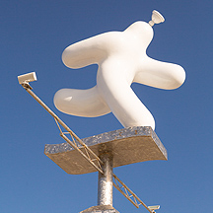**WHEN:** **April 12, 2021**

**6:00pm – Networking**

**6:30pm – Short Meeting**

**6:45pm – Program: Urban Art**

**WHERE:** **via Zoom. See link below**

**PROGRAM:** For our April program RMGA Member, Carol Carder, will share a sampling of outdoor art and sculpture, some historic and some modern, for a virtual urban art tour with the stories of this art. Included will be Wynken, Blynken, and Nod, the articulated wall, RTD stations art, and selections from the Denver’s districts: 40 D west, Santa Fe, Golden Triangle, downtown, and RiNo.

Carol Carder became interested in Colorado’s history in 1976 when she began working part time for the Colorado Prospector. She later used bits of Colorado History in volunteer tour guiding on Amtrak between Union Station and Grand Junction. A couple years ago she wrote and led two tours for Brookdale residents one on the Speer Legacy and another on Denver’s art districts showcasing outdoor murals and sculptures. Art lover Sherry Moon helped Carol with sources for the stories on the artists.

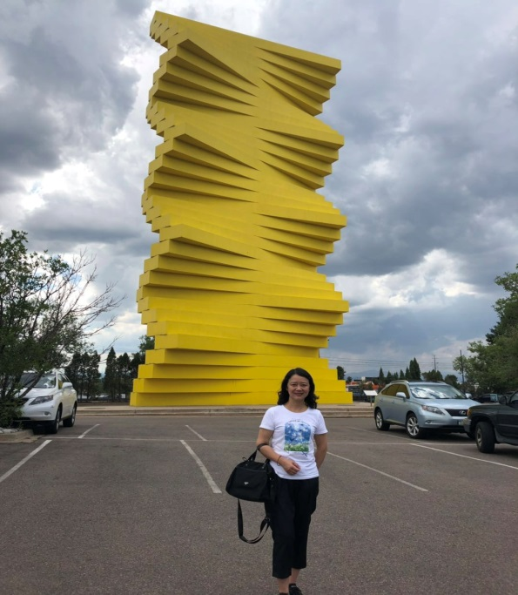**REFRESHMENT:** your call

**DIRECTIONS:** To Join the Meeting click on this link or copy it to your browser: <https://zoom.us/j/93758381784>. You may start to join the meeting at 5:50 pm. click on “Join” in the invitation, enter the necessary codes, and wait to be admitted.

**PARKING:** Your garage, driveway, or curbside.

**GUESTS:** Members are encouraged to invite potential members as a guest to the meeting.

**CONTACT:** J. Mark Blaising, Program Chair 303-830-8440 (voice) 303-263-8647 (text)