Triple T Sports Center

Before/After School / Day Camp Registration Form

# Date: _____________

# Student: _________________________________Male / Female

# Address: _____________________________________________

Phone # : _____________________________________________

Child’s Birthdate: ________________________________________

Allergies: _____________________________________________

Prescriptions: ____________________________________________

Existing Medical Conditions: _______________________________

Has this child or any other family member ever been enrolled in Triple T? _____

Primary Email address: ____________________________________

(will be used **only** to distribute gym information)

**Mother:** _________________________ Phone: _______________

**Father:** _________________________ Phone: _______________

**Emergency Contact Information: (other than parent)**

Name: ______________________________________________

Address: ______________________________________________

Phone #: ______________________________________________

Relationship to child: _______________________________________

Code Word for pick up :_____________________________________

How did you hear about Triple T?

____Newspaper ____Yellow Pages ____Direct Mail ____ Demo/Brochures

____Referred by (please put name)______________________ Other_____________

School : ___________________________________________________

Day(s): (Circle all that apply) Mon Tues Wed Thrs Fri - AM / PM

Triple T Member: Yes / No Currently Enrolled in : _____________ class

**For Office Use only:**

Amount Paid: $_______ Check #: ______ Cash: _____ Rec’d By: _______

Registered for Before/After School Progam _____ Payment Entered: _____

**Copy of Birth Certificate _______ Copy of Shot Record _________ Copy of Physical ______________**

**\*I understand that a 2 week written notice is required to remove my child from the program, otherwise I am responsible for payment for the full tuition for those 2 weeks. ______ (*Initial). If the child is not to be picked up on a regularly scheduled day, I am responsible for notifying Triple T prior to pick up, if no notice is given a $15 fee will be charged. __________ (*Initial)**

Waiver of Liability:

I hereby release Triple T Sports Center from any and all liability for any injury (or loss of property) incurred while practicing, training, taking class, competing, participating in after school program, open gym, sleepovers, birthday parties, special events, demonstrations or shows, or in any other way involved in gymnastics, karate, dance, cheerleading, cheertumble, preschool or teams at Triple T for any reason whatsoever, including ordinary negligence on the part of Triple T Sports Center, its owners, volunteers, or employees.

I give permission for Triple T staff to sign my child into licensed/unlicensed areas of the facility.

_______________________________ ___________

Signature of parent/legal guardian Date

Triple T Sports Center

619 E. Constance Rd Suffolk, VA 23434

WAIVER AND RELEASE OF LIABILITY

DISCLAIMER: TRIPLE T GYMNASTICS SPORTS CENTER IS NOT RESPONSIBLE FOR ANY INJURY (OR LOSS OF PROPERTY) TO ANY PERSON WHILE PRACTICING, TRAINING, TAKING CLASS, PARTICIPATING IN OPEN GYM, BIRTHDAY PARTIES, TUMBLEBUS, SPECIAL EVENTS, FIELD TRIPS, DEMONSTRATIONS OR SHOWS, OR IN ANY OTHER WAY INVOLVED IN GYMNASTICS, NINJA, CHEERLEADING, TUMBLE, DANCE, TAEKWONDO, PRESCHOOL, OR TEAM AT TRIPLE T CLUB FOR ANY REASON WHATSOEVER, INCLUDING ORDINARY NEGLIGENCE ON THE PART OF TRIPLE T, ITS OWNERS, OFFICERS, AGENTS, OR EMPLOYEES.

In consideration of my participation, I hereby release and covenant not-to-sue Triple T Sports Center , LLC, the Triple T Parent’s Association, or any of their employees, teachers, coaches, or agents, from any and all present and future claims resulting from ordinary negligence on the part of Triple T Sports Center, LLC or others listed for property damage, personal injury, or wrongful death, arising as a result of my engaging in or receiving instruction in gymnastics, cheerleading, or any other activities incidental thereto, wherever, whenever, or however the same may occur. I hereby voluntarily waive any and all claims resulting from ordinary negligence, both present and future, that may be made by me, my family, estate, heirs, or assigns.

Further, I am aware that gymnastics, karate, dance, and cheerleading are vigorous sporting activities involving height and rotation in a unique environment and as such they pose a risk of injury. I understand that gymnastics, cheerleading, and related activities always involve certain risks, including but not limited to, death, serious neck and spinal injuries resulting in complete or partial paralysis, brain damage, and serious injury to virtually all bones, joints, muscles, and internal organs, and that the mats, pits, and other safety equipment and apparatus provided for my protection, including the active participation of a coach or teacher who will spot or assist in the performance of certain skills, may be inadequate to prevent serious injury. The risk of harm may be limited by all of the safety equipment and trained coaches, but never eliminated. I understand that participation in gymnastics and related activities involves activities incidental to active participation in gymnastics, including moving from event to event, conditioning, stretching, and other activities which may leave me vulnerable to the reckless actions of other participants who may not have complete control over their actions or who may not see other students in the gym. Student is voluntarily participating in this activity with knowledge of the risks involved and hereby agree to accept any and all inherent risks of property damage, personal injury, or death.

I further agree to indemnify and hold harmless Triple T Sports Center and all others listed for any and all claims arising as a result of my engaging in or receiving instruction in Triple T Sports Center LLC, activities or any activities incidental thereto, whenever, whatever, or however the same my occur.

I understand that this waiver is intended to be as broad and inclusive as permitted by the laws of the state of Virginia and agree that if any portion is held invalid, the remainder of the waiver will continue in full legal force and effect. I further agree that the venue for any legal proceedings shall be within the state of Virginia.

I affirm that I am of legal age and am freely signing this agreement. I have read this form and fully understand that by signing this form, I am giving up legal rights and or remedies, which may be available to me for the ordinary negligence of Triple T Sports Center, LLC, or any person listed below.

I also consent to the use, by Triple T Sports Center, or anyone it authorizes, of any and all photographs, tapes, or other representations, and any reproductions thereof for the purpose of promotion (including sale, publication, display and exhibition) without compensation. The member further consents to the use of the member’s name in connection with such materials, and agrees that such materials and negatives shall constitute Triple T Sports Center property, with full right of distribution.

______________________________________ _________________

* (Signature of Parent or Legal Guardian) Date

*This is a legal document and must be signed by parent or legal guardian only. By signing above you are stating that you fulfill this requirement.

______________________________________ Emergency number ________________________ (name of Participant)

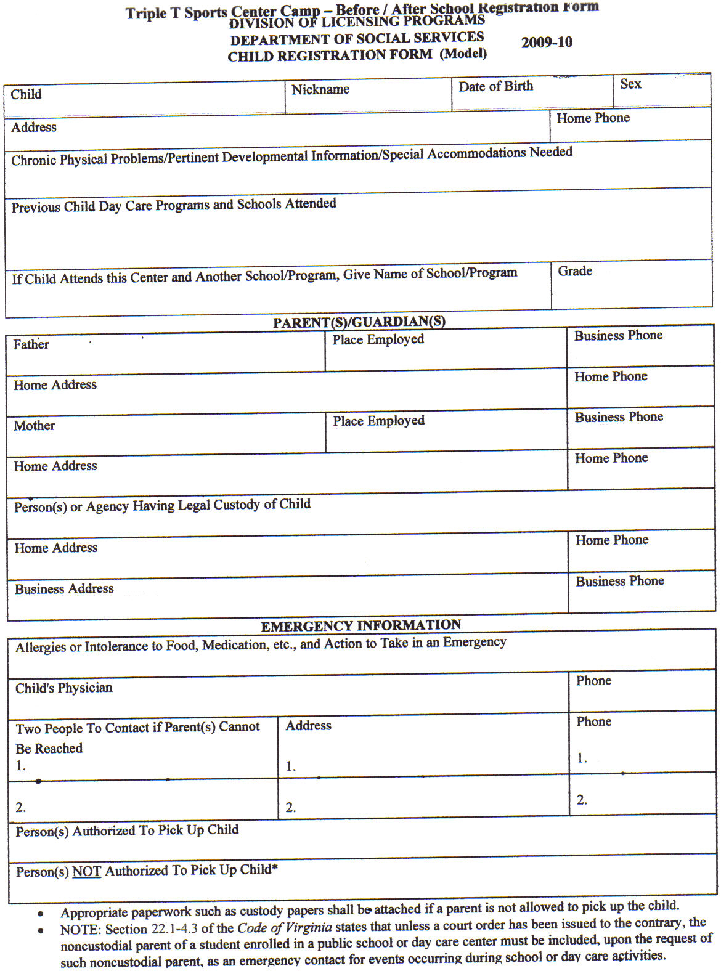

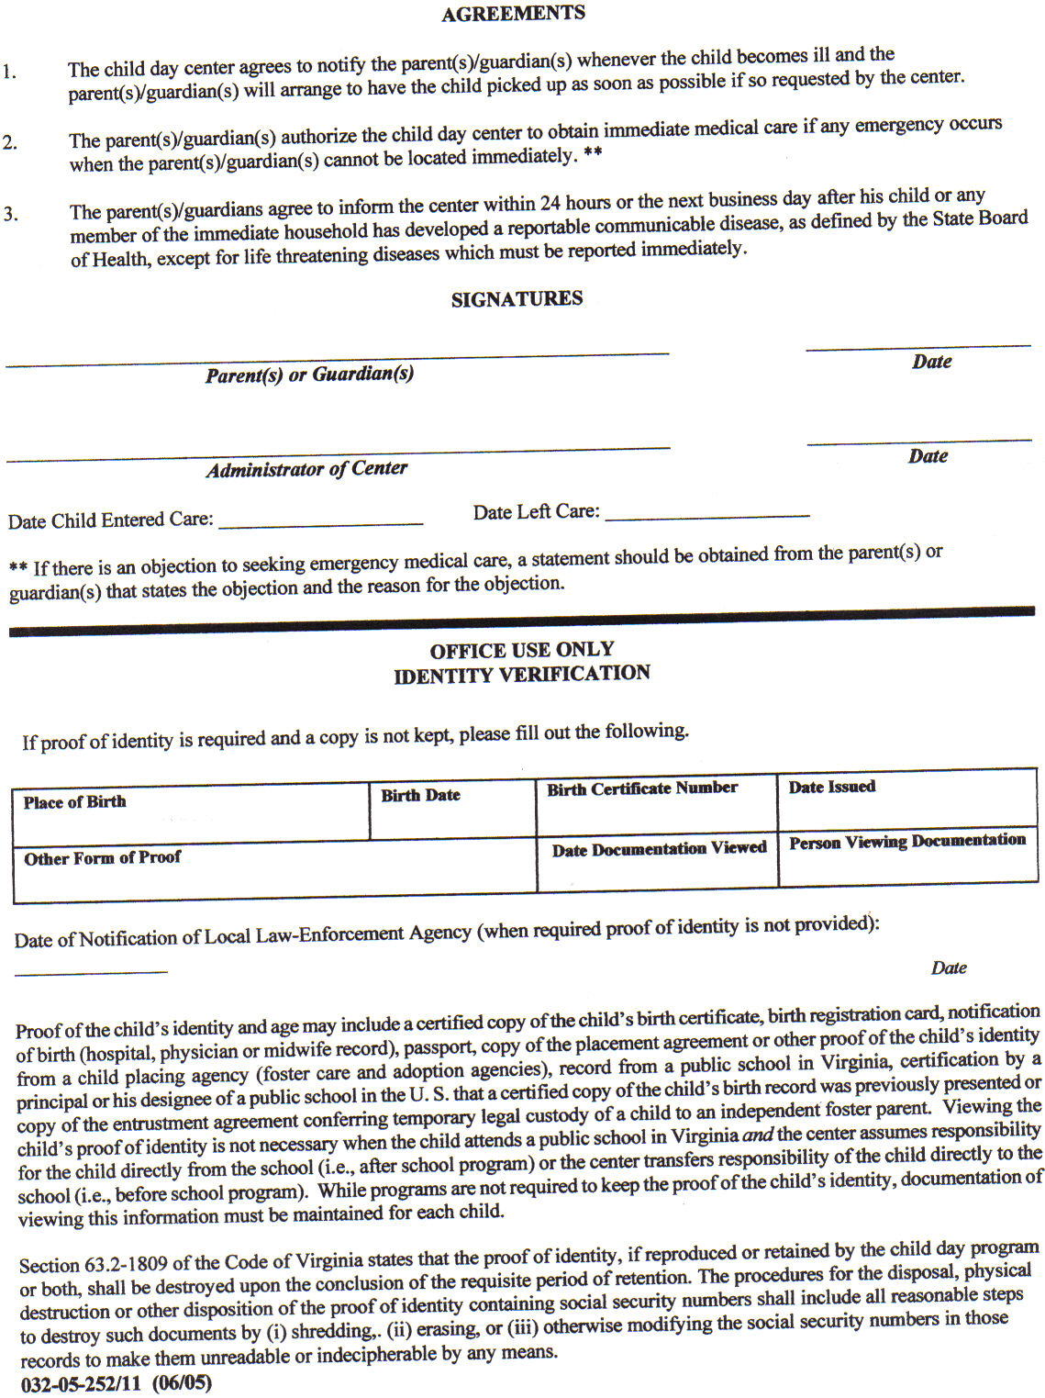

 Triple T Sports Center 

*619 East Constance Rd. Suffolk, Virginia 23434*

*(757) 923-5150 (757) 923-5185 Fax*

Nansemond Parkway Elementary

q Elephants Fork Elementary (Pending # of children registered)

Kilby Shores Elementary

Booker T Elementary (Pending # of children registered)

Mack Benn Elementary (need transportations approval to ride their bus)

Re: After School Pick Up

I authorize Triple T Sports Center, Cheryl Burks, and Kaitlyn Sabatino to pick up my child, __________________________, from school for after school care starting on ______________.

______________________________ _________

Parent (Legal Guardian) Signature Date

______________________________

Printed Name

Days of the week for Triple T pick up: (circle all days)

Monday Tuesday Wednesday Thursday Friday

Cost: (due the wed the week prior)

Before & After 5 days $95 per week

$105 Non-Member

Before only 5 days $55 per week

$65 Non-Member

After only 5 days $70 per week

$80 Non-Member

Triple T Sports Center

*Childcare*

**Preschool Member Registration Fee:** $50 / $35 add’l children

**Non-Member Preschool Registration Fee:** $65 / $50 add’l children

**Full Time Rate:** 5 Full Days $160 / $185 Non-Member

**Part Time Rate:** 3 Full Days $115 / $130 Non-Member

**Before School Care:** $55 / $65 Non-Member

**After School Care:** $70 / 80 Non-Member

**Before / After School Care:** $95 / $105 Non-Member

**5% Sibling discount for each sibling:** If one sibling is a member and siblings are not then we will do the member rate without the discount.

**Registration for Triple T serviced schools & Mack Benn for Before & Afterschool will begin on 7/25/2023. Before or only after will begin August 10th.**

**Cash, Check, Debit Card, Master Card, Visa, Discover Accepted**

**Childcare Hours 6am-6pm**

**Licensed / Non – Licensed Areas:** I understand that there are licensed and non – licensed areas of Triple t Sports Center. The licensed areas include the lobby, kitchen/party room, preschool room, and back TaeKwondo room. I give Triple T staff my permission to sign my child in and out of licensed and non – licensed areas during childcare based on the activities they are participating in.

**Children will not be able to attend if tuition is not current.**

**Payment must be received by the Wednesday before each week. A guaranteed form of payment in the form of a credit card for childcare is required to be added to your BrightWheel account. You will be responsible for payment regardless of attendance. Tuition holds their place in childcare.**

**Very Important! We follow CDC Health Guidelines. A health screen must be submitted daily on BrightWheel prior to drop off. You will scan the QR code in the lobby to sign your child in.  Only the parent or authorized person is permitted to pick up. If a person comes to pick up your child that is not on your approved pickup list, then we will not release the child without written permission from the parent or the correct code word is given.**

**I have read and understand the Triple T childcare policies and agree that childcare balances will be paid the Wednesday prior to the start of each week. A $15 late fee will be due if payment is not received on time.**

**__________________________________________________________________________________________Signature** **Date**