**SANCTUS**

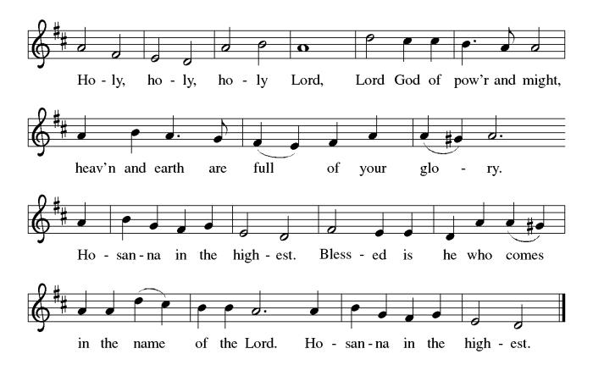

**THE EUCHARISTIC PRAYER**

V. Blessed are you, Lord of heaven and earth, in mercy for our fallen world you gave

your only Son, that all those who believe in Him should not perish, but have

eternal life. We give thanks to you for the salvation you have prepared for us

through Jesus Christ. Send now your Holy Spirit into our hearts that we may

receive our Lord with a living faith as He comes to us in His holy supper.

**C. Amen. Come, Lord Jesus.**

V. In the night in which he was betrayed our Lord Jesus took bread,

he gave thanks; broke it, and gave it to his disciples, saying:

*Take and eat; this is my body, given for you.*

*Do this for the remembrance of me.*

V. Again, after supper, He took the cup, he gave thanks,

and gave it for all to drink, saying:

*This cup is the new covenant in my blood,*

*shed for you and for all people for the forgiveness of sin.*

*Do this for the remembrance of me.*

**THE LORD’S PRAYER**

(We ring the bell throughout the Lord’s Prayer at all services to

invite those in the community to join in praying the Lord’s Prayer.)

V. May we now join with one another and pray together as Jesus has taught us.

**C. Our Father, who art in heaven, hallowed be thy name, thy kingdom come,**

**thy will be done, on earth as it is in heaven. Give us this day our daily**

**bread; and forgive us our trespasses, as we forgive those who trespass**

**against us; and lead us not into temptation, but deliver us from evil. For**

**thine is the kingdom, and the power, and the glory, forever and ever.**

**Amen.**

**LAMB OF GOD**

**C:\Users\Vince and Heather\Downloads\Lamb of God, ELW Setting Four (Melody).tif**

(We invite you to be seated.)

**HOLY COMMUNION**

V. Communion here is pretty simple, and all who are baptized and believe in Jesus

Christ are welcome at the table.

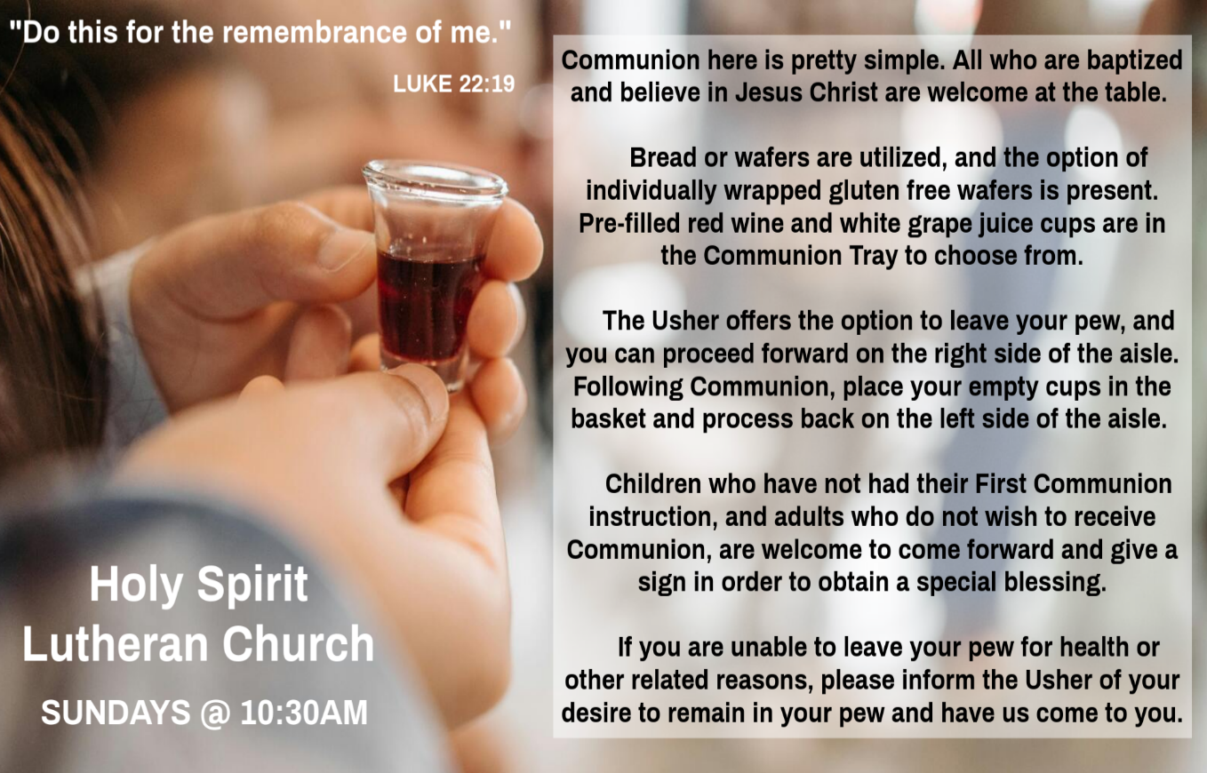

**INVITATION TO COMMUNION**

V. Jesus welcomes sinners and eats with them.

Come to this meal of mercy.

**C. Amen.**

(Distribution of Holy Communion)

**COMMUNION HYMN**

(Please enjoy various music offered by our Organist during your

quiet time, prayer, and reflection following Holy Communion.)

(Vicar and Assistant remove Communion Vessels from the Altar.)

V. We invite you to stand as you are able.

V. We invite you to stand as you are able.

**OFFERING PRAYER**

V. Let us pray,

Lord of the harvest,

we return to you a portion of what you have given to us.

Turn us to set our hope not on the uncertainty of riches,

but on you, who richly provides for us.

Multiply what we have gathered

to bless all who are suffering and in need,

through Jesus Christ our Lord.

**C. Amen.**

**GREAT THANKSGIVING**

V. The Lord be with you.

**C. And also with you.**

V. Lift up your hearts.

**C. We lift them to the Lord.**

V. Let us give thanks to the Lord our God.

**C. It is right to give him thanks and praise.**

V. It is indeed right and salutary that we should at all times and in all places offer

thanks and praise to you, O Lord, holy Father, through Christ our Lord; who rose

beyond the bounds of death and, as he promised, poured out your Spirit of life

and power upon the chosen disciples. At this the whole earth exults in boundless

joy. And so, with the Church on earth and the hosts of heaven, we praise your

name and join their unending hymn:

**OFFERING SONG**

(We invite you to sing along with the music offered by our Organist.)

Worship & Praise

**156—What Have We to Offer?**

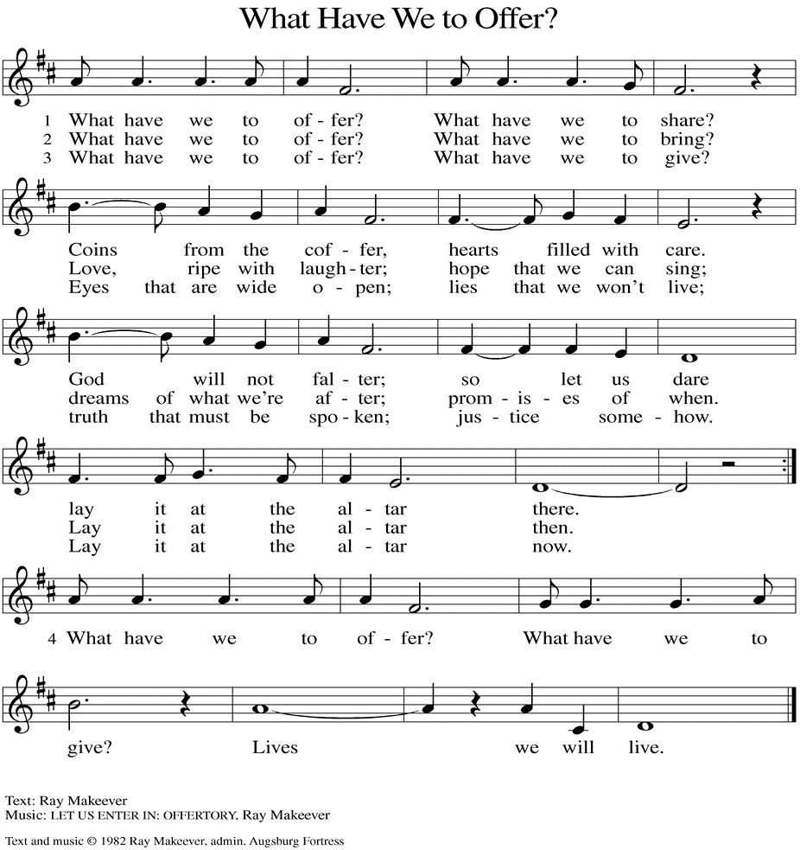

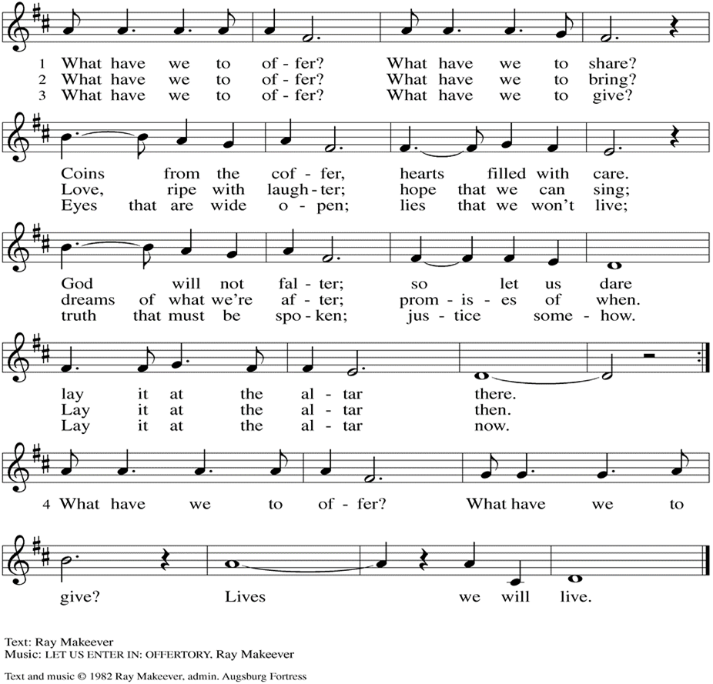

(Usher(s) brings the Tithes and Offerings up front to the Assistant.)

**POST COMMUNION BLESSING**

V. May the body and blood of our Lord Jesus Christ strengthen us and keep us

always in His grace.

**C. Amen.**

**POST COMMUNION CANTICLE**

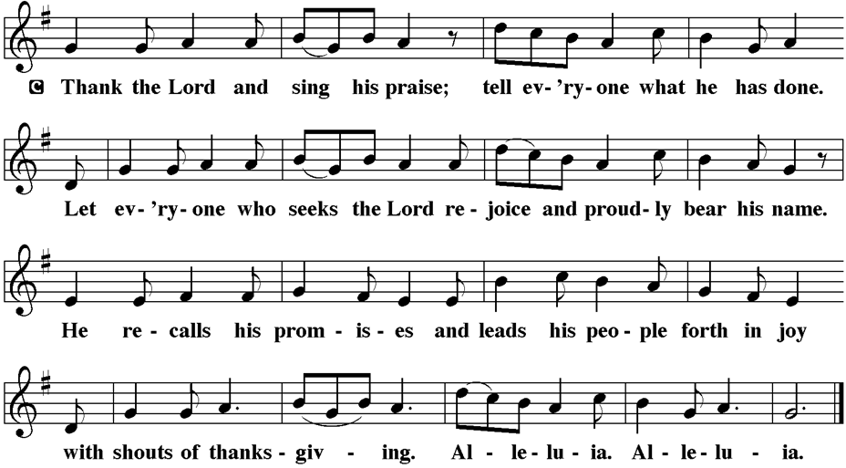

**PRAYER AFTER COMMUNION**

A. Let us pray,

O God,

through this meal you have strengthened us

and appointed us to be your servants.

Send us to do good and to share our possessions

with all in need.

We ask this in Jesus’ name.

**C. Amen.**

**BLESSING**

V. The God of righteousness,

who gives justice to the oppressed,

who gives food to the hungry,

who sets the prisoners free,

**☩** bless you now and forever.

**C. Amen.**



**SENDING HYMN**

(We invite you to sing along with the music offered by our Organist.)

Lutheran Book of Worship—Green Book

**448—Amazing Grace, How Sweet the Sound**

(Assistant extinguishes the Altar Candles half way through the Sending Hymn.)

(Vicar processes out once the Altar Candles have been extinguished.)

(We invite you to be seated.)

**BIRTHDAYS, ANNIVERSARIES, & ANNOUNCEMENTS**

(Offered by Assistant and Congregation.)

**BIRTHDAYS**

14th Bubba Thomas

15th Skip Millard

**ANNIVERSARY**

15th Scott & Kristina Crull

**DISMISSAL**

A. Go in peace. Do not lose heart.

**C. Thanks be to God.**

**POSTLUDE**

(Music offered by our Organist as we depart following our Worship Service.)

**By His Grace**

**SHARING OF THE PEACE**

V. May the peace of the Lord be with you always.

**C. And also with you.**

V. Now, let us share God’s Peace with one another.

(Please respect your neighbor if they desire to still only offer a peace sign or wave.)

(Following the Sharing of the Peace, we invite you to be seated.)

**OFFERING**

V. We now worship God with our tithes and offerings, wine and bread for use in holy

communion, and monetary gifts to support our ministry for service in God’s name.

Our Ushers will be around to your pews to pass the Offering Plates.

(Ushers come forward to get the Offering Plates from the Assistant.)

(Vicar and Assistant prepare the Altar for Communion.)

Messiah Lutheran Church (Oakland, NJ)

Carol Brand (Skip & Bonnie Millard’s Friend)

Joyce Thompson (TDPWC Member)

Barbara Paynter (Leon Stitt’s Family)

Kristy (Pastor David Jones’ Family)

Robert Fox (Carol Amundsen's Friend)

Carol Jordan (Vicki Rinier's Family)

Larry (Carol Amundsen’s Cat)

Ruth (Anthony & Vincent Bruno's Family)

Kathy Poehler (Church Member)

Tom M (Philomena Noak's Family)

Pat Grone (Vicki Rinier's Friend)

William T Hodgetts (Pastor William Hodgetts’ Family)

(Additional Names Added Prior to the Worship Service.)

A. Give us compassionate hearts to accompany those who are hurting and courage

to work for justice and mercy. God of grace,

**C. receive our prayer.**

A. Merciful God, bind us together as a community of forgiveness and love. Supply us

with humility to seek forgiveness when we have wronged one another and

generosity to extend mercy when we have been wronged. God of grace,

**C. receive our prayer.**

A. Merciful God, we remember in love those who have departed this life. Console

those who mourn, and give them the hope of resurrection. God of grace,

**C. receive our prayer.**

(Here other intercessions may be offered.)

V. Watch over all of us who are worried and suffering, and especially those whose

names we now say aloud or hold within our hearts (pause). God of grace,

**C. receive our prayer.**

V. We entrust these prayers to you, O God, in the name of Jesus Christ, our

redeemer and friend.

**C. Amen.**



**WORSHIP MINISTRY**

The most important thing we do each week is gather together as God's people to Worship. God is the center and focus of everything we do. Participating in Worship is active, as Liturgy means the work and actions of the people gathered. Everything we do during the week to prepare for Worship, and everything we do as we Assist in leading Worship is important. We are thankful for all the wonderful work being done. If you have questions, or are interested in any position, reach out to Vicar Vince.

Sign-up sheets are located on the bulletin board between the church offices.



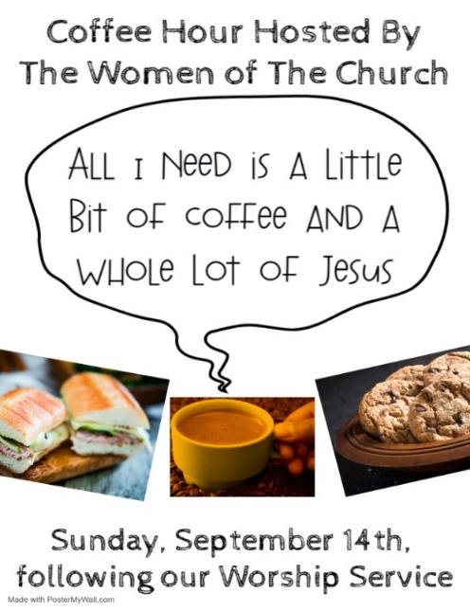

**NEWSLETTER**

Collect information, stories, pictures, and reports for our next seasonal publication. Submit everything to Vicar Vince in-person or via email at vpie8282@gmail.com no later than **TODAY, Sunday, September 14th**, for the Fall Publication.

**CLINICAL PASTORAL EDUCATION**

Vicar Vince has been blessed with the opportunity of joining Chaplain Stephen Faller on-line for CPE classes on **Sunday afternoons from 4PM-8:30PM** on Zoom. Please be respectful of this if you happen to see his car at the church.

**CHURCH COUNCIL**

Share your comments, concerns, questions, or joys with one of our Church Council Members who can bring them back to our meetings. Visitors are always welcome to attend and listen to what is going on in and around the church. Join us In- Person or on our Conference Call at our next Meeting on **Tuesday, September 16th, at 6PM**.



**FOOD PANTRY**

**Open every Thursday**, and the **last Saturday of every month**, from **10AM to 1PM**. 89 people were served in August. 574 people have been served in 2025. Donations can be dropped in the basket in the Narthex, placed in the outdoor drop-box by the Church Office door, placed in the money jug in the back of the Church, mailed into the Church Office, or placed in the Offering Plate. Volunteers are needed each week. Sign-up sheets are located on the bulletin board between the church offices.

If you have questions or need training see Heather, Vicar Vince, or Bonnie.

A special thank you goes out to all who donate, pray, and help in any way!

|  |  |  |
| --- | --- | --- |
| **Thursday, 9/18** | **Thursday, 9/25** | **Saturday, 9/27** |
| Tori & Cathie | Bob & Vicar Vince | Skip & Bonnie |

**COMMUNITY FOOD DONATIONS, DELIVERIES, & MORE**

Our local North Cape May Acme provides us with Expiring Soon, Recently Expired, and Slightly Damaged Food & Items weekly. Kathy helps those in need by delivering items each Wednesday & Saturday in the community, brings leftover items to the Church for church members in need, and those who visit the food pantry during the week. Additional items are taken to the Branches in Rio Grande on Mondays.

Ron Anderson (Bill Kelly's Friend)

Pat Labrae (Kathy Poehler's Friend)

Bud Brearey (Judy Brannan & Mary Melnicoff's Friend)

Mary Skain (Kathy Poehler's Friend)

Robert Chaplin (Mary Melnicoff's Friend)

Jack Wieckouski (Theresa & Kim McGinley's Family)

Carolyn Santarpio (Bob Fritsch's Friend)

Ken Mortensen (Del McKenna's Family)

Harry (Judy Brannan's Friend)

Janet K (Philomena Noak's Friend)

Michael Hart (Diana DeNote's Friend)

Rocco Leonard DeNote (Diana DeNote's Family)

Al Singer & Family (Frank Ford's Friends)

Sherri Lynn (Bob Fritsch's Friend)

John Bannco (Bob Fritsch's Friend)

Nancy Pazarinie (Bob Fritsch's Family)

Jane & Paul Eiben (Rose Lang's Friend)

Joe DiMassimo (Judy Brannan & Mary Melnicoff's Friend)

Tommy Stanford (Sue Waltz's Family)

Audrey McAlister (Sue Waltz's Family)

Joe Waltz (Sue Waltz's Family)

Ronald Velli (Kathy Poehler's Friend)

Denny Papst (Rose Lang’s Friend)

Mike & Alice Rhoades (Rose Lang’s Friends)

Chris (Judy Brannan's Friend)

Helen Ehlers (Judy Brannan's Friend)

Hailey (Fran Green's Friend)

Leanne Bueth (Joan Kilcoyne's Family)

Janett MacFarlane (Carol Amundsen's Friend)

Patrick Davenport (Sue Waltz's Friend)

Sonja Anderson (Theresa & Kim McGinley's Family)

Thish Kelly (Theresa & Kim McGinley's Family)

Joanne Shipper (Del McKenna's Family)

Edward Chapleski (Allison Call's Family)

Scott Levin (Rose Lang's Friend)

Lynne Curlett (Del McKenna's Family)

Alice Ann Dennis (Diana DeNote's Family)

Nancy Taylor (Ted & Diane Bell's Family)

Santa Isabel Lutheran Church (Elizabeth, NJ)

A. Merciful God, we ask forgiveness for the ways we have neglected and harmed

this earth and its creatures. Confirm our commitment to care for all you have

made, and grant us wisdom and strength to take action toward restoring your

creation to its fullness. God of grace,

**C. receive our prayer.**

A. Merciful God, govern all who hold positions of power and authority. Instruct them

to make just decisions that serve the common good. Make them instruments of

your mercy in the world, working to heal divisions and promote peace. God of

grace,

**C. receive our prayer.**

A. Merciful God, we lift up all who suffer. Bring healing, comfort, and peace to those

who are sick, grieving, or in pain; especially:

BettyAnn Rich-White (Church Member)

Chip & Marie Hand (Church Members)

Lynn Bargstadt (Church Member)

Frank Ford (Church Member)

Carol Amundsen (Church Member)

Kim McGinley (Church Member)

Anthony DeLuca (Church Member)

Frank Brunner (Church Member)

Joan Sommerman (Church Family)

Arleen Kinka (Church Family)

Rick Lang (Church Family)

Suzie Clark (Rose Lang's Friend)

Francis Clock (Dianna DeNote’s Family)

Andrew Hudak (Rose Lang’s Friend)

Viena Murtha (Bob Fritsch’s Friend)

Sharon Waicus (Skip & Bonnie Millard's Friend)

Karen O'Brien (Paul Bowker's Friend)

Dustin Irizzary (Mary Melnicoff's Family)

The Bryan Family (Wanda Bryan's Family)

Craig Brearey (Judy Brannan & Mary Melnicoff's Friend)

Sarah Dutton (Frank Ford's Family)

Christina McNasby (Fran Green’s Family)

The Kinkson Family (Judy Brannan's Friends)

Mark Stephen Dennis (Diana DeNote's Family)

Bill Lodge (Skip & Bonnie Millard's Friend)

**BULLETIN ENTRY DEADLINE**

The Bulletin is Printed on **Thursdays** during Church Office Hours. Changes need to be submitted to Vicar Vince or Heather no later than **Thursday by 4PM**. Thank you!

**CHURCH OFFICE HOURS**

Open **Thursdays from 6PM to 8PM** to serve the Congregation, the Community,

and to continue handling the business of the Church. Feel free to stop in to talk,

pick-up or drop off something, pray in the Sanctuary, or for whatever reason.

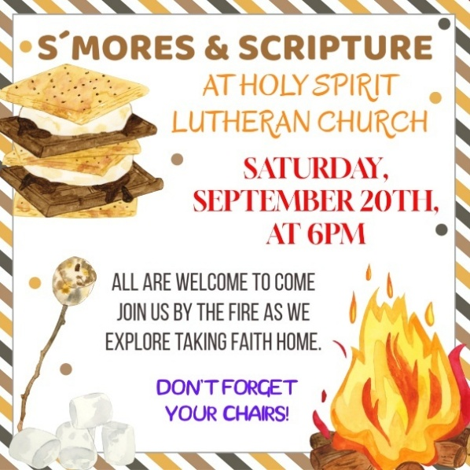

**75TH ANNIVERSARY MEETING**

We are in the final planning stages of celebrating this legacy. Join us at our next Committee Meeting on **Sunday, September 21st, following our Worship Service**.

**BIBLE STUDY & FAITH DISCUSSIONS**

​​​​​Bible Study & Faith Discussions was started in order to focus on various readings,

books, Bible verses, people of faith, and other general topics. Group Members offer

various points of view while reviewing the Bible and various aspects of faith while

being respectful and supportive of each other. **Come on out and join us NEXT Tuesday, September 23rd, at 6PM due to Church Council this week**.

**PREACHING AT BROOKDALE**

Vicar Vince will be Preaching at Brookdale Senior Living in Cape May Court House on **Sunday, September 28th, at 1PM**. Holy Communion will follow the service.

**DONATION STATION**

Get on the train and place all purchased items in the specified project donation bins located on the counter by the front doors. See Heather for more information.



**SPECIAL PREACHER**

Chip Hand has been confirmed and is happy to be here and Preaching on

**Sunday, October 5th**, while Vicar Vince and Heather are on their annual trip to Knoebels. Please note there will not be Holy Communion that Sunday as a result.

**WOMEN OF THE CHURCH**

The next monthly meeting will be held on **Monday, October 6th, at 6PM**.

New members are always welcome to attend! Contact Judy for more information.

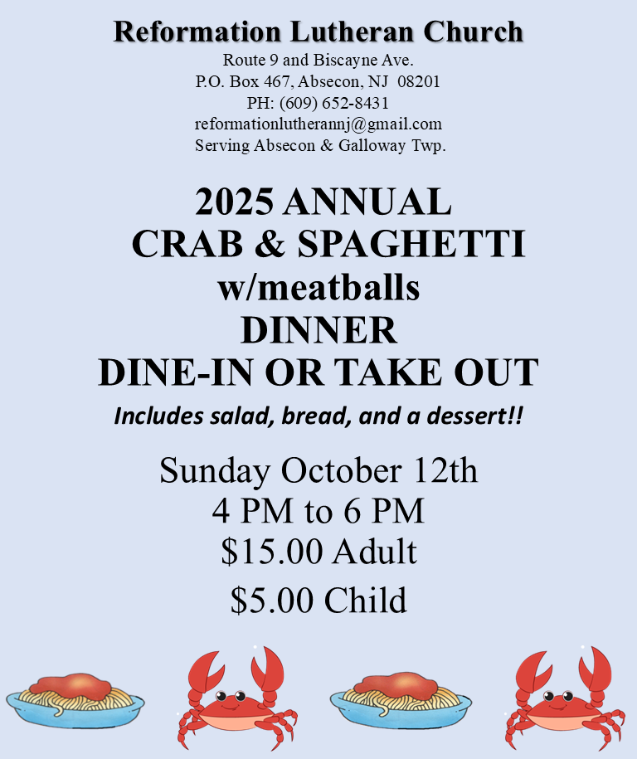

**THEOLOGICAL EDUCATION FOR EMERGING MINISTRIES**

Vicar Vince will be back in Gettysburg, PA at United Lutheran Seminary for

Congregational Studies in Context classes from **October 15th to October 18th.**

**APOSTLES’ CREED**

V. God has made us his people through our Baptism into Christ. Living together in

trust and hope let us confess our faith together using the Apostles’ Creed.

**C. I believe in God, the Father almighty,**

**creator of heaven and earth.**

**I believe in Jesus Christ, God’s only Son, our Lord,**

**who was conceived by the Holy Spirit,**

**born of the Virgin Mary,**

**suffered under Pontius Pilate,**

**was crucified, died, and was buried;**

**he descended to the dead.**

**On the third day he rose again;**

**he ascended into heaven,**

**he is seated at the right hand of the Father,**

**and he will come to judge the living and the dead.**

**I believe in the Holy Spirit,**

**the holy catholic church,**

**the communion of saints,**

**the forgiveness of sins,**

**the resurrection of the body**

**and the life everlasting.**

**Amen.**

**PRAYERS OF INTERCESSION**

(The prayers are prepared locally for each occasion.)

V. Gracious God, we come to you in prayer for the church, the world, and all in need.

(A brief silence.)

A. Merciful God, pour out your grace upon your church. Forgive us for the times

when we have been unfaithful, and renew our commitment to your gospel of love.

Empower us to live as a community of mercy. God of grace,

**C. receive our prayer.**

V. 1 Now all the tax collectors and sinners were coming near to listen to [Jesus.]

2 And the Pharisees and the scribes were grumbling and saying, “This fellow

welcomes sinners and eats with them.”

3 So he told them this parable: 4 “Which one of you, having a hundred sheep and

losing one of them, does not leave the ninety-nine in the wilderness and go after

the one that is lost until he finds it? 5 And when he has found it, he lays it on his

shoulders and rejoices. 6 And when he comes home, he calls together his friends

and neighbors, saying to them, ‘Rejoice with me, for I have found my lost sheep.’

7 Just so, I tell you, there will be more joy in heaven over one sinner who repents

than over ninety-nine righteous persons who need no repentance.

8 “Or what woman having ten silver coins, if she loses one of them, does not light

a lamp, sweep the house, and search carefully until she finds it? 9 And when she

has found it, she calls together her friends and neighbors, saying, ‘Rejoice with

me, for I have found the coin that I had lost.’ 10 Just so, I tell you, there is joy in

the presence of the angels of God over one sinner who repents.”

V. This is the Gospel of the Lord,

**C. Praise to you, O Christ.**

(We invite you to be seated.)

**SERMON**

(Delivered by Vicar Vince Piekarski.)

V. We invite you to stand as you are able.



**HYMN OF THE DAY**

(We invite you to sing along with the music offered by our Organist.)

Lutheran Book of Worship—Green Book

**499—Come, Thou Fount of Every Blessing**

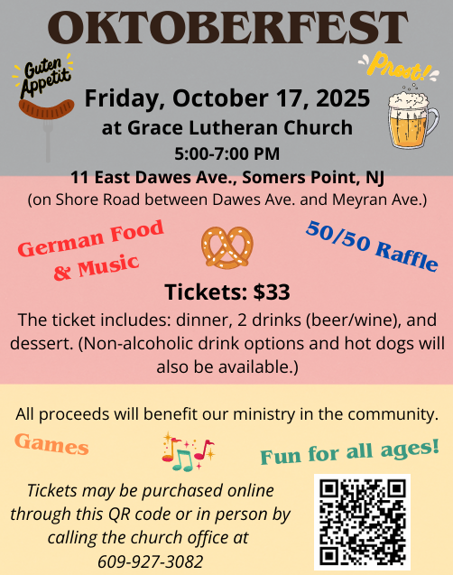

**75TH ANNIVERSARY**

We are on the Bishop’s Calendar for **Sunday, October 19th with one Worship Service to be held at 3PM**. This congregation is a legacy that we have all lived in and through over the years, or maybe just for a short time. However, it is a legacy that we hope and desire to continue to carry on and move forward for those people that will be able to gather and worship with us now and in the future. We are the church carries a strong mentality with it, and it does not just mean within these very walls. We need to celebrate our faith and all that led up to the 75 years of our Congregation and being part of this community. **Please make sure you RSVP!**

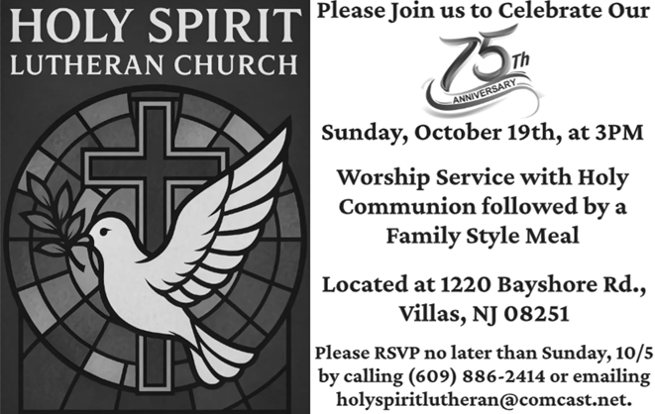

**CONFIRMATION & SUNDAY SCHOOL**

“Here We Stand” allows our young folks to go through a 2-year process while focusing on the Bible and Luther’s Small Catechism. **We are on Summer Break and will begin year 2 of our studies on Sunday, October 26th, from 9-10AM**.

We are also exploring resuming regular Sunday School classes for children of all ages to attend. We are looking at various dates and times in this planning process.

See Heather, Bonnie, & Vicar Vince for more information.

**FALL HARVEST**

True Deliverance Praise & Worship Center will be holding a Fall Harvest with Treat Bags and Activities in the afternoon. All are invited on **Sunday, October 26th**.

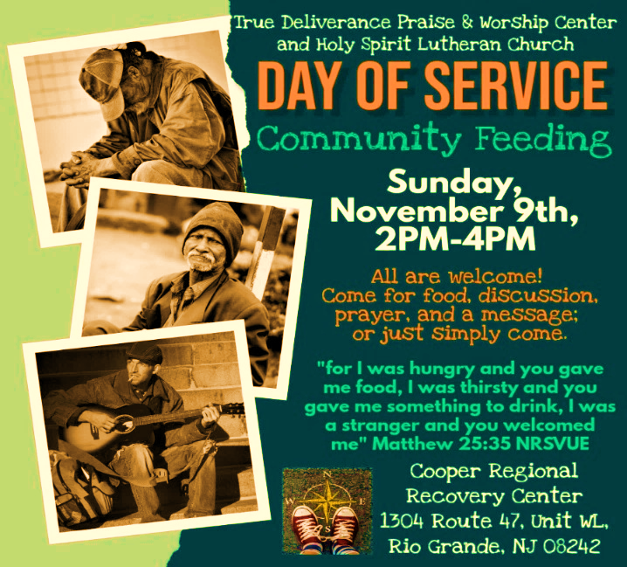

**INTINCTION DURING COMMUNION**

Following discussion and the vote of our Church Council we will be introducing and educating on Intinction while communing together in months that have a fifth Sunday. If you have any questions please see Vicar Vince. Our next time doing this will be on **Sunday, November 30th**, during our 10:30AM Worship Service.

**SECOND READING**

The letters to Timothy and Titus are called the pastoral epistles because they

contain advice especially intended for leaders in the church. Here the mercy

shown to Paul, who once persecuted the church, is cited as evidence that even

the most unworthy may become witnesses to the grace of God.

R. Our Second Reading is from the 1st Chapter of 1st Timothy (Verses 12-17).

R. 12 I am grateful to Christ Jesus our Lord, who has strengthened me, because he

considered me faithful and appointed me to his service, 13 even though I was

formerly a blasphemer, a persecutor, and a man of violence. But I received mercy

because I had acted ignorantly in unbelief, 14 and the grace of our Lord

overflowed for me with the faith and love that are in Christ Jesus. 15 The saying

is sure and worthy of full acceptance: that Christ Jesus came into the world to

save sinners—of whom I am the foremost. 16 But for that very reason I received

mercy, so that in me, as the foremost, Jesus Christ might display the utmost

patience as an example to those who would come to believe in him for eternal

life. 17 To the King of the ages, immortal, invisible, the only God, be honor and

glory forever and ever. Amen.

R. This is the Word of the Lord.

**C. Thanks be to God.**

V. I invite you to stand as you are able, and I invite you to announce the Gospel

Acclamation with me.

**GOSPEL ACCLAMATION**

**C. Alleluia. There is joy in the presence of the angels of God over one sinner**

**who repents. Alleluia.** (Luke 15:10)

**GOSPEL READING**

Jesus tells two stories that suggest a curious connection between the lost being

found and sinners repenting. God takes the initiative to find sinners, each of

whom is so precious to God that their recovery brings joy in heaven.

V. The Holy Gospel According to Luke, the 15th Chapter (Verses 1-10).

**C. Glory to you, O Lord.**

that I have promised I will give to your descendants, and they shall inherit it

forever.’ ” 14 And the Lord changed his mind about the disaster that he planned

to bring on his people.

R. This is the Word of the Lord.

**C. Thanks be to God.**

**PSALM**

R. Our Responsorial Psalm is from the 51st Psalm (Verses 1-10).

**C. Have mercy on me, O God, according to your steadfast love.** (Ps. 51:1)

R. 1 Have mercy on me, O God, according to your steadfast love;

   in your great compassion blot out my offenses.

  2 Wash me through and through from my wickedness,

   and cleanse me from my sin.

  3 For I know my offenses,

   and my sin is ever before me.

  4 Against you only have I sinned and done what is evil in your sight;

   so you are justified when you speak and right in your judgment.

**C. Have mercy on me, O God, according to your steadfast love.** (Ps. 51:1)

R. 5 Indeed, I was born steeped in wickedness,

   a sinner from my mother’s womb.

  6 Indeed, you delight in truth deep within me,

   and would have me know wisdom deep within.

  7 Remove my sins with hyssop, and I shall be clean;

   wash me, and I shall be purer than snow.

  8 Let me hear joy and gladness;

   that the body you have broken may rejoice.

  9 Hide your face from my sins,

   and blot out all my wickedness.

  10 Create in me a clean heart, O God,

  and renew a right spirit within me.

**C. Have mercy on me, O God, according to your steadfast love.** (Ps. 51:1)

**PRAYER LIST**

Our Prayer List continues to lengthen and we realize the important need for prayers and healing. Sometimes the unfortunate result is that someone has passed away, and the words “The Family & Friends of” appear before someone’s name. However, sometimes we forget names are still on the list and their health has improved or the they are no longer struggling, and they can be removed. Please share the good and bad stories as we continue to pray for strength and healing. Names can be added or removed from the list on the clipboard in the Narthex prior to the Worship Service, by calling the church office, or addressing it on the Conference Call. Please let us know the relation to the person(s) you listed so we can be more mindful with our prayers. Names will stay on the list until removed by the person(s) who requested prayer.

**PRAYER SHAWL MINISTRY**

Prayer Shawls, Lap Quilts, Scarves, and other items have been made with love. Blessed items are located in the Narthex, and are free for anyone. Members of the group continue working at home on new stitches and patterns. We are blessed to be able to continue collecting new items. We have a donation station of yarn and other items located in the Narthex. You can find some new supplies for your next creation!

**HOME COMMUNION MINISTRY**

A Minister is available if you have a loved one, or if you desire services. We look forward in sharing the Word and Holy Communion! Please inform Vicar Vince, Kathy, or the Church Office so plans can be made for visits.

**TITHES, OFFERINGS, & ENVELOPES**

Please see Heather if you have not received or would like 2025 Offering Envelopes. For we do indeed worship God with our tithes and offerings. “Each of you must give as you have made up your mind, not reluctantly or under compulsion, for God loves a cheerful giver.” (2 Corinthians 9:7) Drop your envelopes in the offering plate, mail them to the church, or drop them in the locked mailbox. Thanks for your continued support in the mission of our church, its ministries, the NJ Synod, and other needs!

**ED GREEN CAPITAL IMPROVEMENT FUND**

We continue raising money for unforeseen costs or repairs.Kathy sells Wawa Tickets for $6, the donation bin is in the back of the church, and we have our Annual Church Rummage Sale. Thanks for your continued donations, prayers, and support!

**SPACE AVAILABLE**

​​​​​Do you know anyone interested in utilizing our Fellowship Hall for a Party or Event?

It is a suggested $50 refundable security deposit, and $250 for facility use. There is no alcohol or games of chance permitted due to ELCA policy. Please contact Vicar Vince or the Church Office with questions, for info, or to reserve a date and time.

**INTERESTED IN BECOMING A NEW MEMBER**

Have you been attending our church for a while? Have you just recently returned to church after being away for a bit? Maybe you transitioned from another church,

or just started to recently attend our church. We are glad to have you, and would love to have you as a member of our Congregation. See Vicar Vince for more info.

**BAPTISM**

We are a church whose unity is in Jesus Christ, who gathers us around word and water, wine and bread. Baptism is a significant part of our faith journey as we come from the baptismal waters to live a new life as children of God. Our baptism sets us out on a lifelong journey that is characterized by our relationship to God, our relationship to our faith community, our relationships in our community and the wider world. Living our baptismal covenant means living a life of growth in the faith practices of discipleship. Please see Vicar Vince for more information.

**FIRST COMMUNION**

Although no particular age for first communion is prescribed by The Use of the Means of Grace, one guideline is offered. Because admission to the Sacrament is by invitation of the Lord to the baptized, "baptized children begin to commune on a regular basis at a time determined through mutual conversation that includes the pastor/vicar, the child, and the parents or sponsors involved, within the accepted practices of the congregation.” Each congregation is encouraged to ask the question of readiness for first communion, establish their own policies regarding age and practice, and accompany that practice with catechesis appropriate to the age of the communicant. If anyone has questions, please see Vicar Vince.

**2025 CHURCH DIRECTORY**

Additional copies are by the Church Office on the bookshelves. We continue keeping it updated and undoubtedly miss a few changes or have made a few errors. There are spaces for changes in info, new people’s info, notes, and your favorite Bible verses. Please continue to inform the Church Office of any changes or updates.

**PRAYER OF THE DAY**

V. The Lord be with you.

**C. And also with you.**

V. Let us pray,

O God, overflowing with mercy and compassion, you lead back to yourself all

those who go astray. Preserve your people in your loving care, that we may reject

whatever is contrary to you and may follow all things that sustain our life in your

Son, Jesus Christ, our Savior and Lord.

**C. Amen.**

(We invite you to be seated for our Readings and Psalm.)

**FIRST READING**

While Moses is on Mount Sinai, the people grow restless and make a golden calf

to worship. Today’s reading shows Moses as the mediator between an angry

God and a sinful people. Moses reminds God that the Israelites are God’s own

people, and boldly asks for mercy for them.

R. Our First Reading is from the 32nd Chapter of Exodus (Verses 7-14).

R. 7 The Lord said to Moses, “Go down at once! Your people, whom you brought up

out of the land of Egypt, have acted perversely; 8 they have been quick to turn

aside from the way that I commanded them; they have cast for themselves an

image of a calf and have worshiped it and sacrificed to it and said, ‘These are

your gods, O Israel, who brought you up out of the land of Egypt!’ ” 9 The Lord

said to Moses, “I have seen this people, how stiff-necked they are. 10 Now let me

alone so that my wrath may burn hot against them and I may consume them, and

of you I will make a great nation.”

11 But Moses implored the Lord his God and said, “O Lord, why does your wrath

burn hot against your people, whom you brought out of the land of Egypt with

great power and with a mighty hand? 12 Why should the Egyptians say, ‘It was

with evil intent that he brought them out to kill them in the mountains and to

consume them from the face of the earth’? Turn from your fierce wrath; change

your mind and do not bring disaster on your people. 13 Remember Abraham,

Isaac, and Israel, your servants, how you swore to them by your own self, saying

to them, ‘I will multiply your descendants like the stars of heaven, and all this land

**HYMN OF PRAISE**

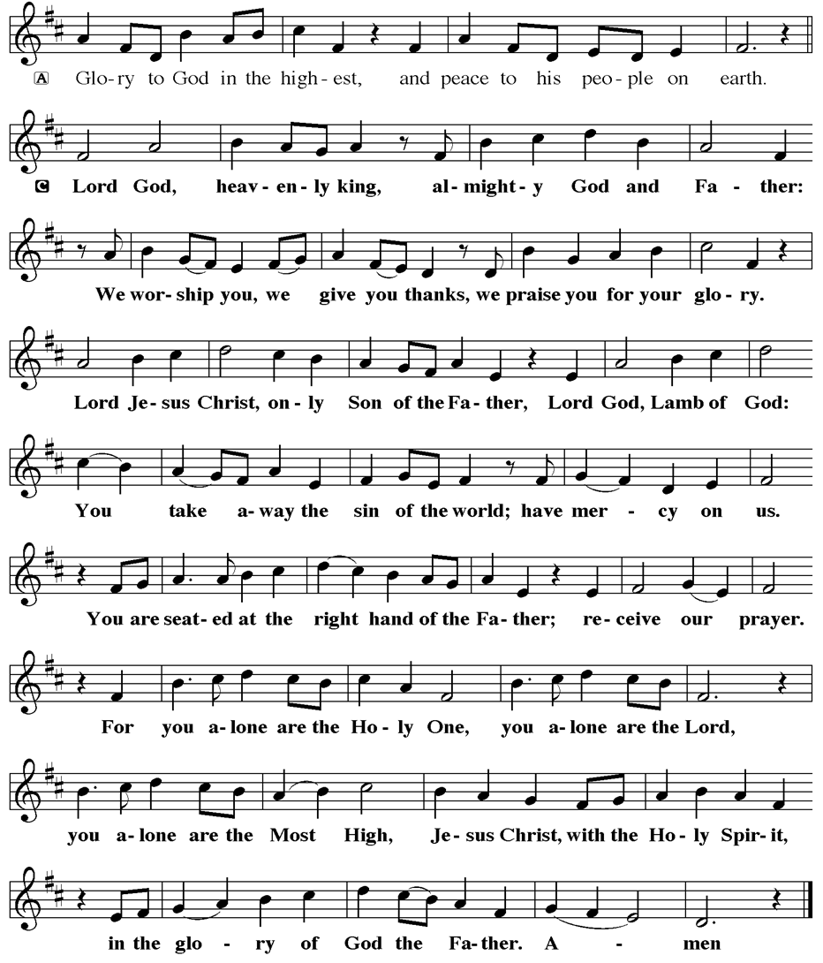

**LIBRARY**

New books are added to our library from time to time. Several are borrowed and read and exchanged. Who knows, you might find one particularly interesting and share that with someone as well. Reading is a great way to pass spare time, learn, and explore. You may find some fresh ideas for prayer, ways to grow more spiritually, ways to grow closer to God, or some opportunities to understand our faith more. Visit the library between the church offices and see what books are there!

We also have an extended library located in Vicar Vince’s office. There are Bibles of various translations, books from his personal collection, books inherited from Pastor Leah, movies, past Bible Study Curriculums, and more. Just ask to check things out!

**TAKING FAITH HOME**

Vicar Vince was introduced to Milestones Ministries weekly guides for faith-filled studies and conversations through a Seminary class. A decision was made to pass these along to you. If you missed a week, or lost your insert, check our website for past issues. Feel free to ask questions and provide feedback to Vicar Vince.

**FAVORITE HYMNS**

Carol is willing to play some of your favorite hymns for the Prelude & Postlude each Sunday during our Worship Service. Feel free to let her know of your suggestions.

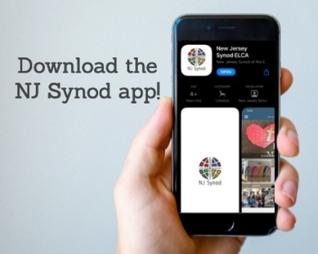

A weekly e-newsletter that connects our synod together with weekly prayer, upcoming events, synod and churchwide activities, mission stories, congregational activities, and more. Sign up by going to https://www.njsynod.org/stay-connected and filling out the form or download the app on your smartphone.

**VICE PASTOR UPDATE**

Pastor William Hodgetts continues to attend our monthly Church Council Meetings. Pastor William continues to provide Supervision and Direction for Vicar Vince.



**VICAR APPOINTMENT ON MARCH 19TH, 2023**

A Memorandum of Understanding on the Matter of Pastoral Appointment

In Theological Education for Emerging Ministries (TEEM) Candidacy

TO: Congregation Council, Holy Spirit Lutheran Church, Villas

FROM: The Rev. Tracie L. Bartholomew, Bishop, New Jersey Synod

Dear Brother and Sisters in Christ,

This memorandum is in support of your discussions with Vincent Piekarski as pastor of Holy Spirit, Villas. Because this is not the usual pattern for completing the educational and candidacy requirements for ordination, it is my hope that this memorandum will both provide guidelines and engage in conversation with those who are invested in this process.

I would say at the outset that because Vincent is an outstanding candidate for the Ministry of Word and Sacrament, we will all want to do whatever is necessary to assure that his placement serves the mission of the church in the best possible fashion.

The following notes reflect my own understanding of this matter:

(1) The appointment for Vincent will begin on April 1, 2023. At this time, Vincent

will assume all responsibilities of a regularly called pastor, including presiding at

the Sacrament of Holy Communion and Baptism at Holy Spirit, Villas.

(2) A pastoral appointment in the TEEM process is an option for completing

seminary educational requirements and the steps of the candidacy process.

Upon completion of the candidacy process and seminary education, the

candidate may receive and accept a call to ordained ministry from the

congregation where the appointment is being served.

(3) This appointment is jointly supervised by the Office of the Bishop and the TEEM

pastor’s seminary. A mentoring relationship with a local pastor is required for the

length of this appointment.



**APOSTOLIC GREETING**

V. May the grace of our Lord Jesus Christ, the love of God,

and the communion of the Holy Spirit be with you all.

**C. And also with you.**



V. In peace, let us pray to the Lord.

**C. Lord, have mercy.**

V. For the peace from above, and for our salvation, let us pray to the Lord.

**C. Lord, have mercy.**

V. For the peace of the whole world, for the well-being of the church of God,

and for the unity of all, let us pray to the Lord.

**C. Lord, have mercy.**

V. For this holy house, and for all who offer here their worship and praise,

let us pray to the Lord.

**C. Lord, have mercy.**

V. Help, save, comfort, and defend us, gracious Lord.

**C. Amen.**

V. Merciful and loving God,

**C. we are your stiff-necked people.**

**We trample on the needy.**

**We grumble about your grace to others.**

**We turn away from the poor.**

**Have mercy on us and forgive our sins.**

**Rejoice over us as ones who were lost**

**and have been found.**

**Amen.**

V. Even when we are faithless, God remains faithful.

Jesus Christ came into the world to save sinners.

You who were lost have been found.

In the name of ☩ Jesus, your sins are forgiven!

**C. Amen.**



**GATHERING HYMN**

(We invite you to sing along with the music offered by our Organist.)

Lutheran Book of Worship—Green Book

**526—Immortal, Invisible, God Only Wise**

(4) The synod of candidacy origin will be responsible for the approval process.

(5) Upon approval for ordination, the congregation would be expected to extend a

call to the pastoral appointee.

(6) Compensation for the TEEM pastor will be according to the guidelines of the New

Jersey Synod. All normal forms of compensation should be in place for the term

of the appointment, including stipulation that base salary and housing shall be in

accord with synod guidelines for first call at time of ordination.

(7) The ELCA Portico benefit plan for lay persons in full-time church service should

be used for the pastoral appointee up to the time of ordination, whereupon the

benefit package is to be converted to the plan for ELCA clergy.

(8) A decision for Pastoral Appointment is made with the agreement of a synod and

its candidacy committee, and the ELCA, normally represented by the regional

staff person of each in consultation with the seminary and its Director for

Contextual Education.

(9) Pastoral Appointment in a TEEM Candidacy is an option that is to serve the

mission of the Church in a particular and vital way and is not to be viewed or

used as a means to circumvent the normal candidacy process and/or first call

placement process.

In the specific case of Vincent, the New Jersey Synod remains responsible for the candidacy and approval process, and has agreed to this proposal for Appointment at Holy Spirit, Villas.

Continued blessings to both Holy Spirit and Vincent Piekarski as you embark on this journey of mutual ministry. As partners in ministry, we walk with you and rejoice in this new relationship.

**VICAR VINCE’S DAY OF REST**

A day of rest can have physical, mental, and spiritual beneficial. “Mittwoch,” German for mid-week, or Wednesday, is the day that Vicar Vince will use to recharge and do some other things. Please do not hesitate to reach out if there is an emergency!

**TRUE DELIVERANCE PRAISE & WORSHIP CENTER**

Reverend Maria Brooks and True Deliverance Praise & Worship Center utilize our facilities from 1-4PM on Sundays. TDPWC helps with the Food Pantry and hosts or assists with other events throughout the year. TDPWC hosts a **Prayer Line** on **Mondays, Thursdays, & Fridays at 5PM** on the **Conference Call 1-657-390-7957.**

**TWO OFFERINGS FOR YOU FROM OUR NEIGHBORS**

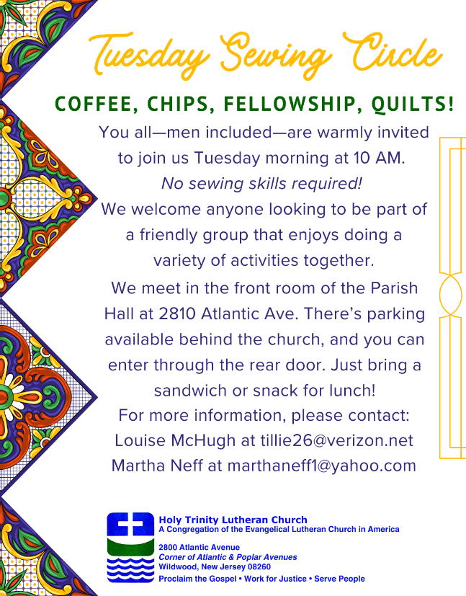 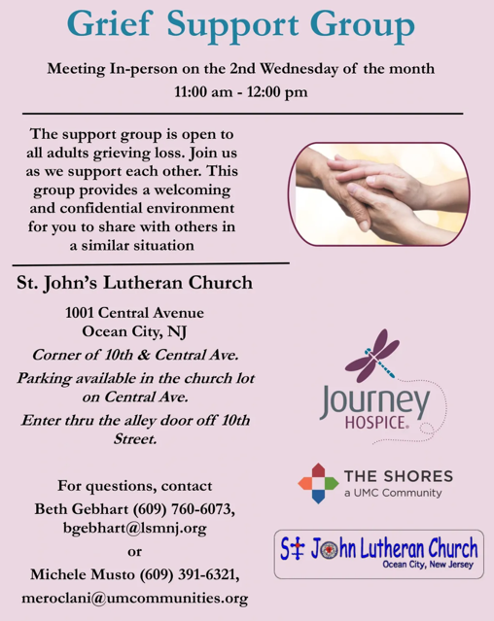

**ST. BARNABAS CARES THRIFT STORE**

Are you a person who enjoys staying active, interacting with others, likes the flexibility of working an hour or two per month and would like to support a good cause? If so, then St. Barnabas Cares Thrift Store is looking for you! The store in the Villas is looking for friendly, outgoing people to volunteer and sell clothing. There is no heavy lifting, but instead you would be arranging clothing attractively for sale. The Thrift Store is open 11-3 Monday through Saturday so even volunteering a few hours a month will help. If you are interested, please call Maureen Kersch 609-425-1317.

**CONFERENCE CALL CHECK-IN**

(Roll Call and Attendance.)

**WELCOME & ANNOUNCEMENTS**

(Vicar (V), Assistant (A), Reader (R), and Congregation (C).)

**INTRODUCTION**

A. The grumbling of the religious leaders in today’s gospel is actually our holy hope:

This Jesus welcomes sinners and eats with them. That our God seeks and saves

the lost is not only a holy hope, it is our only hope. As the writer of 1st Timothy

reminds us, “The saying is sure and worthy of full acceptance, that Christ Jesus

came into the world to save sinners.” Thanks be to God.

**PRELUDE**

(Music offered by our Organist at the start of our Worship Service.)

**In Times Like These**

**CHIMES**

(Music offered by our Organist at the start of our Worship Service.)

**Jesus, We Just Want to Thank You**

V. We invite you to stand as you are able.

**CONFESSION & FORGIVENESS**

(All may make the sign of the cross, the sign that is marked at baptism.)

V. Blessed be the holy Trinity, **☩** one God,

our maker, our helper, and our keeper.

**C. Amen.**

V. Trusting in God’s mercy, let us confess our sin

in the presence of God and of one another.

(Silence is kept for reflection.)



We, the Evangelical Lutheran Church of the Holy Spirit, are People of God, who

are called by the Holy Spirit to pray, worship, joyfully proclaim Jesus Christ,

and compassionately witness and serve others in Christian Love.



We are glad that you joined us for Worship today! Thank you for enriching our time together! We would like to get to know you better, and for you to get to know us better too. Brochures, welcome gifts, prayer shawls, Bibles, and other items are available throughout the church. We would be happy to show you around and share about our ministries. Please do not hesitate to speak up and ask questions.

Also, please make sure you sign-in on our clipboard on the podium in the lobby.



Our Worship Services are conducted in coordination with our Conference Call.

Join us at 657-390-7423 or 701-802-5170, with access code 8221190#.

You may need to dial 1 first depending on your phone plan. After logging in please announce your name and feel free to talk with others until we get started.



**SANCTUARY CANDLE FOR SEPTEMBER**

Given to the Glory of God & In Memory of ELAINE RAND & JEAN CLARK

by Wayne & Eleanor Rand.

**ALTAR CANDLES FOR SEPTEMBER**

Given to the Glory of God & In Memory of PHILIP ZIMMERMAN, JR.

by Jean, Phil, & Bob Zimmerman.

**WHAT IS THE EVANGELICAL LUTHERAN CHURCH IN AMERICA?**

The ELCA was formed in 1987 by the merger of three Lutheran Church bodies –

the ALC (American Lutheran Church), the LCA (Lutheran Church in America),

and the AELC (Association of Evangelical Lutheran Churches).

To learn more, go to the ELCA's website at www.elca.org.

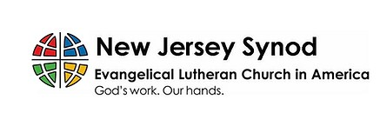

**WHAT IS THE NEW JERSEY SYNOD?**

The New Jersey Synod is a geographical grouping of Evangelical Lutheran Church in America (ELCA) congregations that share the mission and ministry of the Church on the New Jersey territory. It is one of 65 synods in the ELCA. The NJ Synod is comprised of 143 congregations, which include over 45,000 baptized members.

|  |  |
| --- | --- |
| **2025 FINANCIAL STANDING** | |
| **AUGUST INCOME** | $6,340.00 |
| **AUGUST SPENDING** | $16,806.08 |
| **AUGUST GAIN OR (LOSS)** | ($10,466.08) |
| **2025 INCOME** | $50,198.38 |
| **2025 SPENDING** | $69,053.95 |
| **2025 GAIN OR (LOSS)** | ($18,855.57) |
| **ED GREEN CAPITAL IMPROVEMENT FUND** | $4,652.55 |
| **FOOD PANTRY FUND (SOCIAL MINISTRY)** | $9,845.72 |
| **CD** | $26,078.46 |
| **75TH ANNIVERSARY** | $8,988.05 |



**LICENSES & EXPIRATION DATES**

Worship Service Content is used via permission through Augsburg Fortress Liturgies Annual License #SB144368. The next Subscription Renewal Date is 2/28/2026.

Our Hymns and Worship Music are used via permission through CCLI One

License #11327166. The next Subscription Renewal Date is 1/31/2026.

**CHURCH STAFF & VOLUNTEERS**

**VICAR, BIBLE STUDY & FAITH DISCUSSIONS,**

**EVENTS, NEWSLETTER, & WEBSITE**

Vicar Vince Piekarski

**VICE PASTOR**

Pastor William Hodgetts

**ORGANIST & PIANIST**

Carol Amundsen

**CHURCH OFFICE, SUNDAY SCHOOL, & FOOD PANTRY**

Heather Piekarski

**CHURCH COUNCIL PRESIDENT**

Mary Melnicoff

**CHURCH COUNCIL VICE PRESIDENT**

Judy Brannan

**CHURCH COUNCIL TREASURER**

Bonnie Millard

**CHURCH COUNCIL SECRETARY**

Vicki Rinier

**CHURCH PROPERTY**

Frank Ford & Wayne Rand

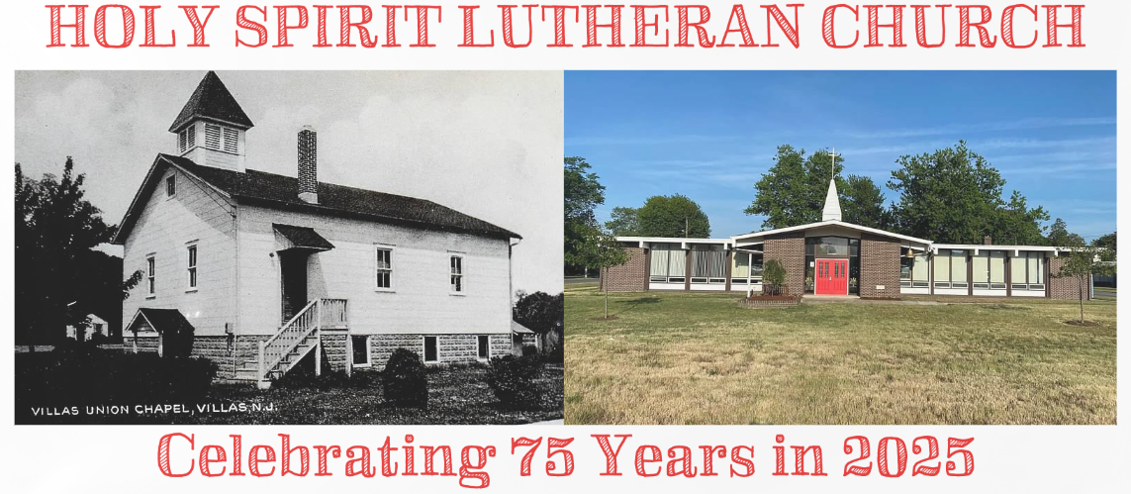

**WELCOME TO**

**HOLY SPIRIT LUTHERAN CHURCH**

A Member of the Evangelical Lutheran Church in America, New Jersey Synod

1220 Bayshore Rd., Villas, NJ 08251, 609-886-2414,

holyspiritlutheran@comcast.net, holyspiritvillas.com, facebook.com/holyspiritvillas

Vicar Vince Piekarski can be contacted at any time for conversation or prayer through call or text at 412-225-0287, or through email at vpie8282@gmail.com.

**SUNDAY, SEPTEMBER 14TH, 2025**

**14TH SUNDAY AFTER PENTECOST**

**10:30AM WORSHIP SERVICE WITH HOLY COMMUNION** 

