RSAI Legislative Update
Jan. 12, 2018
These updates are posted on the RSAI legislative web page at http://www.rsaia.org/legislative.html.

The 2018 Session is off and running. This update includes coverage of the Governor’s State of the State Speech and Budget Recommendation, Education Committees convene their first meeting with new members, and a recap of RSAI priorities still alive from the 2017 Session (including links to new position papers.) Some new school choice data and a map from the ISFIS weekly SitRep Webinar yesterday are provided to help you advocate with your local legislators about the priority of public education. Thanks for all you do to advocate for Iowa’s children. margaret@iowaschoolfinance.net
Governor’s Budget: Governor Reynolds delivered her first State of the State speech and released her budget on Tuesday of this week, Jan. 9. A full analysis of the budget recommendation done by the Legislative Services Agency is found here: https://www.legis.iowa.gov/docs/publications/LAGR/916989.pdf
In short, Gov. Reynolds recommends sparing school foundation aid in the FY 2018 deappropriations adjustments and is recommending a 1.5% increase in the state cost per pupil for FY 2019, at a cost to the state of $54 million. DOM Director David Roederer was quoted in the Des Moines Register confirming the Governor plans to continue the early intervention/class size program (Iowa Code 256D) which is scheduled to sunset July 1, 2018. Particularly of note to rural districts, the governor’s budget partially restores funding for Iowa Learning On-Line at $500,000 (although there was mention in the LSA budget documents about access for home school students so we’ll have to learn more), includes a $300K increase for the Iowa Reading Research Center, but has no mention of the first year funding for SF 455 Transportation and Formula Equality. The Governor includes new appropriations of $5 million for LEA assessment, (the DE requested $8 million state test implementation), Computer Science Professional Development Incentive Fund of $500,000 (already appropriated for FY 2019 in last year’s two-year budget) and $600K for a summer joint enrollment program (details pending). Noteworthy: The Governor also recommends a decrease of $94K for Teacher Shortage Loan Forgiveness, which rural districts find useful in attracting new teachers. The only other two recommended increases are $125K for DE administration (which only partially offsets the FY 2018 deappropriation amount of $584,830) and an increase of $1.2 million for Community College General Aid, which only partially offsets the $1.8 million deappropriation for FY 2018.
New Education Committees Convene
The Senate held their first Education Committee meeting on Wednesday. During opening remarks, Chair Sen. Sinclair of Allerton, mentioned their intent to continue work on district flexibility. Sen. Quirmbach, Ames, Ranking Member, reiterated the importance of timeliness, admonishing the legislature and governor for repealing the requirement to set SSA in the year preceding the budget year. He also stressed adequacy of funding. Both of these are RSAI priorities. Sen. Sinclair expected to see the SSA bill very soon and committed to meeting the 30-day deadline (Feb. 8)
In the House, their first Education Committee, Chair Walt Rogers, Cedar Falls, welcomed newly elected Reps. Jon Jacobsen, Council Bluffs, who replaces Rep. Greg Forristall, and Rep. Phil Miller, Fairfield, who replaces Rep. Curt Hansen. Both Reps. Forristall and Hansen passed away during the Interim. Rep. Steckman, Ranking Member, Mason City, stated her support for the continued priority of public education for which this committee is responsible.
Education Committee Members:

Senators

- Amy Sinclair (R, District 14), Chair
- Jeff Edler (R, District 36), Vice Chair
- Herman C. Quirmbach (D, District 23), Ranking Member
- Jerry Behn (R, District 24)
- Tod R. Bowman (D, District 29)
- Mark Chelgren (R, District 41)
- Jeff Danielson (D, District 30)
- Robert E. Dvorsky (D, District 37)
- Thomas A. Greene (R, District 44)
- Rita Hart (D, District 49)
- Craig Johnson (R, District 32)
- Tim Kraayenbrink (R, District 5)
- Mark S. Lofgren (R, District 46)
- Liz Mathis (D, District 34)
- Ken Rozenboom (R, District 40)
Senate Switchboard # 515.281.3371
House Switchboard # 515.281.3221

From links above or the legislative page https://www.legis.iowa.gov/legislators , find email addresses, home mailing address and home/work phone numbers for you legislators.
Representatives
- Walt Rogers (R, District 60), Chair
- Jon Jacobsen (R, District 22), Vice Chair
- Sharon S. Steckman (D, District 53), Ranking Member
- Wes Breckenridge (D, District 29)
- Timi Brown-Powers (D, District 61)
- Cecil Dolecheck (R, District 24)
- Joel Fry (R, District 27)
- Ruth Ann Gaines (D, District 32)
- Tedd Gassman (R, District 7)
- Kristi Hager (R, District 56)
- Mary Ann Hanusa (R, District 16)
- Megan Jones (R, District 2)
- Kevin Koester (R, District 38)
- Mary Mascher (D, District 86)
- Phil Miller (D, District 82)
- Norlin Mommsen (R, District 97)
- Tom Moore (R, District 21)
- Amy Nielsen (D, District 77)

- Sandy Salmon (R, District 63)
- Ras Smith (D, District 62)
- Art Staed (D, District 66)
- Skyler Wheeler (R, District 4)

2018 is the second year of the 87th General Assembly biennium, so the following bills remain alive for consideration:
Status: In the 2017 Session, SF 455 was approved unanimously by the Senate, approved 22:1 in the House Education Committee, then assigned to the House Appropriations Committee, with a subcommittee recommending passage. The bill remains alive for the 2018 Session. See if your legislators are on the House Appropriations committee here.
- Transportation Equity: Supports a mechanism that covers school transportation costs that does not unreasonably disadvantage property tax payers in property poor districts or compete with general funds otherwise spent on providing education to students. Position paper found here.
and

- Equality in the formula: RSAI supports raising the state cost per pupil to the maximum district cost per pupil in the formula. Position paper found here.
Status: HF 633 was approved by the House 99:0 on April 17, 2017, was assigned to the Senate Approps Committee on April 18, and remains there, alive for consideration in the 2018 Session. Subcommittee of Sens. Kraayenbrink, Hart, and C. Johnson was assigned on Jan. 10. See if your legislators are on the Senate Appropriations committee here.

- Operational Sharing Incentives: Opportunities to achieve efficiencies, share capacity to operate, and redirect resources to educational programs, should be maintained and expanded to provide additional capacity to school districts to improve educational outcomes for students. Position paper found here.
- Quality Instruction in Rural Iowa: RSAI supports district authority to create online alternatives and allow dual enrollment courses to meet offer and teach requirements to ensure students in rural Iowa have access to great instruction and support district compliance with accreditation standards. Position paper found here.
Status: SF 475 Omnibus Education Bill: approved 33:15 in the Senate in 2017 session. Now in House Education Committee with the subcommittee members likely to be assigned next Tuesday. See House Education Committee members above.

- State Penny for School Infrastructure Extension: RSAI calls on the Iowa Legislature to extend or repeal the sunset of the state penny for school infrastructure. Since voters in Iowa’s 99 counties approved the sales tax for public schools, any change in use of the revenue in the extension should be dedicated to educational purposes only. Position paper found here.
Status: Although bills in both chambers to extend the state penny were introduced last year, we expect new legislation to be introduced in each chamber as the conversation starts. Continue connecting with your local legislators about the priority of extending the penny and what that means for your local taxpayers and students.

School Choice Information
School choice advocates have been pushing for expansion of state funding for school tuition organization tax credits, legislation creating school vouchers, and charter schools authorized by entities other than the local school board. We anticipate such legislation to move forward. Don’t wait to see it before engaging public school parents and school leaders in conversations about the priority of public education.
In the ISFIS SitRep Webinar on Jan. 11, the following information was shared. These resources can help you elevate the understanding of public school priority in your area. Please ask us if you need assistance in editing letters to the editor or creating local talking points for your community.
The following information was sourced in documents presented to the Iowa Department of Revenue to the Legislative Tax Expenditure Committee in November 2017. School Tuition Organization Tax Credit Report https://www.legis.iowa.gov/docs/publications/IH/865235.pdf and the Tuition and Textbook Tax Credit report from Iowa Department of Revenue https://www.legis.iowa.gov/docs/publications/IH/865237.pdf
Iowa DOR estimates that 30% of nonpublic school enrollees would attend public school if the state did not provide tax credit for contributions to school tuition organizations. ISFIS created the chart below to allow a visual picture of the change in nonpublic school K-12 enrollment and increased state investments in STO tax credits over time. This data allows you to question that assumption of net savings to the state general fund by investing in STO credits assuming the state would not have to spend $6,664 for each student in the public school. The nonpublic enrollment data comes from DE Education Statistics web page here. We subtracted the preschool enrollment since it is often funded by State Voluntary Preschool Program funds through public/private partnerships, so should not be included in the total for analyzing impact of the STO.

About voucher expansion: If there’s no nonpublic school near your district, state investments in private school tuition would not benefit voters in your community or your legislator’s district. Meanwhile, such investments in private schools would reduce the resources available for public schools when the state budget is tight.
Tuition and Textbook Tax Credit Utilization by
School District w/Private School Location
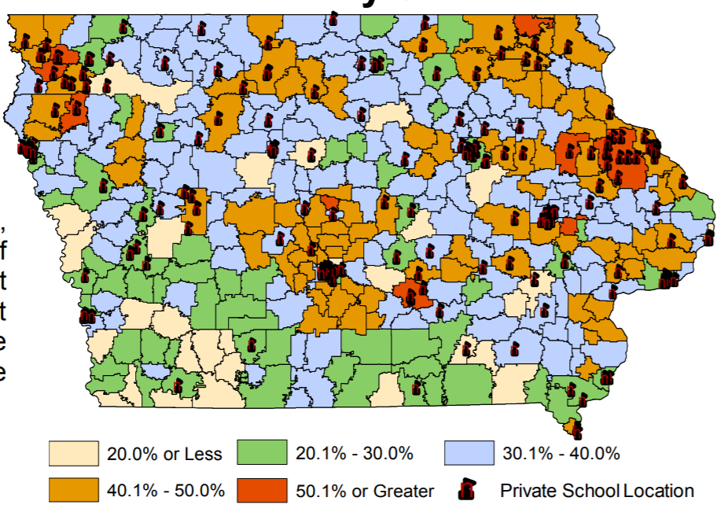
This map of tuition and textbook tax credit claims includes the location of private schools in Iowa. If your district does not have a private school nearby, local parents would not benefit from the creation of vouchers.

RSAI Contacts
RSAI Professional Advocate, margaret@iowaschoolfinance.com 515.201.3755

Robert Olson, Chair, Clarion-Goldfield/Dows, Superintendent, robert.olson@rsaia.org ,
Paul Croghan, East Mills and Essex Superintendent, pcroghan@emschools.org ,
Lee Ann Grimley, Springville, Board President, leeann.grimley@rsaia.org ,
Dennis McClain, Clay Central Everly, Superintendent, dmcclain@claycentraleverly.org
Laurie Noll, Fairfield, Superintendent, laurie.noll@fairfieldsfuture.org
Dan Smith, Harmony, Board President, dan.smith@rsaia.org
Duane Willhite, Superintendent, North Fayette Valley, dwillhite@nfv.k12.ia.us

