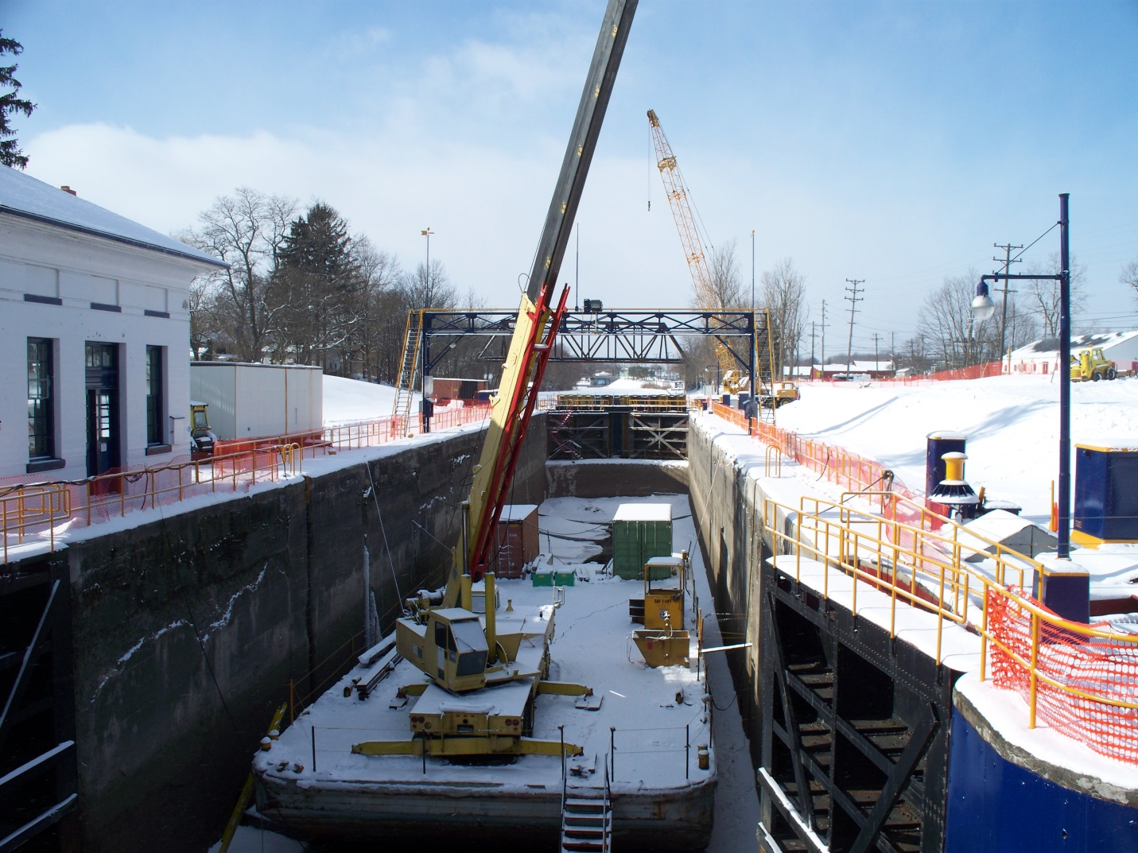

Lock E28B has been drained and is undergoing maintenance.

