Geneforce Power Systems Wiring Diagram - Wiring an External Bypass Switch and Sub Panel for 30A/120V Geneforce Units.
Flanged Inlet 30A/120V (*optional for quick disconnect) (male to female cable required)
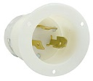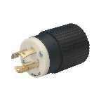
30A/120V Twist Lock Input Plug included
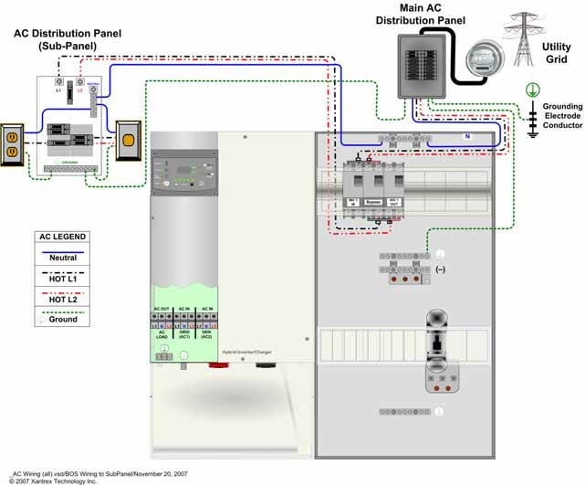
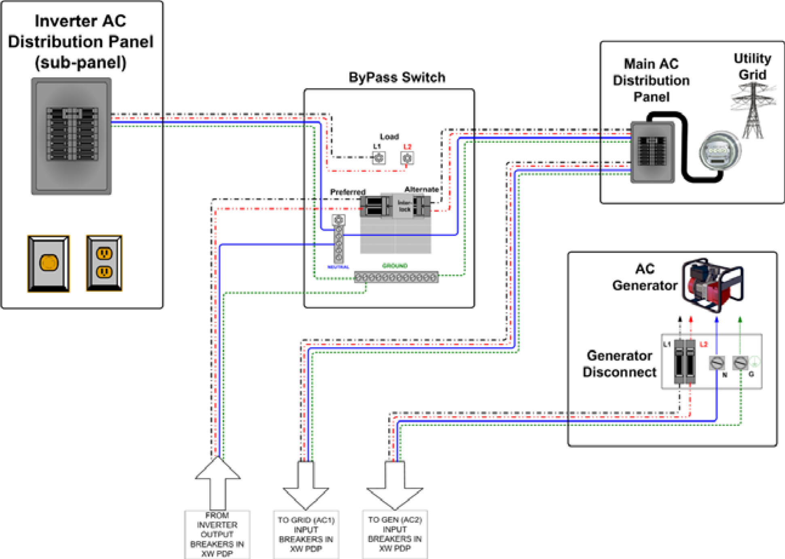
Geneforce recommends Eaton EGSU200ACA ATS or similar. Manual Transfer Switch is optional.
+ ZOOM
AC Input 2 30A/120V Single Pole, 3-Wire 10/3 Cable
AC Input 2 is for optional use. Used for shaving loads or providing redundancy with an auxiliary generator.

AC Input 1 Eight foot 30A/120V Input Plug, Single Pole, 3-Wire 10/3 Cable Breaker Box Installed in Geneforce

AC Output 30A/120V Output Receptacle, Single Pole, 3-Wire 10/3 Cable Breaker Box Installed in Geneforce
Auxiliary Gas Generator Optional for Load Shaving and Redundancy.
Automatic Generator Start Switch
AC Output 120V
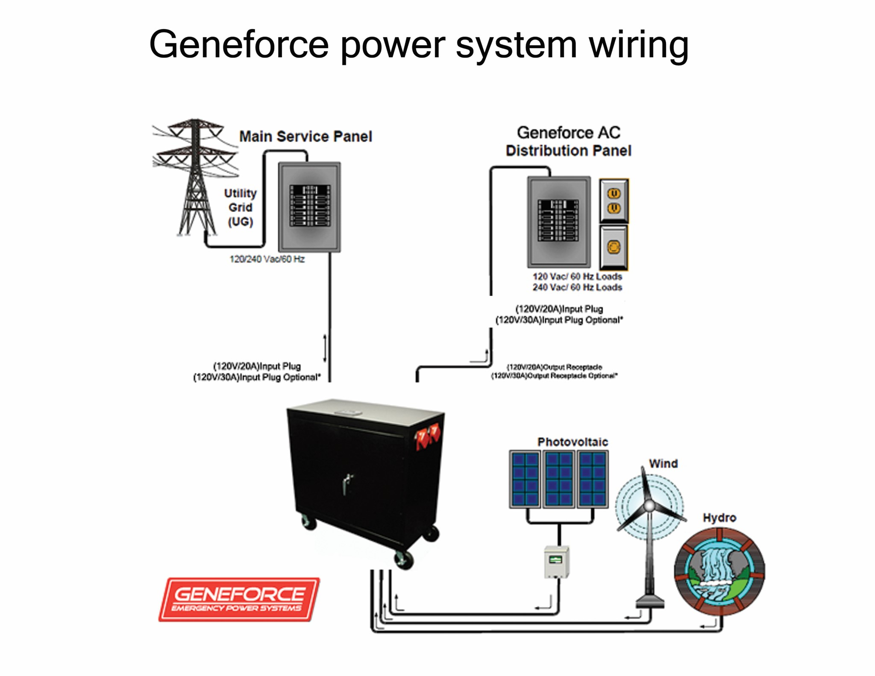
30A/120V Automatic Transfer Switch /Relay Included. Automatically transfers power to loads during power failures & automatically resumes charging when power is restored.
Geneforce Incorporated www.geneforcepower.com Telephone (305) 215-5443 For questions email techsupport@geneforcepower.com

6-Gauge Positive & Negative Cable used for alternative Energy charging.
30A/12V Solar Panel Charge Controller Included
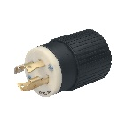
10/3 Male to Female Cable. Connects to Flanged Inlet at Sub Panel for quick disconnect. Not included.

