**Geneforce Power Systems Wiring Diagram - Wiring an External Bypass Switch and Sub Panel for 30A/120V Geneforce Units.**

**Flanged Inlet 30A/120V (*optional for quick disconnect) (male to female cable required)**

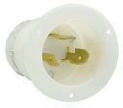 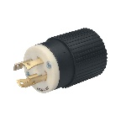

30A/120V Twist Lock Input Plug included

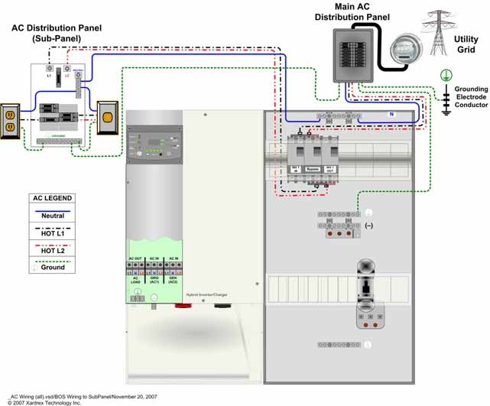 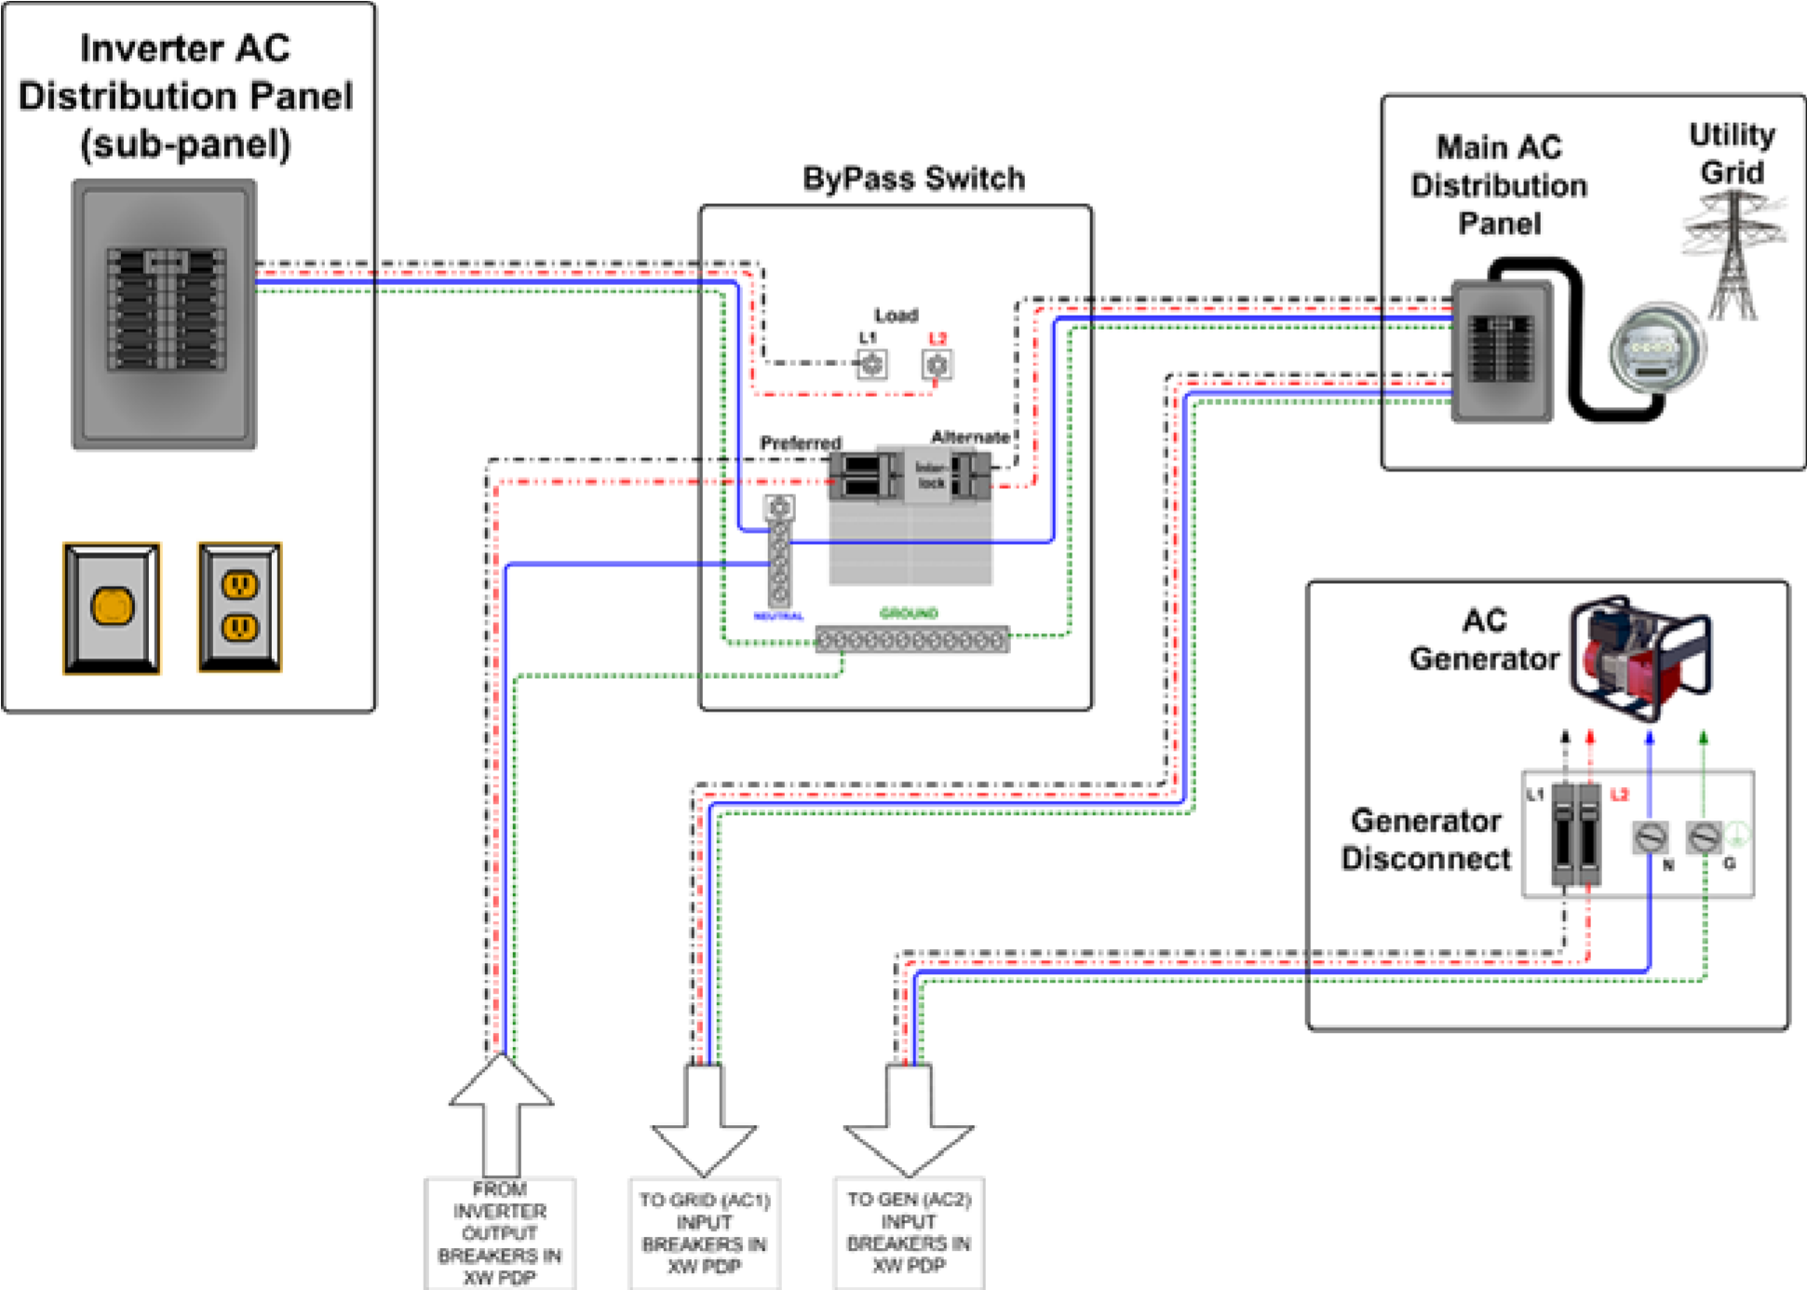

Geneforce recommends Eaton EGSU200ACA ATS or similar. Manual Transfer Switch is optional.

+ ZOOM

AC Input 2 30A/120V Single Pole, 3-Wire 10/3 Cable

AC Input 2 is for optional use. Used for shaving loads or providing redundancy with an auxiliary generator.

**AC Input 1** Eight foot 30A/120V Input Plug, Single Pole, 3-Wire 10/3 Cable Breaker Box Installed in Geneforce

**AC Output** 30A/120V Output Receptacle, Single Pole, 3-Wire 10/3 Cable Breaker Box Installed in Geneforce

Auxiliary Gas Generator Optional for Load Shaving and Redundancy.

Automatic Generator Start Switch

**AC Output 120V**

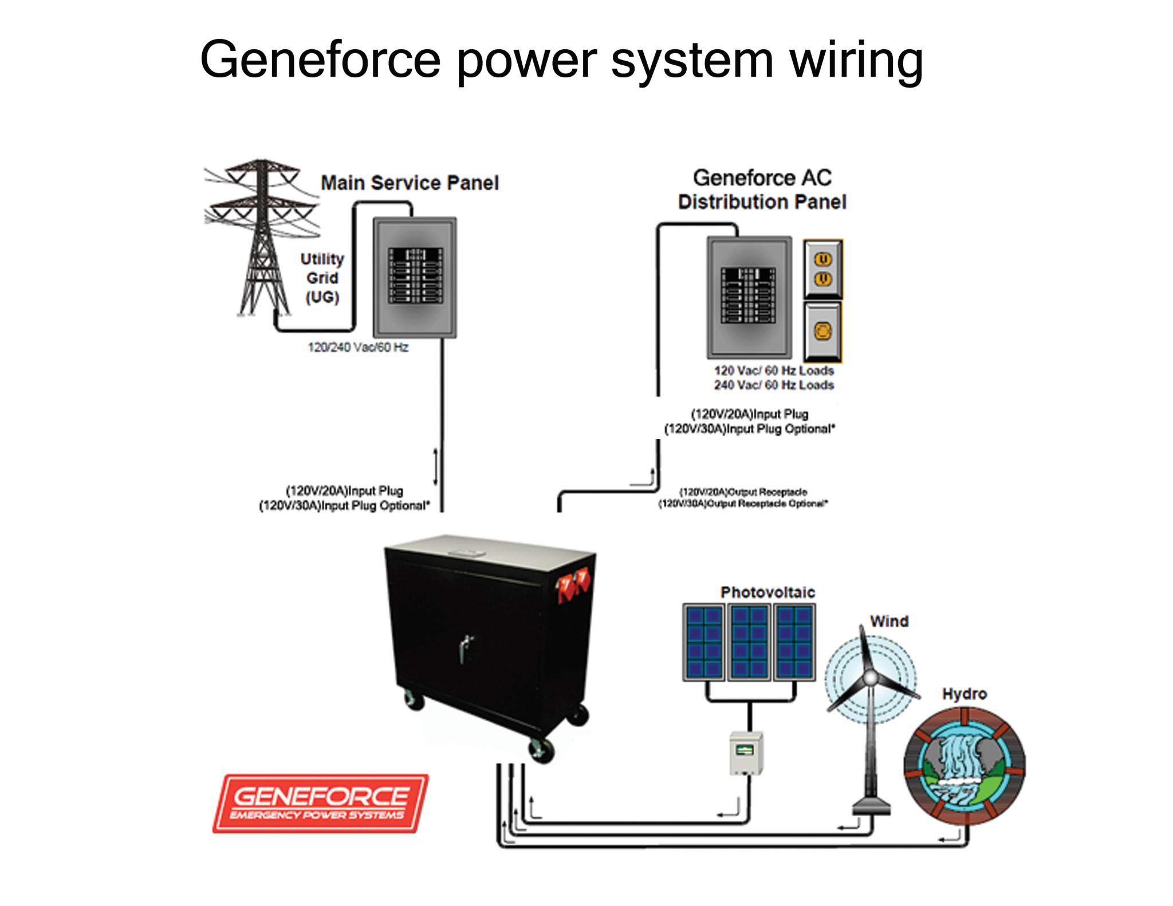

30A/120V Automatic Transfer Switch /Relay Included. Automatically transfers power to loads during power failures & automatically resumes charging when power is restored.

Geneforce Incorporated [www.geneforcepower.com](http://www.geneforcepower.com) Telephone (305) 215-5443 For questions email [techsupport@geneforcepower.com](mailto:techsupport@geneforcepower.com)

6-Gauge **Positive** & **Negative** Cable used for alternative Energy charging.

30A/12V Solar Panel Charge Controller Included

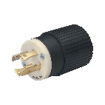 ** *C:\Users\chinos333\Documents\Geneforce Incorporated\Website Info - gn\website fotos\soow3.jpg*

10/3 Male to Female Cable. Connects to Flanged Inlet at Sub Panel for quick disconnect. Not included.