BOARD NOTICES
HOLIDAY THANKS
As I drive through the community, I am excited to see that others seem to share my passion for the holidays and decorating their homes.

It is a challenge to decorate the community for all to enjoy and this is not something I could accomplish on my own.

I hope you've all noticed the beautiful new trees we have on the main level of both club houses. These trees were purchased for us by the Fundraising Committee! Thanks to the Chair, Irene Gagne, and her committee for their generosity.
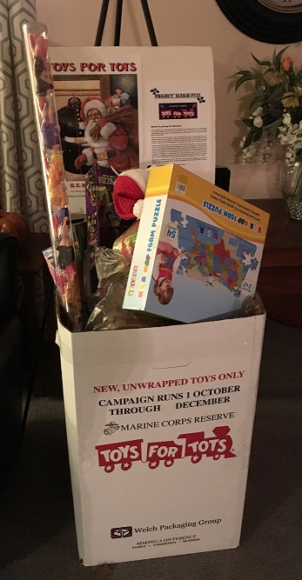
Toys: first load, circa 11/16. Photo: Alyn Miller

Speaking of the trees, have you seen the beautiful angel on the top of the tree at Partridge Club House? She was crafted and donated by Rolande Moore who also helped to decorate the tree. Others who helped to decorate the trees and the club houses were Dorrie Kossuth and Irene Gagne. Thank you so much for your time, ladies!

By the way, have you seen the village set up at Partridge Club House? That daunting task was taken on by Rolande Moore with the guidance of the Wilsons and it is just amazing! It is my understanding that the Wilsons donated the village to Medvil when they moved away. If you cross paths with Rolande, please be sure and thank her for taking on such a task. It took them several days to get the job done. Thanks so much, Rolande, for your time and effort. It's appreciated by all of us here at Medvil!

Last but not least I would like to thank our Maintenance Team, Joe and Ren, for taking time out of their very busy schedule to hang the wreaths on the light poles at the Community entrances and the lighted wreaths on the Partridge sign. These things would not be possible without their assistance. Thanks, guys, from all of us in the community!

I hope you all have a very merry Christmas and a happy, healthy New Year!!! OP
OTHER NOTICES

TOYS FOR TOTS WAS A TOUR DE FORCE!

Well Medvil, you’ve done it again. You’ve responded enormously to the Marines’ appeal for toys to give kids in need a happy holiday. Over roughly five weeks we made three runs from Medvil to the Bedford Police Station with at least three and a half box loads of toys…more toys…and toys overflowing! Some to roll, some to color, some to read aloud, some to make noise, some to assemble, some to pretend-cook and clean, even an enormous Big Wheels spin-out racer to get on and ride! Then there were the cuddly toys, the giant teddy bear, and the doll that talked when people walked by the collection box. Looks like Medvil loves shopping for toys. Must be that mémé and pépé vibe we’ve got going here! Thank you so much, Medvil! Thank you also to Alyn for being at our beck and call to make the big delivery runs to Bedford. Finally, thanks also to a friend, Deb from down in Whitinsville, MA. We told her about Medvil’s Project Sleigh-Full and she sent us straight back up to Bedford with the equivalent of probably another half box of small plush toys from the retail gift shop she closed upon her retirement. So one way or another our campaign generated about four of those big boxes to fill Santa’s sleigh. Well done!
Third load—12/10. Maybe next time we do TFT we’ll ask the Marines to send us TWO boxes! Photo: Alyn Miller

MB. Wulf
The Medvil Messenger
Toys: second load, brimming over just a bit on 12/1. Photo: Alyn Miller

ANYONE HERE FROM QUINCY?

Sally Nielson just moved here from Quincy and still gets her weekly paper, The Quincy Sun, in the mail. She is willing to share it with others in the park. Would you like to keep up with the local news? Just call Sally at 384-2767 and enjoy.
BOARD & COMMITTEE REPORTS

BOARD OF DIRECTORS

The final board meeting of the year was held on December 18, 2018 with seven board members in attendance. The meeting commenced at 6:00 PM with the Pledge of Allegiance.

There were no initial member comments.
The Treasurer reported a favorable debt ratio and higher than budgeted income and expenses. The expense overage was due to our management company’s overpayment of our water bill, so our incurred expenses were actually lower than budgeted and we now have a credit for our next water bill. The report was accepted 7-0.
A motion was made to approve purchase of a CD. It was seconded and passed with little discussion.

The secretary moved to accept the minutes for the previous meeting. Motion was seconded and passed 7-0 with no discussion.

The Operations report followed. Motion to allow improvement to a home passed 7-0. A cement cutter had been lined up to work on the chair lift and work will commence in January.
Emergency drainage repair on Roger Road was effected.

A motion to require a form releasing the cooperative of responsibility for collateral damage when it removes shrubs for home owners was passed 7-0 after some discussion and amendments. Homeowners who decline to sign the form can still have their shrubs cut down at ground level, but the roots will not be removed. Shrubbery root systems can spread unpredictably and cause mischief when pulled out.

A home that was removed by the owners had to return due to a broken axle. A motion was made for Medvil to purchase it to be gutted and turned into storage units to be rented to residents. After much discussion a motion was made to make the purchase but failed when it drew no second.

Committee reports consisted of reminders of an upcoming fish bake and a soup and chowder extravaganza, both in January.

Old Business – Discussion of the employee review policy was put off until the January meeting.
The solar project is still waiting for clarifications expected from Chris Bourcier of NH Community Loan Fund.
Evergreen Management is now part of a nationwide company, and Medvil’s future with them was discussed. There are no immediate difficulties, but it was determined that the board would be prudent to investigate other management or accounting firms in the event the company’s policies or support level become problematic. Enquiries will be made to Chris Bourcier for companies with good records of supporting other New Hampshire cooperatives.

A request to park an RV at a home site until a permanent manufactured home is installed was discussed and failed to pass. The vote was 1-4, with two abstentions.

A rule or policy concerning pets in the club houses was discussed. A rule will be considered for the next General Membership meeting, and in the interim a policy will be crafted for consideration in a future board meeting.

The final member comment segment included a suggestion that the home not to be purchased by Medvil might be donated to the Goffstown Fire Department for firefighting practice rather than simply torn down. Suggestions were made about pets that leave stains of various kinds in the clubhouses: Medvil could use DNA testing to determine culprits, or cameras could be installed in the club houses. Letters could be sent to owner of pet who befouls a clubhouse whenever we know who the owner is. In response to one comment, Kim said that in event of an emergency situation like a power outage, pets would still be allowed in the club houses even if a general rule were to ban them.

The meeting ended at 7:04 PM to be followed by an executive session.

Alyn Miller reporting

EVENTS COMMITTEE
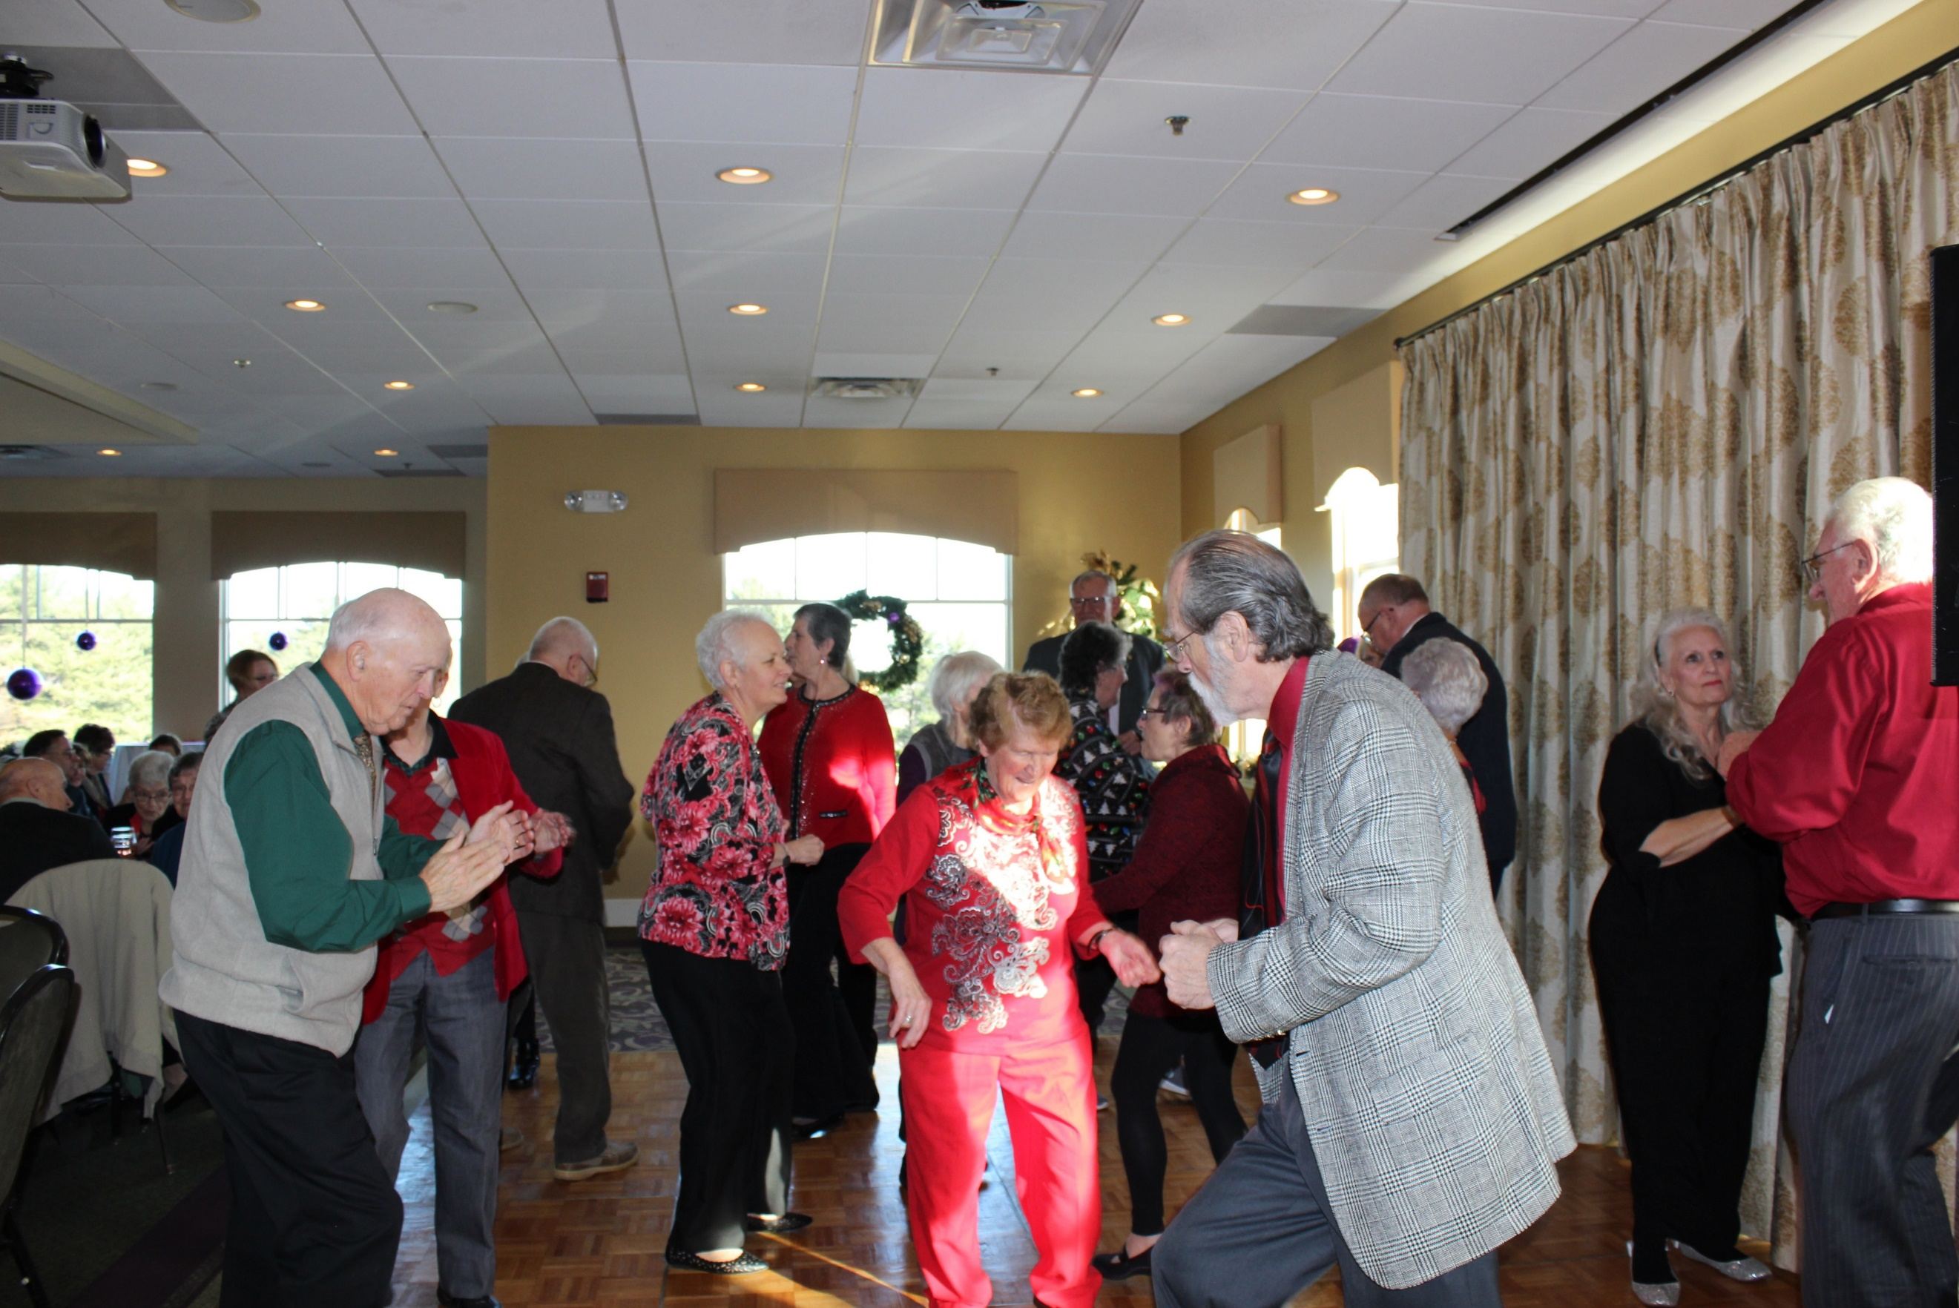 Kim and Sister Regina cutting the rug! Photo: Cat Pragoff

What's up at Medvil? The events committee has some fun things planned for everyone!

WHAT'S HAPPENED WITH EVENTS SINCE OUR LAST CHAT

With over 100 people in attendance, the Medvil Christmas Party at Derryfield Country Club was a huge success. There was lots of food, a line of happy campers at the bar, and a wonderful DJ who played many of our community's favorites. Just check out some of your neighbors having a fantastic time, dancing to beat the band!
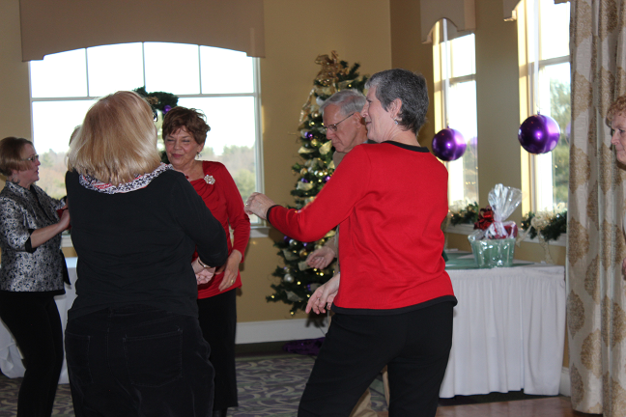
Look at Odie go! Photo:
Cat Pragoff

The annual Holiday Open House was once again a huge success, with every dish a home-made delicacy. We had a full house with lots of friends and neighbors in attendance, taking the opportunity to visit, chat, enjoy the food and the company.

LOOKING AHEAD!

On January 11, we have a Baked Stuffed Haddock Dinner planned. Our next Soup & Chowder event is scheduled for January 23. Look for another tasty breakfast in early February, followed by a rousing afternoon of Meat Bingo later that month.

As always, your Events Committee is looking forward, scheduling another year of special ways to enhance your time at Medvil. We hope you'll join us.

The Events Committee tries hard to offer a variety of fun and informative events for Medvil residents, giving you all a chance to get out and visit with neighbors and friends and make new ones. Also, here's an opportunity to enjoy some quality entertainment and good food. We hope you are pleased with what is offered and take advantage of these opportunities. Have a suggestion? See a committee member.
A small portion of the treats at the Holiday Open House. Photo: Barb McDermott

Have you been missing some of our events because you forgot about them? Give your email address to the office so they can send you our reminders before each event. CP
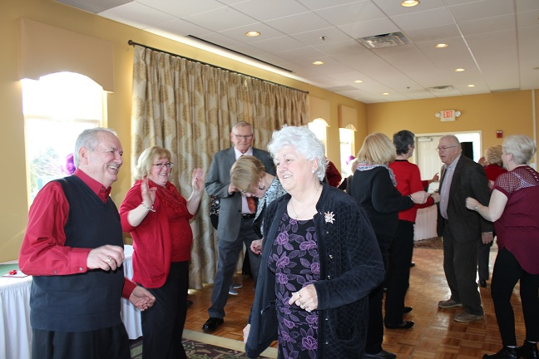
A full dance floor is a happy dance floor! Photo: Cat Pragoff

FUNDRAISING COMMITTEE
Fundraising Pool

The 12/1 winner was Helen Daigle for $250 (5th time). All numbers are being played with a guaranteed winner. There are currently 6 residents on the wait list. Please call the office to place your name on the list. It’s only $5/month and you can play more than one number.

Consignment Store/Yard Sale

If you have items to donate please contact Irene Gagne at 622-1869. What doesn’t get accepted by the consignment stores will be placed in the 4/6/19 yard sale. Please do not place any items in the mail houses. Call the office and the volunteer will contact a Fundraising Committee member to make arrangements to rid you of your unwanted items.
Spring Festival – 4/6/19 – We are already receiving items for this yard sale. We are also looking for volunteers. We had over 30 of them for the fall festival.

Committee Members – We are a committee of 10. We are looking for more members with fresh ideas and help with yard sales. You don’t have to be a committee member to give us suggestions for projects to use our funds for the benefit of the Medvil community – call Irene at 622-1869 IG

REAL ESTATE COMMITTEE

If you are thinking of selling your home the first step is to fill out the Intent to Sell form and return it to the office. The second step is to locate a realtor. Please consider Medvil Real Estate to help you sell your home. Sales benefit Medvil community.

Medvil RE Committee - 497-4440 Prompt 2

Dorrie Kossuth.................Chairperson
Paul Allard.......................Appraiser
Roger Bruneau.................Photographer
Richard Ball.....................Representative
Pam Gallagher..................Representative
Sue Soule..........................Representative
Jean Cass..........................Closing Assistant
Carol Hallworth................Representative

Website: www.medvilcooperative.com Homes for Sale

The month of November the Real Estate Committee had 4 listings, 2 pending Purchase and Sales, 6 showings, and 0 closings.

The Real Estate Committee does not have set monthly meetings. We meet on an as-needed basis. DK

RESOURCE COMMITTEE

Your Medvil Community Resource Committee wishes everyone a HAPPY NEW YEAR.

This year make resolutions that you know you will keep all year long!! DK
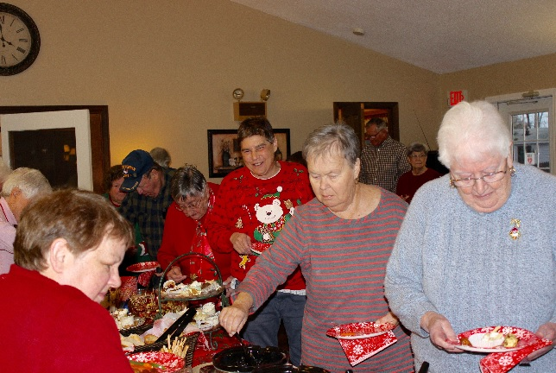
Karen, Claire, Yvonne, and Carol sampling the wares at the Holiday Open House. Photo: Cat Pragoff

SINCERE CONDOLENCES

Heartfelt condolences to those who have recently lost a loved one:
- Bob and Barbara Keene, who lost their daughter Kelcie.
- Emile and Pamela Gardner who lost his mother Violette Gardner.

The nicest place to be is in someone’s thoughts. The safest place is in someone’s prayers. The last place to be is in God’s hands. JS
MEET YOUR NEIGHBOR

Although she has only been a part of our community for five years, she is known for her bouncy strawberry blond curls and her effervescent personality. She was born in 1937 in Asheville, North Carolina. She is 81 years old and living every moment. Through family genealogy, she discovered that she is of Irish and French descent.

Her father enlisted in the Army in 1941. Consequently, the family moved around quite a bit. Her father was stationed in Germany working in the Army Post Office (APO). She and her brother, returned to the States after their parents adopted their sister, an orphan from Germany. As WWII ramped up, the army needed officers badly. Her father completed 90 days of training in Officer Candidate School (OCS). The family moved to Carmel California, and her father was stationed in the Philippines. Her father was shot in the foot and his 1st Sergeant was fatally wounded. He died in her father’s arms. For 3 days he nervously heard the Japanese enemy nearby. He was saved by a Filipino man with a water buffalo, and he was taken to the field hospital. When he returned home, he was only 140 lbs. and yellow from malaria. He was never the same. He died at the age of 49.

Her husband was also career Army. He was in the Military Police Corps (MP). She was “18 and 3 days” when they were married at Ft. McPherson, Georgia, in 1955. They had seven children: five boys and two girls. Her family moved quite often. The longest was four years in Panama. She would return “in a heartbeat.” During the Vietnam Conflict her husband was sent to the MeKong Delta where he spent two tours of duty in the infantry. She admits those were the hardest years of their marriage. She worried about whether or not he would come home. Truly, she had reason. He was shot in the neck, a fraction of an inch from his jugular and spine. After being shot, he maintained radio contact and reported on the enemy until he was forced to leave. He earned a Silver Star, Bronze Star, and Purple Heart. He retired after 22 years of service.

There is one day each year that she could “stay in bed and hide under the covers.” Strangely, her father and husband were both shot on April 13th. Incredible.

After her husband’s retirement, they moved to his home town of Warren, NH. Together they ran a summer resort. At 35 she went to Plymouth State College and majored in history and political science. She used her education in social services. She tutored inmates at the Grafton County Jail for 15 years. She worked at the Woodsville Community Action Program. This program provided fuel assistance, a food pantry, and a home for battered women. When her son Christopher entered the Army and was stationed at Redstone Arsenal, Alabama, she and her husband took their “huggy mobile,” a blue van, on a Blue Highway trip (seeing the country, using the back roads) and returned to Alabama to live. Their final home together was built in North Haverhill, NH.

In 1990 her husband underwent heart surgery. Sadly, in 1994 her oldest son Michael died after a long illness. He was 38. She laughed at how funny he was. In 2004, she and husband returned to the Mekong Delta. In spite of minor propaganda, she enjoyed discovering more about the people and the place.

On June 19, 2013, her husband of 57 years died at the age of 81. Since her son Christopher lived in the Medvil Co-op, she sold her house and moved to our community. Her son Daniel lives in Weare, and she and her daughters frequently meet at Putnams to catch up. She went to Ireland with her daughter and granddaughter, and she visits her son and his wife for 3 weeks in Austria. She is blessed with 16 grandchildren and 17 great-grandchildren. She enjoys history, knitting and quilting. She loves her cats. She takes delight in meeting new people and sharing many of her life stories. I know I enjoyed every moment, each picture, and numerous narratives.

“We’ve all got problems,” she said, “and I wouldn’t want to change my life with anyone. So celebrate it.” And that, readers, is her truth!
Who is she? JDB

Answer on the page 9.

MEMBERS’ ARTICLES
Editor’s note: We actually got the following back in the summer. We decided that, with a few adjustments, the message might have more impact in the middle of winter! Eastern philosophy refers to rationale of this sort as “cultivating mindfulness,” but we make no claims to such beatific living. Perhaps we’ll just concede that Jack Frost has won this round, and make the most of what we’ve got.
TEN REASONS WHY WINTER IS BETTER THAN SUMMER!
By Liz Warren

While some of you may be yearning to return to those days of high temperatures and humidity, I am not! I have devised a list of the top ten reasons why winter is far better than summer:

- In the cold you can put on an extra sweater or blanket, even an extra pair of socks. But in summer’s heat, you can remove all your clothing and the sweat will still drip into your eyes.
- You can have snowball fights, build snow forts and sled laughing down a hill. Try having any fun sledding down a hill of dead crispy grass.
- In winter you can use your porch as an extra refrigerator! BUT, although it can be done, I do not want my eggs cooked on the street, driveway or the hood of my car
- Bugs. I hate bugs! In the winter, bugs do not buzz in your ears, bite you and drive you nearly insane. Bugs seem to be getting immune to bug spray.
- Snakes. Oh my. Those slithery, ugly-faced tongue wagging reptiles make me wish for winter faster than you can say, “EEEEK!”
- You never have to water the snow. You shovel the snow, and there is no guesswork involved. Over-watering your grass kills the grass. Over-shoveling the snow simply means a cleaner driveway.
- Sweating. Oh my. How I hate that! Take a lovely shower and try turning on the cold before you finish, and you still can’t get yourself dry. Dry off your arms, and your face starts to drip again; dry off your legs, and then your arms are wet again. By the time you think you’re done, you need another shower.
- In the winter, just think of the pleasure sitting on the couch, nursing a nice cup of cocoa, coffee, tea, herbal tea, or, as my son does sometimes, just a nice cup of hot water. In the summer, you have to drink so much cold water you slosh when you walk. And you spend half the day in the bathroom, or half the night. And if you take a nice cold refreshing beverage out of the fridge, then put it on the end table, you have to put a towel folded a hundred times under it so it doesn’t ruin your table top.
- Speaking of table tops made me think about chairs. Oh, my goodness gracious! You need to wear shorts in order to be cool, but then you end up leaving half the skin from the back of your legs on the chair when you get up. I have had bruises from this that look like someone hit me with a 2X4.
- Heat seems to rob the whole population of all sense of modesty. If you go to the mall, the grocery store or even the liquor store, what is visible to the eye is unbelievable. I’m no slim jim or young thing, but I do avoid tank tops that cannot contain my bosom and shorts that show off half my butt cheeks. I’ve gotten used to the tattoos, but when a man has on a tank top with the armholes down level with his belly button, I just do not find that attractive. I could go on and on but what I could say would probably offend some of you. And why? Because people are just trying to stay COOL!

These are just my top ten. I have many more but will not bore you at this time. Who knows—if I can wipe the sweat off my keyboard I may write again when summer returns.

TRAVEL IS SO BROADENING

By Sheila Asselin

Having just returned from three weeks in Austria, I have a brand-new appreciation of the broadening effects of travel. Leaving Boston, I was presented with a wide assortment of liquid refreshment. Later Lufthansa gave me a great meal complete with wine. Gotta love them! The hop from Munich to Vienna also served liquids. Arriving in Vienna, I was met by my son carrying a large box of chocolates.

On to the house. Since my son’s wife was away for a few days, we decided on a great café where we
marveled at the variety of food. Next morning, he presented me with an assortment of pastries. Visited Stephensplatz for the Christmas fair. Drank several cups of Glühwein, mulled spiced wine. First two cups were so-so, but after the third everything got so much better. On to climb the church tower for a spectacular view of the city.

Every Austrian town has a monument to the plague, which took so many lives. They are erected in gratitude that God spared them. Stephensplatz had one too.

Next day we visited Karlzplatz for another spectacular church. This church, like the Sistine Chapel, has paintings on the ceiling, with elevators so you can go as far up as you wish and actually touch the paintings. We saw a complete history of the Reformation, painted there with Martin Luther being tortured by St Michael and his angels! After all, Austria is a very Catholic country. Another plague monument rounded out the picture.
ANSWERS
On to Salzburg for the biggest Christmas fair of all. Salzburg means salt mountain in German. There are sculptures and lamps made out of salt in many colors, depending on the other chemicals in the salt. Had a little more Glühwein just to keep up our strength! Gotta take care of that, after all. So many beautiful things to see and sample, not nearly enough time. One more plague monument, of course.

Every Sunday, David's wife would create a beautiful tray of cheeses, fresh veggies, rolls and pastries, sliced meats and fruit so we could nosh the morning away. Lots of chocolate for everyone.

Trip home? Equally filling. Liquids every few hours and, of course, spectacular food. About thirty minutes before we landed in Boston a male flight attendant ran down the aisle with two half full bottles of wine, shouting, "Must get rid of this before we land!” Being a cooperative passenger, I relieved him of several ounces. In the interests of aviation safety!

Arriving home, I found that my grandson, who had been cat sitting, had made me some homemade lentil soup. Got a good night’s sleep.

Next morning, showered and decided to wear my favorite jeans. For some reason they were awfully tight! Had to lie down on the bed to zip. Now don't tell me you have never done that! I think I’ve discovered why they say travel is so broadening. Here’s to many more tasty adventures!

MEET YOUR NEIGHBOR: She is Sheila Asselin of Donald Drive, and if you’ve been reading The Medvil Messenger regularly for the last three or four years, you’ve already read many of her stories!

The Medvil Messenger encourages members to submit articles for consideration. Recipes, helpful hints, reminiscences, jokes, poems--please keep it upbeat and positive. Due to space considerations, original material will take precedence over reprints from other sources, including printouts of email pass-arounds. If you submit previously published material, please try to cite a source. We reserve the right to reject material that may offend, divide our community or cause political arguments. Please submit your items to our email: medvilnewsletter@comcast.net Or place a copy in the Messenger mailbox in the Reception Office in the DDC.

Medvil Messenger Staff: Sheila Asselin, Jocelyn Bergeron, Jeane Cass, Debbie Cyr, and MB. Wulf

Medvil Messenger Writers: Sheila Asselin, Jocelyn Bergeron, Kim Capen, Debbie Cyr, Peggy DiDonato, Irene Gagne, John Menczywor, Alyn Miller, Odette Perron, Cat Pragoff, Jan Soucy, MB. Wulf

Special thanks to Irene Gagne for additional proofreading.

