3/31/2018 The Sign of the Descent of the Heavenly Palace on 4/1/2018

Abram was called by YaHuWaH Elohim to leave his home in the city of Ur. His eventual destination was a city in the sky fashioned by the Master YaHuShua Messiah Himself.

Revelation 21:9 And there came unto me one of the seven angels which had the seven vials full of the seven last plagues, and talked with me, saying, Come hither, I will shew thee the bride, the Lamb’s wife.
10 And he carried me away in the spirit to a great and high mountain, and shewed me that great city, the holy Jerusalem, descending out of heaven from YaHuWaH ,

Revelation 21:23 And the city had no need of the sun, neither of the moon, to shine in it: for the glory of YaHuWaH did lighten it, and the Lamb is the light thereof.

Song Link - Yerushaliym Descending by Lamb: https://www.youtube.com/watch?v=GDKQutuUxSc

Living the Scriptures

As children, both my wife and I were raised in Christian homes. Her mother was a Sunday School teacher in a Presbyterian church in rural Ohio.

My grandmother saw to it that her young daughter and I attended a Friends (Quaker) church each Sunday in the same small town. She also read from the bible to my young aunt and I each day.

In late 1967, I was unemployed as the day for our wedding approached, and several months before the wedding I began preparing for a job, aquiring a license from the Federal government to repair and operate high power radio and television transmitters.

At that time my wife and I were both 21 years old, and not religious at all, not attending a church, not praying, etc.

About a month before our wedding date I had received two job offers. One was from a television station in Muncie, Indiana, and another was from a station in Corpus Christi, Texas.

For several days I thought about which job to take. One night I had a dream and saw a warm sandy beach with an ocean of large blue waves. That's when I decided to take the job in Corpus Christi.

Connie and I were married in the church where her mother had been a teacher. On our wedding night we drove away in our car, heading for Corpus Christi. I had no idea of the prophetic implications of the dream of blue ocean waves, a wedding, and living in Corpus Christi.

Little did my wife and I know after our marraige in 1968 that exactly 10 years later we would be on our way to another covenant relationship, entering the literal Corpus Christi, the Body of Christ.

Abram was given a dream, and he left home for a city. He would enter into a covenant with the Almighty Elohim, and be led to the city in the sky.

The Prophetic Births

Our eldest child was born in Corpus Christi on 3/31/1969. Our eldest grandchild was born to another of our children on 4/2/1999, thirty years and two days later.

The dates 3/31 and 4/2 bracket (chiastically emphasize) the date 4/1.

I hadn't thought much about that situation until recently when it was discovered that 4/1/2018 would be exactly 49 years from the decree by Israel's Knesset on 4/1/1969 to rebuild Jerusalem.

Daniel 9:25 tells us that 7 sevens from the decree to rebuild Jerusalem is involved in the coming of Israel's Messiah King. The 7 sevens could be 49 years.

It also means that the date 4/1/2018 , 49 years from 4/1/1969, could be involved with the arrival of the city from the sky, the city of Abraham's dream, the living Corpus Christi.

Daniel 9:25 and the Coming of Messiah

Below: A previous article showed how that the comet Hale-Bopp, that placed an "X" in the sky on satan's forehead, was involved with a description in Daniel 9:25 relating to 4/1/1969 and Messiah's coming arrival.

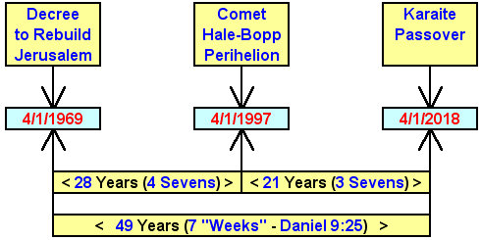

Below: Another article noted that the date 4/1/2018 was a waypoint in the 70 weeks of Daniel, and the beginning of a 62 literal weeks period to the Feast of Shavuot on 6/9/2019.

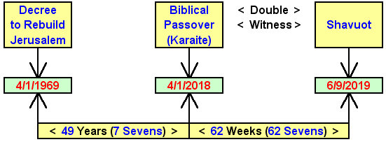

The Symbolic Descent of the Heavenly Palace on 4/1/2018

The Chinese Tiangong-1 space station was launched on 9/29/2011, the Hebrew Day of Trumpets.

Global media attention was given to the descent of the Chinese Tiangong-1 space station that was determined by scientists to be happening on 4/1/2018.

The Tiangong-1 space station will probably descend from the sky on 4/1/2018 in a blaze of glory at 16:15 UTC + or - 9 hours.

Link: http://earthsky.org/space/china-tiangong-1-uncontrolled-re-entry-mar-apr-2018?utm_source=EarthSky+News&utm_campaign=984e3eaae4-EMAIL_CAMPAIGN_2018_02_02&utm_medium=email&utm_term=0_c643945d79-984e3eaae4-394633189

The name "Tiangong" in Chinese means "Heavenly Palace".

Link: https://en.wikipedia.org/wiki/Tiangong_program

The descent of the Heavenly Palace on 4/1/2018 is a symbolic prophetic picture and warning to the world governments of the arrival of YaHuShua Messiah with His city from the sky.

This warning to the world of Messiah's arrival is being given by YaHuWaH Elohim exactly 49 years after the decree by Israel's Knesset to rebuild Jerusalem on 4/1/1969. Ref: Daniel 9:25

