RSAI Position Paper Funding and Flexibility for At-Risk Students A 2016 Legislative Priority
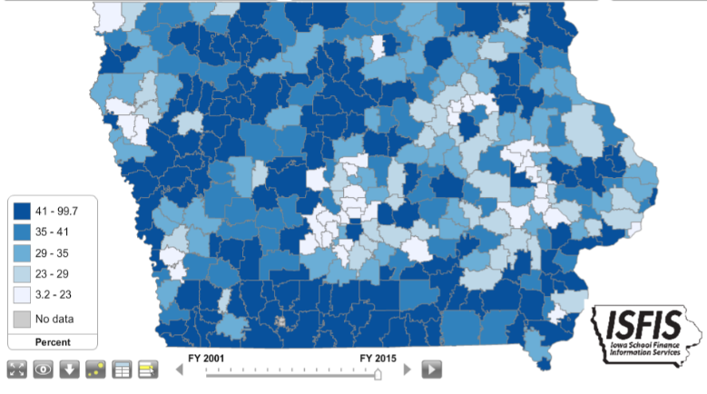
Background: Iowa has traditionally been a homogenous state with relatively low rates of poverty compared to the rest of the nation. In 2001, about 28% of students were eligible for Free and Reduced Lunch, with the lowest district percentage of eligibility at 4.2% As such, Iowa’s funding formula has little recognition of low income as a driver of at-risk student funding or programing. Dropout Prevention funding is based on total enrollment count, not the percentage of students at-risk. DoP funding is limited to 2.5% of the total regular program district cost or up to 5% of regular program district cost based on historical practice.
Current Reality:
- Free and Reduced Lunch eligible children now exceed 43% of school enrollment in 2015, with 210,092 Iowa children eligible for the program.
- Poverty is no longer concentrated in Iowa’s urban centers but found throughout the state. Of the 65 school districts in FY 2015 with more than half of their students eligible for Free and Reduced price lunch, 32 are school districts with less than 1,000 students enrolled.
- Iowa’s funding for at-risk students and dropout prevention resources, combined with targeted grant funds for high-needs schools, translates into less than 10% additional funding commitment to support success for these students.
- Other states invest resources in educating needy students. The national average investment is an additional 29% funding beyond the base for low-income students.
- Students from low income families are more likely to begin school behind their peers academically, exhibit nonproficient literacy skills, especially in early elementary grades, and to fall further behind over summer breaks, unless schools have the resources, staff and programs to meet their needs.
- Recent flexibility provided to dropout prevention expenditures is welcomed as school districts engage in prevention for younger students at-risk of early and subsequent failure. RSAI districts thank the DE for advancing the flexibility language, commend the legislature for approving it in the 2015 session and await DE guidance to implement these changes.
RSAI calls on the Iowa Legislature to address the issue of Funding and Flexibility for At-risk Students: Resources for serving at-risk students should be based on need, such as the number/percentage of students eligible for Free and Reduced Price Lunch, rather than enrollment of the district. Districts should be given flexibility in determining the expenditure of at-risk resources to support students to graduate college/career ready for success.

