Pleasant Township Board of Trustees Unofficial Meeting Highlights
Date __July 13, 2021 Next Resolution No.__ 42---07-13-21_______

- Call to Order

- Please stand for moment of silence----Pledge of Allegiance-----Roll Call, Paula absent due to illness
UPDATED 7-13-21--SPECIAL NOTE: THE GOVENOR’S REQUIREMENTS FOR COVID RESTRICTIONS HAS BEEN LIFTED, WE WILL CONTINUE TO CONDUCT A VIRTUAL MEETING FOR THE PUBLIC TO JOIN USING WEBX, IF THEY CHOOSE, ALL BOARD MEMBERS ARE REQUIRED TO ATTEND IN PERSON.
- Minutes to approve- no minutes

- Financial Reports – Motion to pay expenditures.

- Visitors – (Hannah Poling with the Messenger via WebX)

- Department Reports

- Franklin County Sheriff’s Report-Deputy Travis Carter (attends the 4th Tuesday)
Blue is On going/unresolved
- Dealing with complaints of speeders and ATVs riding on the roads in the area of Gardner, Robroy and Riebel Roads.
- The Sheriff’s Dept. is being called numerous times to one house on Dawn Dr. for many things such as loud parties all night, revving cars all day and night, large groups of people among other things.

- Road Department- Robert Bausch

  - Unresolved from, 8787 Alkire Rd. about drainage caused by The Rails to Trails project behind his house. His backyard floods and so does his two neighbors to the west of him problems (7-14-20 -- I talked to these residents couple weeks ago, the heavy rain we had seemed to back up the standing water more but I went away in a couple days.)
Blue is On going/unresolved
  - Updates for 5590 Thornhill Ct. drainage problems.
  - New drainage easement Johnson Rd.
  - 9300 Gerich Lilly right of way
  - (added to list 6-22-21) 6816 Meadowlark (Andy & Brenda Goodrich) fence built on or over the property line, trees hanging over on the neighbors property. I believe we have dealt with this problem before, a drainage ditch goes down the property line and the fence is on top of it. The problem is trees and debris hanging over the fence and if it’s built on the property line can one neighbor do whatever they want on both sides of the fence?
  - Cemetery deed transfer – motion made to approve the letter of transfer.
  - Rolling Hills drainage update – bids out, earliest the work will begin is 2022, from Hellbranch NW Rolling Hills Ln.
  - Thomas tile on hold (Johnson Rd. easement) – due to shortage of needed 12” tile
  - Paving meeting FCEO- final bid is in, due to many projects going on at this time Franklin County Engineers have asked for 50% of the job up front for resurfacing of Gerich and Riebel Roads, which should begin in a week or two.
  - Road building roof estimate-one bid is in, waiting on more.
  - 1 burial
  - Working on drainage problem on Ohio St. in Georgesville. Looking for one or two tiles in the easement for homeowners to connect downspouts to correct the problem.

Fire Dept. – Chief Taylor

  - 88 Runs for June
  - First half year run totals
    - 584 for 2021
    - 595 for 2020
    - 581 for 2019
- Apparatus Maintenance
  - E-232
    - Atlantic Emergency was in to address an air leak and light issue leftover from the refurb
- Station Projects
  - Breathing Air completed annual maintenance on the Compressor and Fill Station
  - Had some issues with the hydraulic rescue tools – Howell Rescue in to fix and complete annual maintenance.

- Old Business –

  - The property on Dawn Dr. continues to be a problem. As of 7-12-21 the RV is gone. FCSO was called there at least twice this past weekend.
  - OPEC-HC hearing was postponed until October 21, 2021. As legal counsel put it, “So it looks like there is no end in sight to this thing….”
  - Order from the OPSB (OHIO POWER SITING BOARD) the Pleasant Prairie Solar hearings are as follows:
Public Hearing
July 19th at 6:00 p.m.
Battelle Darby Creek Metro Park Nature Center, 1415 Darby Creek Drive, Galloway, OH 43119
There will be a sign-in sheet for testimony; first come, first serve; testimony limited to 5 minutes each.

Evidentiary Hearing
August 16th at 10:00 a.m.
Public Utilities Commission of Ohio, Hearing Room 11-A, 11th Floor, 180 East Broad Street, Columbus, Ohio 43215
Parties must register at the lobby desk and then go to the 11th floor to participate in the hearing.

- New Business –
  - Ashville Propane Contract – Resolution ___42___ to accept the contract for $1.65 gal for a summer fill, lock in $1.85 gal for the contract for 2021-2022 year for a fee of $20 to processes the contract.

- Announcements-
  - Ed reminded everyone that North bound ramp to I71 from 62 is closed. A lot of traffic in that area especially at rush hour.

- Clerk Updates- Paula
- Budget Meeting date?
- Paperwork for ARP funding – Randi (American Rescue Plan (ARP) funding will be distributed to non-entitlement units of local government based on population. (All townships are considered non-entitlement units, with the exception of three that have populations over 50,000 and were included in the "Metropolitan Cities" category.)
COPIED FROM OTA EMAIL, the amounts are a small portion of the state, to many pages to do all—
Registration for ARP Funding Now Open
On July 6, the Office of Budget and Management (OBM) announced that the registration portal for ARP funding is now open for non-entitlement units of local governments to provide information and receive funding. Initial information was sent via email.

Townships must register for this funding by September 4, 2021. If you do not register during this period, you will not be eligible for any direct ARP funding.

OBM had a webinar today on the registration process. If you missed it, OBM will be posting a webinar recording shortly. You can also find all previous OBM webinars at that link.

The OTA also has steps to register and other information available on our website under the ARP tab. Additionally, packets of information have been mailed to each fiscal officer in the state; you should be receiving them next week.

Upcoming Webinar: Use of ARP Funds
Wednesday, July 28 from 10:00am - 12:00pm
with Greg Beck, Attorney (Baker, Dublikar, Beck, Wiley & Mathews)
Register here
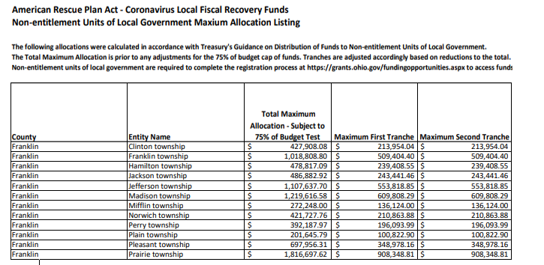

- Speaker Sheets-
  - President for Timberlake Association asked about repainting street signs. Robert said the law states must be reflective high visible signs, he will look into the cost and get back with us. Also asked about painting the fire hydrants. Chief said hydrants are owned and controlled by Franklin County Sanitary Engineers Dept.

- Executive Session

  - “I move to go into Executive Session according to Ohio Revised Code Section 121.22 (G)( 1) for the purpose of discussing personnel____. Do I have a second?” ROLL CALL VOTE (G1 is most common for personnel issues)
  - Reconvene
    - Under the Ohio Revised Code Section 121.22(G), I move to come out of Executive Session, do I have a second? ROLL CALL VOTE
- Adjournment

