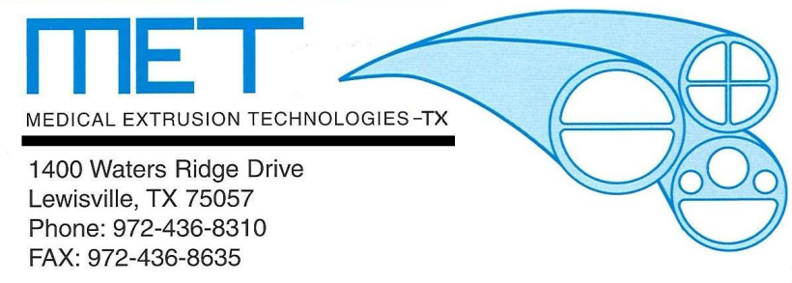

01 Apr 98 -Medical Extrusion Technologies, Inc. moves to its new location.
Murietta, CA. Medical Extrusion Technologies, Inc. (M.E.T.), a manufacturer of custom tubing extrusions from thermoplastic resins, has just acquired a new, 16,600 sq. ft. manufacturing facility in Murrieta, CA. This new facility will allow Medical Extrusion Technologies to meet the needs of its clients to a greater degree than ever before. M.E.T. is well respected in the tubing industry and it is expected that the corporation will continue to grow with this new addition of real estate.

Brian Frechette
General Manager
Medical Extrusion Technologies, Inc.-TX
Brian@MedicalExtrusion.com

