**CAPE FEAR POULTRY ASSOCIATION**

APA/ABA SANCTIONED **DOUBLE** OPEN SHOW

JUNIOR SHOW AND YEPA JUNIOR SHOWMANSHIP

THE CAPE FEAR POULTRY ASSOCIATION MEMBERS WISH TO EXTEND A SPECIAL INVITATION TO YOU, YOUR FAMILY, AND YOUR FRIENDS TO EXHIBIT THEIR BIRDS WITH US.

**SHOW DATE**

DECEMBER 14, 2024

Entry Deadline – DECEMBER 9, 2024

JOHNSTON COUNTY LIVESTOCK ARENA

520 COUNTY HOME ROAD

SMITHFIELD, NORTH CAROLINA 28577

COMPETITION OPEN TO THE FOLLOWING:

BANTAMS, LARGE FOWL, WATERFOWL, TURKEYS, AND GUINEAS

**JUDGES:** Brian Knox, David Adkins, Matt Lhamon, Mike Sayre, Steve Stanulonis

*********************************************************************************************

WEBSITE

[www.capefearpoultryassociation.com](http://www.capefearpoultryassociation.com)

(Entry Forms & Catalog available online)

EVENTS SCHEDULE

**FRIDAY, DECEMBER 13, 2024 SATURDAY, DECEMBER 14, 2024** SHOW HALL OPENS 4:00 PM FOR EXHIBITORS SHOW HALL OPENS AT 6:00 AM FOR EXHIBITORS

NC TESTERS AVAILABLE FOR NPIP TESTING ONLY NC TESTERS AVAILABLE FOR NPIP TESTING ONLY

4:00 PM to 8:00 PM 6:00 AM TO 8:55 AM

Meet & Greet 5:30 pm – 7:00 pm CONCESSIONS: OPENS 7:00 AM AND CLOSES 2:30 PM

**ALL BIRDS MUST BE COOPED IN NO LATER THAN 8:55 AM**

**NC TESTERS WILL LEAVE AT THIS TIME**

JUDGING BEGINS AT 9:00 AM

Judges and Clerks will break for lunch between 12:00 and 1:00 pm. Close of Show and Awards around

3:00 pm (or sooner) SHOW HALL CLOSES AS SOON AS ALL EXHIBITORS ARE COOPED OUT.

SHOW RULES AND REGULATIONS

1. Competition is open to all breeds of poultry listed in the APA and ABA Standards. All entries, exhibitors, and visitors are subject to the following rules and regulations.
2. The Open Show Entry fee is $6.00 per bird. We accept entries as single birds only. Double-cooping is available on a limited basis for $5.00 per double-cooped entry and a clean-up fee of $5.00 per exhibitor. The Junior Entry fee is $3.00 per bird, a double coop is $3.00, and the clean-up fee is $1.00.
3. ***Birds are entered at the sole risk of the owner. Cape Fear Poultry Association will not be responsible for the loss or accidents of any birds or people. Ample supervision of the birds and facilities will be provided. Birds are to be managed only by the owner, Judge, or CFPA Administration.***
4. **Every person making an entry is responsible for the entry fee, even if the individual is unable to attend.** Please make Checks and Money Orders payable to Cape Fear Poultry Association.All fees must be paid before your birds are cooped in. ***All returned checks are subject to a $35.00 return fee!***
5. **The deadline for all MAIL-IN entry forms MUST BE RECEIVED BY DECEMBER 9, 2024, AND must be accompanied by the entry fee. Any** entries RECEIVED AFTER

DECEMBER 9, 2024, WILL BE RETURNED.

1. ALL POULTRY for exhibition in NC shall originate from U.S. Pullorum-Typhoid Clean Flocks or have a negative Pullorum-Typhoid Test within 90 days**, 30 DAYS FOR OUT OF STATE BIRDS,** of the day of the exhibition. All NC owned birds must be tested by agents of the N.C. Department of Agriculture. For North Carolina birds and for out-of-state birds from U.S. Pullorum-Typhoid clean states, these test requirements may be satisfied by a negative test conducted by an N.C. Department of Agriculture agent at the time of entry. Poultry for exhibition shall not have been vaccinated with a live virus vaccine within the last 30 days preceding the exhibition. Each bird must be identified with a “tamper-proof” band at the time of the Pullorum-Typhoid test. A copy of the Pullorum-Typhoid test chart must accompany birds to the exhibition. Birds are subject to examination (including blood tests and swabs) by a representative of the N.C. Department of Agriculture. Birds will not be accepted who are infected with or showing any clinical signs of a contagious disease or infested with lice or mites. **OUT-OF-STATE BIRDS** shall be admitted provided they are from an area that is not under quarantine for infectious disease and have a negative ANITGEN detection test for **Avian Influenza performed within 21 days prior to the exhibition**, or paperwork proving the flock is AI certified. YOU MUST HAVE YOUR **AI** TEST PAPERWORK WITH YOU AT THE SHOW TO COOP IN.
2. ALL PERSONS SELLING POULTRY ON THE PROPERTY AT THE SHOW MUST HAVE DISPLAYED A CURRENT LICENSE/CERTIFICATE FOR POULTRY/RATITE DEALER card AND BIRDS MUST MEET THE NC HEALTH REQUIREMENTS AS STATED ABOVE.
3. To obtain your exhibitor’s number please go to the ENTRY CHECK-IN table **before cooping in.**
4. Aisles are “CLOSED **“**during judging. Only the JUDGE, CLERK, and Show Officials are allowed

in these areas.

1. The club provides food, BUT IT IS YOUR RESPONSIBILITY TO FEED AND WATER YOUR BIRDS.
2. **NO ALCOHOLIC BEVERAGES ARE ALLOWED ON THE PREMISES!! SMOKING IS NOT ALLOWED IN THE BUILDING. THIS IS COUNTY OWNED COMPLEX.**
3. All matters not covered herein will be addressed as needed by the club's **Executive Board** and/or Judges. ALL DECISIONS ARE FINAL. The Show Committee reserves the right to refuse any entry submitted.
4. **No entries will be accepted from any state having active AI.**
5. **The Cape Fear Poultry Association will use every precaution to guard against accidents, mistakes, loss, or damage, but will not be responsible should any occur.**
6. **The CFPA reserves the right to substitute and/or add judges, as necessary.**
7. **ABSOLUTELY NO EARLY COOPING OUT! The CFPA Administration will strictly enforce this rule. Please remember that your entry form SIGNATURE states that you understand and agree to follow this rule. PLEASE RESPECT YOUR FELLOW EXHIBITORS by observing this rule! No exceptions unless approved by the CFPA Administration.**

JUNIOR SHOW RULES AND REGULATIONS

***The rules and regulations for the Junior Show are the same as the open show,***

***Including the following guidelines:***

1. The Junior Show is open for ages 5 to 18 years of age. Showmanship is open for ages 5 to 18.

2. Junior exhibitors are solely responsible for cooping and grooming their birds.

3. The Junior BIRDS are judged separately from the open show exhibitors.

4. Juniors are NOT required to show in the Junior Show. They CAN show in BOTH

shows if they make SEPARATE entries for both shows. However, the same bird

CANNOT be shown in BOTH SHOWS.

5. Junior exhibitors are required to manage their birds.

6. Junior exhibitors must be present to receive any awards they may win.

7. Please specify on the JUNIOR entry form, the exhibitor’s age at the time of the show, and

indicate if you will participate in the showmanship program. Please ***do not use*** the open show entry form for a junior entry.

***ENTRY FEES are $3.00 per bird, $3.00 double coop, $1.00 cleanup fee.***

ENTRIES

**PHONE ENTRIES:** Deadline – Monday. DECEMBER 9, 2024

CALL-IN TIME: 10:00 AM – 9:00 PM – Donna Worthington - 252-827-2491or 252-341-8706

6:00 PM – 9:00 PM – Wilbur Hanley – 984-279-8384

**EMAIL ENTRIES**: Deadline Monday, DECEMBER 9, 2024, by Midnight

allow 24 hours for acknowledgment of entry,

PLEASE INCLUDE ALL INFORMATION AS SHOWN ON THE ENTRY FORM

PLEASE “NO ENTRIES” by TEXT or MESSENGER

**EMAIL TO:** [**donna.worthington@aol.com**](mailto:donna.worthington@aol.com)

**MAIL ENTRIES:** MUST be IN HAND no later than DECEMBER 9, 2024

Mail to: Donna Worthington - 118 Kincalf Lane, Macclesfield, NC 27852

Please verify your name and address are listed as in the APA and ABA to ensure that your earned points from the show are recorded correctly.

OPEN SHOW AWARDS

CHAMPION OF SHOW PLAQUE/$100.00

RESERVE CHAMPION OF SHOW PLAQUE/$75.00

***************************************************

**Champion Land Fowl and Reserve Land Fowl are paper awards made only on the APA Show Report**

CHAMPION LARGE FOWL PLAQUE/$50.00

RESERVE CHAMPION LARGE FOWL PLAQUE/$25.00.

CHAMPION BANTAM PLAQUE/$50.00

RESERVE CHAMPION BANTAM PLAQUE/$25.00.

THE FOLLOWING BREED CLASSES FOR BOTH THE OPEN SHOW AND JUNIOR SHOW WILL RECEIVE ROSETTES FOR THE CHAMPION AND RESERVE CHAMPION

AMERICAN, ASIATIC, ENGLISH, MEDITERRANEAN, CONTINENTAL, AOSB, MODERN GAME BANTAMS, OLD ENGLISH GAME BANTAMS, SCCL, RCCL, FEATHER LEGGED, AOCCL, BANTAM DUCKS, TURKEY, GEESE, DUCKS, GUINEA, AND WATERFOWL

JUNIOR SHOW AWARDS

**CHAMPION OF SHOW PLAQUE/$20.00**

**RESERVE CHAMPION OF SHOW PLAQUE/$10.00**

SHOWMANSHIP

A TROPHY WILL BE GIVEN FOR THE 1ST AND 2ND PLACE IN THESE THREE CLASSES

JUNIOR, INTERMEDIATE, AND SENIOR CLASS

PARTICIPATION RIBBONS WILL BE GIVEN TO EVERYONE PARTICIPATING IN THE NOVICE CLASS

AND PRE-JUNIOR CLASS

YEPA (APA/ABA) SANCTIONED SHOWMANSHIP

**NOVICE CLASS AGES 8 & UP (HAS NEVER DONE SHOWMANSHIP) PRE-JUNIOR CLASS: AGES 5-7**

**JUNIOR CLASS: AGES 8-10 INTERMEDIATE CLASS: AGES: 11-13 SENIOR CLASS: AGES 14-18**

(ALL SHOWPERSONS SHOULD BE CLEAN, WELL-GROOMED, AND NEATLY DRESSED)

Junior Exhibitors must have a separate bird for showmanship (no additional cost). If you are not an Exhibitor in the Junior Show, you will need to have a bird available and there is a $3.00 fee for showmanship.

CAPE FEAR POULTRY ASSOCIATION SHOW EVENTS

**CHINESE RAFFLE ***** 50/50 DRAWING**

A BIG “THANK YOU” TO ALL THE CLUB MEMBERS FOR THEIR DONATIONS. TICKETS WILL BE ON SALE STARTING AT $1.00 PER TICKET – SO GET YOUR TICKETS AND TRY YOUR LUCK AT WINNING YOUR FAVORITE ITEM. THE RAFFLE TICKETS WILL BE DRAWN STARTING AT 12:30 PM, BUY A TICKET STARTING AT $1.00 FOR A CHANCE TO WIN CASH IN THE 50/50 DRAWING. YOU WILL RECEIVE ONE HALF OF THE CASH COLLECTED FROM THE TICKET SALES.

**SILENT AUCTION**

THIS IS WHERE YOU WILL FIND QUALITY BIRDS FROM SOME OF THE TOP BREEDERS. BECAUSE THE INTENT IS TO PROVIDE FANCIERS AN OPPORTUNITY TO ACQUIRE QUALITY BIRDS TO EXPAND THEIR FLOCK OR BREEDING PROGRAM, THERE WILL BE A REASONABLE MINIMUM STARTING BID PLACED ON ALL OF THE BIRDS. A SPECIAL THANK YOU FOR YOUR DONATIONS. THE BIDDING WILL END AT 1:30 PM

**“MEET AND GREET”**

CAPE FEAR POULTRY ASSOCIATION MEMBERS INVITE OUR EXHIBITORS TO JOIN THEM FOR LIGHT REFRESHMENTS FRIDAY, December 8, 2023, FROM 5:30 PM TO 7:00 PM AT THE JOHNSTON COUNTY LIVESTOCK ARENA. THIS WILL BE EVERYONE’S TIME TO SAY “HELLO” TO OLD FRIENDS AND MEET NEW FRIENDS”! WE WANT TO THANK EACH OF YOU FOR YOUR SUPPORT OF OUR CLUB AND SHOW. COME JOIN US

**ACTIVITY TABLE**

THIS IS WHERE THE YOUNG AND OLD CAN PLAY GAMES, COLOR, CROSSWORD PUZZLES, CRAFT CREATIONS, and more. HOPE EVERYONE ENJOYS THEIR TIME WHILE AT OUR SHOW!

DISTRICT MEETS

AMERICAN BANTAM ASSOCIATION

Individual membership dues are the same for individuals, partners, couples, and families (with no limit on the number of children but only one household). All members receive a free copy of the latest available yearbook and quarterly, membership card, coupons, information brochure, etc. Email: [bantamclub@gmail.com](mailto:bantamclub@gmail.com)  
American Bantam Association  
PO Box 127, Augusta, NJ 07822 973-271-3335

District Meet – Blue Card - Special Meet – White Card

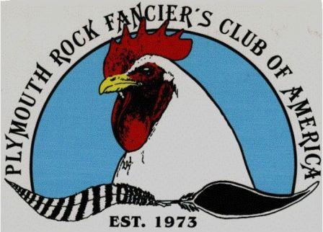PLYMOUTH ROCK FANCIER’S CLUB OF AMERICA

Membership of the Plymouth Rock Fancier’s Club Includes: A subscription to the Plymouth Rock Quarterly Newsletter. Eligibility to earn club points and awards. Option to be included in our public Plymouth Rock Breeder’s Directory. Members-only classified advertising on the PRFC website.

(Additional fee applies.) Eligibility to vote and participate in all club elections.

Annual membership runs from January 1 to December 31 of the calendar year.

Adult Membership – $20 Annual membership for any individual over 18 years old. Junior Membership $10 Annual membership for youth under

18 years of age.

Contact: [plymouthrockfanciersclub@gmail.co](mailto:plymouthrockfanciersclub@gmail.co)

District – White Card - Special Meet Blue Card

STATE MEETS

AMERICAN POULTRY ASSOCIATION

Secretary: Becky Weaver - 717-279-1899 - PO Box 205, Landisville, PA 17538

secretary@amerpoultryassn.com

Annual dues are $20.00 for one year and $50.00 for three years. Junior Membership dues are $20.00 for one year and $50.00 for three years. Outside of the US and Canada memberships are $40.00 for one year. An Endowment Trust Life Membership is $395.00. Please visit our website for details regarding your membership, what you will receive as a member of the APA, and information on how the Points Program works for you.

State Meet – White Card Special Meet Blue Card

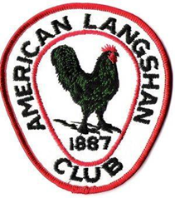AMERICAN LANGSHAN CLUB

To enjoy the benefits of the American Langshan Club, you must be a current member of

the club. The club offers a quarterly newsletter, special awards, and recognition

for its members.

PLEASE SEND DUES (PAYABLE TO AMERICAN LANGSHAN CLUB) TO

MICHELLE OAKLEY, 15643 ST. RT. 720, LAKEVIEW, OHIO 43331 977-539-6588

YOUTH MEMBERSHIP $5.00, ADULT MEMBERSHIP $15.00,

LIFETIME MEMBERSHIP $200.00

State Meet – Blue Card – Special Meet – White Card

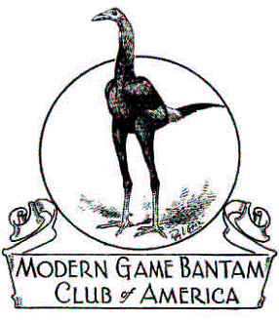MODERN GAME BANTAM OF AMERICA

Secretary/Treasurer: Alexis & Sheldon Macha

2590 CR 191, Littlefield, Texas 79339

[mghcaseretary@outlook.com](mailto:traverfarm@wildblue.net)

AWARD REQUIREMENTS, PAID MGBCA MEMBERS PRIOR TO JUDGING ARE ELIGIBLE FOR CLUB AWARDS, THERE MUST BE A MINIMUM OF 28 MODERNS ENTERED, WITH A MINIMUM OF 3 MEMBERS SHOWING

ANNUAL DUES $20.00- SEND DUES TO THE SECRETARY OR MAY BE PAID TO THE DISTRICT DIRECTOR

State Meet – Blue Card Special White Card

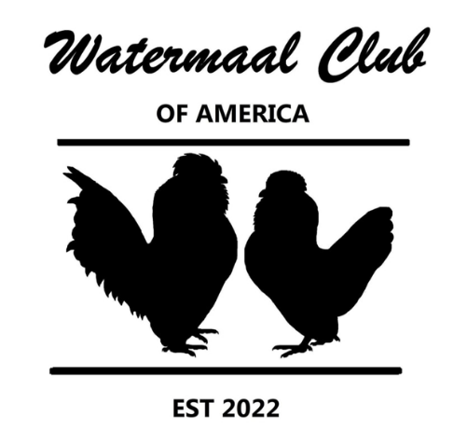

WATERMAAL CLUB OF AMERICA

The Watermaal club of America is a dedicated group of poultry enthusiasts across the United States who adore this plucky little bantam breed. The club was founded in 2022.

To join the club, complete[**the membership form**](https://watermaal.weebly.com/uploads/1/4/7/8/147841364/watermaal_membership_form_2023.docx). Either mail to the address listed on the form with a check or money order or email to [**watermaalclub@gmail.com**](mailto:watermaalclub@gmail.com)**.** With this option, you will receive a reply with a link to pay by PayPal.​

**Membership dues** *Traditional (mailed newsletter) membership.*

Juniors (6-18): $20/year or $25/2 years

Individuals: $25/year or $40/2 years

Family or Business/Farm: $40/year or $65/2 years

State Meet – White Card Special – Blue Card

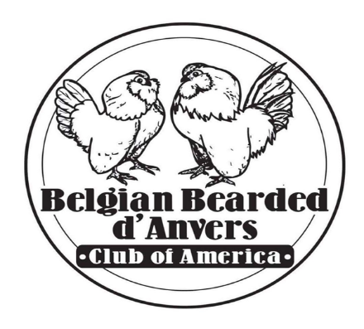SPECIAL MEETS

BELGIAN BEARDED D’ANVERS CLUB OF AMERICA

If you would like to join the club dues are $12 per year, $20 for two years per Adult Single Membership. Dues for Junior Members are $10 per year or $18 for two years. We do offer Family Membership which includes 1 Adult and up to three youth living in the same household for $20 per year, or $35 for two years. ***All memberships start the first full month after your membership is received, and run for a full 12-24 month

**Website: https://danverclub.webs.com**

You can fill this out and submit it via postal mail to the Club Secretary or

Email: secretaryBBDCA@gmail.com

OLD ENGLISH GAME BANTAM CLUB OF AMERICA

Membership: Available to individuals, family, partnerships, or club at $20.00 or $22.00

Quarterly newsletters and a yearbook are also included with your membership.

-

AVAILABLE LODGING

OTHER HOTELS – Smithfield, NC BECKY’S LOG CABIN

SLEEP INN 919- 209-2360 2491 US HWY 70 BUSINESS EAST

FAIRFIELD INN & SUITES 919-932-0156 SMITHFIELD, NC 27577

COMFORT INN 919-912-5271 PHONE # 919-934-1534

½ MILE OFF I-95 AT EXIT 95

LODGING, RESTAURANT, AND LOUNGE

HOST

SUPER 8 MOTEL

735 INDUSTRIAL PARK DR

SMITHFIELD, NC 27577

PHONE: 919-989-8988

*************************************************************************************************************************

DRIVING DIRECTIONS

JOHNSTON COUNTY LIVESTOCK ARENA

520 COUNTY HOME ROAD

SMITHFIELD, NC 27577 - PHONE # 919-934-9569

COMING FROM I-95 NORTH OR SOUTH TAKE EXIT 95 WEST (SMITHFIELD) ON TO

HWY 210/70 (MARKET STREET) GOING WEST 2.7 MILES THEN VEER OFF TO THE LEFT ONTO

HWY 210. CONTINUE ON HWY 210 ABOUT 6.6 MILES TURN RIGHT ON TO COUNTY HOME ROAD, GO ABOUT 1/4 MILE AND WE ARE ON THE RIGHT.

COMING FROM I-40 NORTH OR SOUTH TAKE EXIT 319 EAST (TOWARD COATS CROSSROADS) ON TO HWY 210 EAST, CONTINUE ON HWY 210 ABOUT 7.9 MILES UNTIL YOU SEE COUNTY HOME ROAD ON THE LEFT, TURN ON TO COUNTY HOME ROAD, GO DOWN ABOUT 1/4 MILE WE ARE ON THE RIGHT.

PLEASE FOLLOW YOUR GPS DIRECTIONS AS THERE MAY BE DETOURS AT THE TIME OF OUR SHOW



**A BIG THANK YOU TO NUTRENA FOR SPONSORING THE POULTRY FEED AT OUR SHOW.**

**They are also donating feed for the raffle, and coupons will be available.**

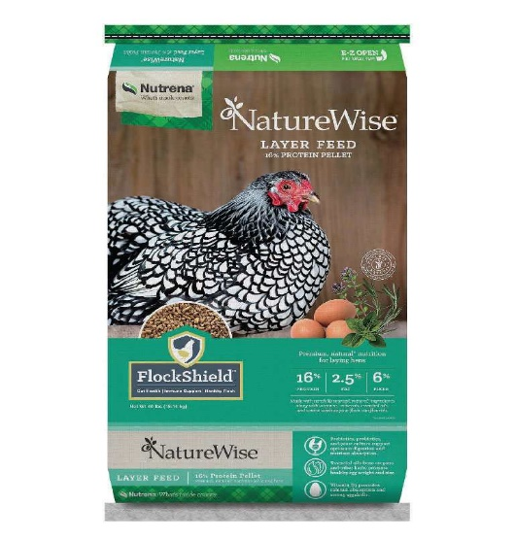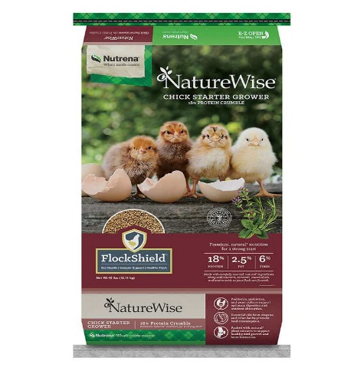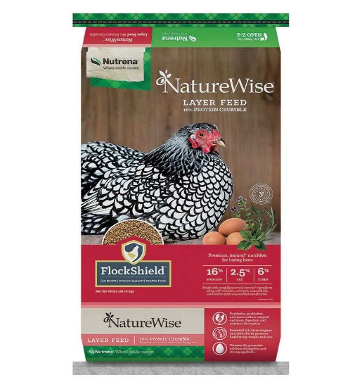

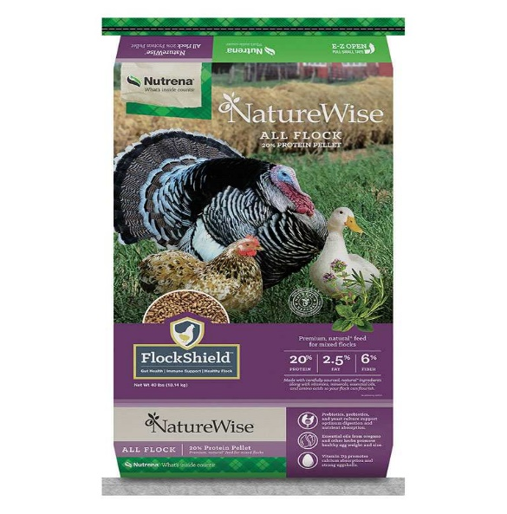

From the beginning, we made it our business to give you and your animals the best.

We’ve been feeding animals for over 100 years! Our people are passionate about delivering quality nutrition to keep your animals happy and healthy.

Exhibitor _________ Received _____________ Amount Paid_________ Check no._________ Received by __________

CAPE FEAR POULTRY ASSOCIATION **OPEN** SHOW ENTRY FORM

**DATE OF SHOW: DECEMBER 14, 2024 ENTRY DEADLINE: DECEMBER 9,2024**

I, ___________________________________________, **do hereby acknowledge and agree that by attending and participating in this show, I do so at my own risk due to the uncertainty of the COVID-19 Virus.** I make the following entry subject to the rules and regulations in the show catalog. By making this entry I give Cape Fear Poultry Association permission to use my contact information (address, phone #, email) for the Exhibitors List, club members, etc., I agree and accept the NO EARLY COOPING OUT rule. I understand all entry fees must be paid, even if I am unable to attend. I acknowledge and accept the North Carolina State Health Requirements for exhibiting poultry in North Carolina.

STREET ADDRESS__________________________________________________________ PHONE: (_______) ______________________

CITY______________________________________________________________________________STATE_____________ZIP___________

EMAIL ADDRESS ____________________________________________________________________________________________________

***\*\*PLEASE USE YOUR SAME NAME AND ADDRESS AS RECOGNIZED BY THE APA/ABA & BREED CLUBS***

***SO, YOU WILL RECEIVE YOUR POINTS**.***

UNDER **TYPE** USE “**L**” LARGE FOWL, “**B**” BANTAM, “**T**” TURKEY, “**Ga**” GUINEA, “**D**” ALL DUCKS “**G**” ALL GEESE

UNDER **VARIETY** use Bearded or Non-Bearded, SC (single comb) or RC (rose comb) ***only if it applies with that color or breed.***

***FORMS MAY BE COPIED FOR MORE SPACE, MORE THAN ONE ENTRY***

|  |  |  |  |  |  |  |  |
| --- | --- | --- | --- | --- | --- | --- | --- |
| BREED | **VARIETY** | **TYPE** | **COCK** | **HEN** | **COCKEREL** | **PULLET** | **TOTAL**  **BIRDS** |
| EXAMPLE: PLYMOUTH ROCK  EXAMPLE: SILKIE  EXAMPLE: RHODE ISLAND | WHITE  Bearded or non-bearded- Color  Red or White SC or RC | L  B  L | 1 DC  2  3 DC | 2  3  2 | 3 DC  4  4 DC | 2  5  3 | 8  14  12 |
|  |  |  |  |  |  |  |  |
|  |  |  |  |  |  |  |  |
|  |  |  |  |  |  |  |  |
|  |  |  |  |  |  |  |  |
|  |  |  |  |  |  |  |  |
|  |  |  |  |  |  |  |  |
|  |  |  |  |  |  |  |  |
|  |  |  |  |  |  |  |  |
|  |  |  |  |  |  |  |  |
|  |  |  |  |  |  |  |  |

**Total number of birds entered_______ X $6.00 per bird Entry Fee ________________**

**Number of double coops ______ X $5.00 (Please specify bird for Double Coop) DC Fee _________________**

**Clean-Up Fee $5.00 per Exhibitor Clean UP $ 5.00**

**Total Amount Due $______________**

Send the completed form with a check or money order payable to Cape Fear Poultry Association

C/O Donna Worthington, 118 Kincalf Lane, Macclesfield, NC 27852

**Phone: 252-827-2491 or 252-341-8706 Email: donna.worthington@aol.com**

**Pay Pal available on the website:** [**www.capefearpoultryassociation.com**](http://www.capefearpoultryassociation.com)

Exhibitor _________ Received _____________ Amount Paid_________ Check no._________ Received by __________

CAPE FEAR POULTRY ASSOCIATION JUNIOR SHOW ENTRY FORM

**DATE OF SHOW: DECEMBER 14, 2024 ENTRY DEADLINE: DECEMBER 9, 2024**

JUNIOR AGE __________ JUNIOR SHOWMANSHIP YES ______ NO______

I, ___________________________________________, **do hereby acknowledge and agree that by attending and participating in this show, I do so at my own risk due to the uncertainty of the COVID-19 Virus.** I make the following entry subject to the rules and regulations in the show catalog. By making this entry I give Cape Fear Poultry Association permission to use my contact information (address, phone #, email) for the Exhibitors List, club members, etc., I agree and accept the NO EARLY COOPING OUT rule. I understand all entry fees must be paid, even if I am unable to attend. I acknowledge and accept the North Carolina State Health Requirements for exhibiting poultry in North Carolina.

STREET ADDRESS_____________________________________________________________ PHONE: (________) _____________________

CITY______________________________________________________________________________STATE_____________ZIP___________

EMAIL ADDRESS ____________________________________________________________________________________________________

***\*\*PLEASE USE YOUR SAME NAME AND ADDRESS AS RECOGNIZED BY THE APA/ABA & BREED CLUBS***

***SO, YOU WILL RECEIVE YOUR POINTS**.***

UNDER **TYPE** USE “**L**” LARGE FOWL, “**B**” BANTAM, “**T**” TURKEY, “**Ga**” GUINEA, “**D**” ALL DUCKS “**G**” ALL GEESE

UNDER **VARIETY** use Bearded or Non-Bearded, SC (single comb) or RC (rose comb) ***only if it applies with that color or breed.***

***FORMS MAY BE COPIED FOR MORE SPACE, MORE THAN ONE ENTRY***

|  |  |  |  |  |  |  |  |
| --- | --- | --- | --- | --- | --- | --- | --- |
| BREED | **VARIETY** | **TYPE** | **COCK** | **HEN** | **COCKEREL** | **PULLET** | **TOTAL**  **BIRDS** |
| EXAMPLE: PLYMOUTH ROCK  EXAMPLE: SILKIE  EXAMPLE: RHODE ISLAND | WHITE  Bearded or non-bearded- Color  Red or White SC or RC | L  B  L | 1 DC  2  3 DC | 2  3  2 | 3 DC  4  4 DC | 2  5  3 | 8  14  12 |
|  |  |  |  |  |  |  |  |
|  |  |  |  |  |  |  |  |
|  |  |  |  |  |  |  |  |
|  |  |  |  |  |  |  |  |
|  |  |  |  |  |  |  |  |
|  |  |  |  |  |  |  |  |
|  |  |  |  |  |  |  |  |
|  |  |  |  |  |  |  |  |
|  |  |  |  |  |  |  |  |

**Total number of birds entered_______ X $3.00 per bird Entry Fee ________________**

**Number of double coops ______ X $3.00 (Please specify bird for Double Coop) DC Fee _________________**

**Clean-Up Fee $1.00 per Exhibitor Clean-UP $ 1.00**

**Total Amount Due $______________**

Send the completed form with a check or money order payable to Cape Fear Poultry Association

C/O Donna Worthington, 118 Kincalf Lane, Macclesfield, NC 27852

**Phone: 252-827-2491 or 252-341-8706 Email: donna.worthington@aol.com**

**Pay Pal available on the website** [**www.capefearpoultryassociation.com**](http://www.capefearpoultryassociation.com)